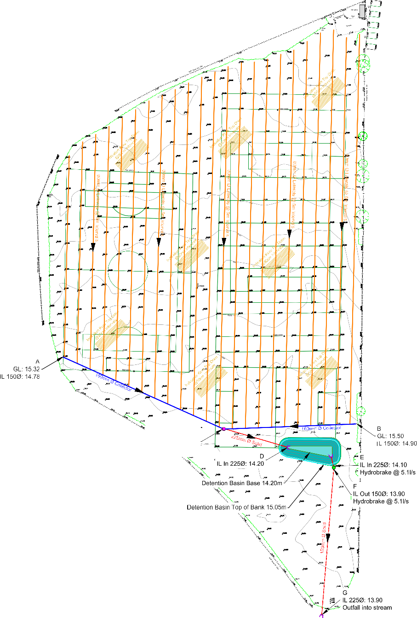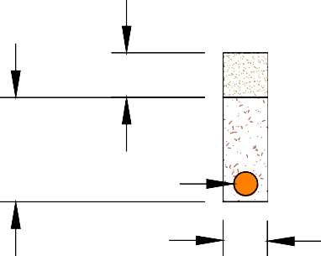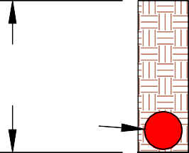

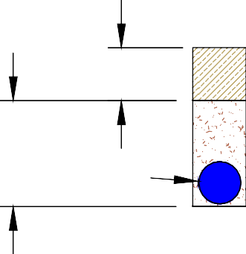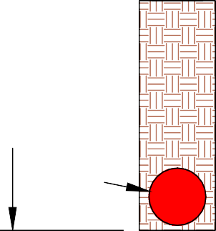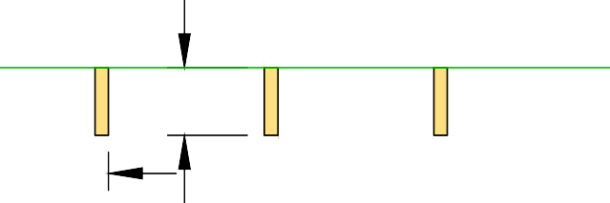

|  |  |  |  |  |
| --- | --- | --- | --- | --- |
| Revisions | | | | |
| Rev | Date | Description | Drawn By | Checked By |
|  |  |  |  |  |
|  |  |  |  |  |
|  |  |  |  |  |

|  |  |  |  |  |  |
| --- | --- | --- | --- | --- | --- |
| C GL: 15.32  IL In 15000 14.30  IL Out 22500 14.30 | 0.150 Rootzone  0.350  00.080 2-6mm 0 Gravel  0.150  80mm 0 Lateral (Perforated Plastic Pipe)  0.200 Site Won Topsoil  0.400 2-6mm 0 Gravel  00.160  0.200  160mm 0 Collector (Perforated Plastic Pipe)  Depth Varies  00.150  0.200  150mm 0 Solid Twin Walled Carrier  Depth Varies Backfill with site won Topsoil and Subsoil  00.225  0.300  225mm 0 Solid Twin Walled Carrier  0.200 Sand  0.040  0.500  Top Drain Sand Slits @ 0.5m Intervals | Notes :  1) Existing Levels taken from drawing 25982Y_01 *"Topographical Survey"* by JPP.   1. Detention Pond Earthworks Cut = 160m3   Fill = 0m3  Net = 160m3 (Material to be removed)   1. The detention basin has capacity to retain 135m3 of water. | | | |
|  | | | |
| Legend  Contours 25cm Intervals  80mm 0 Laterals @ 6m Intervals 160mm 0 Collector  150mm 0 Solid Twin Walled Carrier  225mm 0 Solid Twin Walled Carrier  Indicative Top Drain Sand Slits @ 50cm Intervals  Inspection Chamber  Inspection Chamber / Hydrobrake  Headwall  Detention Basin - Base Level 14.20m  Detention Basin - 1:4 Slopes  Top of Bank Level 15.05m | | | |
| Drawing Status  Design | | | INDICATIVE ONLY |
| Grounds Management Association  28 Stratford Office Village Walker Avenue Wolverton Mill  East Milton Keynes MK12 5TW  Tel: 01908 312511 | | | |
| PROJECT  Parish Parish Field | Job No. | GMA0930.34 | |
| Scale | 1:750 / 1:20 @ A2 | |
| Drawn By | OM | |
| Date | 16th December 2022 | |
| Consultant | Alex Vickers | |
| CLIENT  Great Sankey PC | Drainage Design  Data copyright © GMA 2022 | | |
| DRAWING No.  GMA0930.34-1 |