**OPM’s for Civils Patching**

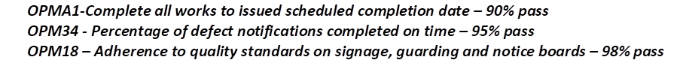

The Subcontractor will put at risk 3% (designed to represent average profit) of the amount due at each months application. The Subcontractor will then be judged on the % of the ‘applicable OPMs’ they meet each month. This will be used to determine the ‘risk % due’ for that month. For instance:

**Example 1 (standard ‘risk % due’ calculation)**

Risk %: 3%

Applicable OPMs for Month y: 3

No. of Applicable OPMs met for Month y: 2

Total Profit: 2/3 x 3% = 2.01% risk % due for month y