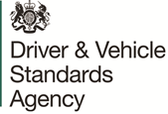
Magda Borkowska
Senior Commercial Category Manager
Driver and Vehicle Standards Agency
Ellipse
Padley Road
Swansea
SA1 8AN

Magda.Borkowska@dvsa.gov.uk

Contract Agreement Number: K280021414

12 May 2021

Roger Talbot
Insight Direct (UK) Ltd
The Atrium
Uxbridge
UB8 1PH
United Kingdom

Dear Roger

K280021414 Scanning Security Vulnerabilities - Snyk Licences: CONTRACT AWARD

On behalf of the Secretary of State for Transport, I accept your tender dated 7th May 2021 for the above-mentioned Contract. This letter and the documents listed below form a binding contract between you and this Department.

        - Form of Tender
        - General Conditions of Contract for Services
        - Statement of Requirements
        - Pricing Schedule
(v) How to Bid including Evaluation Criteria

The operative period of the Contract will be 1 year with a possible extension of a further 1 year. The contract starting date will be 17/05/2021 and it will end on 16/05/2022.

The Approved Maximum Cost for the Contract is £51,494.40 exclusive of Value Added Tax. The value of 1 year extension is the same as contract value and equal to £51,494.40 exclusive of Value Added Tax.

Suppliers must be in possession of a written purchase order (PO), before commencing any work under this contract. The Purchase Order Number for this contract will be provided as soon as possible. You must quote the PO number on all invoices, and these must be submitted directly to SSa.invoice@sharedservicesarvato.co.uk. Invoices received without the correct PO number will be returned to you and will delay receipt of payment.

Please acknowledge receipt of this letter and contact the Darren Hitchmough or Tracey Taylor by email at assets&licencing@dvsa.gov.uk, to discuss arrangements for commencement of the Contract.

Yours sincerely
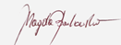

Magda Borkowska
Senior Commercial Category Manager
by authority of the Secretary of State for Transport

We accept the terms set out in this letter and its Annexes, including the Conditions.
Signed for and on behalf of Insight Direct (UK) Ltd (“the Supplier”)
Name: Roger Talbot
Job Title: Contracts Manager
Signature: 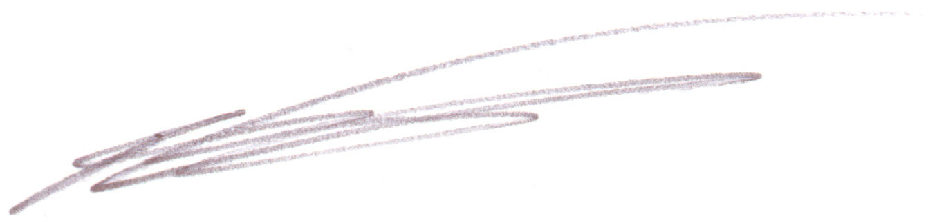
Date: 12/05/2021

