
Shifnal Town Council

Main Tender Document

Provision to Refurbish Public Toilets

Market Place, Shifnal, TF11 9AP

To be submitted no later than 9th September 2022.

Late submissions will be disregarded.

General Enquiries
Shifnal Town Council
Dave Gough
01952 461 420
dave.gough@shifnaltowncouncil.gov.uk

RESPONSIBLE PARTIES

The Employer
Shifnal Town Council
Shifnal Community Hub, Tudor Way
Shifnal
Shropshire
TF11 8DJ

Contract Administrators
Dave Gough – Shifnal Town Council
Lucie Pritchard - Shifnal Town Council

TABLE OF CONTENTS

1. General Requirements.........................................................................................4

  - Overview and Objective of Project............................................................4

  - Budget and Costings ................................................................................5

1.3 Non-Consideration of a Tender Response................................................5

2. Contract Conditions..............................................................................................5

2.1 Works and Standards................................................................................5

2.2 Purchase Order and Contract Agreement ................................................6

2.3 Insurance ................................................................. ................................6

2.4 Contractor Documentation ........................................................................6

3. Scope of Works......................................................................................................6

3.1 Requirements ............................................................................................6

3.2 Specifications.............................................................................................7

3.3 Removals, Relocation and Disposals ........................................................7

4. Timetable for Project .............................................................................................8

5. Scoring of Submissions........................................................................................8

5.1 Scoring Criteria ..........................................................................................8

5.2 Scoring Matrix.............................................................................................9
6. Procurement Process .........................................................................................10

6.1 Type of Procedure....................................................................................10

6.2 Site Meeting with Interested Parties.........................................................10

6.3 Questions and Clarification ......................................................................10

6.4 Notice of Intent to Bid...............................................................................10

6.5 Consultation or Public Engagement ........................................................11

6.6 Revisions and Negotiation.......................................................................11

6.7 Decision and Award of Contract..............................................................11

6.8 Supplier Responses.................................................................................11

7. Named Contact for the Project ..........................................................................11

8. Supplier Submission Checklist and Instructions.............................................12

8.1 The Supplier Checklist.............................................................................12

8.2 Delivery of Hard Copies...........................................................................12

1. General Requirements

  - Overview and Objective of Project

Shifnal Town Council (The Employer) is seeking a suitably qualified company (The Contractor) to refurbish the existing public toilets in Shifnal.

The location of the site is Public Toilets, Market Place, Shifnal, Shropshire, TF11 9AP

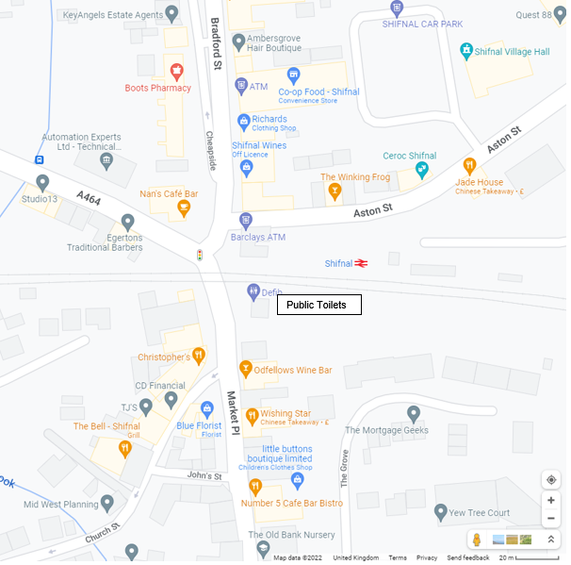
© Google Maps

The aim is to refurbish the existing public toilet building as a free facility that can be used by the residents of Shifnal.

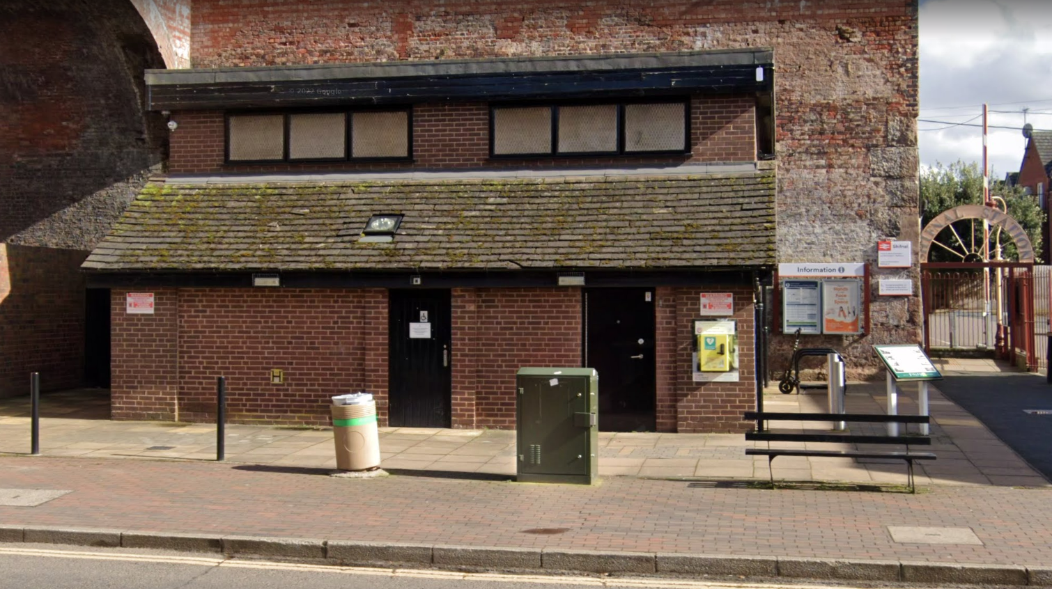
© Google Maps

  - Budget and Costings

➢ The council has set aside a budget of approx. £55,000.00 (Ex VAT).
However, pricing will be part of the scoring criteria.

➢ All pricings should be exclusive of VAT and in GBP (£)

➢ Pricing to be valid for 90 days from the due date of the response.

➢ Prices will be fixed and firm for the duration of the contract.

  - Non-Consideration of a Tender Response

The council has the right to refuse any or all submissions without tenderers being able to claim any compensation. All costs associated with the tender process and submission is the responsibility of the suppliers that have been decided to participate.
The council may refuse a tender response if there has been any attempt to vary or alter the details within the document or is not able to provide all the information required by the council to make a full evaluation. Any offence or inappropriate actions by the supplier, including an offence under the Prevention of Corruption Act may result in disqualification. Anything other than “appropriate” contact made to the individuals named within this document for the purposes of clarifying the requirements or raising any questions pertaining to the tender may be considered a breach in the procurement process.

2. Contract Conditions

2.1 Works and Standards

The work is for the refurbishment of the public toilets and associated works which should comply to any relevant regulations and guidance by appropriate sporting organisations.

If there is evidence that the work does not conform to the required standard and as a result the materials or workmanship are substandard or require replacement or repair, this will be completed at the cost of the Contractor.

The contractor must follow the 2015 CDM regulations and will have the skills, knowledge, and experience, and, if they are an organisation, the organisational capability, necessary to fulfil the role that they are appointed to undertake, in a manner that secures the health and safety of any person affected by the project.

2.2 Purchase Order and Contract Agreement

The successful contractor will enter into an agreement by way of a Purchase Order with Shifnal Town Council. In addition, a binding contract (Appendix 3) with agreed terms and conditions will be provided for both the Employer and the Contractor to jointly authorise, the agreement will not be final until both parties have signed this contract.

The contract will refer to all documents received, and communications during the tender process which form the total understanding and obligations of what has been agreed the Contractor will supply the Employer.

2.3 Insurance

The successful contractor must be able to provide evidence of:
➢ Public Liability Insurance of no less than: £10 Million
➢ Product Liability Insurance of no less than: £5 Million
➢ Employers Liability Insurance of no less than: £5 Million
➢ Professional Indemnity Insurance of no less than: £1 Million

2.4 Contractor Documentation

The selected contractor will commit to periodic meetings on site during construction between agreed parties from both The Employer and The Contractor, until work is completed and handed over. The timing of these site visits will be agreed before work commences, and The Contractor will provide in advance of any construction the following:

➢ A Construction Phase Plan

➢ A Risk Assessment and Method Statement

➢ An Organisational Chart outlining escalation contacts that are
available to remedy any issues that arise, and their roles

3. Scope of Works

3.1 Requirements

The Council has decided to refurbish the existing public toilets to modernize them and keep them fit for purpose.

3.2 Specifications

The specification for the refurbishment has been prepared by DPS Architects, please refer to the full specification shown in appendix 4.

3.3 Removals, Relocation and Disposals

Removal of any spoil and packaging off site and disposed in an appropriate waste depot.

4. Timetable for Project

Below is the table set out for the project which suppliers will need to confirm they can achieve to ensure the primary deadline is met.

Action: | Date
Tender Release Date: | 29th July 2022
Site meeting for interested contractors (30 minute slots from 10:00am to 15:00pm): | 8th August 2022
Notification of your intention to provide a response and any questions about the tender: | 12th August 2022
Tender Submissions Due: | 9th September 2022  16:00 (4:00pm)
Decision on Preferred Supplier: | September 2022
Work to Commence: | October 2022

5. Scoring of Submissions

5.1 Scoring Criteria

Criteria | Information Required | Weighted Percentage
5.1.1 Specifications | Appendix 4 lays out the specification for the refurbishment.  Scoring (Points):  Non-Compliant – 10%  Partial Compliance – 20%  Compliant – 30%  Exceed Compliance – 40% | 40%
5.1.2 Questions | 1. Confirm how your company manages supply chains in relation to meeting time frames, quality control, health and safety and assess their performance and output. Please be specific in terms of processes, performance indicators and the personnel involved.  Scoring: 15%  2. Outline details of the experience and qualifications in terms of the company, employees and sub-contractors that will be involved in delivering this project. Provide  specific detail on individual qualifications, company memberships and what sector and facilities the company specialise in.  Scoring: 15% | 30%
5.1.3 Total Cost | Scoring will be made according to the overall cost of the tender, assuming the minimum specifications of the brief are met. Scoring on cost will be based on increments that are proportionate and fair to the submissions provided from highest to lowest cost as a  percentage of the proposed budget. Example: proposals that are within the budget will score an automatic 5/10 then increase based on the increment of submissions. If the cost difference is deemed minimal (i.e. less than 1%) between suppliers, the scoring will be considered equal. | 20%
5.1.4  Presentation  and Quotation | Suppliers are to provide:  - An Itemised Quotation  - Electrical Drawings  - Mechanical Drawings | 10%

5.2 Scoring Matrix

Responses to 5.1.2 and 5.1.3

9-10 | Superior | Exceptional demonstration of the relevant ability, understanding, experience, skills, resources & quality measures required to meet the projects aims or requirement. Response highly relevant with comparable contract value.
7-8 | Good | A comprehensive response submitted in terms of detail and relevance and clearly meets most of the project aims or requirement with no negative indications or inconsistencies
5-6 | Adequate | Reasonable achievement of the requirements specified in the tender offer & presentation for that criterion. Some errors, risks, weaknesses, or omissions, which can be corrected/overcome with minimum effort.
3-4 | Below Expectations | Minimal achievement of the requirements specified in the tender offer & presentation for that criterion. Several errors, risks, weaknesses, or omissions, which are possible, but difficult to correct/overcome and make acceptable.
0-2 | Poor to Deficient | Limited or no response provided, or a response that is inadequate, substantially irrelevant, inaccurate, or misleading

6. Procurement Process

The Procurement Process will be conducted and in compliance with The Public Procurement Regulations 2015 and any updated guidance since. The objective is to be fair, transparent, and proportionate based on the type of project, and to ultimately select the Most Economically Advantageous Tender.

6.1 Type of Procedure

The tender process will be an Open Procedure, Single Stage Tender.

6.2 Site Meeting with Interested Parties. There will be a site meeting to give all suppliers the opportunity to meet with the consultant in 30-minute individual slots to clarify any questions. However, this is not mandatory, and suppliers are welcome to visit the site at their own convenience without penalty.

6.3 Questions and Clarification

Please note that any responses to queries or clarification requests will, subject to there being a confidentiality issue that cannot be resolved, be circulated to all bidders. Questions should be emailed to the council, not by telephone or in person other than the site meeting. Suppliers are forbidden to approach any person/s outside of the named person (Section 7) within this document in relation to this tender and project, failing to do so may result in disqualification of the tender process.

6.4 Notice of Intent to Bid

Suppliers should notify the named consultant a confirmation of your intent to provide a submission by the due date, and all questions relating to the tender will need to be made no later than the date provided in Section 4.

Failure to notify your intention to bid, or are unable to attend the site meeting, circulation of any questions or updates to the Tender Process may not be sent to your organisation, potentially missing relevant information and submitting an incomplete response.

6.5 Consultation or Public Engagement

The Employer reserves the right to conduct a public consultation. The purpose of any consultation will primarily be to update the community on the preferred design, allowing an opportunity to collect feedback which may contribute to any revisions. Guidance on how the consultation will be conducted and what information should be
collected will be discussed between The Employer and any relevant third parties such as a consultant. However it will not be used to score any of the original designs submitted.

6.6 Revisions and Negotiation

If required, the council will engage with the preferred contractor to amend the design or negotiate any changes or costs associated with the submission, however, will not be deemed “substantial” changes to the original brief. These revisions will be discussed and agreed to before any agreement or purchase order is made final.

6.7 Decision and Award of Contract

The Employer will be responsible for making the final decision based on the scoring criteria set out in the tender document. All parties who have submitted a formal tender response will be notified of the outcome and scoring results of the preferred contractor and that supplier only. An agreement (Appendix 3) will be provided setting out any specific terms and conditions to be signed by both The Employer and The Contractor.

6.8 Supplier Responses

The submissions received by each of the suppliers will not be disclosed to other parties and should not be requested by other parties. Only the scoring of the submissions will be provided on request. The preferred contractor will be advised either via email or on Contracts Finder when the Award Notice is issued.

7. Named Contact for the Project

Shifnal Town Council

Contact: Dave Gough

Phone: 01952 461 420

Mobile: 0745 805 4144

Email: dave.gough@shifnaltowncouncil.gov.uk

8. Supplier Submission Checklist and Instructions

8.1 The Supplier Checklist

Response | Format (Fill in supplier name with your company)
- Completed Copy of Appendix 1 | PDF or Word Document Labelled – Supplier Name Appendix 1
- Completed Copy of Appendix 2 | PDF or Word Document Labelled – Supplier Name Appendix 2
- Response to each question in 5.1.2 | PDF or Word Document Labelled – Supplier Name Questions
- Quotation | PDF or Word Document Labelled – Supplier Name Quotation
- Drawings | PDF or JPG Document Labelled – Supplier Name CAD  Supplier Name 3D
- An Email or electronic transfer of all above responses should only be sent after the contract is awarded. | Email above files as attachments or an electronic transfer with no expiry date
Do NOT include the following information for the initial tender response:

➢ TUV Certificates
➢ Copies of Insurance Certificates
➢ Installation documents and drawings
➢ Trade Association or other member certificates
➢ Warranty Certificates or Health and Safety Policies

8.2 Delivery of Hard Copies

The above documentation should be submitted to Shifnal Town Council by the date shown in Section 4 as a sealed bid. All envelopes should be marked in the top left corner “Public Toilet Refurbishment Tender Documentation – Sealed Tender”.

Public Toilet Tender Documentation Sealed Tender
Shifnal Town Council
Shifnal Community Hub
Tudor Way
Shifnal, Shropshire
TF11 8DJ

