MUSIC QUIZ
Description of current solution
Objective
Technical design requirements
Digital production
Content to be included
Audience
Dwell time
Copyright

Description of current solution
The Music Quiz is one of the most popular interactive elements at the Wondrous Place Gallery. Situation in the music exhibition, the quiz is a fun way for visitors to find out more about some of the content and the people included within the exhibition. Four digital touchscreens presenting the same content run a number of timed questions. A countdown appears before each question and then it shows on the screen. The answers were given in the form of a video, with 'fun facts' running along the bottom of the screen. A spinning record graphic projects on the table while the video runs.

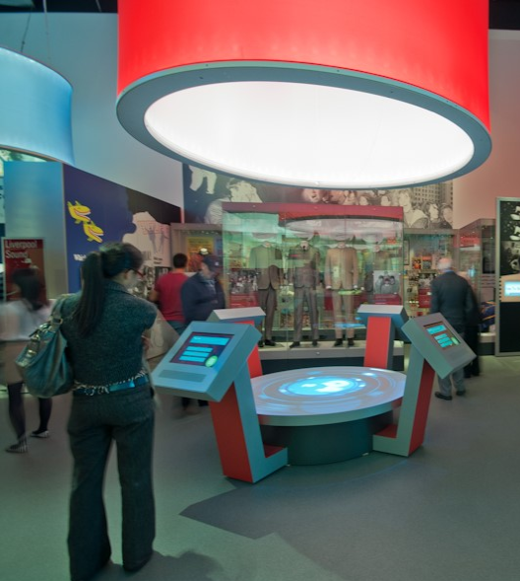

Objective
To propose a digital, modernised and attractive new version of this quiz. We wish to ensure that the level engagement is enhanced for all ages and levels of interest. To achieve this, we want visitors to be able choose how they access the quiz by opting for different levels of difficulty.

All the questions/answers will be local, relevant and informative. The answers will be supported by a relevant song and image or music video footage so that the process and content is as engaging as possible.

Technical design requirements
The new Music Quiz will be a free-standing tabletop structure that sits centrally within the Music exhibition in the gallery. We would like to maintain the number of screens provided so that the quiz can be played by up to 4 - 8 people as individuals or in pairs, who can stand around the quiz easily. However, the spinning record graphic projected on the table is a feature that should no longer be part of the exhibit. We welcome proposals that include a system where individuals or groups can challenge each other by each team using a screen.

We would also welcome proposals that deliver a solution either through a large tabletop touchscreen or a series of touchscreens, one for each user or pair of users. Any sound should be delivered through the table via speakers. Any equipment needs to be housed within the table and needs to be easily accessible for regular maintenance. The design must be accessible and adhere to NML’s access guidelines.

The footprint of the Music Quiz should be no bigger than 1.4m in diameter to allow for enough visitor flow around the space. The area around the Music Quiz will have a combination of cased objects, large graphics and other AV elements (see visual below). The Music Quiz will need to be powered from a floor socket, and this needs to be considered within the design.

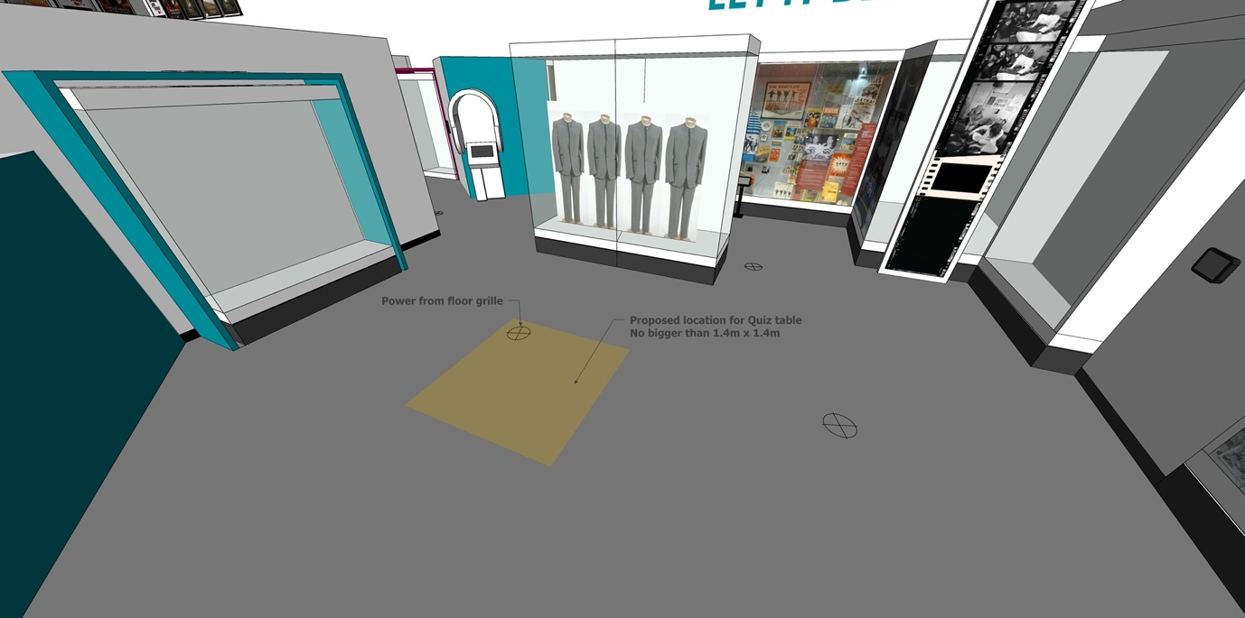

The design of the Music Quiz should be fresh, exciting and attractive. However, it should respect and match the overall look and feel of the Music Exhibition and not be too overpowering in the space. The gallery has been designed to have a light colour palette with most walls being white and the flooring a mid-grey tone. The gallery has some natural daylight, so projection is not effective in this area.

Below are some visual reference examples of tabletop interactives to give a look and feel of what NML are looking to produce on the gallery:
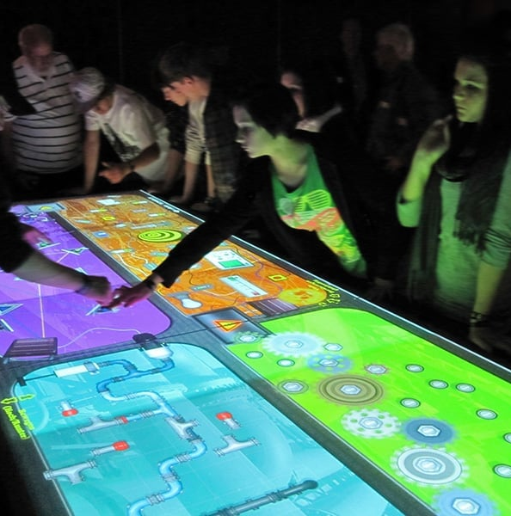
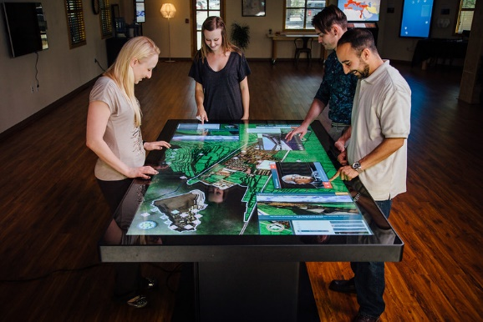

Digital production
The format of the quiz should maintain a similar, yet refreshed format of multiple-choice answers. The quiz will need a screensaver/holding screen that can attract the visitor before the interaction begins and advertise the content. The quiz design should be bright and playful, but also contain a level of competitiveness with the potential for a leader board embedded into the software. The graphics should match the colours and fonts used in this section of the gallery, information to be supplied by NML.

Content to be included
Situated centrally in the music exhibition, the quiz will pull content from all areas of the exhibition, covering topics as wide ranging as early jazz and folk influences, the punk scene in Liverpool and contemporary club dance nights. Some of the answers will be found within the displays, some will be basic general knowledge.

The quiz will be divided into three selectable options:

- Easier general knowledge questions
- Harder more niche questions, but still accessible
- Beat the DJ – questions submitted by local radio DJs

The NML content team will deliver a ‘pool’ of questions with associated multiple-choice answers for each section (minimum a pool of 40 x questions per section) for the contractor to animate and develop into engaging content. There is potential to expand the pool of questions if required. It is the responsibility of the successful bidder to source and deliver supporting sound/images or footage to animate the information.

Audience
The Music Quiz exhibit is aimed at a general audience, but it needs to be accessible for visitors on the autism spectrum and dementia.

Dwell time
Our expectation is that, once the visitor has selected the level of difficulty, the quiz should show from 8 to 10 questions. This is the ideal number of questions for visitors to feel satisfied and to acquire a sense of achievement and successful participation. Depending on the proposed design, this can be discussed. The quiz could be played again with different questions being drawn from the pool for each section.

Copyright
The research, sourcing and purchase of all footage and imagery copyright licenses/rights, under the guidance of the NML content, are the responsibility of the supplier. NML requires all copyright license clearance to be at least ten year or a lifetime, nothing less. NML will require copies of the project files and media, as well as access to the content management system or web platform, so the AV presentation can be updated if and when necessary, by NML.

