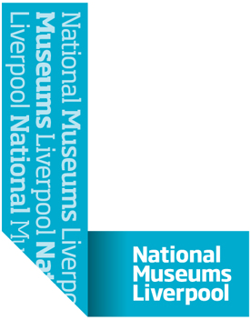

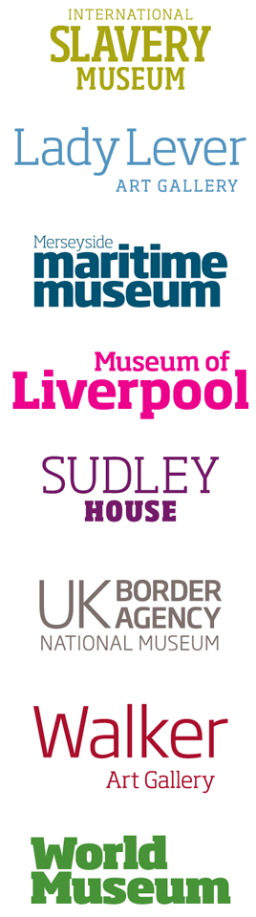

NATIONAL MUSEUMS LIVERPOOL

NML MOL Atrium Screens Tender

Author: Sam Planche
Date: 11/11/2016

Introduction

Company Background
National Museums Liverpool (NML) holds in trust and safeguards some of the world’s most important museum collections, which are universal in their range – everything from archaeology and ethnology, natural and physical sciences, fine and decorative arts, maritime, social and industrial history. We are the main museum service for Liverpool and Merseyside; we are the North West’s largest cultural organisation and we operate at national and international levels. NML currently comprises eight museums in and around Merseyside. Entry to all our venues is free, with circa 3 million visitors per year.

NML's mission is to promote the public enjoyment and understanding of art, history and science. This is achieved through exhibitions, education, consultancy, archaeological excavation and fieldwork, scientific and historical research and building and collection care. In the past 10 years, NML has won many national and international awards for education, tourism, architecture and scholarship.

National Museums and Galleries on Merseyside was established as a national museum as an incorporated Trustee Body by the Merseyside Museums and Galleries Order 1986, because of the outstanding quality of its collections. In 2003 the name was changed to National Museums Liverpool. Our origins go back to 1851 and the founding of Liverpool Museum. NML is an exempt charity by virtue of Schedule 3 to the Charities Act 2011.

NML has status as a Non Departmental Public Body (NDPB) sponsored by the Department for Culture, Media and Sport (DCMS). The DCMS became the principal regulator of NML on 1 June 2010 and provides the majority of its revenue funding.

High Level Overview of Additional Requirements
NML is looking to replace its current Atrium video wall screens in the Museum of Liverpool. The current solution comprises of 9 screens with 9 adtech units. The contract will include the supply, and installation support for the solution.

This Tender

Suppliers are asked to submit a formal tender for the supply and installation of a video wall in the Museum of Liverpool. Tendering is required by NMLs procurement processes that ensure that NML is adhering to Managing Public Money guidelines.

Please Ensure Appendix A is read and all instructions are followed

2.1 Basis of tender
The Supplier is requested to propose a solution that will meet the current and future requirements of NML, as detailed within this tender pack.
NML has a preference to select a supplier that can demonstrate they have in-house project management and technical skills to successfully deliver the project.
This tender is not an offer to contract. Acceptance of a proposal neither commits NML to award a contract to any supplier, even if all requirements stated in this tender are satisfied, nor does it limit NML’s right to negotiate in their best interest. NML reserves the right to contract with a supplier for reasons other than the lowest price. Contract award will be post the tender process and may be awarded without discussions or negotiations
NML also reserves the right to cease discussions with any supplier from the date of submission of supplier tender.
Failure to meet a qualification or requirement in this tender will not necessarily subject a proposal to disqualification but may do so.

2.2 Confidentiality and Non-Disclosure
The information contained in this Tender (or accumulated through other written or verbal communication) is confidential. It is for proposal purposes only and is not to be disclosed or used for any other purpose.
Information received by NML in this Tender will be held in strict confidence and will not be disclosed to any party, other than within NML and their engaged consultants if appropriate, without the express written consent of the supplier.
NML undertakes not to publicise any information obtained during this Tender process, either generally or to any other suppliers involved in the Tender. Additionally, there will be no obligation on the part of NML to share any of the results or conclusions of the Tender process with any supplier.

2.3 Cost of Preparation
NML will not accept any liability or responsibility for any costs incurred by the supplier in preparing this Tender document or any associated work effort.

2.4 Oral Agreement or Arrangements
Any alleged oral agreements or arrangements made by the vendor with any NML agent or employee will be disregarded in any proposal evaluation or associated award.

2.5 Independent Price Determinations
The vendor shall warrant, represent, and certify that the following requirements have been met in connection with their proposal for this tender:

The costs proposed have been arrived at independently, without consultation, communication, or agreement for the purpose of restricting competition as to any matter relating to such process with any other organisation or with any competitor;

Unless otherwise required by law, the pricing proposed has not been knowingly disclosed by the vendor on a prior basis directly or indirectly to any other organisation or to any competitor; and no attempt has been made, or will be made, by the proposed to induce any other person or firm to submit or not to submit a proposal for the purpose of restricting competition.

2.6 Payments Against a Contract Award
Under no circumstances shall the successful vendor begin to perform under the contract prior to the effective date of the contract. NML shall assume no liability for payment of services under the terms of the contract until the successful vendor is notified that the contract has been agreed by both parties.

2.7 Questions and Additional Information
Formal queries concerning the content of this tender and the supplier’s submission should be submitted in writing by e-mail to Ian Lindsay (Ian.Lindsay@liverpoolmuseums.org.uk) with the subject title “NML MOL Atrium Screens Tender”.
Where questions are raised by suppliers and answers given clarify NMLs requirements for the tender, then these questions and answers may be shared with other suppliers responding to this tender.
Queries must not be directed through any other employee, contractor or consultant who is engaged as part of the tender working party.

2.8 Vendor Misrepresentation or Default
NML may reject the proposal and void any award resulting from this tender to a vendor who makes any material misrepresentation in their proposal or other submittal in connection with this tender.

2.9 Target Timetable
The target timetable for this project is shown in the table below but suppliers must be aware that whilst every effort will be made to meet these dates, the timetable may change for operational reasons

Step | Task | Date
1. | Tender issued | 14/11/2016
2. | Meeting with preferred Suppliers | 22, 23 & 29/11/2016
3. | Deadline for email Tender Questions | 25/11/2016
4. | Responses to clarification questions issued | 30/11/2016
5. | Deadline for Tender Response | 6/12/2016
6. | Supplier selection decision | 12/12/2016
7. | Notification to unsuccessful Bidder | 13/12/2016
8. | Provisional notification to Successful Bidder | 15/12/2016
9. | Order Placed & contracts signed | 21/12/2016
10. | Work Commencement | 16/1/2017
11. | Installation complete | 30/1/2017

2.10 Timing and Delivery
The supplier must provide a full submission by email. Bids should be in Microsoft Word, Excel or PDF format. The submission must include a copy of “T2 - Form of Tender”.
The submission must be made to Tenders@liverpoolmuseums.org.uk. To ensure that your submission is successful you should ensure that each email is less than 8Mb. Emails should be titled “NML MOL Atrium screens tender”. If multiple emails are sent the header should indicate they are “Part x of xx”.
Tender responses must be received no later than Noon on 6th December 2016. Any response received after this date and time may be discounted from further consideration. Any requirement that the supplier might have for proof of delivery is at the supplier’s discretion and cost.
No tender response will be opened until the deadline of Noon on 6th December 2016.
To enable an efficient and fair evaluation process this process must be strictly adhered to.

2.11 Evaluation
The tender responses will be checked initially for compliance with this ITT and for completeness. Responses that are not substantially complete and/or complaint may be rejected. During the evaluation period, NML reserves the right to call for further information from the bidders to assist in its consideration of their responses.
The tender responses will be evaluated according to the following criteria, to determine the highest scoring responses. :

Element of Evaluation | Max Score Available
Audio visual installation experience including relevant references | 10
Fit for purpose design including ease of use, performance and appearance | 20
Meeting the Specification Criteria | 10
Cost competitiveness | 60
Total | 100

3. Statement of Requirements

The supplier is required to prepare the proposal and pricing based on the hardware and software provided as well as implementation consultancy and information presented in this tender. Any assumptions that the supplier makes must be clearly stated in the appropriate section.
The costs must be fully itemised and transparent.
If the supplier has additional information that is directly relevant to the stated requirements but not explicitly requested, this may be added to the end of the most appropriate section under the heading “Additional Information” or referenced out to appendices.

3.1 Management Summary
The supplier must provide a concise management summary of their offering, including the following:
- A brief overview of the proposed solution including reference to any partners and third parties.
- Reasons why NML should choose the proposed supplier and solution.
- Summary of the supplier’s commercial offer.

3.2 Company Background

3.2.1 Company Details
The supplier must provide the following information:
- The registered name and address of the company
- Details of any holding companies
- The date the company was established
- The main activities of the company
- The proportion of the total business accounted for by the proposed services
- The number and location of offices, identifying the main functions of each
- Insurance details (Professional Indemnity cover, Employers Liability cover, IPR cover)
- Company accreditations (professional body accreditations and trade body accreditations but excluding awards)
- Certifications and last audit dates, e.g. ISO9000 / 9001
- An organisation chart that highlights those functions that would be involved in the delivery and subsequent support of the proposed services
- The quality assurance mechanisms employed by the supplier
- Describe any recent mergers or acquisitions
- Detail any significant partnerships that will be used to deliver the proposed services. Detail the specific nature of each partnership and describe the commercial and contractual implications

3.2.2 Financial Information
The supplier must provide audited accounts for the last three financial years.

3.2.3 Third Party Services
The supplier must provide the following information for each of the proposed third parties that may form part of the proposed new system:
- System name
- Supplying vendor name
- Product name and version
- List of relevant clients where the supplier has provided that service

3.2.4 Reference Clients
As part of the selection process NML will require to contact existing customers of the supplier for similar solutions. The supplier must select 2 reference clients and provide the following contact information:
- Company name and address
- Description of solution provided
- Key contact name, title, and contact information
- Length of the supply relationship
NML undertakes not to contact any reference company without arranging such contact via the supplier’s Account Manager first.

3.2.5 NML Security and Health & Safety requirements
As part of the selection process NML will require to potential suppliers to agree to NML’s security and Health and Safety requirements. Please review the enclosed documents:
i) Appendix B – NML supplemental conditions
ii) Appendix C – NML Safety Guidelines for Contractors
iii) Appendix D – NML H&S Questionnaire

Please complete and return the NML H& S Questionnaire with your submission.

3.2.6 Timetable
Please note that the project must be completed by Jan 30th 2017. Suppliers should present a detailed timetable for planning, installation and completion for the project as a whole, indicating how this date will be achieved.

3.3 Contractual Considerations
The supplier must provide a copy of their standard Terms and Conditions for the proposed services.

4. Requirements Specification
4.1 Requirements Detail
NML requires the tender submission to detail a replacement video wall for the current nine screen solution in the Museum of Liverpool Atrium. The current solution is described in the brief description and images below.

4.2 Current Solution brief description:
AV presentation to work in three different modes, the standard mode will use still images and film footage from the galleries, will be a medium paced silent presentation.

The Secondary mode is a colour wash screensaver following the brand creating a neutral backdrop.

Bespoke mode is for adhoc 3rd party presentations (including Powerpoint presentations) and company logos promotions for room hire. The collective wall is made up of a series of screens which can show independent images or form one big image across all of the screens.

Current Hardware:

9x Adtech units – one connected to each screen, each running individual content (1920x1080x60P)
The solution also has a mini PC connected using VGA that is then split across all the screens to make on large screen, using the features “Tile” and “bezel Compensation” to split the image across all nine screens.

Current Individual Screen Spec:
NEC MultiSync P521
Size: 52 inch
Resolution: 1920 x 1080
Display type: LCD
Connector type: HDMI, DisplayPort, VGA, DVI
Hd format: 1080p
Width: 120 cm
Depth: 14.8 cm
Height: 69.6 cm
Weight: 40 kg

Floor Plan:
Dimensions:
Width 368.0 cm
Depth 26.0 cm
Height 228.0cm

It is advised that suppliers visit the site, we would designate a day for all selected tender applicants to visit if required. This will ensure that all parties get the same information and opportunity. This would be arranged on either 22, 23 &/or 29/11/2016. Please contact ashley.beggs@liverpoolmuseums.org.uk by 21/11/2016

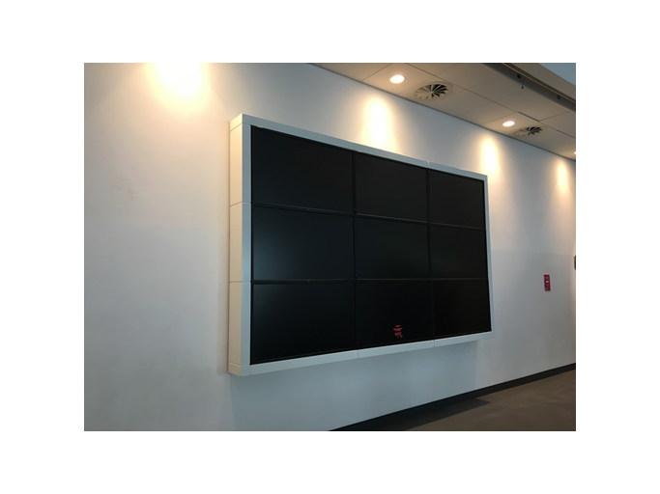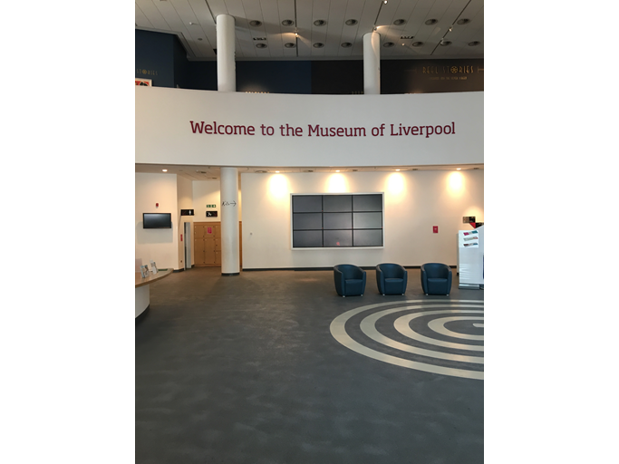

Information desk is on the left side of the picture above

4.3 New Video Wall Replacement Specification Criteria

- The new atrium Video wall solution does not have to be nine individual screens but must equal the same screen size or slightly larger than the current solution
- Zero bezels or if multiple screens thin bezels in comparison to the current solution
- A secure screen housing, depending on the screen sizes and depth or associated equipment
- Each individual screen must be easily accessible, for example cantilever brackets provided for easy access for maintenance
- Minimum of a five year warranty and replacement guarantee for all equipment
- Any software licences are included
- Any ongoing maintenance costs should be detailed
- All media must be able to stretch display across the full video wall and the ability to have more than one type of media displaying across the video wall at any one given time.
- Accessible remotely via an internet browser on the National Museums IT network. This access will allow the user to see the current live status of the screen and upload new files/content via the browser remote session and change the resolution if required.
- A solution to provide HDMI, VGA and Audio must be located at the Information desk that devices such as laptops can be plugged into to provide visual playback and sound if required. Wireless link to the screens if possible if not cabling will need to be considered
- The ability for the display to be switched off with a timed schedule
- Heat and ventilation is considered and accounted for
- Full training on all aspects of hardware and software is included and full documentation and manuals provided

4.4 Installation
NML expects the installation of the equipment to cause minimum disruption or disturbance in the venues. NML would expect the system to be fully installed, tested and operational in order to minimise the disruption to our security coverage and procedures.

Once installed, the equipment and fixings should be as unobtrusive as possible and should be sympathetic to the venue. The client will have final approval of fittings used as part of the installation.

The tender submission should clarify whether cabling is included and also detail any cabling / network connectivity they expect NML to provide. The supplier will ensure that where existing cabling is to be utilised, it is both appropriate and fully operational. The supplier will provide specific detail of all wiring connections which will be installed. Particularly where connection to NML’s network and equipment are required. The client will have final approval on materials used as part of the installation. Installation techniques will be approved by the client. The supplier should include specific network requirements for each site.

The supplier must comply with NML Health and Safety standards as detailed in Appendices B & C and complete the Health and Safety questionnaire - Appendix D as part of the tender submission.

The supplier will guarantee that replacement parts are available for a minimum of five years following installation.

4.5 Performance
Details of any licence charges which are applicable to be included in the tender submission.

NML will require any system to have a degree of flexibility and be adaptable in accordance with our changing environment and for any temporary exhibitions

This document details baseline requirements for the new system. This is not meant to be an exhaustive list of requirements but it will however serve to identify suitable solutions and suppliers. NML reserves the right to modify its requirements at any time.

4.6 Support/Maintenance
Costs for maintenance Monday to Friday 8am to 6pm should be included as an optional extra.

Training is required as part of the installation procedure.

Details of support provided to be included in tender submission.

4.7 Costs
A full breakdown of all costs is to be provided

This document details baseline requirements for the solution. This is not meant to be an exhaustive list of requirements but it will however serve to identify suitable solutions and suppliers. NML reserves the right to modify its requirements at any time.

Please provide details of any potential extra costs.

