 |  | MOD Commercial

FLEET/00678
Managed Learning Services Framework (RM3822)
OFFICIAL-SENSITIVE-COMMERCIAL
Provision of Stage 2 & 3 of the BA Honours Social Work (England) For the Royal Navy Welfare and Royal Marines Welfare Personnel of the Naval Service

This Contract is made
BETWEEN (1) HER BRITANNIC MAJESTY’S SECRETARY OF STATE FOR DEFENCE, acting by Defence Commercial Commands & Centre Navy, Building 1/080, Jago Road, HM Naval Base, Portsmouth, Hampshire, PO1 3LU (“the Authority”)
AND (2) CAPITA BUSINESS SERVICES LIMITED, 4th Floor, Barnard’s Inn, 86 Fetter Lane, London, EC4A

- The Contractor shall provide the Services described in the Statement of Requirements, in accordance with the Conditions of Contract (as detailed in Framework Schedule 4 - Order Form and Call-Off Terms for the Framework Agreement entered into between the Authority and the Supplier on RM3822), the firm prices attached and the Contractor’s Work Order (WO) Reference PSGW00294.
- The Contract shall come into effect on 14 September 2018 and expire 30 June 2021.
- Except where there is prior written approval from the Commercial Branch no payment shall be made for work performed which is outside the scope or period of the Contract.
- If there is a conflict between the documents described in Paragraph 1 above the order of precedence shall be:
- Work Order (WO) Reference PSGW00294.
- Statement of Requirements at Schedule 1.
- Conditions of Contract (as detailed in Framework Schedule 4 - Order Form and Call-Off Terms for the Managed Learning Services dated 4 July 2017 - to the Framework Agreement entered into between the Authority and the Supplier on RM 3822).

Index to Schedules - Fleet/00678
SCHEDULE 1 STATEMENT OF REQUIREMENTS
SCHEDULE 2 PRICING SCHEDULE
SCHEDULE 3 ADDRESSES AND OTHER INFORMATION

Schedule 1
Statement of Requirements - Fleet/00678

To provide Stage 2 and 3 of the BA (Honours) Social Work (England) for the Royal Navy Welfare (RNW) and Royal Marines Welfare (RMW) personnel of the Naval Service.

- Royal Navy Royal Marines Welfare (RNRMW) is a non statutory generic Welfare Organisation providing welfare support to the Naval Service (Royal Navy and Royal Marines). This support is provided by trained Specialist Welfare Workers from the Naval Service and Registered Social Workers in the Civil Servants (CS).

- Since 2001, it has been a requirement for military personnel within RNRMW to complete a Social Work Degree (SWD). Historically, this course has been delivered by the Open University (OU) using distance learning over 2 years. The degree has been delivered over 2 years as the OU has accredited our internal Defence Specialist Welfare Workers Course (DSWWC) as 120 credit points which is equivalent to Stage one of the the SWD. The DSWWC is a mandatory course for all military personnel entering into the RNRMW organisation, and completion of the SWD is a qualifying condition for commission transfer eligibility for RNW Officers in accordance with BR3 Ch. 86. With effect from May 17 the OU no longer offer accreditation for the DSWWC but offer exemption of Stage one of the SWD to all students who have completed the DSSWC. Continuation from that currently being delivered under FLEET/00535 & FLEET/00535 (WPS 106 & WPS 107)
- The requirement is for a 3 year contract, to enable up to a maximum of 4 students per year to complete stage 2 and 3 of the BA (Honours) Social Work (England). Study will be over a 2 year period starting in Autumn 2018.
- No new students will start stage 2 of the SWD in the final year of the contract, it will be for completion of stage 3 only unless the contract award date for the Selbourne Contract (April 2020) is not met. If this happens there will be the option to extend the contract for a further 2 years.
- The Authority requires the provider to be a recognised UK awarding body that can award Bachelor degree with honours in Social Work qualifications.
- The supplier will recognise the DSWWC as equivalent to Stage 1 of the SWD and as such the student will have accumulated sufficient credits from the DSWWC be exempt from stage 1 of the SWD.
- The Authority requires the SWD course programme to be registered and approved by the Health & Care Professions Council (HCPC) in England.
- The qualification must be recognised on the higher education qualification frameworks of England, Wales, and Northern Ireland (FHEQ).

- The Awarding Institution must be a recognised UK University, and so will be subject to the requirements and expectations of UK higher education, as represented by the Quality Assurance Agency for Higher Education (QAA).
- The course must be delivered by distance learning.
- The provider must ensure student access to library resources and online electronic resources for the purposes of study and research.
- The student will have an expert tutor available to offer advice and guidance, provide feedback on course work and lead group tutorials. Tutors will be contactable via online, email and telephone.
- The Authority will select the SWD candidates’ in line with HCPC selection guidance with the provider supplying a selection board member where required/appropriate.
- Facilitate annual meeting(s) to review the progress of the contract with the Authority.
The provider will support the Authority and student in securing relevant External Work Placements and Practice Educators (PE). Ensuring that PE’s have appropriate training in providers internal processes and access to relevant documentation.

Schedule 2
Pricing Schedule

FY | Degree Title | Number of Delegates | Accreditation Cost per | Supplier Cost | Service Fee (5.95% Margin) | Total Cost
2018/2019 | BA (Hons) Social Work Stage 2 | 2
2018/2019 | BA (Hons) Social Work Stage 3 | 2
2018/2019 | Totals | 4
2019/2020 | BA (Hons) Social Work Stage 2 | 4
2019/2020 | BA (Hons) Social Work Stage 3 | 2
2019/2020 | Totals | 6
2020/2021 | BA (Hons) Social Work Stage 3 | 4
2020/2021 | Totals | 4

Schedule 3 – Fleet/00678
Addresses and Other Information

PFCS SO3 Command Support & Training (CST) DSSW
2nd Floor, JERVIS Block, HMS Nelson, Portsmouth, PO1 3HH
PO1 3HH
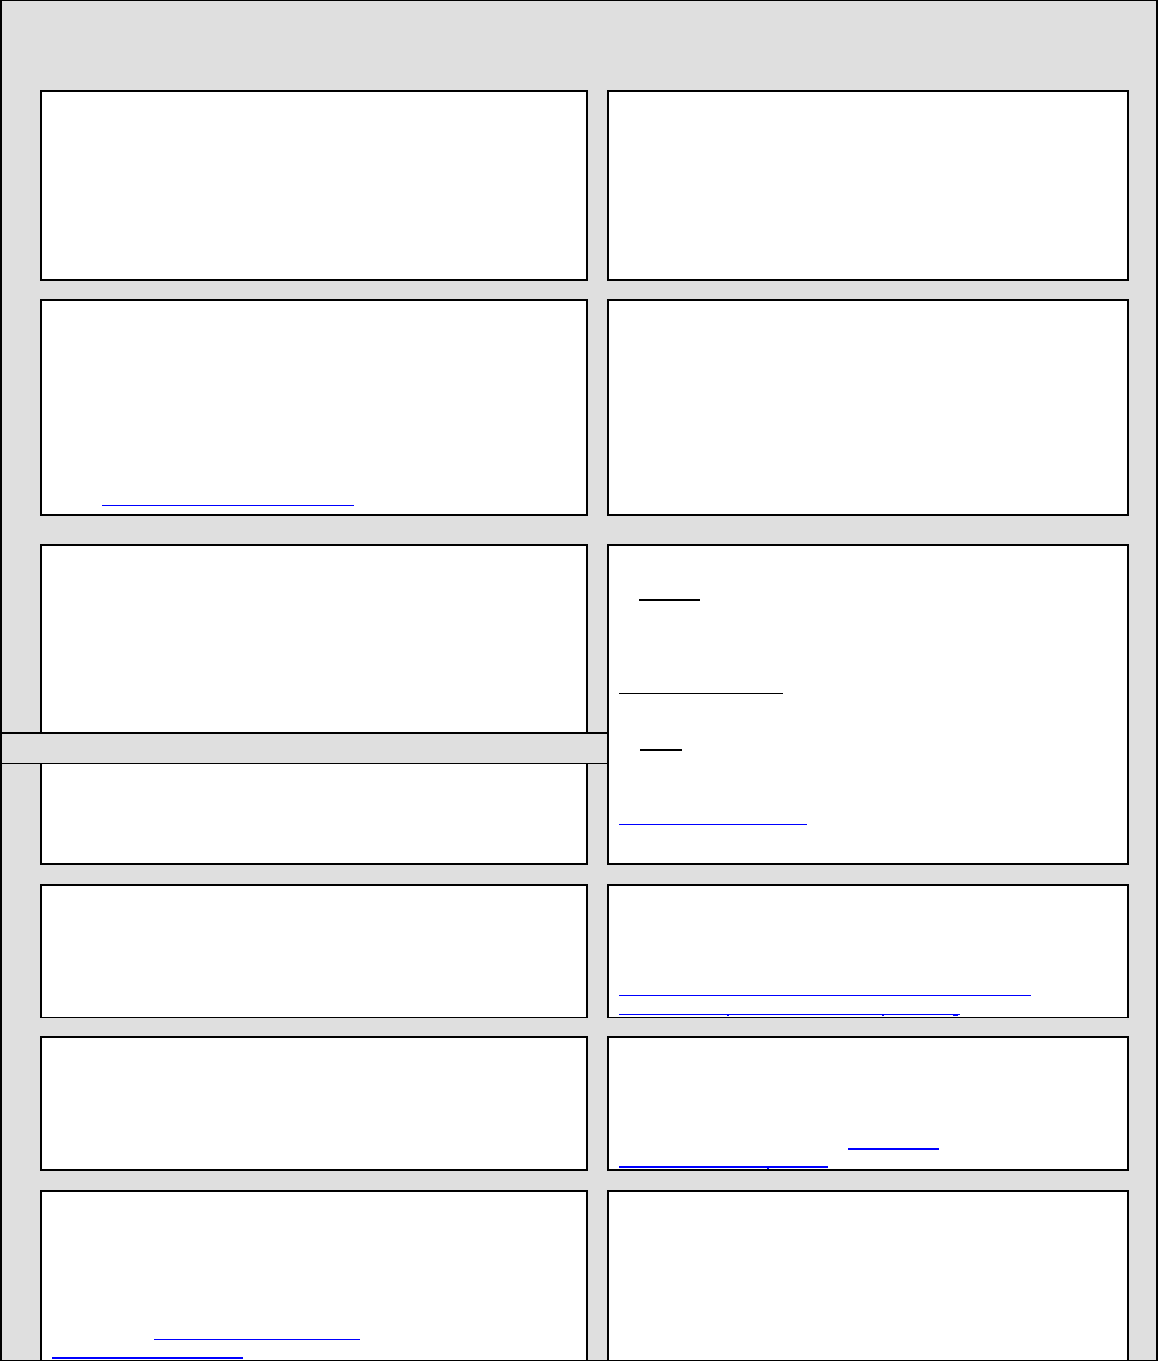
DEFFORM 111 (Edn 02/16)
Appendix - Addresses and Other Information
1. Commercial Officer
8. Public Accounting Authority
Helen Teggart
Defence Commercial CC-Navy 4
Room 303, Building 1/080, Jago Road,
HM Naval Base, Portsmouth, Hampshire, PO1 3LU
- Returns under DEFCON 694 (or SC equivalent) should be sent to DBS Finance ADMT – Assets In Industry 1, Level 4 Piccadilly Gate, Store Street, Manchester, M1 2WD
 44 (0) 161 233 5397

- For all other enquiries contact DES Fin FA-AMET Policy, Level 4
Piccadilly Gate, Store Street, Manchester, M1 2WD
 44 (0) 161 233 5394
2. Project Manager, Equipment Support Manager or PT Leader (from whom technical information is available)
9. Consignment Instructions
The items are to be consigned as follows:
Email:
3. Packaging Design Authority
(Where no address is shown please contact the Project Team in Box 2)
10. Transport. The appropriate Ministry of Defence Transport Offices are:
- DSCOM, DE&S, DSCOM, MoD Abbey Wood, Cedar 3c,
Mail Point 3351, BRISTOL BS34 8JH
Air Freight Centre
IMPORTS  030 679 81113 / 81114 Fax 0117 913 8943
EXPORTS  030 679 81113 / 81114 Fax 0117 913 8943
Surface Freight Centre
IMPORTS  030 679 81129 / 81133 / 81138 Fax 0117 913 8946
EXPORTS  030 679 81129 / 81133 / 81138 Fax 0117 913 8946
- JSCS
4. (a) Supply/Support Management Branch or Order Manager:
Tel No:
(b) UIN – (c) RAC –
JSCS Helpdesk No. 01869 256052 (select option 2, then option 3)
JSCS Fax No. 01869 256837
www.freightcollection.com
5. Drawings/Specifications are available from
See Box 2
11. The Invoice Paying Authority (see Note 1)
Ministry of Defence  0151-242-2000 DBS Finance
Walker House, Exchange Flags Fax: 0151-242-2809
Liverpool, L2 3YL Website is: https://www.gov.uk/government/organisations/ministry-of-defence/about/procurement#invoice-processing
6. For contracts containing DEFCON 5, mauve Copies of MOD Form 640 are to be sent to
(where no address is shown the mauve copy should be destroyed)
12. Forms and Documentation are available through *: Ministry of Defence, Forms and Pubs Commodity Management PO Box 2, Building C16, C Site
Lower Arncott
Bicester, OX25 1LP (Tel. 01869 256197 Fax: 01869 256824) Applications via fax or email: DESLCSLS-OpsFormsandPubs@mod.uk
7. Quality Assurance Representative: NAVY RP-P3M ACQ SO2
Commercial staff are reminded that all Quality Assurance requirements should be listed under the General Contract Conditions.
NOTES
1. Forms. Hard copies, including MOD Form 640 are available from address in Box 12., All other invoicing forms e.g. AG Forms 169 and 173, are available from the website address shown at Box 11.
AQAPS and DEF STANs are available from UK Defence Standardization, for access to the documents and details of the helpdesk visit http://dstan.uwh.diif.r.mil.uk/ [intranet] or https://www.dstan.mod.uk/ [extranet, registration needed].
2.* Many DEFCONs and DEFFORMs can be obtained from the MOD Internet Site:
https://www.aof.mod.uk/aofcontent/tactical/toolkit/index.htm

