08
Fall
Tender Information
Skate Area
Eastington Parish Council

Background information
Eastington is a village in the Stroud district of Gloucestershire, Eastington has a population of approximately 1,500 individuals, 20% are believed to be under the age of 18. We have a community site that includes the community centre, sporting facilities, allotments and a play area, within this site we have identified an area that is suitable for a skate area. We have carried out a public consultation which has proven the need and secured approximately 30% of the necessary funding.

The Site
- Total area size 35m by 13m
- Access to water and toilet facilities can be arranged
- Good site access, the area in question is adjacent to a large parking area, easy access for large vehicles and plant machinery
- Heavy clay based soil
- There is a large amount of soil, currently in the form of a large bund that can be used to landscape the site

The Budget
We are asking for quotes between £50,000 and £60,000 excluding VAT. Quotes should include:
- All design costs
- Materials and labour
- Permits
- Installation
- Removal of all waste materials
- Appropriate pathways and access
- Initial ROSPA inspection and any snagging suggested as a result.

The Need
Our research with the community has suggested that they key important features are
- Half pipe
- Fun box
- Access for all ages
- Challenge and variety
- Compliance with all relevant safety standards for both the installation process and the final facility.
- Consideration to the risks presented by the site including the areas proximity to car park area.

Installation
- Able to ensure the site is left safely over night
- Would you be willing and able to work with volunteers for ground works and landscaping
- Insurance and relevant permits

More information
We are happy to offer site visits and consultation opportunities with our user focus group.

Closing date for tenders
Tenders to be submitted to the Parish Clerk by 31st July 2016.

Contact:
Mrs J Shirley
Parish Clerk
Eastington Parish Council
60 Hawk Close
Abbeydale
Gloucester
GL4 4WE
Email: eastingtonparishcouncil@gmail.com
Tel: 01453 799616

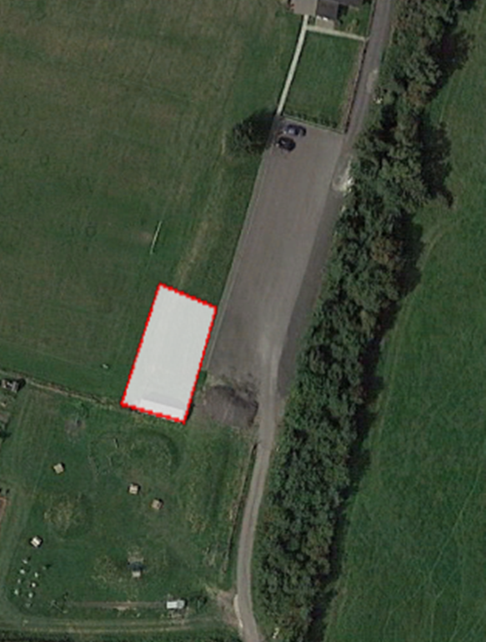
Proposed site is occupied by storage trailer and bund.
Trailer to be removed and excavation/modelling on the bund required
