**Annex A**

**UKRI Strategic Priorities Fund   
Monitoring and Evaluation Plan**

Contents

1. Introduction 3

1.1 Purpose of the document 3

1.2 SPF aims and outcomes 3

1.3 Evaluation challenges and our high-level strategy 3

2 Overall framework for SPF monitoring and evaluation 4

3 Governance of SPF monitoring and evaluation 6

3.1 SPF Oversight Working Group 6

3.2 NPIF Evaluation Board 7

3.3 Programme-level M&E governance and resource requirements 7

4 Fund-level evaluation 8

4.1 SPF objectives 8

4.1.1 Defining MIDRI 9

4.2 Evaluation approach 9

4.3 Evaluation questions 10

4.3.1 Process evaluation questions 10

4.3.2 Early assessment of impact questions 10

4.4 Evaluation milestones 10

5 Monitoring and evaluation planning: requirements for programme leads 11

5.1 Project delivery reporting 11

5.2 Outcome monitoring data collection 12

5.2.1 Minimum requirements 12

5.2.2 Collecting additional outcome monitoring data 13

5.3 Programme evaluation guidance 13

5.3.1 Will my programme require an evaluation? 13

5.3.2 Programme evaluation plans 13

5.3.3 Programme evaluation objectives 14

5.3.4 Commissioning an external evaluation 14

5.3.5 Guidance for conducting evaluation using a peer review panel 15

Annex A: Evaluation plan template 16

Annex B: Evaluation questions and data sources 20

Annex C: Illustrative ‘menu’ of impact evaluation approaches 22

Annex D: SPF logic model 24

# Introduction

## Purpose of the document

This document sets out how monitoring and evaluation (M&E) will be carried out for the Strategic Priorities Fund (SPF). It is intended to support M&E leads within organisations in receipt of SPF funding, e.g. UKRI Councils and non-UKRI partner organisations[1], by providing guidance on monitoring, data collection and evaluation requirements. It is also intended to inform BEIS and other stakeholders of the overarching plan for M&E of the SPF, noting plans will necessarily evolve as we prepare to deliver the SPF evaluation. The guidance in this document is designed to be consistent with the UKRI Monitoring and Evaluation Framework, and with wider BEIS evaluation guidance.

The processes outlined in this framework seek to enable robust analysis of how the SPF is delivered in practice and whether its objectives are being met, including what impact it has on knowledge, the economy and society. Through providing an understanding of the extent to which the fund met its objectives, and the socio-economic impact of the SPF, the SPF evaluation will enable UKRI to assess how well the SPF is implemented, whether it delivers as expected, and whether it represents value for money.

## SPF aims and outcomes

The SPF aims to provide funding for high-quality multi-disciplinary research and innovation (MIDRI) and funding to respond to emerging strategic opportunities, whether identified by the Research & Innovation (R&I) communities or by other Government Departments. The SPF has an initial investment of £560m which UKRI will allocate over 3 years, aiming to fund:

* High-quality multi-disciplinary and inter-disciplinary research and innovation (MIDRI);
* Research and innovation that crosses the boundaries between the 9 UKRI Councils and other government departments (OGDs) to address Government R&I priorities; and
* Strategically important R&I that cannot be supported through other mechanisms. This will include:
  + Medium scale programmes which are typically too large to be funded through a Research Council / Innovate UK award, but not large enough to constitute an Industrial Strategy Challenge Fund (ISCF) ‘Grand Challenge’.
  + Emerging opportunities that are not aligned to specific ISCF challenges but are strategically important.

## Evaluation challenges and our high-level strategy

The Strategic Priorities Fund (SPF) business case was approved by BEIS on the condition that the SPF undergoes rigorous evaluation, and UKRI will be held to account on this. Evaluating the overall impact of the SPF represents an enormous challenge due to the breadth and diversity of programmes[2] and projects, each of which will have its own unique route to impact. Conventional challenges with evaluating research and innovation – such as time lags, data paucity, attribution, displacement, additionality etc. – further complicate the task.

Good evaluation relies on good data. Without the right data being collected at each stage of a project, from application to completion and beyond, it is difficult to establish an accurate baseline and to monitor progress from this. This in turn limits our ability to establish the impact of funding further down the line.

Therefore, our overall strategy for overcoming the challenge of evaluating the SPF at the fund- and programme-level involves:

1. Ensuring the collection of a minimum baseline dataset for all commissioned evaluations, with appropriate annual outcome monitoring data collection processes in place for all delivery organisations (see Section 5.1 through Section 5.3);
2. Planning the SPF fund- and programme-level evaluations well-ahead of commencement, to inform data collection requirements on SPF programmes, adapt reporting exercises (as necessary) as early as possible, and to ensure that programme-level evaluations complement the fund-level evaluation while comprehensively assessing their unique objectives (see Section 4 and Section 5.4);
3. Governing all SPF evaluation activity centrally though the NPIF Evaluation Board, and all performance monitoring activity through the SPF Oversight Group (see section 3).

# Overall framework for SPF monitoring and evaluation

Figure 1 below illustrates the links between monitoring and evaluation activity at all levels. Data and evidence collected on the impact of project funding will feed up to inform programme-level evaluations (where they take place). Programme-level evaluations will build on this information but will also consider wider, cross-cutting questions that will go beyond the data itself. Similarly, programme-level evaluation data and evidence will then feed into and inform the SPF fund-level evaluation, though this will not simply be an aggregation of programme-level evaluations.

**Figure 1: Links between projects, and subsequent evaluations at the programme- and fund-level**

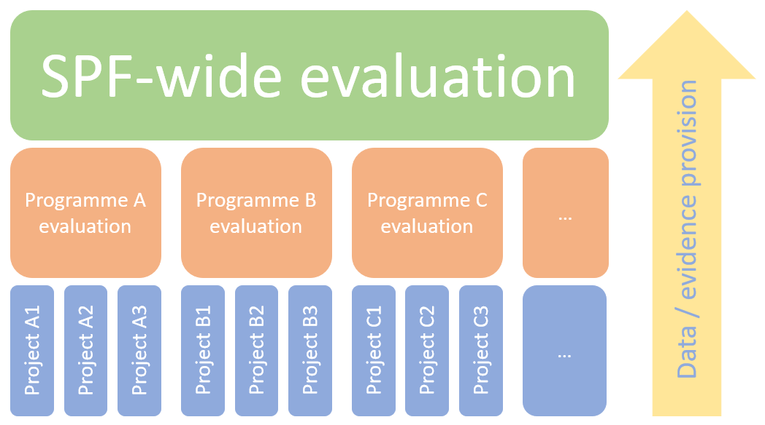

Section 4 sets out the approach to evaluation at the fund level, while Section 5 sets out the data collection, monitoring and evaluation activities required at the programme-level. All evaluations that take place, at every level, should contain an impact evaluation and a process evaluation, and should be planned using the evaluation plan set out in Annex A. Evaluation objectives that are common across all SPF programmes can be found in Section 5.4.3. For information on when a programme-level evaluation is required, please refer to section 5.4.1.

Figure *2* below summarises the overall framework for monitoring and data collection activities that will underpin evaluation activity. Monitoring will be conducted by all SPF delivery organisations in receipt of funding, in addition to relevant partner delivery organisations directly involved in projects or programmes that do not receive funding. Monitoring and data collection activities consist of delivery monitoring (see section 5.1), baseline data collection for commissioned evaluations, and outcome monitoring (see section 5.3).

**Figure 2: overall framework of M&E activity for the Strategic Priorities Fund**

# Governance of SPF monitoring and evaluation

Monitoring and evaluation are intrinsically linked. We need to closely monitor our SPF investments from the outset to ensure they are performing as intended, but also to support the processes of evaluating their impact at a later stage. We therefore have separate processes for governing performance monitoring and evaluation planning, on the basis that these functions require different decision-making expertise and decisions on different timescales. Figure 3, below, shows the interaction between boards.

**Figure 3: SPF Governance Board Structure**

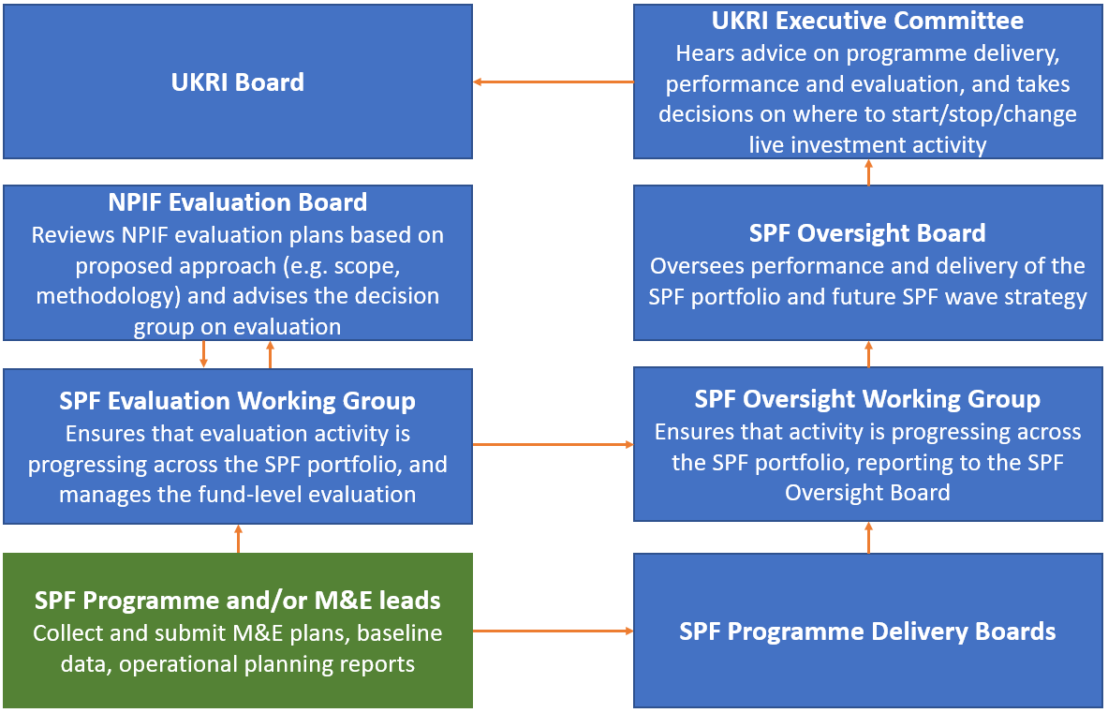

## SPF Oversight Working Group

The SPF Oversight Working Group will meet quarterly (and more regularly when needed); its role includes governing SPF performance monitoring activity. The group will be chaired by Richard Meadows, SPF Lead in UKRI Strategy Team; supported by the UKRI Strategy Team; and will report to the SPF Oversight Board, the membership of which includes the UKRI Strategy Committee. The Group will be responsible for assessing overall progress on live programme delivery and performance, escalating issues to the UKRI Strategy Committee as necessary. Its remit with respect to monitoring and evaluation is to ensure that monitoring and data collection is happening across the SPF in line with the principles and expectations set out in this document. Will Naughton, the SPF lead, will be responsible for reviewing and approving M&E plans, and for escalating analytical issues to the NPIF Evaluation Board as necessary.

The membership of the SPF Oversight Group may evolve over time, but at present, it has the following members:

* UKRI SPF Lead (Chair, Richard Meadows)
* SPF Finance Business Partners (Gavin Mapstone and Edyta Winkler-Cope)
* SPF Lead Analyst (Gareth Ward)
* SPF M&E Lead (Will Naughton)
* Operational Planning Lead (Peter Rigby)
* Communications Lead (Chris Buratta)
* SPF Team members (Hayley Terlevich, Secretariat; and Jamie Cowie)

## NPIF Evaluation Board

The expertise required to oversee the design and delivery of the evaluation of cross-cutting funding programmes is common across our NPIF funding programmes. As such, the NPIF Evaluation Board will be responsible for approving SPF evaluation plan and will agree the overall approach to the SPF process and impact evaluation. The Board is chaired by Henry Cormack; will report to the UKRI Strategy Committee, escalating issues as necessary; and will receive support from the UKRI Strategy Team and the UKRI Evaluation Team.

The NPIF Evaluation Board’s specific responsibilities, with respect to the SPF evaluation, will include:

* Approving the evaluation plan for the fund-level SPF programme evaluation
* Reviewing and approving programme-level SPF evaluation plans that are escalated by the SPF M&E lead
* Setting direction and expectations on evaluation leads and their teams, providing advice and challenge as needed, including on data collection responsibilities
* Assessing progress on SPF programme and project evaluation
* Providing overall guidance and direction to evaluation development and methodology
* Ensuring that evaluation commitments and responsibilities are being met by programme teams
* Escalating to the UKRI Strategy Committee where evaluation progress, or findings from evaluation, suggest a change of direction may be needed.

The membership of the NPIF Evaluation Board for meetings relevant to the SPF will include:

* Head of UKRI Evaluation (Henry Cormack, chair)
* Representative from the BEIS Business & Science Group
* Representative from the BEIS Central Analysis Team
* SPF Evaluation lead (Will Naughton)
* Representative from the UKRI Performance and Evaluation Network

## Programme-level M&E governance and resource requirements

There is the need for dedicated resource for monitoring and evaluation on SPF programmes to meet our obligations set out in the business case, upon which our funding from BEIS and HMT is conditional. Programme leads are responsible for ensuring that adequate resource is in place to deliver monitoring and evaluation. Typically, this means appointing a dedicated M&E lead[3], and ensuring there is sufficient monitoring and evaluation expertise in the relevant area of research, science, industry, sector or technology. Having identified relevant individuals to support the process, monitoring and evaluation leads should consider how best to draw on their input during delivery. In most cases, a steering group that brings together experts at key moments in monitoring and evaluation delivery will be an effective way to do this.

Will Naughton, the SPF M&E lead, will be responsible for coordinating SPF M&E, commissioning the evaluation of the fund-level evaluation, reviewing programme-level M&E plans, and for supporting the operation of the NPIF Evaluation Board. The UKRI Evaluation Team, will support Will Naughton on issues to do with analytical design and approach to the SPF programme evaluation. Will Naughton should be the point of contact for M&E leads in delivery organisations for all enquiries relating to SPF M&E.

For programmes that are undertaking an evaluation (see Section 5.4.1 for guidance on whether your programme should be doing so), programme leads must ensure that there is sufficient budget for their evaluation, and sufficient management and governance processes to ensure that the evaluation is successful. Guidance on managing evaluations is set out in Section 5.4.4 (for commissioned evaluations) and 5.4.5 (for evaluation using a peer review panel).

# Fund-level evaluation

## SPF objectives

As set out in Section 1, the SPF aims to provide funding for high-quality multi-disciplinary research and innovation (MIDRI) and funding to respond to emerging strategic opportunities, whether identified by the Research & Innovation (R&I) communities or by other Government Departments.

The high-level objectives of the SPF are therefore to:

* Drive an increase in high quality multi-disciplinary and inter-disciplinary research and innovation (MIDRI), by:
  + De-risking the process of preparing/submitting MIDRI proposals for the R&I community
  + Improving the efficacy of the funding system in assessing MIDRI proposals
* Ensure that UKRI’s investments link up effectively with cross-departmental R&I priorities and opportunities, by:
  + Improving the join up across Departments to establish consensus on key Government priorities for R&D
  + Increasing the understanding of Government priorities among R&I funders
  + Improving the ability of the R&D funding system to deliver cross-Government R&D priorities through enabling Public Sector Research Establishments (PSREs) to bid for open competitions funded through the SPF
* Ensure the system is able to respond to strategic priorities and opportunities, by:
  + Providing a funding route for high quality medium scale programmes
  + Improving the agility of the funding system to respond to emerging opportunities

High-quality M&E is critical in enabling UKRI to track the progress of these funded activities, and to ensure public money is being spent in accordance with the stated aims of the SPF. It will also allow us to assess the value for money of the SPF, and to understand the impact of its activity on the UK’s knowledge, the economy and society.

### Defining MIDRI

As above, driving an increase in high-quality MIDRI, de-risking the process of submitting MIDRI proposals and improving the funding system’s efficacy in their assessment are a key objective of the SPF. Assessing whether the SPF has achieved these objectives will therefore be a key question that the evaluation will need to tackle.

We can define MIDRI as research and training that brings together knowledge and modes of thinking from two or more disciplines or established fields of study. By this definition, however, no single way of measuring MIDRI. As such, we will recommend the use of a range of input and outcome indicators for the purpose of evaluation. The core set of MIDRI metrics are set out below.

Potential input indicators (as absolute values and percentages of total research/training budgets) are as follows:

* Investment in grants involving researchers from more than one department discipline;
* Funding of programmes which are focused on a multidisciplinary area or are specifically to promote multidisciplinary research or training; and
* Funding into cross-council programmes.

And potential output indicators:

* Authorship of papers for evidence of researchers in one discipline collaborating with others in other disciplines; and
* Analysis of citations received by authors in one discipline for evidence that those citing their work are active in other disciplines.

## Evaluation approach

Obtaining a reliable assessment of the impact of the SPF will, as for any research and innovation evaluation, be difficult. Firstly, it will be a difficult to obtain a true baseline for the SPF’s impacts. Comparison with existing or alternative schemes may be possible, as well as comparison with high-quality but unsuccessful SPF applications, but this is predicated on there being successful and unsuccessful projects that have similar intended outcomes. Secondly, many of the longer-term outcomes and benefits of the SPF may not be visible for several years after the initial investment. At the same time, postponing the evaluation too long may increase the difficult of being able to track the outcomes and impacts of SPF projects. There are also issues with counterfactual construction, identifying appropriate control groups, and attribution of benefit (e.g. in many cases the SPF investment may be one contribution towards an economy- or society-changing outcome, or small relative to the size of an affected market).

We have set out in Annex C a summary overview of methodological approaches that could be used to evaluate the SPF, highlighting their dependencies and potential issues[4]. Broadly, we will seek to use quantitative analysis where it is feasible and sensible to do so, though our primary aim in impact evaluation will be to develop a rounded understanding of impact to ensure that decisions on future investment within the SPF are based on an understanding of the holistic impact of the investments. In any evaluation we will seek to use a range of quantitative techniques, (including stakeholder interviews, surveys of successful and unsuccessful applicants, and case studies) alongside qualitative methods, to build up a rounded understanding. This will include a consideration of impacts across the logic model (shown in Annex D), where SPF funding may be one of several inputs that lead to the ultimate outcomes.

## Evaluation questions

The precise questions, indicators and methodology for the overarching SPF evaluation will be developed through the process of developing an evaluation specification, and subsequently refined by the appointed SPF evaluating organisation lead as part of their task of developing a framework for the SPF evaluation.

For now, we have set out some high-level questions and possible indicators that the evaluation should seek to address in Annex B. We have also set out an indicative menu of possible approaches to the evaluation in Annex C. These will be built upon in the SPF evaluation tender.

In the following subsections, we have listed the key questions that should be addressed by the fund-level process and early assessment of impact evaluations.

### Process evaluation questions

The SPF fund-level process evaluation will tackle questions such as those set out below. These process evaluation questions should also apply to programme-level evaluations.

* Is it working as intended?
* Is it being delivered as intended?
* Are targets for inputs and outputs being met?
* Are there any unexpected barriers or facilitators to desired impact?
* What lessons are there for future waves / similar projects?

### Early assessment of impact questions

The early assessment of the SPF’s impact will tackle questions such as:

* Is it on course to deliver intended impact?
* What have the observed changes been, compared to what was already in place?
* Are there interim outcomes that provide an indication of future impact, and to what extent are these attributable to SPF funding?
* Have any outcomes occurred which were not originally intended, and how significant are they?

## Evaluation milestones

As set out in the previous section, there will be a bespoke, independently-led evaluation of the SPF, which will include a:

* Mid-term evaluation, covering an evaluation of the process and an early assessment of impacts; and
* Final evaluation, covering a full (final) assessment of the SPF process, its performance relative to its objectives, and its overall impact.

The SPF M&E Lead in the UKRI Strategy Team, supported by the UKRI Evaluation Team, will be responsible for delivering the SPF evaluation according to the following, high-level timetable:

1. Agree evaluation specification with the NPIF evaluation board – September 2019
2. Publish the invitation to tender for the SPF evaluation – September/October 2019
3. Award contract to the SPF evaluating organisation – December 2019
4. First draft of SPF evaluation framework – March 2020
5. Sign-off SPF evaluation framework – April 2020
6. First draft of mid-term process evaluation – June 2022
7. Sign-off of mid-term process evaluation – July 2022
8. First draft of early assessment of impacts – June 2023
9. Sign-off of early assessment of impacts – July 2023
10. First draft of SPF final process and impact evaluation – June 2026
11. Sign-off SPF final process and impact evaluation – July 2026

# Monitoring and evaluation planning: requirements for programme leads

This section lays out the monitoring and evaluation requirements for each SPF programme and guidance on how to approach them. The SPF consists of a diverse range of research and innovation activities. There is, therefore, no one-size-fits-all approach to monitoring and evaluation. All programme leads should develop a plan for monitoring and evaluation that sets out the way in which their programme will address:

* The governance and resource requirements set out in Section 3.3;
* Project delivery reporting (section 5.1), to enable UKRI to monitor the overall delivery of the SPF in ‘real time’;
* Outcome monitoring data collection (section 5.3), to enable UKRI to monitor the outcomes of SPF projects during (and for a period beyond) delivery, and to provide key evidence to support an evaluation at the fund- and programme-level; and
* Evaluation planning (Section 5.4) for a programme-level evaluation.

Monitoring and evaluation plans should be developed using the template in Annex A, and submitted to the Central SPF mailbox[5] for review within six months of receiving funding. For queries and guidance on completing these plans, please contact Will Naughton[6], the SPF M&E lead in the UKRI Analysis Team, who can assist you.

## Project delivery reporting

Each SPF programme will be required to submit the *UKRI Project Reporting Dashboard*, monthly, to the Operational Planning team. Peter Rigby in the Operational Planning team will provide programme leads with the template once your programme has commenced and provide further information on completing these forms. Submitted progress reports will be used by the SPF Oversight Group (see Section 5) to monitor progress on a regular basis; and to escalate risks and issues as necessary to the UKRI Strategy Committee.

To support the completion of this reporting, SPF delivery organisations should take appropriate steps to monitor the delivery of the individual SPF projects within their programmes. It will be up to delivery organisations to determine the appropriate approach to monitoring the delivery of SPF projects, including the data gathered; but data and information gathered should enable the delivery organisation to effectively assess progress relative to aims and commitments made at the outset of the project; and assess risks and issues associated with delivery.

## Outcome monitoring data collection

### Minimum requirements

The collection of outcome monitoring data both during and after the delivery of SPF projects provides the evidence base to facilitate evaluations at both the programme- and fund-level. Monitoring and evaluation plans should therefore set out the outcome data that they intend to capture, and the mechanisms in place for collecting and storing this data.

All UKRI Councils have outcome monitoring data collection tools in place. Research Councils rely on online outcome reporting via the *researchfish ®* platform; while Innovate UK have their own monitoring processes as part of the Innovate Funding Service. Programme leads must ensure that researchers in receipt of SPF funding report the outcomes of their research using one of these platforms, in addition to the bespoke monitoring approaches set out in business cases.

This reporting exercise should happen at least annually during the delivery phase and until at least 5 years after project completion. It is the responsibility of the Research Councils to ensure researchers in receipt of SPF funding have access to *researchfish ®* and are aware of the requirement to report SPF research outcomes on at least an annual basis during and after project delivery. It is essential that SPF outcomes are clearly attributed to the SPF as part of submissions to *researchfish ®*, and Research Councils should ensure researchers are aware of this. For Innovate UK-led SPF projects, quarterly monitoring will take place via Innovate UK’s well-established Monitoring Officer regime. For advice on these outcome reporting platforms, you should contact your relevant UKRI Council representative on the Performance and Evaluation Network.

For instances where non-UKRI delivery organisations cannot access these platforms, please get in touch with Will Naughton, copying the SPF mailbox, at the earliest opportunity. Ultimately, in these instances, the programme’s monitoring and evaluation plan should set out in detail how they propose to monitor the outcomes of their SPF project. This should include the coverage of outcomes metrics that will be monitored, and how the data will be collected and stored.

### Collecting additional outcome monitoring data

Programme leads should consider whether the data collected by these systems will be sufficient to evaluate their programme. It will be necessary in some instances to supplement this data with additional data fields if there are programme-specific outcomes that will not be captured by the existing question set.

As a first step in collecting additional data, programme leads should consider whether it is feasible to obtain additional data through existing reporting platforms. This can be achieved by, for example, providing prompts and guidance to users to answer questions in a specific way.

Where a second, separate collection exercise cannot be avoided, data should be collected in Microsoft Excel, with clear unique identifiers for each delivery organisation or grant recipient. Data should be collected with one row per data user, with unique identifiers in the first column. This will better allow for evaluators to collate and review this data.

## Programme evaluation guidance

### Will my programme require an evaluation?

Not all NPIF programmes, and by extension SPF programmes, should be subject to the same scale of monitoring and evaluation. The NPIF Evaluation Oversight Board has agreed a decision tree to help UKRI programme leads determine the default expectation for the overall scope of monitoring and evaluation activity that should be conducted for their programme, based on the combination of the programme’s value, expected outcomes or impacts and extent to which it is novel, complex or contentious. Please refer to the *Monitoring and Evaluation expectations for programmes funded through UKRI’s cross-cutting funds* document to assess the evaluation expectations for your programme.

### Programme evaluation plans

For programmes that require an evaluation, an evaluation plan must be completed using the template set out in Annex A. Having an evaluation plan in place at the programme’s outset will ensure that all aspects have been considered and help to guide monitoring and evaluation to success. Evaluation plans should be submitted to the Central SPF Mailbox within 6 months of receiving funding.

The following sections of this document should serve as a useful reference when developing an evaluation plan:

* Section 4.1 sets out the fund-level evaluation aims and outcomes;
* Section 5.4.3 sets out the programme evaluation objectives;
* Annex B provides an overview of the potential evaluation questions, indicators and data sources that may facilitate an evaluation at the programme- and fund-level; and
* Annex C sets out an illustrative summary of potential methodologies that would underpin these evaluations.

There are, of course, differences in scope between evaluations which are externally commissioned, and those that are conducted via peer review. As set out in the previous section, programme leads should refer to the *Monitoring and Evaluation expectations for programmes funded through UKRI’s cross-cutting funds* document to assess the evaluation expectations for your programme. For an overview of the requirements for a commissioned evaluation, or for a peer review panel, please refer to the *UKRI Monitoring and Evaluation Framework.*

### Programme evaluation objectives

As set out in Section 2, the fund-level evaluation will build upon and complement evaluations undertaken at the programme level. As such, it is essential that consideration is given to the aims, outcomes and evaluation questions that the wider fund-level evaluation will consider, which are set out in Section 4. While programme evaluation objectives will be unique to each programme, all evaluations should seek to answer the following:

* To what extent, and how, has the programme produced high quality multi- and/or inter-disciplinary research and innovation?
  + Has the SPF de-risked the process of preparing and submitting proposals within the programme’s sector? If so, how has it done this, and to what extent?
  + Has the efficacy of the funding system improved in the programme’s disciplinary area as a result of the SPF?
* To what extent has the programme linked up effectively with cross-departmental research and innovation priorities[7] and opportunities?
  + Has the programme improved join up across departments to establish consensus on key Government priorities for R&D?
  + Has it increased the understanding of Government priorities among R&I funders?
* To what extent has the SPF enabled a more agile funding route for the programme than typical routes to funding?

In addition to these questions, all programme-level impact evaluations should assess the extent to which their investment has delivered a discernible impact on knowledge creation, the economy and society. Furthermore, all programme-level evaluations should seek to answer the process evaluation questions set out in Section 4.3.1, and should consider the questions set out in Section 4.3.2 for an early assessment of impacts.

### Commissioning an external evaluation

When commissioning an external evaluator, a clear milestone timetable should be in place to allow sufficient time for procurement. The commissioning stage is crucial to ensure that the Invitation to Tender (ITT) receives high-quality proposals. Externally conducted evaluations must happen in line with government purchasing rules and be subject to fair and open competition. We recommend that you visit the UK SBS procurement page[8] before commencing planning for procurement.

As set out in Section 3.3, programme leads are responsible for ensuring that there is sufficient evaluation support available to evaluators. We recommend the use of steering boards to guide the evaluation, comprising of sector-specific and evaluation specialists. For more detailed guidance on commissioning evaluations, please refer to Annex C in the UKRI Monitoring and Evaluation framework.

### Guidance for conducting evaluation using a peer review panel

Expert peer review evaluation involves using sector experts, typically those not involved in the research that is the focus of the evaluation, to produce an evidence-based assessment of the investment process and/or its impact. A panel should consist of between 6 and 14 members depending on the size of the investment and should contain a good balance of researchers and research users, with consideration given to UK and/or international panel members.

The terms of reference for the review panel should be clearly defined at the outset, as should the role of the panel, and the evaluation questions that they should seek to address, following the guidance in this document. Those involved in the delivery of the programme should collate relevant data and evidence and submit it to the peer review panel for review and should organise structured surveys and/or unstructured exercises such as theme days with those involved in the delivery of the programme.

The peer review should draw upon the full range of evidence gathered, clearly assessing the investment’s process and its observed impact against each of the evaluation objectives set out in Section 5.4.3.

The report should include a brief executive summary, an overview of the programme and evaluation methodology, an analysis of performance against each of the programme objectives, and clear conclusions and recommendations.

# Annex A: Evaluation plan template

As set out in Section 5, all programmes should seek to complete this evaluation plan template and return it to the SPF inbox within 6 months of receiving funding, where it will be reviewed by the SPF M&E lead and the wider Central UKRI Evaluation Team. The purpose of this is to ensure that the evaluation activity proposed for your programme is sufficient and/or proportionate to the programme activity, to assist you with preparing for undertaking and/or commissioning an evaluation as appropriate, and to keep a clear record of expected evaluation activity. While we require answers to each of the question prompts, you are welcome to remove these prompts if you would prefer to provide a more holistic overview for each section.

|  |  |  |  |  |
| --- | --- | --- | --- | --- |
| 1. **Project/programme objectives and anticipated effects[9]** | | | | |
| *What are the programme’s or project’s objectives?*  *…*  *What are the* ***issues*** *being addressed and the* ***context*** *within which the project or programme is taking place?*  *…*  *If your programme has an up-to-date logic model, please include it here and/or complete the table below setting out the programme’s key expected inputs, outputs, outcomes and impacts.* | | | | |
| *What are the* ***inputs*** *i.e. resources and activities?* | *What are the* ***outputs****, i.e. what is being delivered?* | *What are the* ***outcomes****, i.e. short / medium-term results?* | *What are the* ***impacts****, i.e. long-term results?* | |
| 1. **Evaluation objectives and questions** | | | |
| *What do you need to know about what difference the programme made, and/or how it was delivered?*  *…*  *Is it clear what will constitute success and how this will be measured?*  *…*  *The evaluation questions are as follows:*   * *[Objective 1]*   + *[Sub-objective 1a]*   + *[Sub-objective 1b]* * *[Objective 2]*   + *[Sub-objective 2a]*   + *[Sub-objective 2b]* * *…*   *How do you anticipate that your programme’s evaluation activity will complement the wider fund-level evaluation and its objectives, set out in Section 4?*  *…* | | | |
| 1. **Evaluation use and audience** | | | |
| *As set out in Section 4 of the SPF M&E plan, all evaluation activity undertaken at the programme level will underpin and complement the fund-level evaluation, which will allow UKRI to assess the value for money of the SPF and ensure public money is being spent in accordance with the fund’s stated aims, and to understand the impact of its activity on the UK’s knowledge, the economy and society. Aside from this:*  *How do you anticipate the findings of your evaluation activity will be used, and what decisions will they feed into?*  *…*  *Who will its key audience be (i.e. the users of the findings)?*  *…*  *How will the findings be shared and disseminated? Who else should be made aware of the findings?*  *…* | | | |
| 1. **Type of evaluation required** | | | |
| *What type of evaluation activity will be required for your programme? In answering this question, you should refer to the* UKRI Monitoring and Evaluation expectations for programmes funded through UKRI’s cross-cutting funds *document.*  *…*  *Who will be affected by the programme evaluation, and what are the main anticipated outcomes?*  *…*  *Does the project/programme design allow for a control group to be identified?*  *…*  *How will learning from what worked and did not work be identified and measured?*  *…* | | | |
| 1. **Evaluation specification and milestones** | | | |
| *Who will be involved in developing the evaluation specification and when will it be developed?*  *…*  *When will the evaluation start?*  *…*  *What are the key evaluation milestones?*  *…*  *If you plan to commission an evaluation, how will it be commissioned? And/or if you plan to commission a peer-review evaluation, how will you commission your expert evaluation group?*  *…* | | | |
| 1. **Delivery summary: internal governance and available resource** | | | |
| *As set out in Section 5.4 of the SPF M&E plan, evaluation plans must be submitted to the SPF inbox for review within six months of receiving funding. Please outline your internal governance and approvals process for the M&E plan, setting out who is responsible for signing it off.*  *…*  *What budget is available for the evaluation?*  *…*  *Who will be the project manager?*  *…*  *Who will be on the steering group?*  *…*  *Who are the key delivery and wider stakeholders?*  *…* | | | |
| 1. **Outcome monitoring and evaluation data requirements** | | | |
| *What data will you collect to facilitate your evaluation? (Please include data which is collected by default, such as data from ResearchFish)*  *…*  *When will this data be collected?*  *…*  *What additional data needs to be collected to measure the baseline and monitor progress?*  *…*  *If there is no valid and comprehensive data readily available, is there provision to run primary data collection?*  *…*  *Who will be responsible for data collection and what processes need to be set up?*  *…*  *Information is required about:*  *…*  *These information requirements are being met through the following work-streams:*  *…* | | | |

# Annex B: Evaluation questions and data sources

The table below provides an overview of the potential indicators which will facilitate a robust evaluation of the SPF’s evaluation questions. The breakdown of the overarching evaluation questions can be found in Section 4.1. The final column outlines the likely sources of this data.

|  |  |  |
| --- | --- | --- |
| **Evaluation question** | **Potential indicators to answer questions** | **What are the likely sources of this data?** |
| To what extent has the SPF increased high quality multi-disciplinary and inter-disciplinary research and innovation? | * Number of projects involving multi-disciplinary and inter-disciplinary research before, during and after SPF allocations * Number of researchers working across different research fields before, during and after SPF allocations * Number and type of collaborations before, during and after SPF allocations * Number of publications in peer reviewed journals with co-authorship across disciplines * Assessment of the extent to which MIDRI investment opportunities have been de-risked, and the extent to which the efficacy of the funding system has been improved in assessing MIDRI proposals * IP non-exclusively licensed to multiple organisations, rather than exclusively sold to one * Feedback on success of collaborations from applicant surveys | * Grant application data * Outcome monitoring data (predominantly collected via researchfish ® and IFS) * Baseline data questions * Surveys and interviews with SPF researchers and the wider R&I community |
| To what extent has the SPF ensured alignment with cross-departmental research and innovation priorities? | * Awareness of SPF processes and understanding of objectives (feedback from surveys of applicants and wider research community) * Level of engagement with the SPF process by the research community (feedback from surveys of applicants and wider research community) * Number of projects meeting strategic criteria * Success against objectives of funded projects as compared to baseline (counterfactual) * Proportion of UKRI funding portfolio devoted to government priorities before, during and after SPF allocations | * Government departments’ published Areas of Research Interest * Grant application data * Researchfish ® data * Baseline data questions * Surveys and interviews with SPF researchers and the wider R&I community * Surveys and interviews with government officials |
| To what extent has the SPF increased the ability of the R&I system to respond to strategic priorities and opportunities? | * Number, type and scale of research projects before, during and after SPF allocations * Changes in the balance of UKRI funding portfolio over time * Time lag between identification of strategic or policy priority and commencement of research and innovation activity * Views, opinions and experiences in relation to aligning research and innovation with government priorities | * Government departments’ published Areas of Research Interest * Grant application data * Researchfish ® data * Baseline data questions * Surveys and interviews with SPF researchers and the wider R&I community * Surveys and interviews with government officials |
| What has the been the economic and social impact from research findings, new products, processes or services generated by the SPF? | * Value / share of turnover based on innovations arising from collaborative projects * Additional employment * New additional non-R&D investment * Intellectual Proprty, spinouts, commercial revenue (etc.) enabled by SPF investment activity * Gross Value Added, Gross Domestic Product or productivity increases enabled by the SPF at the national and sub-national level * Research infrastructure, researcher positions, partnerships, secondments, R&I investment enabled by the SPF * Research publications, tools, methods, datasets, awards, recognitions, discoveries (etc.) enabled by the SPF * Medical, software, environmental, artistic and cultural products and services enabled by SPF investment activity * Policy decisions supported by SPF-enabled research and innovation * Wellbeing measures | * ONS economic data * ORCID and online CV data * Outcome monitoring data * Baseline data questions * Wellcome/UKRI Policy Tool * REF case studies * Surveys and interviews with SPF researchers * researchfish ® and IFS data (to identify collaborations/interactions with businesses) |

# Annex C: Illustrative ‘menu’ of impact evaluation approaches

|  |  |  |  |
| --- | --- | --- | --- |
| Method | What contribution will this make to the evaluation if applied? | What’s required to implement this method, e.g. baseline business data? | Potential issues |
| Econometric analysis via difference-in-differences | A quantitative measure of changes in inputs, activities, outputs, and outcomes, that compares those involved in the SPF with a counterfactual | A careful consideration of the counterfactual – such as unsuccessful competition applicants.  A sufficient sample size in both the control and treatment groups | Sample size to allow statistically significant results.  Skewed impacts across the beneficiaries may reduce the statistical significance of any findings |
| Regression Discontinuity Design | Provides a robust, near-randomised, quantitative approach to measuring additional impact at the margin. | A clear threshold between successful and unsuccessful applicants, e.g. through a quality threshold below which applications do not receive funding.  A sufficient sample size of applicants at the margin of this threshold. | Sample size to allow statistically significant results.  Skewed impacts across the beneficiaries may reduce the statistical significance of any findings, though robust sample selection will mitigate against this. |
| Randomised Controlled Trial (RCT) | It would provide a robust assessment of impact. | Early design and the identification of how to source a suitable control group. | Randomised selection process potentially incompatible with funding allocation. |
| Sector modelling through trend analysis or before-after analysis | If possible to conduct robustly, this would allow us to see the impact of the programme on the sector from a macro perspective. | A clearly defined sector which can either be measured in third party data or targeted by a survey for primary data collection.  Sector baseline data needs to be collected at the outset and again at suitable intervals (no more frequently than annually).  An ability to control for, or at least qualitatively assess, the impacts of any exogenous shocks to the sector, or any other policy influence.  The intervention needs to impact upon a significant portion of the industry at a sufficient level to be observable from a macro perspective. | Likely to be a large amount of ‘noise’ in the data, with attribution of any changes difficult.  The robustness of the counterfactual is always likely to be questioned.  Likely to be used only as a peripheral method, but one that could help validate findings of other methodologies. |
| Surveys of beneficiaries and non-beneficiaries | To produce largely quantitative data that can be used as part of an econometric analysis and to measure outcomes | A comprehensive sample (including accurate contact details) to draw from, covering both beneficiaries and non-beneficaries  A sufficient sample size to enable quantitative analysis.  The ability to share contact and application details with contractors.  Sufficient buy-in from potential respondents to respond over a period of time. | Attrition of responses over multiple waves of a survey.  Self-reported evidence can be less reliable, or less credible, although will be necessary for a number of indicators where third-party data doesn’t exist.  Sample size could be an issue, either for treatment or control group. Potential for responses to be pooled across the three main programme elements, although this would reduce the granularity of the analysis. |
| Interviews with key stakeholders | At the start of an evaluation it can help to focus the research questions by speaking to experts in relevant fields. In later stages, provide qualitative evidence on how the SPF (fund or programme) is working and what outcomes have been achieved. | Good knowledge and mapping of the key stakeholders in the sector/programme/project. | Any particular individual’s strong views could skew the results or affect the scope of the research if not representative of the wider stakeholder population. |
| Case studies | Provides an in-depth view of the processes, collaborations and activities that may have led to project outcomes. | A comprehensive sample and framework for selecting case studies, ideally in an *a priori* manner to allow for a range of outcomes to be observed. | A large number of case studies are likely to be necessary to provide a complete picture. These can be costly and require a greater degree of input from programme participants. |
| Peer review | To ensure conclusions are based on the evidence are robust and logical. | Experts who are preferably not involved in the programme. |  |
| Bibliometric methods | Provides an assessment of the quantity and quality of research associated with a project. | Relies on publications being clearly linked to SPF programmes/projects. | General issues with citation measures need to be considered. Typically omits non-formal publications. |
| Mixed methods where no counterfactual is available (e.g. for science capital) | Drawing on a range of the methods above and supplementing it with assumptions and economic modelling can provide an indication of impact in some instances, e.g. science capital investments. | This type of approach needs to be developed bespoke for particular programmes and projects and relies on a clear logic model and data collection at each point of the model. | In the absence of a robust counterfactual this approach can rely on assumptions. |

Annex D: SPF logic model 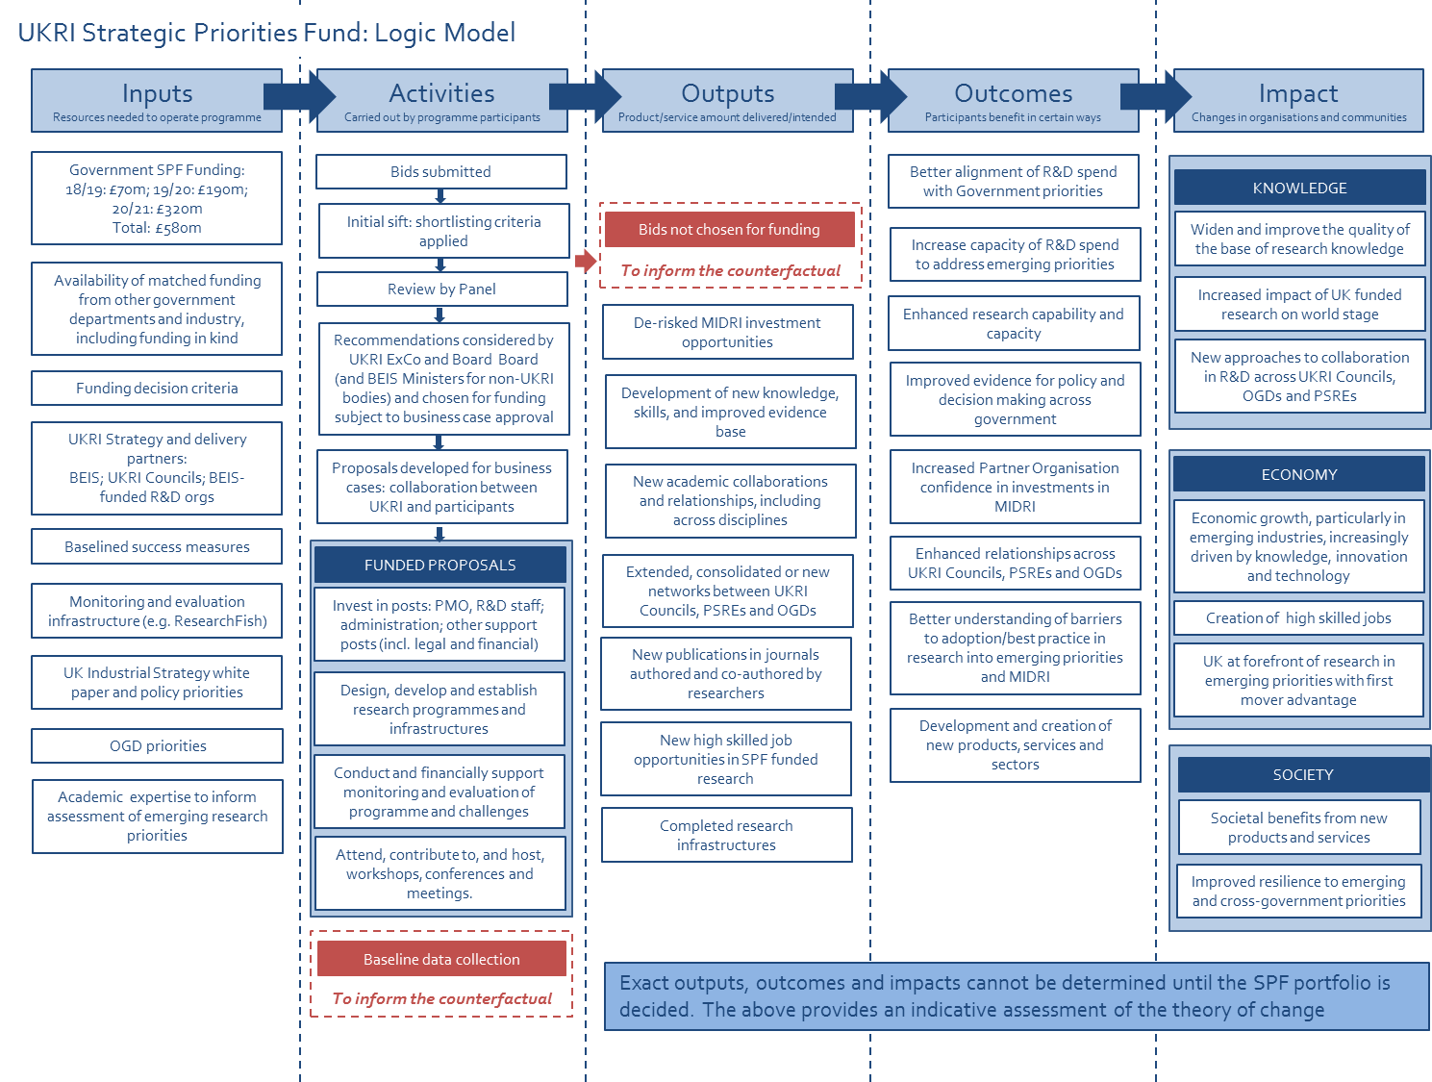

1. UKRI and non-UKRI organisations involved in delivering SPF projects are referred to in the remainder of this document as SPF ‘delivery organisations’.
2. Programmes defined as: a body of work relating to the administration of a successfully funded bid, by an eligible organisation (ie Research Council or PSRE), directly to the SPF
3. In some instances, M&E leads will be responsible for more than one programme within a delivery organisation
4. For a comprehensive overview of methodological approaches, please refer to the UKRI Monitoring and Evaluation Framework
5. <mailto:SPF@ukri.org>
6. <mailto:will.naughton@ukri.org>
7. Defined as Departmental Areas of Research Interest (ARIs)
8. <https://www.uksbs.co.uk/services/procure/Pages/default.aspx>
9. To note, business case information may be transposed here if appropriate and still up-to-date