**Appendix B5: Description and Specification**

LOT 5

1. **Site identification**

|  |  |  |  |
| --- | --- | --- | --- |
| Site name | Yapp Road | | |
| Site reference | H3 | Site Postcode | SP4 7ZG |
| What3Words location | ///wired.actors.circles | | |

Site photograph/s:

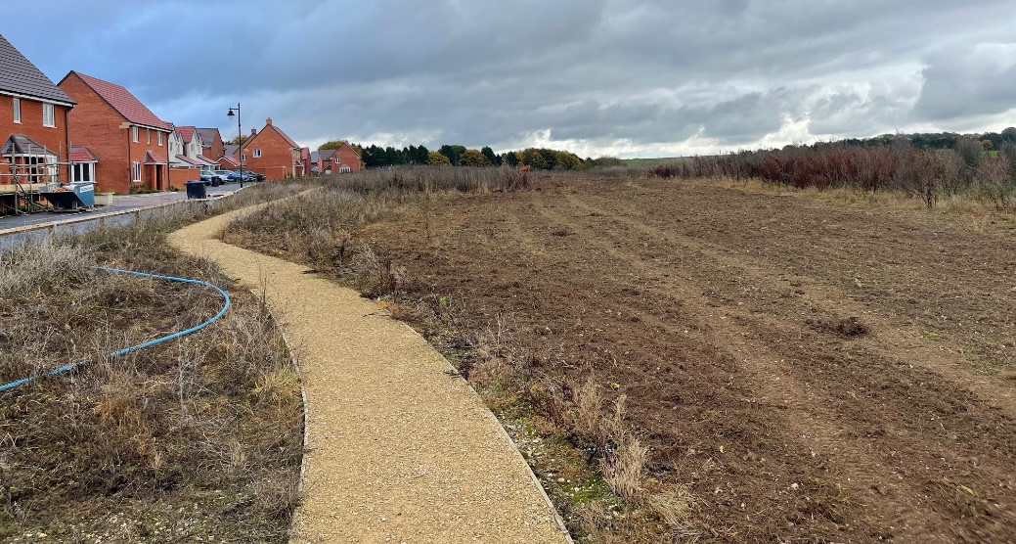

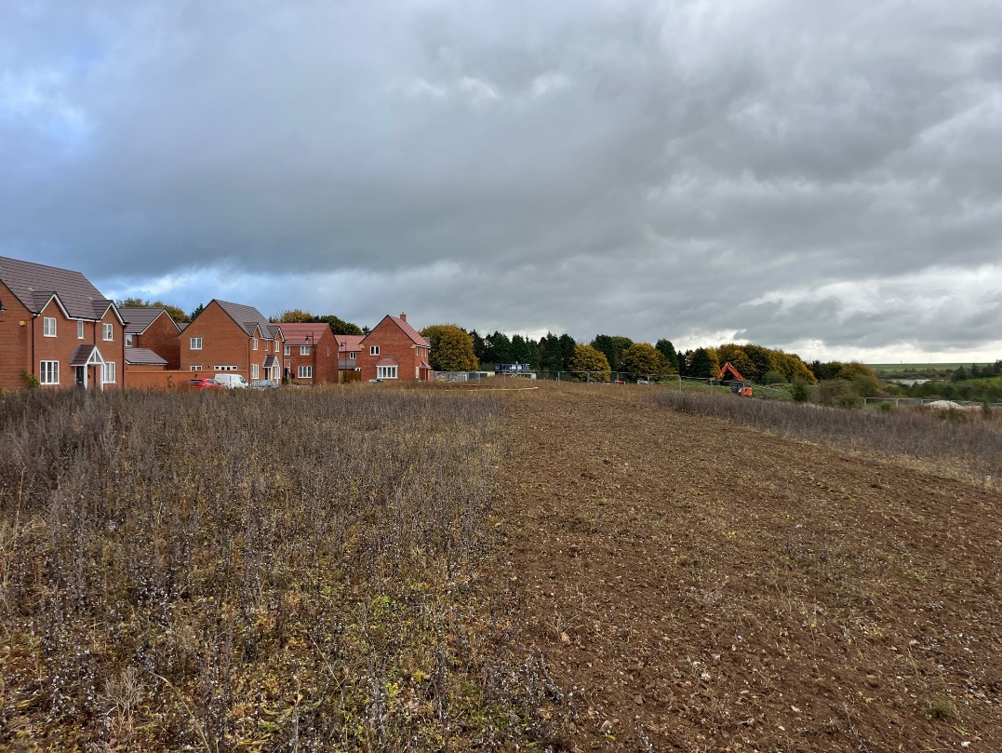

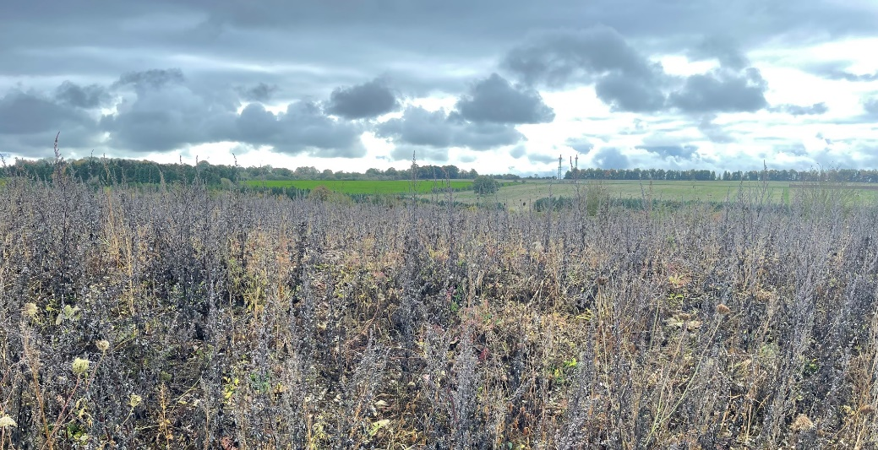

Site set-up:

Welfare (drinking water and a portable toilet) must be provided for the duration of the Works.

Heras Fencing must be established around the entire site for the duration of the Works, with sufficient CDM signage and double clipped.

Compound and Access Route: details on the tender submission should include any vehicle access route and contractor parking, proposed compound, and processes to mitigate any impact on the community such as vehicle movement, noise, or any other factors.

Ground conditions:

The site is currently overgrown with weeds and clearance work is being undertaken. The Town Council are awaiting confirmation of the ground conditions and levels that will be handed over by the Main Contractor (Bloor Homes). Tenderers are required to make themselves familiar with the site and ground conditions and undertake any surveys they require to submit their design and fixed-price tender for a completed play area within the defined boundary. Areas of ground outside the defined play area boundary are outside this scope of work.

1. **Lot budget**

This Lot has an allocated maximum budget of £150,000.00

The full budget should be used but not exceeded.

All features included within the design must be included within the budget and quotation, there must be no ‘suggested’ additional works shown in the design outside the tendered price.

1. **Lot requirements & objectives**

This Lot is required to comprise a Natural Play Area and include provision of some trail based play equipment and additional features for the 7-14 age group. Key requirements are:

A blend of play equipment and landscaping to enhance the natural environment.

Play structures should be incorporated into the landscape to create a natural, playful landscape that is inviting and delivers a wide variety of play opportunities and experiences.

Soft landscape works including alterations to the current ground form shape and levels will be important to create and define the designated play space from the surround area.

Pathways should be included and may be constructed from either a resin bonded stone/ rubber blend or self-binding gravel.

Consideration must be given to preventing misuse at this location, such as anti-social behaviour, riding bikes across the landscaping, viewing into nearby homes.

The design should ensure the play area is inclusive and accessible to all.

Although this play area does not need to meet the traditional definitions of a NEAP play area, the buffer zones set out in the definitions of a NEAP should be applied and noted on the design plans.

1. **Specification** 
   1. Play equipment

Play equipment construction should be predominately **Robinia wood**. Additional materials are acceptable for non-structural parts. Predominately steel equipment and soft wood materials are not acceptable at this location.

Fixings should be anti-tamper style (Torx Screws), and any bolts covered with protective caps.

Chains should be stainless steel.

Basket swing seats should be moulded plastic composite with drainage holes.

Rope should have a steel core.

Maximum height for equipment structures: 4.0 metres

If a swing is included in the design, it should have Anti-Wrap connectors where possible.

* 1. Safety Surfacing

A mixture of different surfaces are encouraged at this location in keeping with the requirement to provide a Natural Play Area. Surfaces that are deemed acceptable are

grass mats, rubber wetpour, limited use of rubber-boned mulch, artificial grass.

Sand, bark, pea gravel and any other loose fill materials are not acceptable.

Grass mats shall be fire retardant, cable tied, trench cut on the perimeter and have turf provided under where grass is not established. Also requires the installation of *Grass Mat Underlay Mesh.*

All other surface sub-base works shall be excavated to the depth required for a flush finish with the surrounding area, back filled with 100mm depth of compacted MOT Type 1 stone laid beneath the rubber surface.

Edges should be trench cut into the surrounding grass or fully resin bonded to the pre-cast concrete (PCC) edging if adjoining a pathway.

Black wetpour shall have a minimum 30% colour fleck.

* 1. Landforms, mounds & landscaping

Soil excavations may remain on site and be formed into an interesting and playful landscape that enhances the play environment. Mounds, slopes and undulations should be finished with turf, watered until established or a surface as described above, and gradients designed to be maintained with a mechanical mower or leaf blower as required.

* 1. Pathways

Connecting pathways should be included in the design to link play zones to the existing footpath serving the site along Yapp Road and to provide a high level of accessibility for all throughout the year and in all weather conditions. Main connecting paths to gates and with wider recreation space must be a minimum 1.2 metres wide. Footpath widths should be clearly noted on your design plan.

Pathways should be constructed from a rubber/stone/ resin mix (such as ‘Conipave’/ ‘Enviro-Pave’ or similar) with pre-cast concrete (PCC) edging. Alternatively, self-binding gravel path material may be used with a timber edge to match the existing footway alongside Yapp Road. Both these surface finishes shall be laid onto 100mm depth of Type 1 stone sub-base.

* 1. Fencing & Gates

The play space boundary may be delineated with landscaping such as a bund or sleepers. The boundary adjacent to Yapp Road should be fenced in order to slow down children exiting the play area directly towards Yapp Road. A chicane style entrance/ exit point could serve this purpose.

Fencing shall be steel bow-top style railings compliant with EN1176, 1.0m high, powder coated in black.

If gates are included they shall be hydraulic (not sprung) self-closing with a flat top style, vertical bar in fill and powder coated in yellow to visually contrast from the fencing. However, it is not a requirement for this location to be fully fenced and gated.

Vehicle access must be provided for locations with grass inside the fenced area. This may be a dedicated vehicle access gate or a combination gate and must be located in an appropriate position for access by mowing vehicles.

* 1. Furniture

Seating should be: Glasdon ‘Pheonix’ seats with armrests and Glasdon ‘Clifton’ picnic tables with wheelchair access. Quantity at the discretion of the tenderer.

All seating should be on hardstanding and preferably connected to any new pathways.

Litter bins (x2) should be: Broxap ‘Derby’ Steel, 120 Litres in Black.

Cycle hoops (x4) should be: Broxap ‘Sheffield’ Stainless Steel.

* 1. Other

A post installation inspection by an independent RPii qualified inspector (i.e. Play Inspection Company, RoSPA or other similar provider) is required to sign off the completed installation. The contractor should allow for this cost within their tender price.

Signage (minimum A2 size) on steel posts should be provided to indicate: The site name, age the play area is intended for use by, telephone number to report any incident or damage, number to call in an emergency, Town Council logo.

Include graphics that demonstrate:

* dogs are excluded
* smoking is prohibited
* litter should be disposed of

Example sign (replace Wiltshire Council with Amesbury Town Council):

