ASTRID – TASKING FORM – Part A
Once complete please email the Tasking Form to:
- Official – ASTRID@baesystems.com.
- Official Sensitive – ASTRID@baesystems.r.mil.uk.
Note to Commercial Staff:
ASTRID has been let and is owned by Defence Science & Technology Laboratory (Dstl) and any work placed under it is subject to UK Govt DEFCONs. Full DEFCON definitions can be found here: https://www.aof.mod.uk/aofcontent/tactical/toolkit/content/defcons/defcon.htm (note account required to access but easy to set up)

TASKING FORM
To: CORDA | From (Organisation): | DB&I, Army HQ

Framework contract number: | DSTL/AGR/01142/01
Agreed quotation date (if known):

REQUIREMENT SUMMARY AND AUTHORITY CONTACTS:
Project Manager  (name & telephone) | (Redacted Personal Info)
Technical Lead  (name & telephone) | (Redacted Personal Info)
Commercial Officer  (name & telephone) | (Redacted Personal Info)
Task title (for Dstl: max 30 characters inc AST/ prefix) | Army Estate Sustainability Strategy
Anticipated start date | 22 Mar 21
Anticipated end date (core work) | 14 Jun 21
Anticipated end date (options)
Requisition or Purchase Order ref | TBC
ASTRID task number | 032
Task description | Please see attached Statement of Requirement

© Crow n copyright 2021 Dstl OFFICIAL

SCHEDULE OF REQUIREMENTS:
Brief list of requirements (core and options) – add rows as appropriate (full details appear in the attached
Statement of Requirement)
Item No | Core or Option | Description / Title
1 | Core | Develop and agree the overarching Environmental Vision, Strategy and Goals/ Outcomes for the Army’s Estate up to 2045.
2 | Core | Baseline: Including review and analyse the current situation. Baselines in priority areas (Environment, Biodiversity, Water and Carbon/Energy)
3 | Core | Roadmap: Develop the Environment, Biodiversity, Water and Carbon/Energy routes. Provide the Final vision statement and outcomes.
4 | Core | Embedded: The roadmap and individual routes against their delivery needs within DB&I
5 | Core | Final Strategy: Deliver the Final Strategy written report.
6 | Core | Lessons: Delivery Learning from Experience (LFE) account report.

Pricing: NTE £120,000 (ex VAT)
Firm Price
Firm Price | ☒
Ascertained cost*
*only at Authority’s discretion
Ascertained cost*  *only at Authority’s discretion | ☐
Firm Pricing shall be in accordance with DEFCON 127 or DEFCON 643 and DEFCON 648 Ascertained Costs shall be in accordance with DEFCON 653 or DEFCON 802.

Cyber Risk:
Risk level: | Very low
Assessment ref: | RAR-RUNR65BX
DEFCON 658 | ☒ (applicable for all risk levels except ‘N/A’)

DEFCONS:
Please confirm which specific DEFCONs are required for the task (Dstl staff click here for greater DEFCON detail and NIPPY Guidance). If you are unsure, please discuss with your IP contact, or commercial

Contractor's Personnel at Government Establishments
(The Contractor's liability under Condition 3 of DEFCON 76 (Edn 12/06) shall
76 | Edn 12/06 | be limited to £50M per incident in accordance with the terms of the agreement between MOD and BAE Systems Plc reference DCS/04/02/32/01/07 dated | ☒
 |  | 17/06/2014).
91 | Edn 11/06 | Intellectual Property Rights In Software | ☒
703 | Edn 08/13 | Intellectual Property Rights - Vesting In the Authority  To be specified on the Tasking Form | ☐
705 | Edn 11/02 | Intellectual Property Rights - Research and Technology  To be specified on the Tasking Form | ☒

© Crow n copyright 2021 Dstl OFFICIAL

Any task placed as a result of your quotation will be subject to the Terms and Conditions of Dstl contract number DSTL/AGR/01142/01

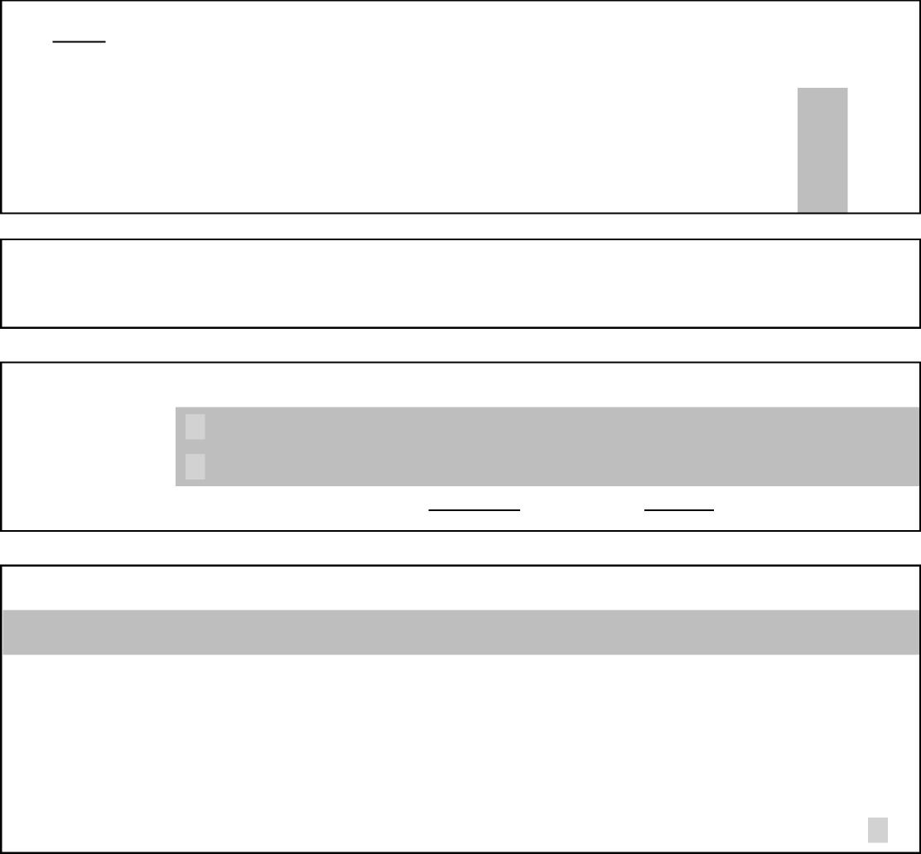
Yes
No
days
days
Acceptance or rejection of deliverables
This MUST match the number of days stated in the SOR. The default for reports is ‘up to 30 days’, and the
default for software is ‘up to 60 days’. Please specify if requesting different and discuss with commercial
524 Edn 10/98 Rejection
525 Edn 10/98
Acceptance
For the Purposes of schedule of requirements item 2 of this Contract the period for acceptance and rejection of deliverables shall be specified within the Tasking Form at Annex D.
☒
☐
DELIVERABLES:
Please see attached SOR for full details
GFX: Draft copy of the MOD Climate and Sustainability (CC&S) Report
If yes, please see attached SOR for full details of equipment / information / facilities
Security Classification of the Work: (delete as appropriate*)
Official
*Failure to delete unnecessary higher classifications will result in delays at the firewall
The overarching ASTRID contract contains a Security Aspects Letter (SAL) covering tasks up to Official Sensitive at quotation stage. If the Statement of requirement (SOR) is a higher classification, please complete the relevant SAL and send with this tasking form and SOR.
If this is the case, please tick the box to indicate you are attaching a separate SAL for your task ☐

© Crow n copyright 2021 Dstl OFFICIAL

ASTRID – TASKING FORM – Part B
To: | From: CORDA
FAO: | PoC: (Redacted Personal Info)
Tel: | Tel: (Redacted Personal Info)

Proposal Reference AST\CM RCL\Prop\01815 (attached)
The proposal shall include, but not be limited to:

- A full technical proposal that meets the individual activities that are detailed in Statement of Requirement (Part A to Draft Tasking Form)
- A Work breakdown structure/project plan with key dates and Deliverables identified including required
delivery dates for Government Furnished Assets.
- A clear identification of Dependencies, Assumptions, Risks and Exclusions which underpin your Technical Proposal.
COST BREAKDOWN (to be completed by the Contractor)
You are to use rates that have been previously agreed within the Analysis for Science & Technology Research in Defence (ASTRID) at Annex E.
Please also provide a price breakdown which should include, but is not limited to: labour costs, transportation, travel and subsistence, overheads and profit. In support of your Proposal you are requested to provide clear details of all Dependencies, Assumptions, Risks and Exclusions that underpin your price
Price quotation of £119,904.26 (ex VAT) is submitted for Task 032 – Army Estates Sustainability and breakdown attached
Ascertained Price ☐
Firm Price ☒
*if hybrid, please specify which pricing mechanism applies to which work
Hybrid* ☐ packages and/or deliverables in the “Milestones Deliverables and
Payments” table
VALUE FOR MONEY EVIDENCE - KPI 1 (to be completed by the Contractor)
The Collaborative sourcing mechanism was utilised for supplier selection. This maximises Value for Money
by:
- Deploying the optimum team to deliver the work (maximising quality)
- Promoting discussions with the customer during proposal work up:
Better aligning the supplier's understanding of the requirement,
Better informing the customer's understanding of their problem and the solution to solving it,
Eradicating 'gold plating',
Deploying the appropriate SQEP and;
Reducing technical (and financial) risk.
- Enforcing use of suppliers lowest UK Government rates
- Reviewing effort levels to ensure that they are commensurate with the required level of work
- The Technical Lead will provide assurance that the Statement of Work is delivered as per the specification CORDA’s extensive track record and knowledge of providing strategic support and thought leadership means we have extant capability and techniques that we can readily bring to bear to deliver the Army Estate Sustainability Strategy and Roadmap. We can reuse tried and tested techniques and toolsets, negating the need for development. Similarly the analytics that we employ to quanify the benefit of strategic measures are mature. Currently, BAE Systems is itself engaged in a programme to assess and reduce its Carbon emissions globally and their may be read across from this activity to help the Army Estates programme.
In particular this proposal contains the following elements:
© Crow n copyright 2021 Dstl OFFICIAL

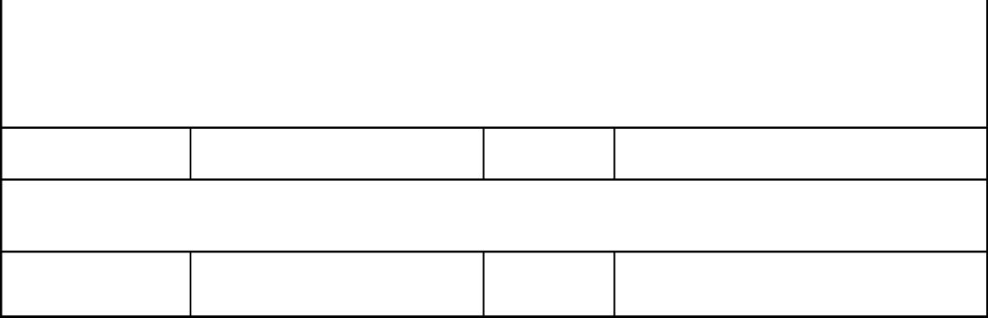
- Confidence that a supplier will deliver the agreed requirements for an agreed firm price
- Task Lead rates have been scrutinised and actively challenged on framework signup to drive value for money. This challenge has resulted in a reduction to the rates from those originally proposed to The ASTRID framework
Start date:
Signed on behalf of the Contractor:
Printed name:
22/03/2021
(Redacted) nfo))
End date:
Date:
14/06/2021
16/03/2021
© Crow n copyright 2021 Dstl OFFICIAL

Contractor’s Cost Breakdown
PROVISION FROM PRIME:
Service (Activity)* indicate whether  work is pre or post award | Rate £ | Qty | Subtotal | Total
(Redacted Personal Info) | (Redacted Pricing Info) | (Redacted Pricing Info) | (Redacted Pricing Info) | (Redacted Pricing Info)
(Redacted Personal Info) | (Redacted Pricing Info) | (Redacted Pricing Info) | (Redacted Pricing Info) | (Redacted Pricing Info)
(Redacted Personal Info) | (Redacted Pricing Info) | (Redacted Pricing Info) | (Redacted Pricing Info) | (Redacted Pricing Info)
(Redacted Personal Info) | (Redacted Pricing Info) | (Redacted Pricing Info) | (Redacted Pricing Info) | (Redacted Pricing Info)
(Redacted Personal Info) | (Redacted Pricing Info) | (Redacted Pricing Info) | (Redacted Pricing Info) | (Redacted Pricing Info)
(Redacted Personal Info) | (Redacted Pricing Info) | (Redacted Pricing Info) | (Redacted Pricing Info) | (Redacted Pricing Info)
(Redacted Personal Info) | (Redacted Pricing Info) | (Redacted Pricing Info) | (Redacted Pricing Info) | (Redacted Pricing Info)
(Redacted Personal Info) | (Redacted Pricing Info) | (Redacted Pricing Info) | (Redacted Pricing Info) | (Redacted Pricing Info)
(Redacted Personal Info) | (Redacted Pricing Info) | (Redacted Pricing Info) | (Redacted Pricing Info) | (Redacted Pricing Info)
(Redacted Personal Info) | (Redacted Pricing Info) | (Redacted Pricing Info) | (Redacted Pricing Info) | (Redacted Pricing Info)
(Redacted Personal Info) | (Redacted Pricing Info) | (Redacted Pricing Info) | (Redacted Pricing Info) | (Redacted Pricing Info)
(Redacted Personal Info) | (Redacted Pricing Info) | (Redacted Pricing Info) | (Redacted Pricing Info) | (Redacted Pricing Info)
(Redacted Personal Info) | (Redacted Pricing Info) | (Redacted Pricing Info) | (Redacted Pricing Info) | (Redacted Pricing Info)
(Redacted Personal Info) | (Redacted Pricing Info) | (Redacted Pricing Info) | (Redacted Pricing Info) | (Redacted Pricing Info)
PROVISION FROM SUBCONTRACTORS:
Service | Cost £ | Qty | Subtotal | Total
RAND (Technical Lead)
CORDA (Task Lead)
GRAND TOTAL Ex VAT |  |  |  | (Redacted Pricing Info)

© Crow n copyright 2021 Dstl OFFICIAL

 | Milestones Deliverables and Payments
 | Milestone No | Description | Pricing  (Ascertained  or Firm) | £ Ex VAT |  |  | Due Date |  | Deliverable  DEFCON  703 / 705  (14, 90 & 91)
 | 1 | Provision of Contractable  Scope of Work and Provision  of Start Up Meeting Minutes | Firm | (Redacted Pricing Info) |  |  | 29/03/21 |  | 703
 | 2 | Delivery of Final Report and  Provision of Presentation  Pack | Firm | (Redacted Pricing Info) |  |  | 14/06/21 |  | 703
TOTAL £ Ex VAT |  |  |  |  |  | (Redacted Pricing Info)

Request for Limitation of Liability
Risk should sit with the party best placed to manage that risk. If the contractor believes that should be the Authority, they should provide a justification detailing the perceived risk, the limitation of liability requested, and link it to the relevant DEFCON where applicable.
☐ | No limitation requested
☐ | Limitations requested – to be absorbed by Prime
☒ | Limitations requested – see attached justification at Annex A

© Crow n copyright 2021 Dstl OFFICIAL

Requested Amendments to Framework Conditions
The Prime should detail below any requests for amendments to the terms and conditions of the Framework if deemed necessary for this particular task
No requirement to produce and provide a deliverable quality plan.
No requirement to provide evidence of certification for any Supplier Accreditations, in relation to
this work.

Options and Payments
Item No | Description / Title from Part A | £ (ex VAT)* | Expiry Date

*Price(s) quoted to be held valid until end date of options ☐
(If unticked a requote will be required)

© Crow n copyright 2021 Dstl OFFICIAL

ASTRID – TASKING FORM – Part C
- Offer of Contract: (to be completed by Authority Commercial Services)
Commercial Officer: | (Redacted Personal Info) |  | Tel: | (Redacted Personal Info)
Vendor Agreement No (if applicable):
Purchase Order Number: | TBC
Start date (T0) is deemed to be: |  | If preferred, CORDA has given permission for you to amend the table in Part B to show actual due dates. If you make any changes, please change the font to RED and draw attention to them in the ‘comments & clarifications’ box below.
Commercial comments and clarifications to proposal:

Commercial Approval: | (Redacted Personal Info)
Date: | 19 March 2021
Please Note: Task Authorisation to be issued by Authority Commercial Services Department once the Vendor Agreement and Purchase Order numbers have been inserted. Any work carried out prior to issue is at the Contractor’s own risk

- Unqualified Acceptance of Offer made in Part C.1 above: (to be completed by the Prime Contractor and returned to Authority’s Commercial Services)
Name: | (Redacted Personal Info) | Tel: | (Redacted Personal Info)

© Crow n copyright 2019 Dstl Choose an item.
Position in Company: | Senior Commercial Officer
Signature : |  | (Redacted Personal Info) | Date: | 23.3.21

ASTRID – TASKING FORM – Part D
COMPLETION OF TASK (to be completed by the Prime Contractor and returned to the nominated Authority Task owner as detailed in Part A - failure to return could result in payment being delayed)
For the avoidance of doubt, Section D confirms the final value of the task. The value stated in this section will be the contracted value for the task and will take precedence over any previous values referred to in sections above.
Confirmation of Deliverables as per Part A:
Yes ☐ No ☐
Actual Task start date:
Actual Task completion date:
Final invoice submitted on:
For firm price of: | £
For the final LoL price of: | £

Comments from Contractor on the task:

© Crow n copyright 2019 Dstl Choose an item.

Task completed to Authority’s satisfaction (to be completed by nominated Task owner)

Comments from Task owner on the task:

© Crow n copyright 2019 Dstl Choose an item.

Anticipated exploitation inc timescales:
Follow-up date with End User if necessary:

Key Performance Indicators (KPIs):
Timeliness of deliverables:
This KPI is a pass or fail question and each deliverable will be given a score of either 1 for meeting the required date or 0 for failure to meet the required date.
Where any agreed contract amendments or changes to the delivery dates have been made, the revised delivery date will supersede the previous agreed date. Where a Deliverable is late as a result of the Authority’s actions, and this is agreed to by the Authority, the deliverable shall be marked as on-time.

© Crow n copyright 2019 Dstl Choose an item.

Total number of deliverables within task:
Of which on time:

Of which deemed late:
Comments / Notes:

Quality of Deliverables:
Deliverables are deemed to be accepted once the Authority has reviewed them and has confirmed that they are of an acceptable standard and is willing to pay the invoice associated with the deliverable. Deliverables can be rejected on the grounds of technical, financial and grammatical errors.
Mark: | Measure: | Number of deliverables in this  category:
Accepted | Technically and editorially acceptable. Minor changes may be needed to improve exploitability of the output or to tailor the output for the end customer.
Minor revisions | Deliverables require minor editorial and/or technical revisions prior to acceptance. Minor changes may also be needed to improve exploitability of the output or to tailor the output for the customer.
Major revisions | Deliverables require significant editorial and/or technical revisions and further review by the Authority.
Rejected | Deliverables do not meet the requirement and are rejected
Any additional comments / Notes:
Signed:
Date:

© Crow n copyright 2019 Dstl Choose an item.

Choose an item. Annex A to ASTRID Tasking Form
DIRECT LOSS - DEFCON 76 (Damage to Government Establishments)
RISK  (Situation) | Worst  Case  Scenario | Worst  Case  Cost  £ | Mitigation | Post  Mitigation  Cost  £ | Proposed  LOL | Contingent  Liability | Probability | Impact
Risk that the deliverables within this task which contain viruses infect the MOD networks upon which are installed | Loss of MOD networks.  Loss of MOD classified information to adversaries that are able to gain access | Unknown – high multi- millions | MOD to virus check any code or model and assure it to be free from virus infection prior to loading it onto any MOD hardware.  Subcontractor to virus check the tool, code or model prior to provision to MOD.  MOD to avoid installing software onto large networks where potential impact would be exponentially increased  Only a word document final report and powerpoint presentation being delivered. Little chance of virus infection. | Unknown – high multi- millions  Or  0 | Excluded | Unknown – high multi millions  Or  0 | Low | Very high
TOTAL PROPOSED CONTRACTOR’S LIMIT OF LIABILITY |  |  |  | Unknown | Excluded | Unknown

© Crow n copyright 2019 Dstl Choose an item.

Choose an item. Annex A to ASTRID Tasking Form
DIRECT LOSS - DEFCON 514 (Material Breach)
RISK  (Situation) | Worst  Case  Scenario | Worst  Case  Cost  £ | Mitigation | Post  Mitigation  Cost  £ | Proposed  LOL | Contingent  Liability | Probability | Impact
Under Clause 2 of DEFCON
514 shall not exceed 150% in
aggregate of the Task Value
TOTAL PROPOSED CONTRACTOR’S LIMIT OF LIABILITY |  |  |  |  | the Contractor's  liability to the  Authority under or in connection  with this  Contract shall  be limited as  follows:  Under Clause 2 of DEFCON 514 shall not exceed 150% in aggregate of the Task Value

© Crow n copyright 2019 Dstl Choose an item.

Choose an item. Annex A to ASTRID Tasking Form
DIRECT LOSS - DEFCON 611 (Loss of or damage to Issued Property)
RISK  (Situation) | Worst Case Scenario | Worst Case Cost  £ | Mitigation | Post  Mitigation  Cost  £ | Proposed LOL | Contingent Liability | Probability | Impact
Loss, of or damage  to, Issued Property | Loss of Authority Data | Unknown | Adherence to BAE  Systems security  protocols and data in  accordance with SAL  specifications. SAQ  has been undertaken  and RAR has been  shared with our  subcontractor for  completion of their  SAQ | Unknown | 100% of Task  Value | £0 | Very Low | Very Low
Loss, of or damage  to Issued Property | Damage or loss due to  contractor  actions/negligence | £0 | No hardware or  equipment is being  received for this task | £0 | 100% of Task  Value | £0 | Very Low | Very Low
TOTAL PROPOSED CONTRACTOR’S LIMIT OF LIABILITY |  |  |  | £0/Unknown | Shall not exceed 100% in aggregate of the Task Value | £0

© Crow n copyright 2019 Dstl Choose an item.

Choose an item. Annex A to ASTRID Tasking Form
DIRECT LOSS - DEFCON 612 (Loss of or damage to Articles)
RISK  (Situation) | Worst Case Scenario | Worst Case Cost  £ | Mitigation | Post  Mitigation  Cost  £ | Proposed LOL | Contingent Liability | Probability | Impact
Clause 1 of DEFCON 612 shall not exceed 150% in aggregate of the Task Value
TOTAL PROPOSED CONTRACTOR’S LIMIT OF LIABILITY |  |  |  |  | The Contractor's  liability to the Authority under or in connection with this Contract shall be limited as follows:  Clause 1 of DEFCON 612 shall not exceed 150% in aggregate of the Task Value

© Crown copyright 2019 Dstl Choose an item.

Choose an item. Annex A to ASTRID Tasking Form

DIRECT LOSS - NEGLIGENCE (that is not included within DEFCON 76, 514, 611 & 612 above)
RISK  (Situation) | Worst Case  Scenario | Worst Case Cost  £ | Mitigation | Post Mitigation  Cost  £ | Proposed LOL | Contingent  Liability | Probability | Impact
Negligence for  professional liability;  Damage as a result  of services or advice  provided by the  contractor (or one of  its subcontractors).  For example:  Damage or Loss due  to an act, error  and/or omission. | Task Lead may  incorrectly analyse  the data within the  scope of this task,  leading to incorrect  ‘advice’ being  provided, which  could go on to  incorrectly inform a  strategic or  operational  decision. | Unknown | - ASTRID PMO and any subcontractor shall ensure that SQEP are used.  - Ensure that all deliverables and outputs are peer and manager reviewed before formal release.  - Task Lead will work closely with the Authority SQEP to minimise chance of errors / omissions.  - MOD are heavily involved with the acceptance testing and assurance of the tool, mitigating the risk of the worst case scenario. | Unknown. | Excluded | Unknown | Low | Medium
TOTAL PROPOSED CONTRACTOR’S LIMIT OF LIABILITY |  |  |  | Unknown | Excluded | Unknown

© Crow n copyright 2019 Dstl Choose an item.

Choose an item. Annex A to ASTRID Tasking Form

INDIRECT/CONSEQUENTIAL LOSS
RISK  (Situation) | Worst Case  Scenario | Worst Case Cost  £ | Mitigation | Post Mitigation  Cost  £ | Proposed LOL | Contingent  Liability | Probability | Impact
There is a risk that  there is an error within  the Analysis or the  MOD provided GFI or  that information is  entered incorrectly  within one of the  Models, which leads to  an error within the  analysis and in turn an  incorrect budgetary  decision.  We would expect MOD  to take responsibility for  any future procurement  decisions and also the  impact of any resultant  changes to Army  Budgets, wider Army  Capability and Strategic  Risk; which are  informed by this  analysis and other  decision support  interventions. | MOD proceed to  procure a  platform/equipment  which is based on  incorrect cost  analysis.  There is an impact to  Army Budgets, wider  Army Capability and  an increase in  Strategic Risk, due to  inaccurate or incorrect  analysis. | Not currently  foreseeable. | MOD should not soley  rely upon the outputs of  this Task to inform a  procurement decision.  The analysis provided  via this Task forms part  of a larger MOD  strategic budget and  capability analysis  which leads to the  decision to alter budgets  and inform environment  sustainability  investment.  In addition to the  rigorous process within  the Task Lead’s  organisation to review  the outputs of the Task,  the MOD w ill be directly  involved with reviewing  the analysis. | Not currently foreseeable. | Excluded | Not currently foreseeable. | Not  currently foreseeable. | Not  currently foreseeable.
TOTAL PROPOSED CONTRACTOR’S LIMIT OF LIABILITY |  |  |  | Not currently foreseeable. | Excluded | Not currently foreseeable.

© Crown copyright 2019 Dstl Choose an item.

