YH25-009 Finance and P2P Solution

# **Section 1: Introduction**

1. General Requirements
   1. The purpose of this document is to briefly explain to providers the business and technical requirements (and the expected scope) of a proposed procurement for a Finance and P2P Solution.
   2. **Please note:** this soft market test exercise is **not** an invitation to tender or a request for formal expressions of interest. This document does not form any part of an invitation to tender. Yorkshire Housing (YH) is issuing this request for **information only**.
   3. Responses to the questionnaire and information gathered from subsequent meetings may be used to inform our future operations and approach to the tender exercise.
   4. Any supplier invited to present to YH is doing so to support market research only and to help make any potential procurement process more focused and efficient. No supplier selection or supplier preference is implied.
2. Confidentiality and Freedom of Information (FOI)
   1. Please note: all information included in this market testing questionnaire is confidential and only for the recipients’ knowledge. No information included in this document or in discussions connected to it may be disclosed to any other party without prior written authorisation.
   2. Where confidential information is provided by YH to the potential providers all recipients of YH information must treat the information provided as confidential and to use the information only for the purpose provided.
3. Background
   1. The nature, scale and complexity of the programme means that fixed-term external capacity and skills are needed to work alongside in-house teams to deliver core elements of the solution.
   2. The preference for YH is to contract with one company that is able to deliver the solution and all professional services from within their organisation or act as a lead for a consortium of companies.
   3. Following a tender process, the supplier or delivery partner is expected to be in place by December 2024.
4. Soft Market Test Timetable
   1. Please read this document and if you feel that your organisation is able to contribute to this exercise, complete the questionnaire at the end of this document and the attached Requirements document and return, via YH Tenders by 12:00 on 06 June 2024.
   2. The YH Tenders email address [YHTenders@yorkshirehousing.co.uk](mailto:YHTenders@yorkshirehousing.co.uk).

The project reference is YH 25-009. Please include this in your email header.

* 1. Potential responders will not be prejudiced in any future procurement processes by either responding or not responding to this market sounding exercise.
  2. Potential Providers may raise questions or seek clarification regarding any aspect of this document at any time to [YHTenders@yorkshirehousing.co.uk](mailto:YHTenders@yorkshirehousing.co.uk).
  3. Dates

|  |  |
| --- | --- |
| Activity | Date |
| Review of the current model and engagement with market | March to June 2024 |
| Tender Issued | July 2024 |
| Tender Submission Deadline | August 2024 |
| Tender Written Evaluation | September 2024 |
| Bidder Interviews and Demonstrations | September/October 2024 |
| Board Meeting | November 2024 |
| Notification of Award | November 2024 |
| Standstill | November 2024 |
| Contract Signing | November/ December 2024 |
| Estimated Contract Commencement | January 2025 |

# **Section 2: Scope (Please refer to Appendix 1)**

1. In Scope

1.1 Minimum Scope

* A full function finance solution
* A full function purchase to pay solution
* Multi company functionality with intercompany capability
* Procurement/e-tendering portal

1.2 Optional Scope (if the solutions deliver as an integral component of the core product)

* Treasury Management solution
* Front end functionality for P2P that includes the sourcing of new suppliers, compliance management, management of new contracts etc., i.e. a full Source to Pay solution
* Budget planning and management

1.3 Target Architecture (expected integration following delivery)

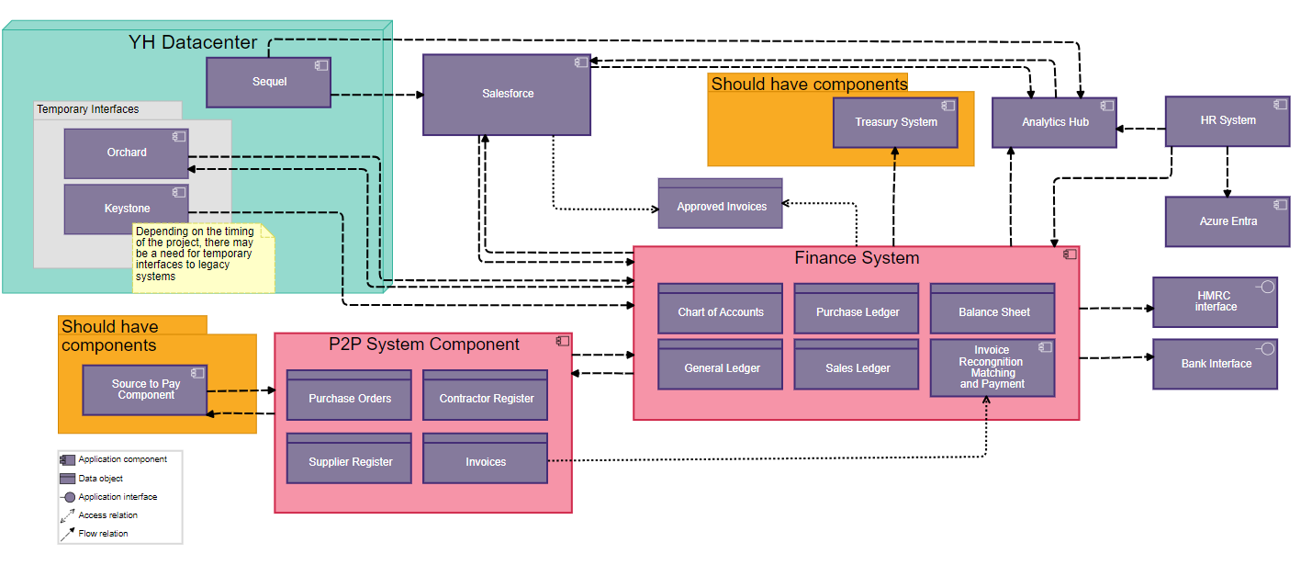

* 1. Licensing Requirements (number of users, configurable by role)
* Finance Solution – up to 55
* P2P Solution – up to 500

1.5 Business Outcomes

1.5.1 A procured solution for Finance which provides the following core functionality:

* Flexibly configured chart of accounts.
* General ledger.
* Sales ledger and debt management.
* Purchase ledger.
* Balance sheet.
* Accounts receivable.
* Accounts payable.
* Account payables audit/forensics
* Cash management.
* Bank account reconciliation.
* VAT management.
* CIS Management
* Fixed assets register.
* Component accounting.
* Property sales receipts.
* Project accounting.
* Standard reporting suite – statutory and management reports.
* Connectivity to the underlying data by API or similar method into a Data Lake
* Audit and controls.
* Approval workflows
* Two way invoice matching
* Cashflow forecasting
* Budget forecasting

1.5.2 A procured solution for P2P which is capable of full integration with the chosen Finance solution and provides the following core functionality:

* Set up, amendment and management of supplier and contractor information.
* Raising, amending and tracking of purchase orders.
* Commitment accounting.
* Invoice processing including automatic matching to purchase orders.
* Management of non-purchase order driven expenditure, e.g. utility bills, ad hoc cash purchases, credit or debit card purchases.
* Invoice capture, storage and archiving.
* Standard reports.
* Flexible reporting functionality.
* Audit and controls.

**1.5.3** **Proven interfaces** with the following:

* Salesforce.
* Orchard
* Document Management (SharePoint).
* Payment gateways, e.g. Allpay.
* Banking portals.
* HMRC
* Procurement Portal - interface with FTS and other required notices

**1.5.4 Data Migration**

* Migration of agreed legacy systems data

**1.5.5 Technical ‘must haves’:**

* Demonstrate alignment to an industry standard, preferably certified to NIST or ISO27001
* Demonstrate cyber security incident management processes.
* Provide information on risk management practices
* Demonstrate adherence to Secure Systems Development Lifecycle practices
* Provide information on data encryption, both at rest and in transit
* Support robust authorisation controls such as MFA
* Integrate with Microsoft Azure and 365 for features such as Single Sign On (SSO)
* Provide information on the physical security of data centres or facilities if the finance system is a hosted solution, e.g. access controls, surveillance and environmental controls.
* Provide details about how often penetration tests and vulnerability assessments are conducted and how vulnerabilities are addressed.
* Yorkshire Housing are aligned to the NIST Framework and any provider will need to ensure they comply with our policies
* API integration capability

1. Out of Scope

* Annual rent reviews
* Service charge setting and management
* Business planning

# **Section 3: Questionnaire**

1. Section A: Organisation and Contact Details

|  |  |
| --- | --- |
| Question | Response |
| Name of your organisation |  |
| Registered office (if applicable) |  |
| Trading address (if different from office) |  |
| Name of person whom an queries relating to this questionnaire should be addressed |  |
| Telephone Number(s) |  |
| Email |  |
| Address if different to above |  |

1. Section B: Questions

|  |  |  |  |  |  |  |  |  |  |
| --- | --- | --- | --- | --- | --- | --- | --- | --- | --- |
| 1. References   Please can you provide three different client references and if possible examples of Registered Social Landlord (RSL’s) organisations who are using your solution:  The following information is required.   |  |  |  | | --- | --- | --- | | Contact Name | Contact Telephone Number | Contract Start / End Date | | Company Name | Contact Email Address | Project Description and Size | | Company Address | Contact Position | Contract Value | |
| Response |
| 1. Business Requirements   Please provide a management summary of your proposed solution detailing how it will meet the Scope detailed in section 5. |
| Response |
| 1. P2P and Source to Pay   Please provide a high-level overview of your solutions P2P and Source to Pay functionality and how it interacts with the other components of your proposed solution. |
| Response |
| 1. Integration   Provide details of how your solution will integrate with YH systems in 1.5.3. |
| Response |
| 1. Implementation   Please provide an overview of the key stages and timelines including migration for system implementation from the point of contract award to system go live. |
| Response |
| 1. Project and Account Management   Please provide details on how the contract will be managed on an operational and strategic level. |
| Response |
| 1. Software Licencing Model   Please explain your licensing options available to YH and detail how they work in practice. |
| Response |
| 1. Management information / reporting functionality   Please provide details of your system’s reporting capability in terms of providing accurate, timely and customisable reports to aid management reporting. |
| Response |

|  |
| --- |
| 1. Purchasing Route   Please provide details of public sector frameworks that the solution you offer is available through |
| Response |
| 1. Rough Order of Magnitude (ROM) Pricing   To help inform our procurement route, please can you provide a ROM price for the solution outlined above. This will be used for budgetary purposes only and is not a commitment.  I.e. Implementation costs, licence and user costs, training costs, running costs, module costs |
| Response |
| 1. Innovation   Is there anything in addition to the information in this brief that vendors / suppliers would need to be advised of in order to aid the tender process?  Please could add if we’ve missed anything, or what we could do differently.  Please can you detail a brief statement to demonstrate what added value your organisation can offer in the market. |
| Response |