Parish Office, Colden Common Community Centre

St Vigor Way, Colden Common, Winchester
Hampshire, SO21 1UU

Clerk: Debbie Harding
Telephone 07775 627131
e-mail clerk@coldencommon-pc.gov.uk
www.coldencommon-pc.gov.uk

TENDER DOCUMENTATION

FOR

INSTALLATION OF A TARMAC PUMP TRACK
AT COLDEN COMMON PARK, SO21 1TA

TENDER TO DESIGN AND BUILD A TARMAC PUMP TRACK
AT COLDEN COMMON PARK

Contractors’ details | Page 2 | To return with tender
Form of tender | Page 3 | To return with tender
Tender information | Page 4
Instructions to tenderers | Page 5
Requirements, further information | Page 6-7
Location maps | Page 8
Address label to use | Page 9

TENDERS MUST BE RECEIVED IN HARD COPY BY 6PM ON
FRIDAY 9TH SEPTEMBER 2022 BY 6PM

PLEASE ENSURE YOU USE THE ADDRESS LABLEL PROVIDED ON PAGE 9

ALL TENDERS WILL BE OPENED ON MONDAY 12TH SEPTEMBER

Please complete in BLOCK CAPITALS

Contractor: ..............................................................................

Address: ..............................................................................

..............................................................................

................................................................................

................................................................................

Telephone No.:............................. e-mail ……..:............................

Website…………………………………………………………………

Contractor's representative: ............................................................

FORM OF TENDER

To: Colden Common Parish Council
Parish Office, Colden Common Community Centre
St Vigor Way
Colden Common
Winchester, Hants
SO21 1UU

TARMAC PUMP TRACK

Dear Sirs,

Having examined the specification and schedule of works for the installation of a tarmac pump track at Colden Common Park, Boyes Lane, Colden Common, SO21 1TA we submit a design and build tender for the sum of:

£............................. + VAT

(Written amount ……………………………………………………………………………………………..)

We undertake to carry out and complete the works in accordance with the specification.

We understand that you are not bound to accept the lowest or any Tender you may receive.

Yours faithfully,

Signature: ......................................................................................

for and on behalf of: ......................................................................................

Date: ......................................................................................

TENDER INFORMATION

- Subject to planning approval the tender should allow for subsequent construction of a tarmac pump track within the area identified, including landscaping, fencing, construction of access road, ROSPA inspection and handover. All dead trees will be removed from the site by Colden Common Parish Council outside of the contract value.

- The new pump track should be suitable for use by users of all abilities and should encourage dynamic and diverse play.

- The design should have the maximum play value for the allocated budget and should be contained within the site identified.

- Construction and finish should demonstrate a reduced risk of damage by vandals.

- The contract must make good and reinstate any damaged grass areas during installation and remove all arisings from the installation.

- Maintenance and management considerations should be of key importance within the design.

- The design should be compliant with all relevant British and European Standards.

- Site access should be agreed with the Colden Common Parish Council as landowner.

- Works must be carried out with minimal disturbance to local residents and users of the open space. Consideration should be given to allowing ongoing access for walkers and park users.

- Designs must factor in the condition of the site and enable practical movement between features/activities with appropriate surfaces being introduced

- This site is not designed for use outside of daylight hours, there are no current plans for extra lighting

- The Contractor should allow within the budget an independent inspection to be carried out upon completion and to carry out any identified remedial works as required prior to handover at no extra cost. A copy of the inspection shall be made available to the Client. The Contractor must respond with a plan for any remedial works within seven calendar days of receipt of the Independent Inspection Report.

- In order for us to undertake consultation with local young people and residents, submissions must include a colour hard copy visual presentation of the proposed design at A1 size with supporting information about the equipment. An electronic copy on CD of all documentation and the presentation is also required

INSTRUCTIONS TO TENDERERS

a) The following instructions are provided for information only.

b) Tenders shall be submitted on the attached Form of Tender not later than
6pm on Friday, 9th September 2022 in an envelope addressed with the label provided by the Council in this document pack (page 9)

c) Any Tender arriving after 6pm on the date stated in (b) above will not be
considered.

d) Colden Common Parish Council is not bound to accept the lowest or any Tender,
the Tender offer is to remain open for a period of at least three months from the tender due date.

e) It is planned that construction will commence in April 2023. Funding is in place, planning permission has not yet been applied for.

REQUIREMENTS AND SCOPE OF WORKS

The Parish Council is inviting companies to submit responses to its Invitation to Tender for the design and build of a Tarmac Pump Track at Colden Common Park, Boyes Lane, Colden Common, SO21 1TA. What three words location ///free.ﬁne.learns. The approx. area is 50 metres by 38 metres (1900 square metres)
A location plan is included on page 8
Tenderers are advised to visit the location in order to familiarise themselves with the existing layout, land levels and environment.
The Council does not bind itself to accept the lowest price or any tender. The company shall not have any claim for expenses incurred in the preparation of a quote
Suppliers tender at their own cost and their fixed price tender shall remain open for acceptance for a period of 90 days after the due date for submission.
The Supplier should note that after the submission of the tender they may be required to attend an interview at the Council’s office to explain tender design proposals including the methods of construction, the construction program and proposed management of the project
The maximum budget for the complete scheme is £65,000. Funding is secured.
Please show that your design concept and tender addresses the following specification:
The tender shall include:
Site investigation and detailed design
1. Design and Build (estimated start from April 2023)
2. Supply and installation of any required safety surfacing
3. Supply of appropriate drawings to show proposed layout
4. Supply and installation of all equipment and site furniture
5. Design and installation of suitable and effective drainage
6. Hard and soft landscaping works to include fencing and access road to the track
7. All surplus materials to be removed from site
8. Post installation certification ( RoSPA)
The Parish Council will remove all the dead trees from the site and therefore this is outside the scope of the project. Other land levelling or clearance works should be included.

LIST OF ITEMS TO BE PROVIDED BY APPLICANTS

- A letter introducing the company.
- Cost for the design excluding VAT.

- The contractor is required to produce risk assessments for each site before the commencement of the contract, which will be provided to the Parish Council upon request.

- All relevant protective clothing will be worn whilst conducting work for the Parish Council, and all safety procedures will be followed to ensure that both employees and members of the public are protected.

- Only suitably qualified staff will use machinery to carry out any work for the Parish Council.

- The contractor is required to have all necessary and relevant licences and certificates, including but not limited to a waste disposal licence and machinery.

- The contractor is required to have Public Liability insurance, details of which will be provided to the Parish Council commencement on site

- Copies of all licences and certificates held, the Public Liability insurance certificate, all other relevant insurance documents, a staff list, an equipment list, company details and bank account details will need to be provided at the same time as the submitted bid. If the intention is to hire staff or purchase equipment once the contract is awarded, then those details should be provided too.

- Copies of all necessary insurance documents, including the value of Public Liability insurance held.
- Company details – including but not limited to how long the company has been in operation.
- Bank account details.
- Examples of current and previous work, including contact details for at least two customer references to be taken up.
- An indication of willingness to take on the potential additions / amendments to the design if finances can be obtained.
- Any further information the company feels would be relevant to the bid.

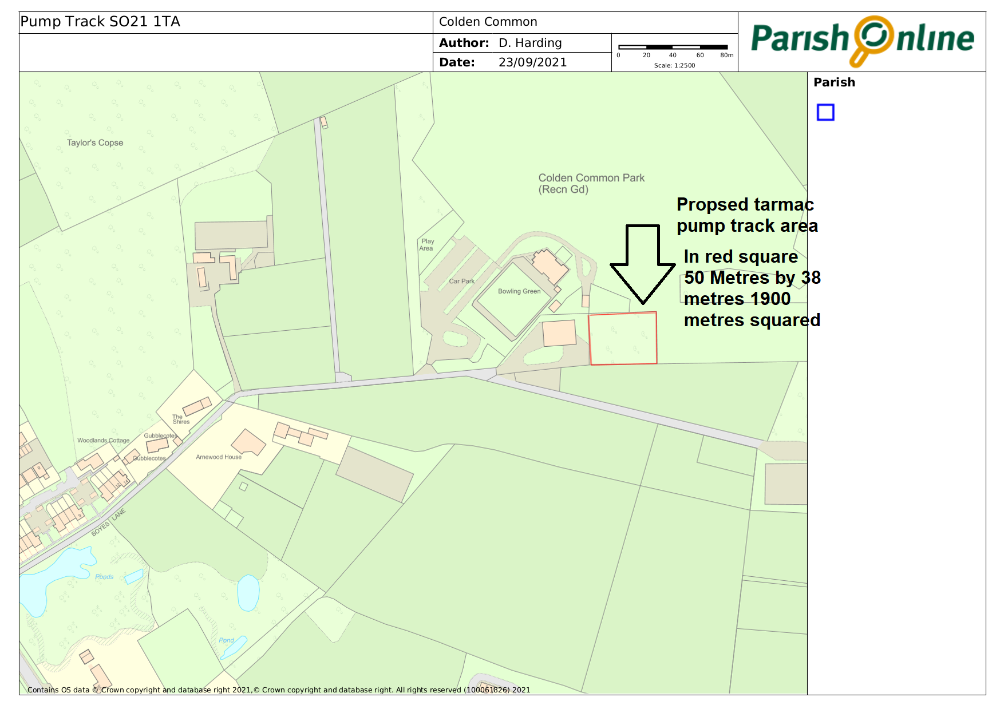
Access track to be extended (constructed) as shown by blue line. This is provide hard scalping surface to enter the pump track from the existing access road. Entrance point to pump track to be determined by design

LABEL TO BE USED FOR RETURN OF TENDERS

TENDER DOCUMENTS FOR PUMP TRACK
DO NOT OPEN UNTIL MONDAY 12TH SEPTEMBER 2022

COLDEN COMMON PARISH COUNCIL
PARISH OFFICE
COLDEN COMMON COMMUNITY CENTRE
ST VIGOR WAY
COLDEN COMMON
WINCHESTER
HANTS
SO21 1UU

Will be used by the Parish Council for a planning application to Winchester City Council.

