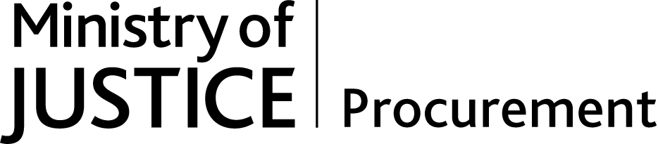
Contract Award Report
prj_4742 MoJ Digital & Technology - Accessibility Testing & Quality Assurance Service

Executive Summary
The purpose of this document is to report the outcome of a procurement for the provision of a central digital accessibility contract and to confirm the winning bidder as Digital Accessibility Centre Ltd. The contract has been procured and will be awarded as a call off under the Crown Commercial Service Framework, G-Cloud 11 Framework Agreement (RM1557.11).

The requirement for this procurement is to ensure compliance with Public Sector Bodies (Websites and Mobile Applications) (No. 2) Accessibility Regulations 2018. To comply with these regulations the Ministry of Justice needs to ensure that its websites and mobile applications meet the international WCAG 2.1 AA accessibility standard. This standard ensures that Government digital services and websites can be successfully accessed by users of assistive technology. Key dates below:

- Public sector websites created before 23 September 2018 will need to comply with the requirements from 23 September 2020.
- Public sector mobile applications will need to comply with the requirements from 23 June 2021.

MOJ Digital and Technology do not have the skills and expertise in-house to carry out WCAG 2.1 audits. Procuring these services on a case-by-case basis will be time-consuming and put our ability to have our highest profile / traffic services compliant by the September 2020 deadline. Delivery of new services will likewise be delayed if teams are required to procure individual assessments.

As the requirement was for a short, flexible Cloud-based service the G Cloud framework was selected as the procurement route. The choice was made to undertake a ‘Desk top’ Benchmarking exercise to determine the best fit service offering.
Twenty Nine G Cloud services were long listed for comparison. Service offerings that could were not able to provide real users with accessibility needs to test the services (rather than solely relying on automated accessibility testing tools) were deselected. The final short listed services included the following:.

Supplier | Service | Service ID
DAC | WCAG 2.1 AA level accessibility user and technical testing/audits | 463267400141628
Nomensa Ltd | Accessibility services | 683794289737643
AbilityNet | Digital Accessibility Services | 427190438667701

Through an assessment of each of the Supplier Service offerings (which included emails and telephone calls), The Digital Accessibility Centre Ltd met all the MoJ requirements, was determined as a best fit service as it offered a flexible and user focused approach to testing along with being the best value for money not only in terms of price (lower than the two alternatives) but also against our other key criteria. DAC provide the most diverse testing team and can accommodate our teams being present during the testing (which is helpful in terms of being able to make immediate fixes and reduce overall remediation time). It should also be noted that Digital Accessibility Centre Ltd have previously run a successful accessibility and testing contract in HMCTS.

Contract and Commercial summary
The contract period is 2 years with the options of two further 12-month extensions as per the standard G Cloud framework terms and conditions. The requirement will be split into separate work packages, the deliverables and duration of which will be agreed in advance. Costs for testing and analysis will be called of the agreed rate card. The contract value is capped at £120,000.

Russell Turner
Commercial Manager
Technology & Digital Contract & Commercial
Management Directorate (TDCCM)

