Design brief

Windlesham Parish Council is seeking a minimum of 3 design concepts for its Community Hub/Pavilion Project on Lightwater Recreation Ground.

The site
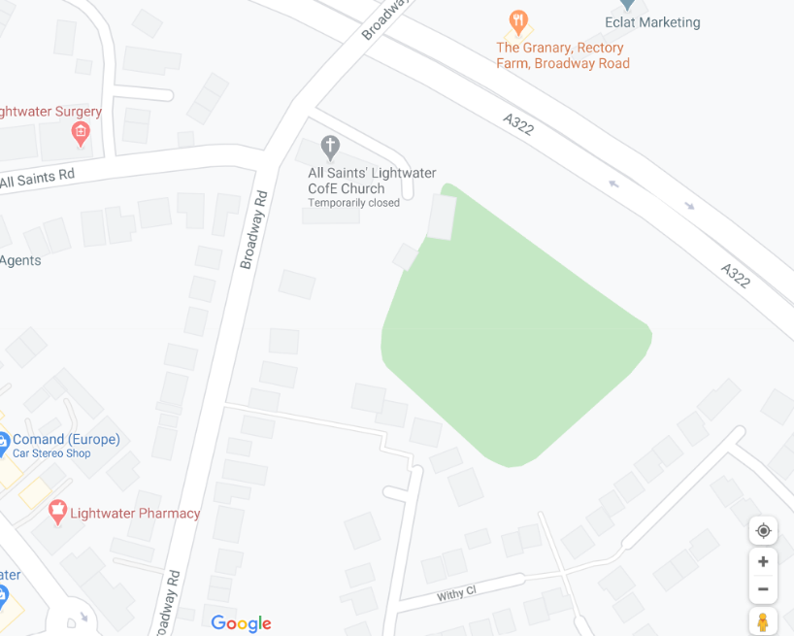
Easting:493303.16, Northing:162230.76
The project
Windlesham Parish Council wishes to redevelop the Lightwater Recreation Ground Pavilion/Hub to create a legacy project for the Parish.
Part of the aim is to move the Council Chamber and Office to a more Central location in the village while offering a flexible community building for residents to enjoy.
Key aims are:
- Flexible community space
- Building to provide a solid barrier between the car park and the field to secure it
- Community building to augment the offer of community space in the 3 Villages and do so flexibly
- Maintain football heritage for development FA football
- Introduce a hub space for community organisations and or the Community Police to use as an outreach centre.
- Be used as a signposting service
- Offer secure and more interesting play equipment for children with an expanded offering to include a greater age-range
- Introduction of table tennis and open-air gym for use of residents not to interfere with the footprint of the football pitch.

The Location
The Lightwater Recreation Ground is a Queen Elizabeth II designated field and has been under the protection of Fields in Trust since 1931.
The 0.81 hectares field is located just off Broadway Rd in Lightwater immediately behind All Saints Church and is accessible via a single lane to the north of the church hall.
The field houses a small U5s playground, a car park for 20 cars and a small pavilion and storage facility.
The field itself hosts a 9-a-side FA football pitch and is used at weekends for matches for U12s.
Outside of football and general recreation, the field is used twice a year for a fete and bonfire. Both events are extremely well attended attracting visitors from the whole County.
The field is planted with a mixture of mature lime trees and oaks measuring circa 18 m in height. The trees were planted in remembrance of soldiers from Lightwater who lost their lives in the wars.
Windlesham Parish Council is the management trustee for the field.
The Council decided in 2013 to redevelop the Pavilion to create a Community Hub.
In recent years the Recreation ground suffered two unauthorised encampments and this project seeks to solve the weakness in access to the field as part of the brief.

The Vision
To deliver a visually pleasing building which would blend with the site and has a neutral footprint and delivers augmented, flexible community space with the new pavilion developed over two floors.
As part of the Council’s visioning exercise, it was decided to re-site the pavilion and bring it forward into the field (Annexe 1) and move it to the north to occupy the space currently occupied by the children’s playground.
The intent is to create a gated access onto the field to allow for entry and egress of emergency vehicles and maintenance vehicles adjacent to the tree line to the north of the site with the use of raised flower beds to create an interesting feature.
The Building would start after the gate, with the gate sliding into the fabric of the building so that it cannot be tampered with from the outside once open. A pedestrian gate would allow access to and from the field to the right of the vehicular access.
Inside the gated area there would be space for community rubbish bins to be kept locked and 3 parking spaces for staff on permeable plastic grass pavers.
The building itself would run north to south parallel to the short side of the pitch behind the goal area.
Consideration will have to be given to protecting the glazed area of the building behind the goals.
The building will be accessed through a lobby corridor from the car park and from the field.
The building will be designed using best design principles for FA U12 clubhouses and will feature:
Ground floor
store facilities, plant room. Referee/infirmary room, a community hub, elevator shaft and stairwell to the first floor; 2 community halls as well as changing and shower facilities for home and away teams. male, female and disabled toilets and a kitchen.
On the outside there will be a covered seating area open on 3 sides overlooking the fully enclosed children playground as well as the football pitch.
First Floor
Council chamber/board room overlooking a terrace onto the field, clerk office with reception room, general office, small meeting room, staff kitchenet and W.C.
Storage is important as the whole space must be multipurpose and used for meeting space/community space/private hire, so furniture must be stored securely and out of sight. This does not apply to the Parish office as that will be a defined space.

The building typology
The users of the building could be a nursery, a club or the general public and there is no specific demographic this scheme is targeting. Consideration has been given to the possible existence of a small coffee shop in the south end of the building on the ground floor closest to the children’s playground.
The Council would like the building to be light and airy with large glass surfaces and consideration will have to be given to making the whole building tamper proof and secure.
Key consideration needs to be given to sustainability of the building with the use of solar roof tiles, sustainable heat and cooling sources such as ground/air source heat pumps and through choice of materials.
Council has expressed a wish that living walls be considered.
As this is a legacy project for the Parish the building would need to have a strong personality so particular consideration should be given to design form where preference would be given to a curved roof profile.
In terms of height, the constraint is for the building not to impact the location and not to tower over the church and church hall. Council would like the building to sit just below the roof ridge of the church.
The footprint Council is looking at is about 32m x 10m at ground floor level with reduced internal floor area at first floor to enable provision of an outside projecting terrace with this providing a covered area for the outside parents’ area below. Total internal area is to be circa 550sqm across the 2 floors.
As previously mentioned, choice of materials is key and cedar cladding has been considered. Council feels that a mix of “interesting” features and materials could achieve the desired effect of the strong personality which underpins the vision of Council.
Constraints
Single entry/exit point
Football pitch location offers no flexibility
Position of bonfire to be moved so as not to affect trees.
Trees
Car Park
Height of Church roof ridge not to be exceeded

A full topographical survey will be provided ahead of design.

Budget
It is envisaged the budget for the project will be between £750,000 and £1million so designs and choice of materials will need to fit within this bracket.

Output
The concept designs will need to be provided in digital format (ideally a commonly available format) and hard copy format in size A0, to allow for consultation.

