 |  |  | Bay 3/21  Spring Place  105 Commercial Road  Southampton  SO15 1EG  United Kingdom
 | All Applicants for the Internal Fit Out Oceansgate, Plymouth  Via Contracts Finder |  | Tel:  Fax:  E-mail: | +44 (0)20 381 72173  contracts@mcga.gov.uk
 |  |  | Our ref: |  | TCA 3/7/1061
 |  |  | 5th July 2018
Dear All

INTERNAL FIT OUT AT SUITE 5, ENDEAVOUR HOUSE, OCEANSGATE, PLYMOUTH, PL1 4RW

We have received a question from an applicant for the above-mentioned contract, and to ensure that all applicants have access to the same information, we have copied the question and our answer to you:

Question:

Please can you provide details of the air conditioning or ventilation as installed, or an as fitted drawing based on the area so that we are able to quote?

Answer:

We do not have a drawing (awaiting from the Council), the following photos and commentary from our Contract Administrator may assist.

Comment from HTC: The extent of works necessary is minimal if anything at all. One of the units will be located in the new meeting room and as such some alteration may be required to the remaining two units to ensure the correct level of ventilation/cooling etc is maintained. This is something that each contractor's M&E subcontractor needs to establish

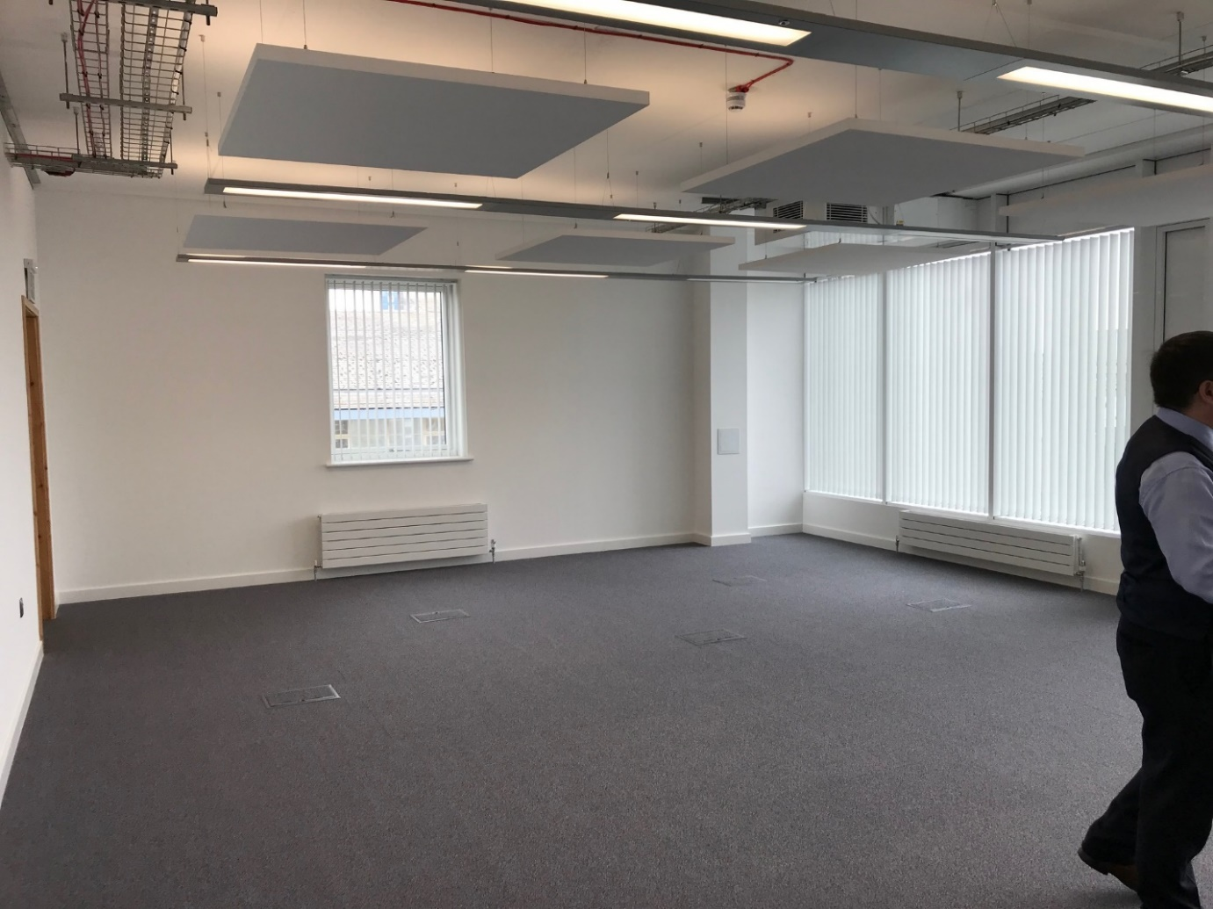
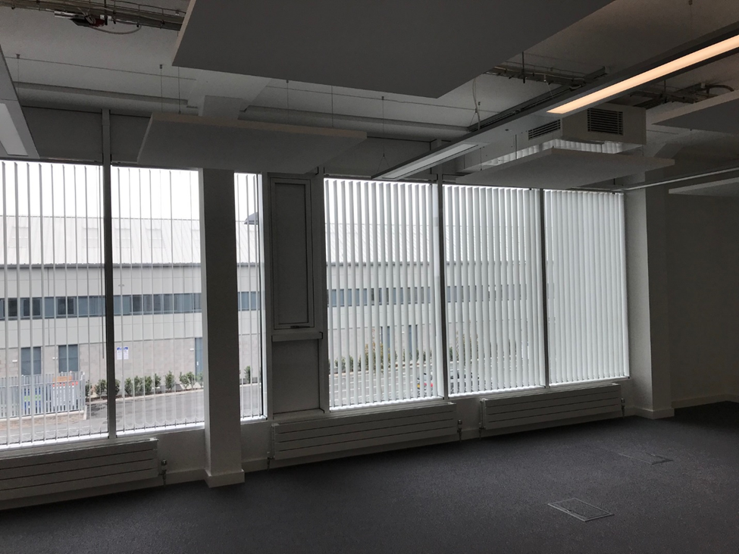
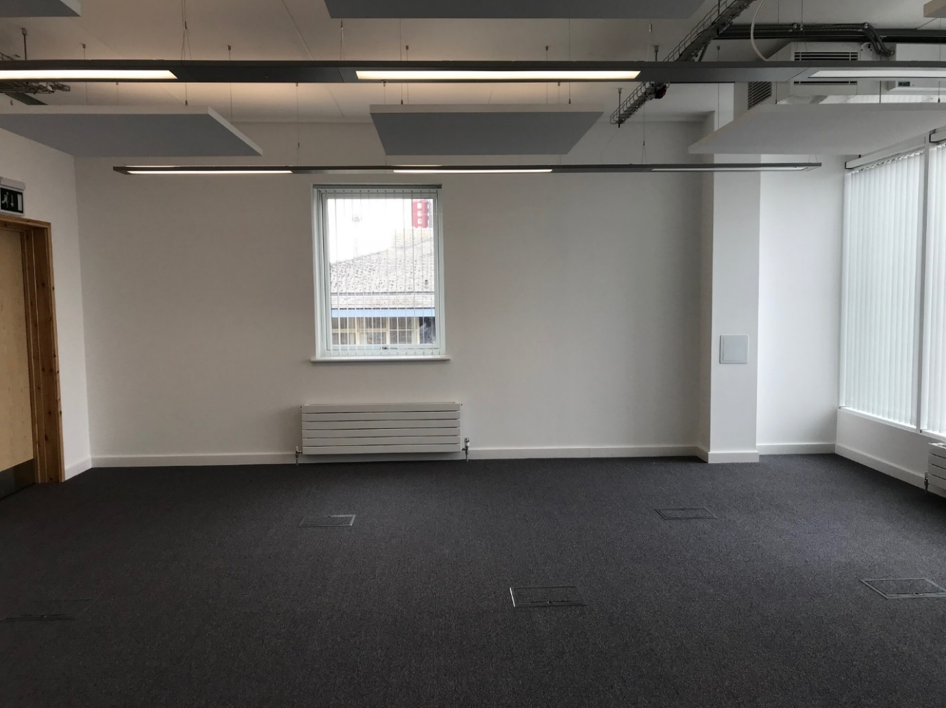
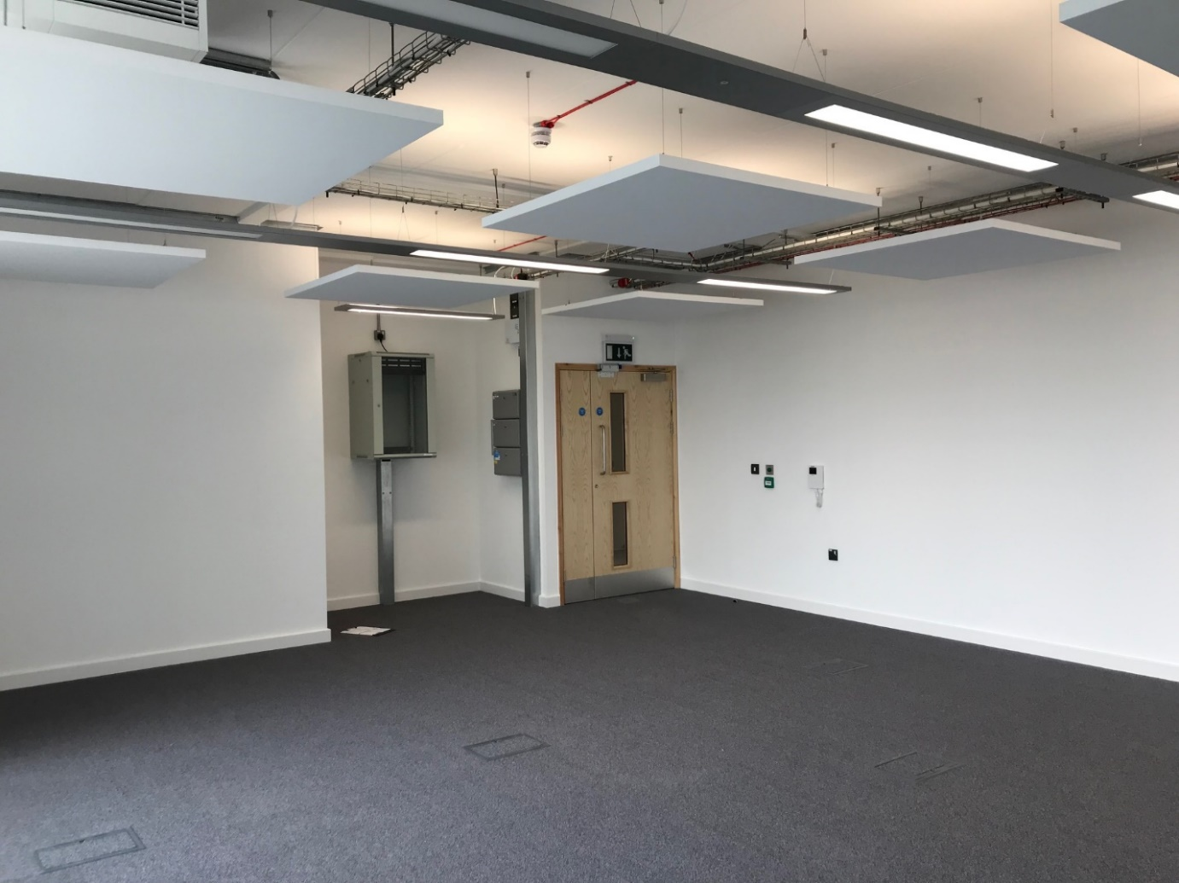

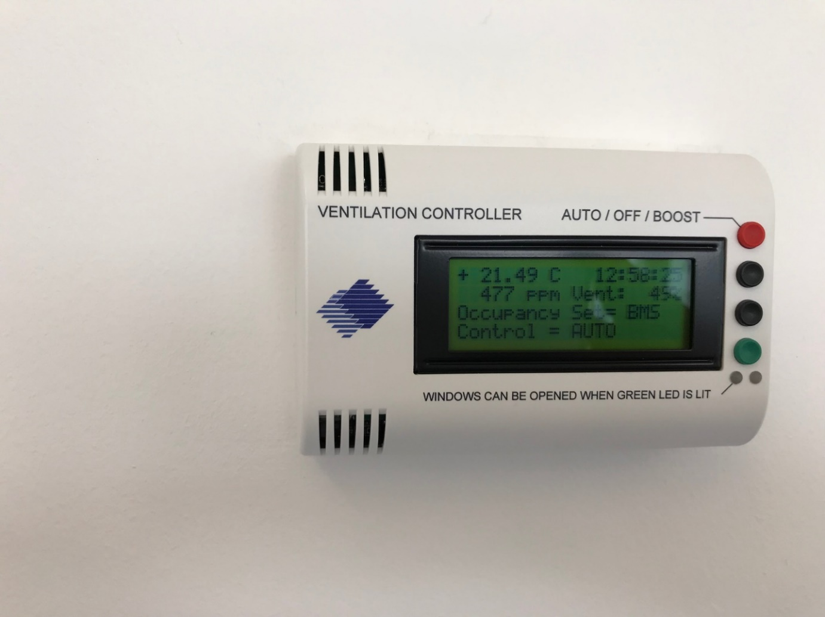

I hope this provides all the information you require

Kind Regards

Amanda Dunbar
MCA Procurement Strategy &Corporate Services

