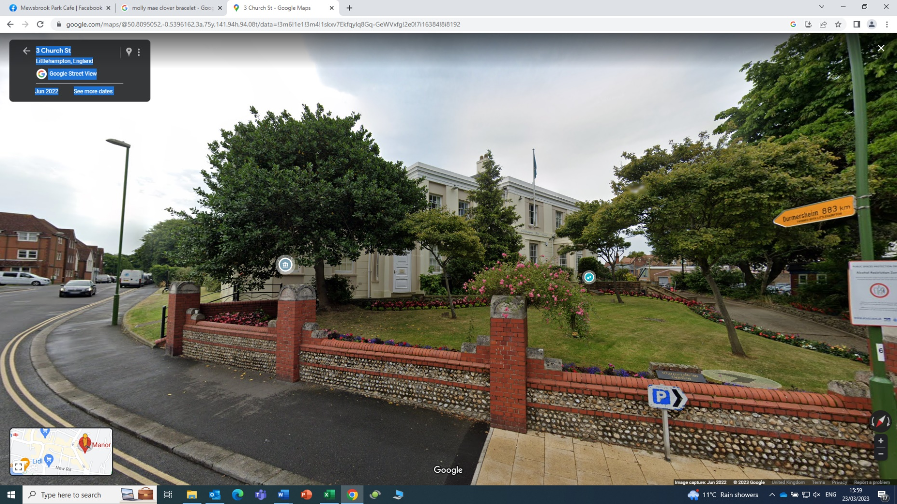
Appendix 6 – Manor House natural tree to be decorated.

