|  |  |
| --- | --- |
| moons_logo.jpg | |
| Document Title | MOONS Field Corrector Manufacturing Procurement Specification |
| Document Number | VLT-SPE-MON-14620-1006 |
| Issue | 2.0 |
| Date | 18th June 2018 |
| Status | Released |

**TABLE OF CONTENTS**

[1 INTRODUCTION 1](#_Toc517093114)

[1.1 MOONS Instrument Overview 1](#_Toc517093115)

[1.2 Scope and Purpose of Document 1](#_Toc517093116)

[1.3 Field Corrector Description 1](#_Toc517093117)

[2 Statement of Work 3](#_Toc517093118)

[2.1 General 3](#_Toc517093119)

[2.2 Proposed Planning 3](#_Toc517093120)

[2.3 Progress Monitoring 4](#_Toc517093121)

[2.4 Deliverable Item List 4](#_Toc517093122)

[3 Environmental Conditions 6](#_Toc517093123)

[4 Operation Conditions, Lifetime and Maintenance 6](#_Toc517093124)

[5 Field Corrector Lenses Specification 7](#_Toc517093125)

[5.1 Definition of Glass 7](#_Toc517093126)

[5.2 Specification of Lens 1 7](#_Toc517093127)

[5.3 Acceptance tests for Lens 1 8](#_Toc517093128)

[5.4 Specification of Lens 2 9](#_Toc517093129)

[5.5 Acceptance tests for Lens 2 9](#_Toc517093130)

[5.6 Specification of Coating for both Lenses 10](#_Toc517093131)

[5.7 Acceptance tests for Coating 10](#_Toc517093132)

[6 Field Corrector Lens Barrel Specification 12](#_Toc517093133)

[6.1 Specification for Lens Barrel 12](#_Toc517093134)

[6.2 Lens mounting tolerances 12](#_Toc517093135)

[6.3 Acceptance tests for Lens Barrel 13](#_Toc517093136)

[6.4 Acceptance tests for Mounted Lenses. 13](#_Toc517093137)

[7 Packaging and Delivery 14](#_Toc517093138)

[Annex 1 – Optical drawings 15](#_Toc517093139)

[Annex 2 – Mechanical drawings 17](#_Toc517093140)

# 

# INTRODUCTION

## MOONS Instrument Overview

The Multiple Object Optical and Near-infrared Spectrograph (MOONS) will operate at the Nasmyth focus of the European Southern Observatory’s Very Large Telescope. MOONS is designed to be a high performance and versatile survey spectrograph, with a large field of view of 25 arc-minutes, capable of simultaneously observing 1,000 objects over the visible and near-infrared wavelength range of 650 nm – 1800 nm. The instrument consists of the three sub-systems: the Rotating Front-End mounted on the VLT rotator on the Nasmyth platform, the two Triple-Arm Spectrographs and the Instrument Control.

The instrument Rotating Front End (RFE) contains several modules and its main functions are:

1. allow the fibres to collect the light from the astronomical targets of interest;
2. provide the necessary metrology and calibrations (flat field and wavelength) for the observations. For this purpose the Fibre Positioners are mounted on a retractable plate. When this plate is pushed toward the field corrector the instrument is in “observing position” with the entrance of the fibres positioned at the focal plane of the telescope. When the plate is retracted (by ~500mm from the field corrector) the instrument is in “calibration position” to perform metrology of the fibre positioners as well as flat and wavelength calibration.

The RFE also contains all the necessary supporting infrastructure and the cable wrap.

Besides the support for all the RFE units (including mechanisms for retraction and screen control) the RFE structure also comprises the MOONS field corrector. The image delivered by the VLT at the Nasmyth focus is astigmatic and has a field curvature that is not concentric to the exit pupil of the telescope. Thus, in order to enable the exploitation of the full 25 arc minute field of view (FOV) of the VLT Nasmyth focus, the use of a field corrector is mandatory.

## Scope and Purpose of Document

This document provides the statement of work and the technical specifications for the procurement of the MOONS field corrector manufacturing.

## Field Corrector Description

The corrector consists of an air spaced doublet with both lenses made from same material. The first lens is a plano-convex and the second is a symmetrical biconcave in order to minimize manufacturing costs. Figure 1 shows the geometry of the VLT and the MOONS field corrector lenses.

The wavelength range for the corrector is 650 nm – 1800 nm.

The material to be used is Heraeus HOQ 310, a low-OH IR-grade Fused-Quartz.



Figure - Geometry of the VLT and the MOONS field corrector (dimensions are only indicative).

A Zemax optical design file of the MOONS field corrector is available on request.

Zemax file reference: MOONS FC 19032018b2\_OS.zar

# Statement of Work

## General

Two lenses are required for the Field Corrector subsystem of the MOONS instrument. Glass blanks will be provided by UK Astronomy Technology Centre (UK ATC).

The contractor will be required to manufacture the lenses in accordance with requirements specified hereafter. Two preliminary drawings VLT-DWG-MON-14620-04-200-501-C01 (see Figure 2) and VLT-DWG-MON-14620-04-200-502-C01 (see Figure 3) are provided for information.

Corrector Lens 2 (VLT-DWG-MON-14620-04-200-502-C01, Figure 2) shall be manufactured first. The radii of curvature of Lens 2 shall then be measured to an accuracy of ±1 mm. The measurements of the geometric parameters of Lens 2 shall then be sent to UK ATC. These measurements of Lens 2 will then be used to re-optimise the radius of curvature of Lens 1.

A baseline single layer coating and an *optional* multi-layer coating is foreseen for this requirement.

The contractor will be required to design, manufacture and assemble (with lenses) the Field Corrector barrel in accordance with drawings VLT-DWG-MON-14620-04-200-100-C01 (see Figure 4) and VLT-DWG-MON-14620-04-200-101-C01 (see Figure 5) and requirements specified hereafter. This shall be presented as an option.

All items shall be tested and delivered to the UK ATC in Edinburgh in suitable shipping containers.

A measurement report demonstrating compliance with all the specifications described in this document and on the drawings shall also be delivered.

The following table lists what is covered by the contract.

|  |  |  |
| --- | --- | --- |
| **#** | **Item** | **Notes** |
| 01 | Lens 1 and Lens 2 manufacturing | Blanks provided by Contractor |
| 02 | Lens 1 and 2 coating and coating witness samples | Baseline is a single layer coating, with a multi-layer coating as an *optional* item |
| 03 | Acceptance tests for Lens 1 and Lens 2 | Manufacturing and coating measurements |
| 04 | Design of the mechanical mount | *Optional item* |
| 05 | Field corrector barrel manufacturing, assembly and acceptance tests | *Optional item* |
| 06 | Packing and transport to Contractor premises | For all baseline or baseline plus *optional* items |

Table – Summary list of what is covered by the contract.

## Proposed Planning

The Contractor shall deliver a first version of the project plan in the call for tenders managerial proposal. It will be updated (if necessary) and approved by the MOONS consortium at the kick-off meeting. Any further modification and/or update shall be approved by the MOONS consortium. The following table summarises the proposed planning.

|  |  |  |
| --- | --- | --- |
| **#** | **Item** | **Dates** |
| 01 | Project kick-off date | T0 |
| 02 | Delivery of coated Lens 1 and Lens 2 | T0 + 16 months |
| 03 | *Optional Item*  Delivery of field corrector barrel with assembled lens 1, lens 2, and protective covers. | T0 + 20 months |

Table – Proposed delivery dates.

## Progress Monitoring

The following table provides a list of the proposed milestone reviews, to be held at the contractor premises, or by videoconference, or teleconference.

|  |  |  |
| --- | --- | --- |
| **#** | **Meetings** | **Contents** |
| 01 | Kick-off meeting | Clarification of open points, including interfaces. Establishing of project organograms, project planning with milestones and action lists. |
| 02 | Lenses Design Review | Review of lens drawings, interfaces, manufacturing process, and acceptances test methods. |
| 03 | Lens 2 Measurements Review | Review of Lens 2 geometric parameters measurement and definition of Lens 1 nominal radii. |
| 04 | Lenses Provisional acceptance | Acceptance of manufactured Lenses according to the requirements and test/check method. |
| 05 | *Optional item*  Barrel Design Review | Review of conceptual design of mechanics, mechanical drawings, interfaces, manufacturing process, and acceptances test methods. |
| 06 | *Optional item*  Corrector Assembly Provisional acceptance | Acceptance of assembled corrector according to the requirements and test/check method. |

Table – Milestone reviews.

Progress reports, sent by e-mail, including an updated plan, shall be sent to the MOONS consortium every month. The MOONS consortium will respond in writing or, if necessary, will call a progress meeting. Any major problems jeopardizing punctual delivery or technical performances and requiring immediate attention must be reported within a week.

Project meetings and project reviews shall as a rule be held at contractor’s premises but they can also be held (in mutual agreement) by videoconference or teleconference.

## Deliverable Item List

The following table lists the items to be delivered.

|  |  |  |
| --- | --- | --- |
| **#** | **Item** | **Notes** |
| 01 | Lens 1 (manufacturing) | Blanks provided by Contractor |
| 02 | Lens 2 (manufacturing) | Blanks provided by Contractor |
| 03 | Lens 1 and 2 Coating | Baseline is a single layer coating, with a multi-layer coating as an *optional item* |
| 04 | Coating test samples | Coating samples blanks provided by Contractor |
| 05 | Lenses manufacturing drawings |  |
| 06 | Lenses acceptance test report (lens 1 and 2) | Manufacturing and coating measurements |
| 07 | Design of the Field Corrector barrel (mechanical mount) | *Optional item* |
| 08 | Corrector Barrel manufacturing drawings | *Optional item* |
| 09 | Corrector Barrel (manufacturing) | *Optional item* |
| 10 | Corrector Barrel covers | *Optional item* |
| 11 | Corrector Barrel assembly and acceptance test report | *Optional item* |
| 12 | Packing and transport to Contractor premises | For all baseline or baseline plus *optional items* |

Table – Deliverable Item List.

# Environmental Conditions

The field corrector lens 1 and lens 2 shall be designed for the environmental conditions experienced in operation, test, and storage as defined in the following table.

|  |  |  |
| --- | --- | --- |
| **#** | **Parameter** | **Condition** |
| 01 | Thermal Operation | 13 °C ±10 °C  with gradients of 0.5 °C / hour |
| 02 | Thermal Storage, test and survival | -10 °C to 30 °C maximum gradient 1 °C / hour |
| 03 | Pressure Operation | atmosphere at 2635 m ASL |
| 04 | Pressure Storage, test and survival | 600 – 1000 mBar |
| 05 | Relative Humidity Operation, storage, test and survival | 5 % to 90 %, non-condensing |

Table – Environmental conditions.

# Operation Conditions, Lifetime and Maintenance

The following table summarises the lifetime, operational and maintenance requirements for the field corrector lens 1 and lens 2.

|  |  |  |
| --- | --- | --- |
| **#** | **Parameter** | **Specification** |
| 01 | Design lifetime | The corrector (barrel, lenses and coating) shall be designed for a lifetime of 15 years in operation conditions. |
| 02 | Lens orientation in operation. | When in operation, the corrector is vertical (optical axis is horizontal) and rotates around the optical axis. |
| 03 | Lens cleaning | Cleaning of external optical surfaces shall be possible using standard techniques. Cleaning and handling instructions shall be supplied by the contractor. |

Table – Lifetime, operational and maintenance requirements.

# Field Corrector Lenses Specification

## Definition of Glass

The material to be used is Heraeus HOQ 310, a low-OH IR-grade Fused-Quartz. The UK Astronomy Technology Centre will provide the blanks and arrange delivery to the contractor. The specification of the blanks is listed in the following table. As-built data for the glass blanks will be made available as soon as the blanks are received from the glass supplier.

|  |  |  |
| --- | --- | --- |
| **#** | **Parameter** | **Value** |
| 01 | Lens 1 blank dimensions | Diameter: 900 mm ± 1 mm Thickness: 90 mm ± 1 mm Wedge Angle: < 5 arc-minutes |
| 02 | Lens 2 blank dimensions | Diameter: 900 mm ± 1 mm Thickness: 150 mm ± 1 mm Wedge Angle: < 5 arc-minutes |
| 03 | Coating test blanks | Diameter: 25 mm Thickness: 10 mm Wedge Angle: < 5 arc-minutes |

Table – Field corrector blanks dimensions.

## Specification of Lens 1

Lens 1, a plano-convex lens, shall fulfil the specifications described in in the following table. A preliminary drawing, VLT-DWG-MON-14620-04-200-501-C01, is provided in Annex 1 – Optical drawings, see Figure 2.

|  |  |  |
| --- | --- | --- |
| **#** | **Parameter** | **Value and Tolerance** |
| 01 | Physical diameter | 900 mm ± 1 mm (to be validated with contractor) |
| 02 | Clear aperture diameter, Øe | 874 mm ± 2 mm |
| 03 | Coated area | The coated area shall be greater than 876 mm in diameter and less than 880 mm in diameter. The anti-reflection coating shall not be applied to the lens mounting surfaces. |
| 04 | 1st Radius of curvature | 1793 mm ± 10 mm (CX) Value to be reassessed after Lens 2 geometrical parameters measurement, as described in section 2.1. |
| 05 | 2nd Radius of curvature | Infinity |
| 06 | Glass thickness | 75 mm ± 1 mm |
| 07 | Decentre | < 0.5 mm |
| 08 | Tilt | < 3 arc-minutes |
| 09 | Optical Quality Regularity | < 150 nm Peak to Valley over 20 mm diameter (with focus removed).  A suitable sampling map shall be proposed by the manufacturer in order to give a high level of confidence that the specification is met over the whole of the optical surface. |
| 10 | Optical Quality Micro roughness | < 3 nm RMS |
| 11 | Optical Quality Cosmetic quality | According to MIL 80-50 |
| 12 | Mounting annulus | The lens area outside 880 mm diameter shall be used for mounting purposes. |
| 13 | Mounting surface finish | Polished  Alternatively, as an optional item, to be specified by contractor for barrel manufacturing. |
| 14 | Chamfers | 1 mm × 1 mm.  Alternatively, as an optional item, to be specified by contractor for barrel manufacturing. |
| 15 | Edge surface finish | Ground |

Table – Lens 1 specifications.

Note regarding surface form error – the field corrector is located near the telescope focal plane, as indicated in figure 1. The beam footprint of each individual object varies from 4 to 14 mm in diameter. The tolerances on the global shape of the surface are therefore not demanding, being the most important constraint to avoid strong local deformations.

## Acceptance tests for Lens 1

The following table lists the required acceptance tests for Lens 1. The contractor may propose alternative test methods which, however, shall address all requirements. The results shall be recorded in a report or test protocol. The MOONS consortium may request that representatives be present to witness the acceptance tests.

|  |  |  |
| --- | --- | --- |
| **#** | **Parameter** | **Acceptance Test** |
| 01 | Dimensions | Check of conformity of mechanical dimensions and surface finish with drawings. |
| 02 | Radius of curvature | Measurement with spherometer or interferometer. |
| 03 | Thickness | Measurement with coordinate measuring machine or equivalent. |
| 04 | Wedge | Measurement with coordinate measuring machine or equivalent. |
| 05 | Surface quality | Certificate of conformity of each individual lens must be delivered. |
| 06 | Surface regularity | Interferometric control (test plate or interferograms). |

Table – Lens 1 Acceptance tests.

## Specification of Lens 2

Lens 2, a symmetrical biconcave lens, shall fulfil the specifications listed in the following table. A preliminary drawing, VLT-DWG-MON-14620-04-200-502-C01, is provided in Annex 1 – Optical drawings, see Figure 3.

|  |  |  |
| --- | --- | --- |
| **#** | **Parameter** | **Value and Tolerance** |
| 01 | Physical diameter | 900 mm ± 1 mm (to be validated with contractor) |
| 02 | Clear aperture diameter, Øe | 874 mm ± 2 mm |
| 03 | Coated area | The coated area shall be greater than 876 mm in diameter and less than 880 mm in diameter. The anti-reflection coating shall not be applied to the lens mounting surfaces. |
| 04 | 1st Radius of curvature | 2071 mm ± 10 mm (CC) |
| 05 | 2nd Radius of curvature | 2071 mm ± 10 mm (CC) |
| 06 | Glass thickness | 35.6 mm ± 1.0 mm |
| 07 | Decentre | < 0.5 mm |
| 08 | Tilt | < 3 arc-minutes |
| 09 | Optical Quality Regularity | < 150 nm Peak to Valley over 20 mm diameter (with focus removed).  A suitable sampling map shall be proposed by the manufacturer in order to give a high level of confidence that the specification is met over the whole of the optical surface. |
| 10 | Optical Quality Micro roughness | < 3 nm RMS |
| 11 | Optical Quality Cosmetic quality | According to MIL 80-50 |
| 12 | Mounting annulus | The lens area outside 880 mm diameter shall be used for mounting purposes. |
| 13 | Mounting surface finish | Ground flat surface.  Alternatively, as an optional item, to be specified by contractor for barrel manufacturing. |
| 14 | Chamfers | 1 mm × 1 mm.  Alternatively, as an optional item, to be specified by contractor for barrel manufacturing. |
| 15 | Edge surface finish | Ground |

Table – Lens 2 specifications.

## Acceptance tests for Lens 2

The following table lists the required acceptance tests for Lens 2. The Contractor may propose alternative test methods which, however, shall address all requirements. The results shall be recorded in a report or test protocol. The MOONS consortium may request that representatives be present to witness the acceptance tests.

|  |  |  |
| --- | --- | --- |
| **#** | **Parameter** | **Acceptance Test** |
| 01 | Dimensions | Check of conformity of mechanical dimensions and surface finish with drawings. |
| 02 | Radius of curvature | Measurement with spherometer or interferometer. |
| 03 | Thickness | Measurement with coordinate measuring machine or equivalent. |
| 04 | Wedge | Measurement with coordinate measuring machine or equivalent. |
| 05 | Surface quality | Certificate of conformity of each individual lens must be delivered. |
| 06 | Surface regularity | Interferometric control (test plate or interferograms). |

Table – Lens 2 Acceptance tests.

## Specification of Coating for both Lenses

The baseline anti-reflection coating is a single layer MgF2 centred at 1000 nm.

It should also be quoted, as an option, a cleanable multilayer dielectric coating for high efficiency in the same wavelength range. Expected transmission shall be indicated.

The single layer anti-reflection coating specifications are listed in the following table. With the exception of transmission efficiency, all the specifications in the following table also apply to the optional multi-layer coating.

|  |  |  |
| --- | --- | --- |
| **#** | **Parameter** | **Value** |
| 01 | Spectral range | 650nm – 1800nm |
| 02 | Transmission efficiency: average | > 98% per surface at zero degree angle of incidence. Theoretical data to be provided. |
| 03 | Transmission efficiency: absolute | > 97% per surface at zero degree angle of incidence. |
| 04 | Lifetime | The coating shall be designed for a lifetime of at least 15 years in the operating environment. |
| 05 | Cleaning | The coating will be exposed to the atmosphere and therefore must be sufficiently durable to allow occasional cleaning.  The contractor will supply a procedure or recommendations for cleaning the lenses. |
| 06 | Composition | The coatings must not contain radioactive elements. The coatings must not include toxic components which would require protective equipment or special procedures to be used when handling the lenses. |

Table – Single Layer Coating specifications.

## Acceptance tests for Coating

The following table lists the required acceptance tests for the coating.

|  |  |  |
| --- | --- | --- |
| **#** | **Parameter** | **Value** |
| 01 | Efficiency | Measurements of efficiency curves on witness plates (reflectivity of individual surface or transmission for both surfaces) for the complete wavelength range. |
| 02 | Abrasion Resistance & Adhesion | MIL-C-48497A / s. 4.5.5.1, MIL-M-13508C / s. 4.4.5, MIL-C-675 C / 4.5.11, (Cheesecloth test, Rubber test); or equivalent.  MIL-C-48497A / s. 4.5.3.1, MIL-M-13508C / s. 4.4.6, MIL-C-675 / s. 4.5.12, (Tape test); or equivalent. |

Table – Coating acceptance tests.

# Field Corrector Lens Barrel Specification

As a separately costed option, the contractor will be required to design, manufacture and assemble the field corrector lens barrel.

The two lenses of the corrector shall be mounted into a mechanical structure according to drawings VLT-DWG-MON-14620-04-200-100-C01 (see Figure 4) and VLT-DWG-MON-14620-04-200-101-C01 (see Figure 5). Only the external shape of the barrel structure is defined by the MOONS consortium. The exact details of the mounting of the lenses inside the barrel structure are left to the contractor. Note that the external shape of the lens barrel is defined to comply with the interface requirements of the Nasmyth focus of the Very Large Telescope.

The proposed design (to be accepted on the design review, Table 3, item 05) has to take into account the thermal conditions (operation and storage) to guarantee the mounting stress on the glass does not exceed safe limits.

## Specification for Lens Barrel

The following table lists the required specification for the lens barrel.

|  |  |  |
| --- | --- | --- |
| **#** | **Parameter** | **Value** |
| 01 | Environmental conditions | The field corrector lens barrel assembly shall be compliant with the environmental conditions as specified in Table 5. |
| 02 | Operation, lifetime, and maintenance | The field corrector lens barrel assembly shall be compliant with the operational, lifetime, and maintenance conditions as specified in Table 6. |
| 03 | Lens barrel material | Stainless Steel.  Specific material to be confirmed with contractor before design review. |
| 04 | Surface treatment | All the mechanical parts of the lens barrel structure must be blackened (black paint or equivalent diffusing treatment). |
| 05 | Protective covers | The field corrector lens barrel assembly shall be delivered with two protective covers screwed on the structure holes, to protect from dust when under test or integration (material, thickness and holes pattern to be confirmed at project kick-off). |
| 06 | Loads | The lens barrel, with mounted lenses, shall support an axial force (along the optical axis) of 3G and a radial force of 4G. |

Table – Specification of the field corrector lens barrel assembly.

## Lens mounting tolerances

|  |  |  |
| --- | --- | --- |
| **#** | **Parameter** | **Value** |
|  | Lens 1 Mechanical positioning Decentre | -100 mm ± 0.5 mm  First dioptre at optical axis with 100 mm to the left with respect to reference shown in drawing VLT-DWG-MON-14620-04-200-101-C01 (see Figure 5). |
|  | Lens 1 Mechanical positioning Tilt | < 3 arc-minutes  With respect to reference shown in drawing VLT-DWG-MON-14620-04-200-101-C01 (see Figure 5). |
|  | Lens 2 Mechanical positioning Decentre | +30 mm ± 0.5 mm  First dioptre at optical axis with 30 mm to the right with respect to reference shown in drawing VLT-DWG-MON-14620-04-200-101-C01 (see Figure 5). |
|  | Lens 2 Mechanical positioning Tilt | < 3 arc-minutes  With respect to reference shown in drawing VLT-DWG-MON-14620-04-200-101-C01 (see Figure 5). |

Table – Lens 1 and Lens 2 mounting tolerances.

## Acceptance tests for Lens Barrel

The following table lists the required acceptance tests for lens barrel.

|  |  |  |
| --- | --- | --- |
| **#** | **Parameter** | **Acceptance Test** |
| 01 | Dimensions | Measurement with coordinate measuring machine or equivalent, for all the distances and angles specified in the manufacturing drawings. |

Table – Lens Barrel Acceptance tests.

## Acceptance tests for Mounted Lenses.

The following table lists the required acceptance tests for mounted barrel.

|  |  |  |
| --- | --- | --- |
| **#** | **Parameter** | **Acceptance Test** |
| 01 | Loads | Verification of Barrel design with Finite Element Analysis. |
| 02 | Centring tolerance | Check of centring tolerances on the assembled unit – Test method to be defined. |

Table – Mounted Barrel Acceptance tests.

# Packaging and Delivery

The contractor is responsible to provide the transport container and packaging material necessary for transport and storage of the two Lenses or, optionally, for the Field Corrector barrel assembly.

The items shall be packed and transported to the consortium premises (UK Astronomy Technology Centre in Edinburgh, United Kingdom). The contractor is responsible to guarantee the integrity of the corrector at the arrival destination.

# Annex 1 – Optical drawings

Optical drawings of the two corrector lenses. Note that Figure 2 and Figure 3 are provided for information purposes only and do not represent the final manufacturing drawings, to be delivered by the contractor.

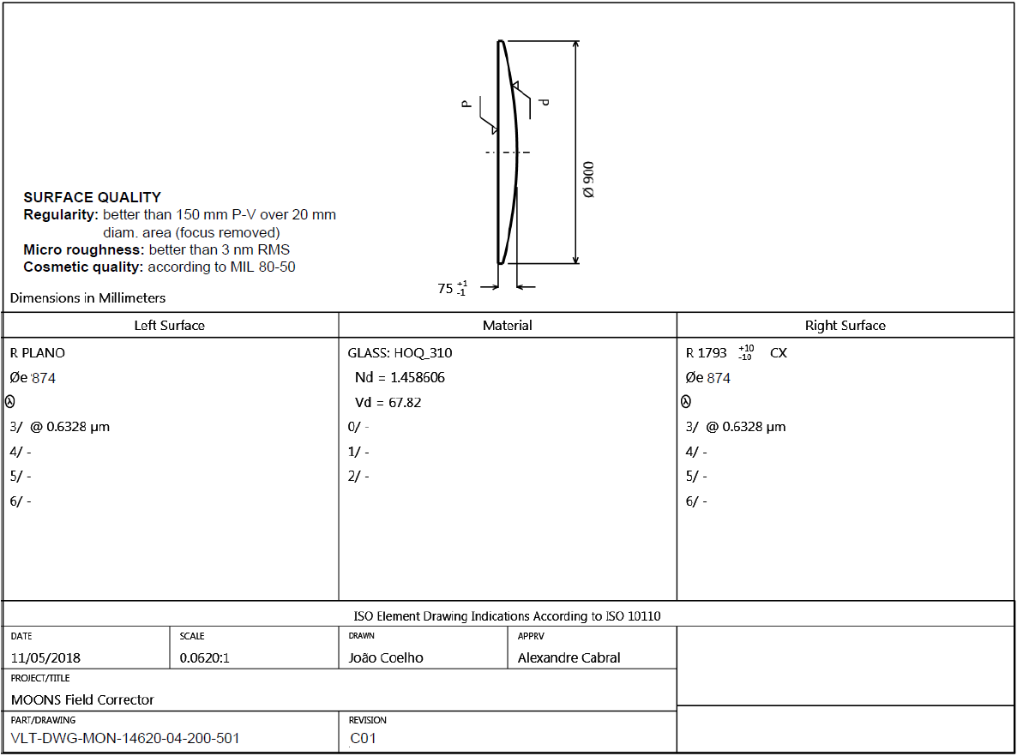

Figure Field Corrector Lens 1. Drawing (VLT-DWG-MON-14620-04-200-501-C01) for information only – not to be manufactured.

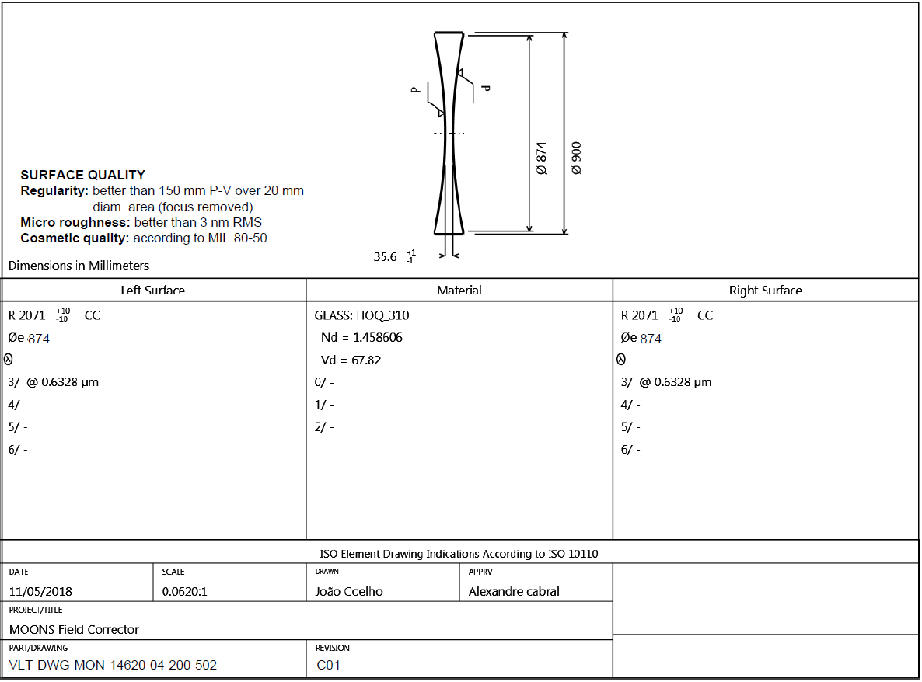

Figure Field Corrector Lens 2. Drawing (VLT-DWG-MON-14620-04-200-502-C01) for information only – not to be manufactured.

# Annex 2 – Mechanical drawings

Corrector barrel assembly and Interface drawings. Note that Figure 4 and Figure 5 are provided for information purposes only and do not represent the final manufacturing drawings, to be delivered by the contractor.

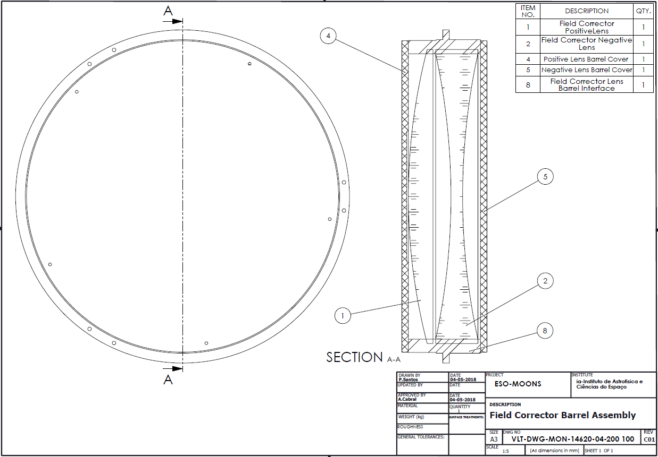

Figure Field Corrector Barrel Assembly. Drawing (VLT-DWG-MON-14620-04-200-100-C01) for information only – not to be manufactured.

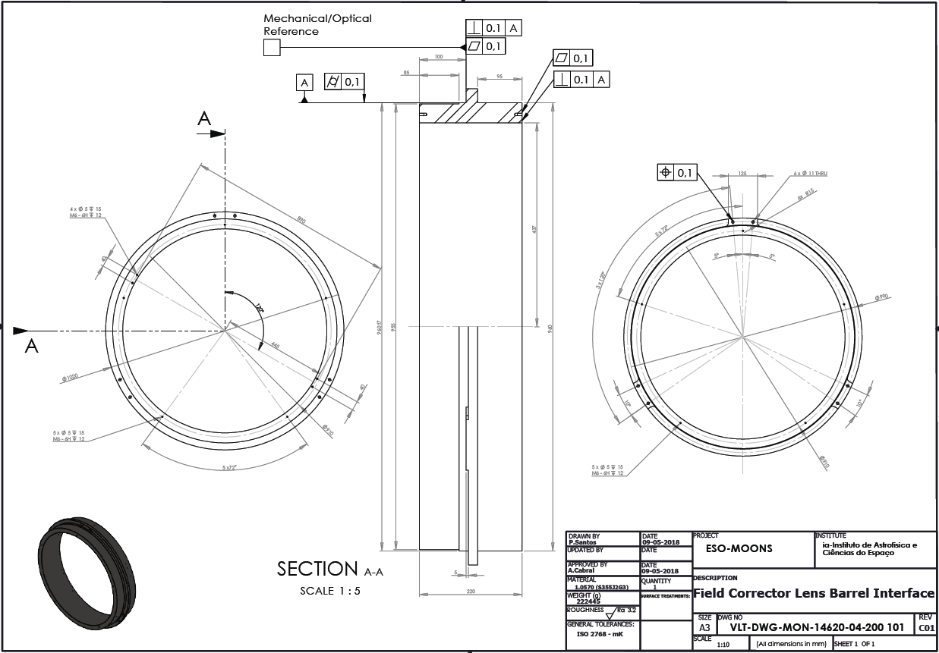

Figure Field Corrector Lens Barrel Interface. Drawing (VLT-DWG-MON-14620-04-200-101-C01) for information only – not to be manufactured.