

Apprenticeship Training Dynamic Marketplace Needs

RM6102 – Apprenticeship Training Dynamic Marketplace



Contents

Welcome 3

What ’we’ and ‘you’ means 5

1. Getting Started - How to Register on the Supplier Registration Service (SRS)? 5
2. How to Request to Participate? 6
3. Selection Process 6
4. Agreeing Process 7
5. Electronic Signature Process 8
6. Selection Criteria: 9
7. Part 2 - Grounds for Exclusion 10
8. Part 3 - Economic and Financial Standing 11
9. Selection Questionnaire – Not Applicable Questions 12
10. What is a Dynamic Marketplace (DMP) Agreement? 12
11. When and How to Ask Questions 13
12. Making the Competition Work 13
13. Updating Answers in the Selection Questionnaire, Dynamic Marketplace Selection

Questionnaire (DPSQ), Generic Prospectus (GP), Apprenticeship Standards specific

Prospectus, and Pricing matrix(s) (where permissible) 16

1. If Bidders Enter into an ‘Assessing’ Status 18
2. If CCS Accept Your DMP Submission 18
3. The DMP Agreement Sign-Off 18
4. Education and Skills Funding Agency (ESFA) Register 18
5. Call for Competition 19
6. TUPE Transfer of Undertakings (Protection of Employment) 19

# Welcome

We invite you to join a Dynamic Purchasing System (DPS) known as the Dynamic Marketplace (DMP) to provide Apprenticeship Training and Related Services for the RM6102 Apprenticeship Training Dynamic Marketplace.

This procurement will be under the Light Touch Regime (LTR) therefore subject to the limited regulation and will be conducted in accordance with regulations 74 to 76 of the [PCR](http://www.legislation.gov.uk/uksi/2015/102/contents/made) [2015,](http://www.legislation.gov.uk/uksi/2015/102/contents/made) and will use the Dynamic Purchasing System (DPS) provided by NQC with a custom built filtering system and includes Supplier prospectus and Pricing matrix(s) submission capability.

**What is a Dynamic Purchasing System (DPS)?**

A DPS is a public sector sourcing tool for common goods and services under regulation 34 (Dynamic Purchasing Systems) of the [PCR](http://www.legislation.gov.uk/uksi/2015/102/contents/made) [2015.](http://www.legislation.gov.uk/uksi/2015/102/contents/made) Bidders can apply to join at any point and don’t require any special IT equipment as a DPS eliminates unnecessary activity for the bidder, up front. The DPS has to be run as a completely electronic process.

This DPS Dynamic Marketplace (DMP) will enable Bidders to submit their Selection Questionnaire (SQ) and their service offering(s) via their Dynamic Purchasing System Selection Questionnaire (DPSQ), with additional information to support suppliers service offering(s) in the form of a Supplier Prospectus and Pricing matrix for each apprenticeship standard and/or End-Point Assessment Standard selected as part of the suppliers SQ submission.

**How will the services within the RM6102 Dynamic Marketplace (DMP) be organised?**

The DMP will be organised into distinct Filters so:

1. Bidders can indicate their services and all elements relevant to their service offering, and
2. Customers can filter the service and elements, use the information in the Supplier prospectus and Pricing matrix to award a contract to a supplier or to produce a shortlist of appointed suppliers to invite to a competition.

The distinct Filter categories comprise of the following:

* Services

o Apprenticeship Standards o End-Point Assessment

* Delivery Methods
* Geographical Location
* Personally Identifiable Information
* Apprenticeship Standard/EPAO specific Prospectus

Customers will have the option to procure supplier services via the following two routes:

* Standard export/ competition process and/ or
* Rapid export/ competition process

Contracts shall be awarded on the basis of most economically advantageous tender ("MEAT") from the point of view of the Customer.

**What is the Bid Pack?**

The CCS participation bid pack includes the following documents:

* **Dynamic Marketplace Needs -** Overview of the procurement, instructions and guidance.
* **Customer Needs -** everything you need to know about what the customer needs.
* **Dynamic Marketplace Agreement (DMP) -** This is the contractual agreement between CCS and you. You will need to agree to electronically sign up to these

T&C’s which are non-negotiable.

* **Attachment 1a -** RM6102 Apprenticeship Training Dynamic Marketplace -

Apprenticeships Services Matrix

* **Attachment 1b -** RM6102 Apprenticeship Training Dynamic Marketplace –

End-Point Assessment (EPA) Services Matrix

* **Attachment 2 -** Management Information (MI) Reporting Template
* **Attachment 3 -** Financial Assessment Template
* **Attachment 4 -** Additional Sub-Contractors - please complete this if you have more than 35 sub-contractors that you are detailing within the Selection Questionnaire. Detail the first 35 in the SQ and any additional sub-contractors over 35 must be recorded on this Attachment 4.
* **Attachment 5 -** Pricing matrix for Apprenticeship Training Providers - please complete for each apprenticeship training you provide.
* **Attachment 6 -** Pricing matrix for End-Point Assessment - please complete for each

End- point Assessment you provide.

* **Attachment 7 -** DMP Schedule 4 - Annexes 1 and 2 - Template Contract Order

Form and Template Contract Terms. This is the contractual agreement between the customer and you and should be inserted into your DMP Agreement at Schedule 4 -

Annex 1 and 2 - following award of a contract.

* **Attachment 8 –** Contract Order Form (information only)
* **Attachment 9a -** (INFORMATION ONLY) Generic Apprenticeship Prospectus Template**:** This is the Generic Apprenticeship prospectus template, all Suppliers will complete if they have confirmed they can provide Apprenticeship standard(s) .
* **Attachment 9b –** (INFORMATION ONLY) Generic End-Point Assessment Prospectus Template: This is the Generic End-Point Assessment prospectus template, all Suppliers will complete if they have confirmed they can provide End-Point assessment for Apprenticeship standard(s).
* **Attachment 9c –** (INFORMATION ONLY) Apprenticeship Service Prospectus template: This is the Apprenticeship service specific prospectus, for each standard a

Supplier has confirmed they can provide. The service 'Advanced golf greenkeeper (in development) - ST0207 - Level 3 has been input as an '**example only.**

* **Attachment 9d –** (INFORMATION ONLY) End-Point Assessment Service

Prospectus template: This is the End-Point service specific prospectus, for each standard a Supplier has confirmed they can provide. The service 'Advanced golf greenkeeper (in development) - ST0207 - Level 3 has been input as an '**example only.**

Make sure you read all the guidance, information and instructions that we provide - they are there to help you to complete your request to participate.

We hope everything is clear - if it is not, we explain in ‘how to request to participate’ when and how you can ask questions.

## What ’we’ and ‘you’ means

When we use “CCS”, “Authority” “we”, “us” or “our” we mean Crown Commercial Service; When we use “you”, “your” or “bidders” we mean your organisation, or the organisation you represent, in this competition.

We are the central purchasing body that procures common goods and services for customers including central government departments and the wider public sector.

The Public Contracts Regulations 2015 regulate how we procure. This means that we and you have to follow processes that are fair, transparent and equitable for all bidders.

**Who can request to participate?**

We are running this competition using the ‘restricted procedure’. This means that anyone who is registered on the Education and Skills Funding Agency (ESFA) and/or the Register of End-Point Assessment Organisations (RoEPAO) can submit a request to participate (submit a bid) in response to the published OJEU contract notice.

We recognise that arrangements in relation to Sub-Contracting may be subject to future change, and may not be finalised until a later date. However, any changes to those arrangements may affect your ability to deliver the RM6102 Apprenticeship Training Dynamic Marketplace requirements, you must therefore tell us about any changes to the proposed

Sub-Contracting. If you do not, you may be excluded from participating in this competition.

We do not require all Sub-Contractors to be disclosed. You need only disclose those

Sub-Contractors who directly contribute to your ability to meet your obligations under the DMP Agreement (including under any Contract Agreement following a Call for Competition). There is no need to specify Sub-Contractors providing general services to the supplier (such as window cleaners etc.) that indirectly enable the supplier to perform the DMP Agreement. Please read the definition of Sub-Contractor in the DMP Agreement.

If you are successfully appointed to the DPS Dynamic Marketplace and are awarded a RM6102 DMP Agreement, any changes to arrangements in relation to Sub-Contracting which are made following the award will be dealt with in accordance with Clause 25 (Supply Chain Rights and Protection) of the DMP Agreement.

## 1. Getting Started - How to Register on the Supplier Registration Service (SRS)?

All Suppliers are required to register on the SRS system prior to submitting a

‘Request to Participate’ (in accordance with the section below ‘How to Request to

Participate’). To register for the SRS system please follow the instructions below:

* ‘register for an account’ at the following link

<https://supplierregistration.cabinetoffice.gov.uk/organisation/register>

* Step 1 - Select ‘Supplier’
* Step 2 – **Click on the DUNS number radio button** (this ensures the correct DUNS number is utilised for your organisation) and complete the required information.

If you are already registered to SRS please ‘sign in’ to your account via the attached link [https://supplierregistration.cabinetoffice.gov.uk/login.](https://supplierregistration.cabinetoffice.gov.uk/login) Please ensure the DUNS number associated to your registration details is the DUNS number you will be using in your

Selection Questionnaire (SQ) at Question Number 4 of the SQ for RM6102.

In the event that your DUNS number does not reflect the DUNS number you wish to use for your RM6102 submission please contact Dun and Bradstreet (D&B) at the following link <https://www.dnb.co.uk/> to make the necessary amendments to your Dun and Bradstreet registration **before** proceeding with your SQ submission for RM6102.

**NB – *When registering at D&B please ensure you include any Trading Names you wish to use for the RM6102 DMP Agreement, as the name you input as part of your***

***D&B registration process will be the name generated when registering on the Supplier Registration Service when using your D&B number (as per Step 2 above)***

## 2. How to Request to Participate?

**Your request to participate must be entered via the Supplier Registration Service (SRS) at: https://supplierregistration.cabinetoffice.gov.uk/dps** We can only accept requests to participate through this route.

You must submit your response in English and through the SRS platform only, further guidance on how to complete the standard Selection Questionnaire (SQ) can be accessed at the following link:

You **must**, in addition, register your organisation on the CCS eSourcing tool to ensure that, if your organisation is appointed to the DPS Dynamic Marketplace, that you are invited to Calls for Competition. Guidance on how to register on the CCS eSourcing tool and how to respond to Calls for Competition through the tool can be found here: [**https://www.gov.uk/government/publications/esourcing-tool-guidance-for-suppliers.**](https://www.gov.uk/government/publications/esourcing-tool-guidance-for-suppliers)

Your bid must be completed by the organisation that will be responsible for providing the services for RM6102 Apprenticeship Training Dynamic Marketplace, if appointed on to the DPS Dynamic Marketplace.

Any supporting evidence will be requested via the SRS and/or CCS Mailbox messaging facility.

Do not upload any attachments we haven’t asked for.

Make sure you answer every applicable question within the SQ.

Only select the services in the SQ that can be delivered by your organisation.

## 3. Selection Process

You must complete and submit your SQ via the Supplier Registration Service.

Once completed your submission will be set to ‘**Assessing**’ status. Following which we will complete further compliance checks of your SQ to ensure you have provided everything that we have requested as part of the selection criteria.

We may seek clarification of any information you provide to validate and verify your responses. Don’t forget to check for messages regularly at frequent intervals in your internal mailbox system (this will be the email address you input to Q104 of the DPSQ (contact details)) throughout the competition.

If you are unsure about how to complete any part of the SQ, you can raise a question via the DPS Marketplace clarification link (on SRS) or through the DPS Mailbox at info@crowncommercial.gov.uk

If we are satisfied with the responses you have provided to the compliance issues we

have raised, your application will move to the

‘**Qualified**’ status (see screenshot below). Following which you will be presented with your generic prospectus which you will only be required to complete once; and an individual prospectus and Pricing matrix for each of the apprenticeship standards you have selected in your SQ submission. To access this generic prospectus you need to click on the ‘Respond’ link as shown on the screenshot below.

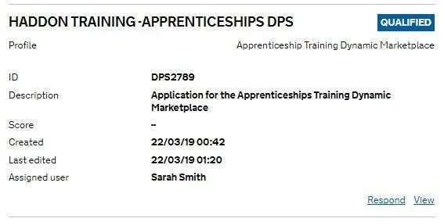

The Pricing matrix template can be accessed in the bid pack for RM6102 at:

* Attachment 5 – Pricing matrix for Apprenticeship Training Providers and/or;
* Attachment 6 - Pricing matrix for End-Point Assessment (EPA)

You will need to download the pricing matrix template(s) ‘Attachment 5’ and/or ‘Attachment 6’ from the prospectus question or from within the bid pack; populate a pricing matrix(s) for each of the apprenticeship services you can provide and upload the pricing matrix(s) for each individual prospectus you complete for each of the service(s) you can provide.

Following completion of your generic prospectus, individual prospectus and completion and upload of your pricing matrix(s) to support each of your service offering(s), your DMP status will change from ‘Qualified’ to ‘Agreeing’.

You will receive a notification via SRS to confirm that your overall DPS submission has entered an ‘Agreeing’ status, which means you will need to accept the CCS Terms and

Conditions electronically, following which your DMP status will change to ‘Appointed’. To support this process, please see the following screenshots and guidance

## 4. Agreeing Process

The screenshot below shows your application on the SRS system, you can see that the blue status box is showing the status of the application as ‘Agreeing’. You now need to select the ‘Agree’ link on the application.

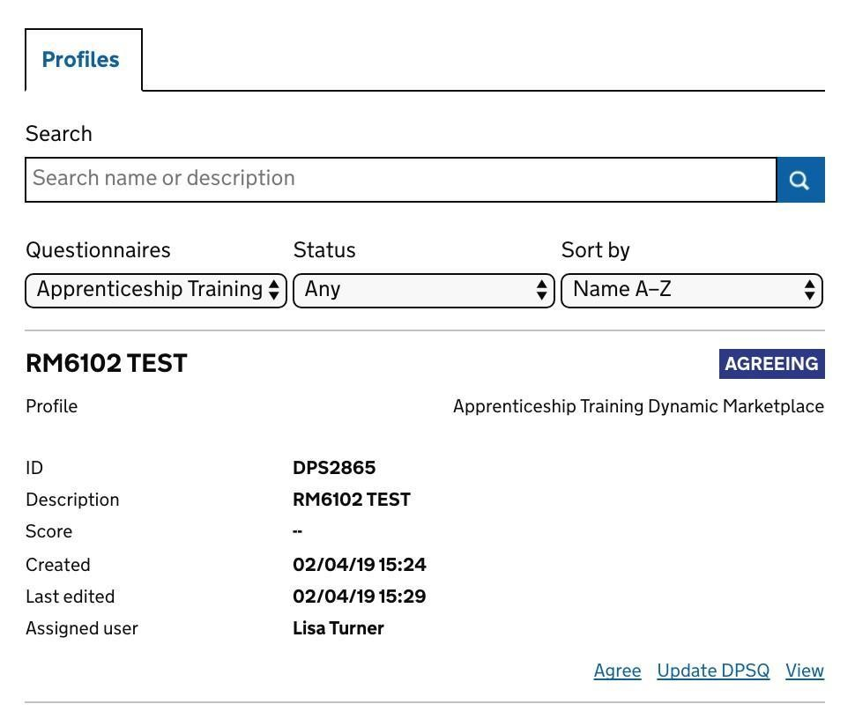

## 5. Electronic Signature Process

1. Once you have clicked on the ‘Agree’ link you will be taken to the page (screenshot below) shown below, here you can review the DMP Agreement, the Privacy statement, your Selection Question, DPSQ, Prospectus responses and the DMP Bid Pack.
2. If you are content to progress, check the ‘I agree’ box and click ‘Join DMP’.
3. This will now change your DMP status to ‘Appointed’.

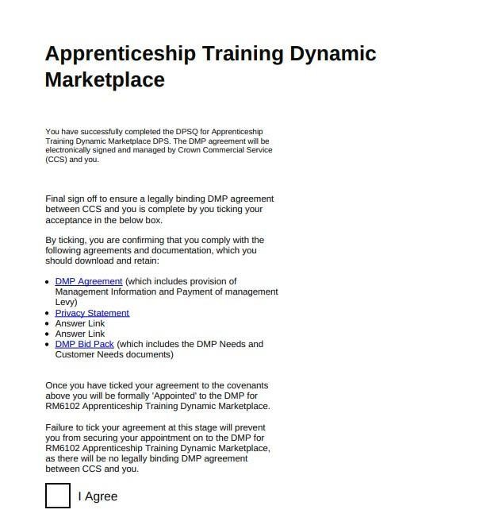

1. We may at any time seek clarification of any information you provide to validate and verify your responses. Don’t forget to check for messages regularly at frequent intervals in the SRS messaging and your internal mailbox system throughout the competition.
2. If you are unsure about how to complete any part of the SQ, DPSQ, Prospectus, and Pricing matrix(s), you can raise a question via the SRS messaging system or through the CCS Mailbox at info@crowncommercial.gov.uk (ensure you insert RM6102 Apprenticeship Training Dynamic Marketplace into the title of the message).

## 6. Selection Criteria:

We may reject your request to participate in the RM6102 DMP at the selection stage for any of the following reasons:

* Fail to accept the terms and conditions;
* Confirm that the Modern Slavery Act applies to your organisation and do not provide evidence of your compliance with that act;
* Do not provide confirmation that you have Cyber Essentials or Cyber Essentials

Plus and upload a valid certificate;

* Do not confirm that you have Employer’s (Compulsory) Liability Insurance of

£5,000,000.00 minimum and upload a valid certificate;

* Do not confirm that you have Public Liability Insurance of £1,000,000.00 and upload a valid certificate;
* Do not confirm that you have Professional Indemnity Insurance of £1,000,000.00 and upload a valid certificate;
* Select ‘Yes’ in response to any of the grounds for mandatory and discretionary exclusion and do not provide sufficient evidence of self-cleaning that remedial action has taken place;
* Are not registered on the APAR (Apprenticeship Provider and Assessment Register)
* Do not upload when requested, a compliant Supplier Prospectus and Pricing

matrix(s);

* Where any of the information you have provided proves to be false or misleading;
* Where you have broken any of the competition rules (as detailed in this Dynamic

Marketplace Needs document), or not followed the instructions given.

In the event that you FAIL any of the above questions this will result in CCS rejecting your SQ submission. Please be aware, this action may be an interim measure only, as you can reapply for the RM6102 DMP at any time, and once you are able to provide the required PASS response to one or more of the questions above.

We will tell you if your bid has been rejected or if your organisation has been excluded at the Selection Stage via the SRS messaging system and/or the CCS Mailbox.

## 7. Part 2 - Grounds for Exclusion

In certain circumstances the Authority is required by law to exclude bidders from participating if you cannot answer ‘No’ to every statement in Part 2 (Mandatory grounds for Exclusion) of the Selection Questionnaire. Your request to participate shall then be excluded from further participation in the SQ (except where disproportionately small amounts of tax or social security obligations are involved).

The Authority is entitled (in its sole discretion) to exclude a bidder from further participation if any of the statements in response to Part 2 (Discretionary grounds for exclusion) of the Selection Questionnaire apply. If you cannot answer ‘No’ to every statement it is possible, that you will be excluded from this request to participate.

**‘Self-Cleaning’ (Covering both mandatory and discretionary exclusion):**

If you provide sufficient evidence that remedial action has taken place subsequently that effectively “self-cleans” the situation, the Authority may decide that you shall not be excluded from this request to participate. As a minimum, you will have to demonstrate that you have:

1. paid or undertaken to pay compensation in respect of any damage caused by any criminal offence or misconduct;
2. clarified the facts and circumstances in a comprehensive manner by actively collaborating with the investigating authorities; and
3. taken concrete technical, organisational and personnel measures that are appropriate to prevent further criminal offences or misconduct.

The measures you have taken will be considered taking into account the gravity and particular circumstances of the criminal offence or misconduct.

The detailed grounds for mandatory and discretionary exclusion of an organisation are set out on this [**webpage,**](https://www.gov.uk/government/uploads/system/uploads/attachment_data/file/551130/List_of_Mandatory_and_Discretionary_Exclusions.pdf) **which should be referred to before** completing these questions in the SQ.

## 8. Part 3 - Economic and Financial Standing

We will undertake an assessment of both you and any named sub-contractors within your SQ submission for economic and financial standing using the DUNS number (as provided by Dun and Bradstreet) for your organisation which you input when registering on the SRS registration system at the following link: <https://supplierregistration.cabinetoffice.gov.uk/organisation/register>

If you indicate as part of the standard SQ that a financial guarantor will be provided, as in the event you do not initially meet the required credit reference agency score as described in point a. below, the Authority will perform an assessment of the proposed financial guarantor’s economic and financial standing.

The report provided by the credit reference agency (Dun and Bradstreet) will be used to determine the level of financial risk you represent. If the score provided by the credit reference agency is **35** or more, then your Request to participate will continue to proceed in the DMP Selection process.

If any of the following circumstances arise:

1. the score provided by the credit reference agency is less than **35** and/or;
2. no standard credit reference agency score is available for your organisation,
3. then the Authority may ask you to provide a copy of your audited accounts for the most recent two years and/or one or more of the following in respect of your organisation or the proposed financial guarantor (as the case may be):

a statement of your turnover, profit and loss account/income statement, balance sheet/statement of financial position and statement of cash flow for the most recent year of trading;

a statement of your cash flow forecast for the current year and a bank letter outlining the current cash and credit position; and/or

an alternative means of demonstrating financial status.

The Authority will use this information as detailed in point (c) above, in addition to a detailed credit reference agency report (where available) to assess whether your organisation’s or your proposed financial guarantor’s financial risk is acceptable. This will be performed using the Authority's financial assessment template that can be viewed at Attachment 3 of the RM6102 participation bid pack, which covers a range of financial risk indicators.

If the Authority then determines that the financial risk is acceptable, then your request to participate will continue to proceed through the DPS Selection Stage process.

If the Authority determines that your financial risk is determined as being unacceptable, then the Authority may (in its sole discretion) request that you nominate a financial guarantor. If you nominate a financial guarantor, a financial assessment will be undertaken of your nominated guarantor. In the event that your nominated guarantor fails to meet the required financial threshold score of **35**, the Authority will undertake the steps as detailed at paragraph (c) above in respect of the proposed financial guarantor.

If, after evaluating all the information requested and provided, the level of financial risk is still deemed unacceptable, or where the requested information has not been provided, **then you will be rejected as an interim measure from further involvement in the RM6102 Apprentice Training Dynamic Marketplace procurement, until you are able to provide the required financial information.**

## 9. Selection Questionnaire – Not Applicable Questions

There are questions in the Selection Questionnaire that are not applicable for this RM6102 Apprenticeships Training Dynamic Marketplace procurement, therefore bidders must please note, a response is **NOT** required to the questions as detailed below:

* Part 2: (Contract Example 2) – Q134
* Part 2: (Contract Example 3) – Q135
* Part 2: (Contract Example) – Q137
* Part 2: Product Liability Insurance – Q143
* Part 3: (Supply Chain Management) – Q147 – Q149
* Part 3: (Past Performance) Q150 – Q154
* Part 3: (DOH Questions) – Q157 – Q161

## 10. What is a Dynamic Marketplace (DMP) Agreement?

A DMP Agreement sets out terms and conditions for bidders satisfying the selection criteria and therefore accepted onto the DMP Agreement and for customers when awarding contracts (competition) throughout the entire duration of the DMP Agreement.

If you are a successful bidder, the RM6102 DMP Agreement will be signed up to electronically and managed by CCS and you. Customers can then use the RM6102 DMP

Agreement to publish calls for competition to meet their individual service requirements.

Each call for competition agreement will be signed and managed by the customer and you. There may be multiple contract agreements under one RM6102 DMP Agreement.

There are general terms and conditions for the RM6102 DMP Agreement. In one of the schedules of the DMP Agreement Schedule 4 (Call for Competition Procedure) sets out the general terms and conditions for the call for competition procedure. You can see the terms and conditions as part of the bid pack for this procurement.

**Timelines for the request to participate**

These are our intended timelines. We will try to achieve these but, for a range of reasons, dates can change as the competition progresses. We will tell you if and when timelines change:

|  |  |
| --- | --- |
| Submission of the OJEU Contract Notice to Tenders  Electronic Daily (TED) | 29/03/2019 |
| Start Date - Open DMP to bidders to request to participate | 03/04/2019 |
| DMP Open to Contracting Authorities for call for competition | 30/04/2019 |

## 11. When and How to Ask Questions

If you have any questions you need to ask them as soon as possible after the publication of the OJEU Contract Notice. This will give you the chance to check that you understand everything before you submit your request to participate via the link detailed above.

You need to send your questions through the SRS supplier messaging system and/or the CCS Mailbox address info@crowncommercial.gov.uk and as detailed in the OJEU Contract Notice, both options can be used to communicate with bidders. Try to ensure your question(s) is specific and clear.

The SRS messaging service and the CCS Mailbox facilitates all messages sent between CCS and you in relation to this DMP. It is the bidders’ responsibility to access messages during this procurement process therefore please ensure that you **access and review messages** through the SRS system and your **internal designated mailbox address** on a regular basis. This will ensure you have sight of all relevant information and have access to all messages that we have sent to you.

If you feel that a particular question should not be published, you must tell us why when you ask the question. We will decide whether or not to publish the question and response or return a response to you confidently via the SRS and/or CCS Mailbox for clarification questions.

Remember that you can ask us questions about the DMP Agreement and contract terms but please do not try to ‘negotiate’ the terms as this is not permitted within the Public Contract Regulations (PCR). All DMP appointments will be made under identical terms.

## 12. Making the Competition Work

We run our competitions so that they are fair and transparent for all bidders. This section (Making the competition work) sets out the conditions of participation for this competition. It needs to be read together with the DMP Agreement and with the Customer Needs.

**What you can expect from us:**

We will not share any information from your request to participate bid with third parties, apart from other central government bodies (and their related bodies), which you have identified as being confidential or commercially sensitive. However, we may share this information but only in line with the Regulations, the Freedom of Information Act 2000 (FOIA) or any other law as applicable.

**What we expect from you:**

Make sure you have read and understood the request to participate and corresponding participation bid pack before you complete the SQ.

Please make sure you have read through all the information available to you. This includes any of the responses provided by CCS to any of your questions raised.

You must comply with the rules in this participation bid pack and any other instructions given by us. You must also ensure (where applicable) members of your Group of Economic Operators or sub-contractors comply also.

You have not fixed or adjusted any element of the response by agreement or arrangement with any other person.

You have only selected the filters for the services that your organisation can deliver.

**Involvement in multiple bids**

If you are connected with another bid for this procurement, we may make further

enquiries. For example, where:

* you submit a bid in your own name which is similar to a separate bid from another bidder within your group of companies.

This is so we can be sure that your involvement does not cause:

* potential or actual conflicts of interest;
* supplier capacity problems; or
* restrictions or distortions in competition.

We may require you to amend or withdraw all or part of your request to participate if, in our reasonable opinion, any of the above issues have arisen or may arise.

**Contracting Arrangements**

Only you, your nominated sub-contractors (as set out in your SQ) can provide services through the RM6102 DMP Agreement.

**Bidder conduct and conflicts of interest**

You must not attempt to influence the Request to Participate process. For example,

you must not directly or indirectly at any time:

* Collude with other others over the content and submission of bids. However, you may work in good faith with a proposed supplier, Group of Economic Operators member or provider of finance in the event that a guarantor is required.
* Canvass our staff or advisors in relation to this competition.
* Attempt to obtain information from any of our staff or advisors about another bidder or bid.

You must ensure that no conflicts of interest exist between you and us. If you do not tell us about a known conflict, we may exclude you from the competition. We may also exclude you if a conflict cannot be dealt with in any other way.

**Confidentiality and Freedom of Information**

You must keep the contents of this bid pack confidential (including the fact that you have received it). This obligation shall not apply insofar as:

* enabling you to submit a bid; or
* compliance with a legal obligation.

**Publicity**

You must not publicise the services or the award of any individual contract unless we have given express written consent. For example, you are not allowed to make statements to the media regarding any bid or its contents.

**Our rights:**

We reserve the right to:

* Waive or change the requirements of this bid pack from time to time without notice.
* Verify information, seek clarification or require evidence or further information in respect of your bid.
* Exclude you if:

you submit a non-compliant bid; your bid contains false or misleading information;

you fail to tell us of any change in the contracting arrangements between your request to participate and appointment onto the DMP. Or, if you do tell us, allowing the change in the contracting arrangements would result in a breach of law; for any other reason set out elsewhere in this bid pack; and

for any reason set out in the Public Contract Regulations 2015.

* Terminate the DMP Agreement at any time.
* Make any changes to the timetable, structure or content of the competition.

**General:**

**Bid costs**

We will not pay your bid costs for any reason e.g. if we terminate or amend the

competition.

**Warnings and**

**disclaimers**

We will not be liable where:

* parts of the bid pack are not accurate, adequate or complete;
* or for any written or verbal communications.

You must carry out your own due diligence and rely on your own enquiries.

This bid pack is not a commitment by us to enter into a contract.

**Intellectual Property Rights**

The bid pack remains our property. You must use the bid pack only for this competition.

You allow us to copy, amend and reproduce your bid so we can:

* run the competition;
* comply with law and guidance;
* carry out our business.

Our advisors, sub-contractors and other government bodies can use your bid for the same purposes.

**13. Updating Answers in the Selection Questionnaire, Dynamic Marketplace Selection Questionnaire (DPSQ), Generic Prospectus (GP), Apprenticeship Standards specific**

## Prospectus, and Pricing matrix(s) (where permissible)

You are able to update your responses as described in the sections below, however please be aware that all bidders who update their service requirements will re-enter into the ‘assessing’ stage, to enable us to monitor changes to submissions to ensure an effective audit trail.

Once you have completed the updating answers process, we will contact you by email from info@crowncommercial.gov.uk to confirm approval of the requested change and to advise that your status is in ‘agreeing’ stage. You are then required to complete an electronic sign off within the supplier registration service portal as directed.

Following completion of above, your status will revert to ‘Appointed’.

#### Assessing

If your organisation enters in to the assessing stage as detailed at ‘*If Bidders enter into an ‘assessing’ stage*’ as below, and following our assessment of your Selection Questionnaire, if CCS are not satisfied with the response(s) you have provided, we will transfer your organisation from the ‘Assessing’ stage to ‘registered 1’ stage.

Once your submission has been returned to ‘registered 1’ stage, you will be able to update your answers to ‘quality Assessment – Section 1’ and ‘Quality Assessment – Section 2’ of the DPSQ section of the Selection Questionnaire.

To update these answers select the ‘Respond’ option which can be located on ‘Your Dashboard’ by setting your ‘Questionnaires’ filter to ‘Apprenticeship Training Dynamic

Marketplace’, and your ‘Status’ filter to ‘Registered 1’.

All your previous answers will be pre-populated and you can navigate through the SQ, DPSQ, Prospectus and Pricing matrix(s) where you can amend your response(s) as appropriate and re-submit your submission to CCS for further assessment.

#### Agreeing

If your organisation successfully meets all of the selection criteria for the RM6102 Apprenticeship Training Dynamic Marketplace, your submission will automatically be directed to the ‘Qualified’ stage. Where you will be able to complete generic template prospectus(es) and Apprenticeship standard/EPA prospectus(es) for your services. Upon completion of all prospectus data Supplier’s will automatically be directed to the ‘Agreeing’ stage, where they can confirm their agreement to the Terms and tick to agree and selecting to join the DPS.

If your organisation does not successfully meet all of the selection criteria your

submission will be directed to the ‘Assessing stage:

* If CCS fail your assessment your submission will be directed to Q1 of the DPSSQ (Registered 1 stage), here you will be able to update all required answers and revisit the entire DPSSQ and then resubmit your questionnaire. If you have met all of the selection criteria you will be automatically directed to the ‘Qualified’ stage, where you will be able to complete generic template prospectus(es) and Apprenticeship standard/EPA prospectus(es) for your services. Upon completion of all prospectus data Suppliers will automatically be directed to the ‘Agreeing’ stage, where you can confirm agreement to the Terms and tick to agree and select to join the DPS.

*N.B. If you have not met the selection criteria you will again be directed to the ‘assessing’ stage and the above will repeat if CCS fails the submission again.*

* If CCS pass your assessment your submission will be directed to the ‘Qualified’ stage where you will be able to complete generic template prospectus(es) and Apprenticeship standard/EPA prospectus(es) for your services. Suppliers will be able to locate their ‘Qualified’ submission from their dashboard by setting their Questionnaires filter to ‘Apprenticeship Training Dynamic Marketplace’ and the status filter to ‘Qualified’. Upon completion of all prospectus data Suppliers will automatically be directed to the ‘Agreeing’ stage where they can confirm agreement to the Terms and tick to agree and select to join the DPS.

#### Appointed

If your organisation is successfully appointed to the DMP, you can update your answers and/or contact details provided in the ‘Quality Assessment – Section 2’ only of the DPSQ section of the Selection Questionnaire.

To update your answers in the above section, select the ‘View’ option on your DMP submission, which can be located on ‘Your Dashboard’ by setting your ‘Questionnaires’ filter to ‘Apprenticeships Training Dynamic Marketplace ’, and your ‘Status’ filter to ‘Appointed’.

By completing the above process, you will be navigated to an overview of your answer sheet, where you are required to select ‘Update Apprenticeships Training Dynamic Marketplace DPSQ , Prospectus and Pricing matrix(s)’ from the ‘Options’ section on the right hand side of the screen.

All your previous answers will be pre-populated and you can navigate through the DPSQ, Prospectus and Pricing matrix(s), where you can amend your response(s) as appropriate and re-submit your submission to us.

#### Qualified

You are NOT able to update your service offerings from the 'Qualified' stage of the DMP; and would therefore be required to complete any outstanding fields within your submission, which will progress you to the 'Agreeing' stage of the DMP process.

Once you have entered the 'Agreeing' stage and accepted the CCS Terms and Conditions; as detailed in section 5 of this READ First DPS Needs document you will become 'Appointed' to the DMP.

CCS will then temporarily reject your submission, which will allow you to be re-directed to the DPSQ; where you will be able to update your service offerings; resubmit your DMP submission and become reappointed to the DMP.

## 14. If Bidders Enter into an ‘Assessing’ Status

If a bidder enters into the ‘assessing’ status, CCS undertake the necessary review of bidder responses to the SQ to determine which question(s) has triggered a risk flag.

CCS and the bidder have a maximum of fifteen (15) working days to work jointly to rectify the issue where possible in accordance with Regulation 34 (Dynamic Purchasing Systems) of PCR 2015.

In the event that the issue cannot be rectified within the 15 working days, CCS will ‘reject’ the bidders DPS submission as an interim measure whilst the necessary further actions are undertaken. The bidder can then reapply to join the DPS within a timescale specified by the Authority via the SRS platform.

## 15. If CCS Accept Your DMP Submission

Once a bidder response has been fully electronically assessed and is considered as having met the published selection criteria, they will be appointed onto the DPS Dynamic Marketplace.

## 16. The DMP Agreement Sign-Off

If you are a successful and therefore ‘appointed’ on to the DMP, the RM6102 DMP Agreement will be electronically signed and managed by CCS and you.

The RM6102 DMP Agreement Terms and Conditions that you agreed to comply with

at the beginning of the SQ, will require your final sign off.

To ensure a legally binding RM6102 DMP Agreement between CCS and you is complete, you must select ‘Yes’ in the required box on the summary page that you are presented with at the end of the SQ and prior to appointment.

Failure to select ‘Yes’ at this stage will prevent you from securing your appointment on to the DMP for RM6102 Apprenticeship Training Dynamic Marketplace as there will be no legally binding RM6102 DMP Agreement between CCS and you.

### 17. Education and Skills Funding Agency (ESFA) Register

* Bidders should ensure their ESFA registered company organisation name should be identical to the name registered to the RM6102 DMP, ensuring any commas, capital letters etc. are identical and included.
* Additionally, bidders should also ensure the Dun and Bradstreet number (DUNS) registered to ESFA, is the same number used in their RM6102 DMP registration and submission.

In the event that both points above aren’t adhered to, your submission will enter into a 'DISABLED' stage, which will require further assessment by CCS.

### 17a If a Bidder is No Longer on the ESFA Register

CCS requires bidders to tell us if you are no longer on the ESFA register.

If a bidder is flagged as no longer being on the ESFA register, they will proceed to the 'Disabled' stage.

Upon entering the 'Disabled' stage, the bidder will see a prompt/notification, advising them to contact CCS at the info@ address, to confirm that they have been re-instated / are back on the ESFA register or to provide details as to why they have been removed from the ESFA Register.

CCS will contact the bidder to confirm their position. CCS will transfer the bidder from the 'Disabled status', once we are satisfied that the bidder may re-enter the DMP, having received clarification from the bidder and ESFA.

Upon 're-instating' a bidder from the 'Disabled' stage, the bidder will re-enter the

DMP at DPSQ 'Registered 1' stage, whereby their previous answers will be pre-populated.

The bidder will need to review that all previous answers are still accurate and re-enter all set workflow acceptance criteria checks, before once again either being accepted and proceeding to the 'Agreeing' stage, or not being accepted and being sent to 'Assessing' for CCS evaluation.

### 18. Call for Competition

Customers may award contracts ‘initially’ under the following 2 procedures undertaken in accordance with the RM6102 DMP Agreement Schedule 5: Call for

Competition Procedure.

1. Rapid Award Procedure this option allows the Customer to use the service filters along with the Suppliers Prospectus and Pricing in order to make a Rapid award(s) to a Supplier(s) who meets their service requirement.
2. Standard Award Procedure this option allows Customers to use the customer Apprenticeships standards service filters to select their specific service requirements. Following which, Customers will export a supplier list and invite the selected suppliers to undertake a capability assessment and/ or to a competition with 2 days (48 hours) of exporting the supplier list. (*If the Customer fails to invite selected suppliers within the 2 day (48 hour) period the customer will be required to use the service filters again and export a new supplier list.)*
3. Future contract award procedure – online

As part of the Governments initiative to transform to digital, CCS intends to implement a fully online digital solution for the RM6102 DMP Agreement. Therefore in accordance with clause 19 of the DPS Agreement and clause 2.2 of Schedule 5: Call for Competition, CCS intends to develop an entirely online call for competition procedure and will also develop an online Contract Award Procedure, Suppliers appointed onto the Dynamic Marketplace will be advised accordingly.

### 19. TUPE Transfer of Undertakings (Protection of Employment)

We consider that the Transfer of Undertakings (Protection of Employment)

Regulations 2006 (“TUPE”) may apply at the Call for Competition.

It is your responsibility to take your own advice and consider whether TUPE is likely to apply in the particular circumstances of the contract and to act accordingly, you are therefore encouraged to carry out your own due diligence exercise.

**20. DMP Services Refresh**

CCS will undertake a monthly refresh of all apprenticeship standards within the DMP, to

ensure apprenticeships standards fully align with those specified at <https://www.instituteforapprenticeships.org/> in accordance with the reform programme at <https://www.gov.uk/government/publications/removal-of-apprenticeship-frameworks>.