**Abstract**

Oracle abstract allows suppliers to view published tenders by Durham University and their associated status.

Durham University is not a contracting authority for the purposes of the UK Public Contracts Regulations 2015 (as amended) and its procurement activities are not subject to the Public Contracts Regulations (PCR) 2015 or the obligations under the European Public Procurement Directives, including the European Remedies Directive.

Advertisement of any Contracts Finder is at the sole discretion of the University and is undertaken on a voluntary basis with no implied obligation to comply with the procurement legislation.

To view published negotiations by Durham University, follow the link:

<https://ehjb.fa.em2.oraclecloud.com/fscmUI/faces/NegotiationAbstracts?prcBuId=300000003996095&_afrLoop=95342440739222388&_afrWindowMode=0&_afrWindowId=1axe683war&_adf.ctrl-state=rie7esos8_1&_afrFS=16&_afrMT=screen&_afrMFW=1488&_afrMFH=750&_afrMFDW=1536&_afrMFDH=864&_afrMFC=8&_afrMFCI=0&_afrMFM=0&_afrMFR=120&_afrMFG=0&_afrMFS=0&_afrMFO=0>

To view relevant negotiation content, select Details on the Negotiation Abstracts screen.

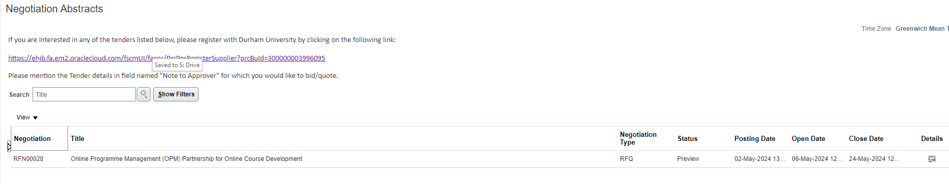

Within the Abstract, you will have access to the description of requirements under Synopsis, any preview dates set, the open date and close date. You will also be able to download all attached documentation in support of the tender negotiation.

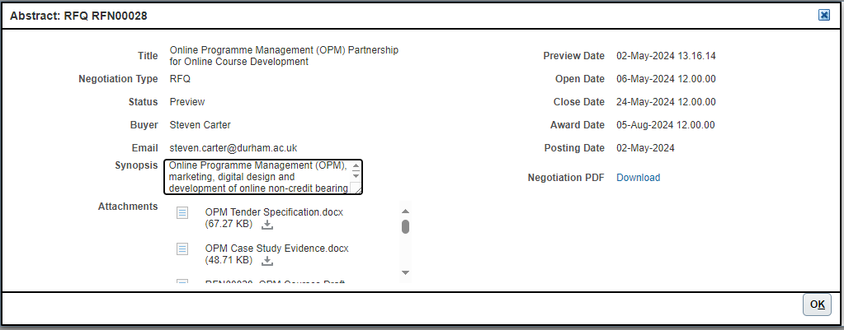

Note: You cannot apply or respond to the tender negotiation from this screen. You will need to register as a supplier using the link contained on the Negotiation Abstracts main screen.

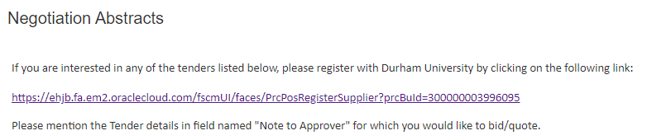

The link to register as a supplier is: <https://ehjb.fa.em2.oraclecloud.com/fscmUI/faces/PrcPosRegisterSupplier?prcBuId=300000003996095>

At the Register Supplier main screen, populate all required fields marked with *

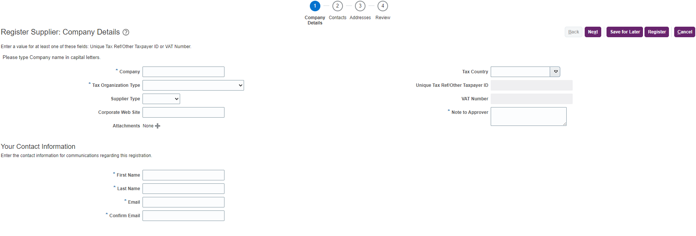

Please include your Tax country and Unique Tax ref/Other Taxpayer ID and or your VAT number. When populating the VAT Number you should remove any hyphens, spaces etc. This must be a whole number with the relevant country prefix.

Within the Notes to Approver, enter in the RFN number relating to the tender negation you wish to apply for. This will ensure your registration is processed to the relevant negation and preventing any delay in you obtaining access to the tender.

Navigate through all sections / stages through 1 to 4 and complete.

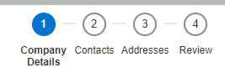

At any stage in the registration process you can pause and return later by selecting Save for Later. Once you have completed all stages, select Register.



See guidance: Supplier Registration regarding follow on information once Durham University process your supplier registration.