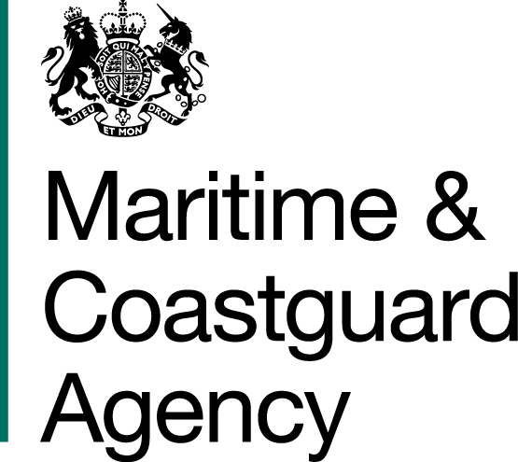 |  |  | Bay 3/19  Spring Place  105 Commercial Road  Southampton  SO15 1EG
 | To whom it may  Concern, |  | Tel:  E-mail: | +44 (0)20 381 72984  contracts@mcga.gov.uk
 |  |  | Our ref: |  | TCA 3/7/1134
 |  |  | 20th November 2019

INVITATION TO TENDER FOR OIL RECOVERY AND CONTAINMENT SYSTEM

You are invited by the Secretary of State for Transport (from now on referred to as "the Authority") to submit a tender for the above contract.

One original and one copy (so marked) of your tender and proposals, including any covering letter, will be required. Your Tender Price should be entered onto the Price Schedule included within the documentation.

Tenders must be delivered by 11.00 hours on 20th December 2019.

Late tenders will not be accepted, and it is your responsibility to ensure that your tender is received on time.

As part of your tender you should supply the following: -

- The MCA’s Form of Tender, signed and dated by an authorised representative of the tendering organisation;
- The MCA’s provided Price Schedule;
- An outline description of how the tenderer will meet the requirements of the MCA.

SHOULD YOU BE SUCCESSFUL, THESE DOCUMENTS AND ANY SUBSEQUENT CORRESPONDENCE BETWEEN YOU AND THE DEPARTMENT WILL FORM A BINDING CONTRACT BETWEEN YOU AND THE AUTHORITY.

Please read all the documents listed in the Form of Tender. To ensure that all tenderers have access to the same information you can only obtain further information about contractual issues and Technical Information from me (The Contract Officer). All requests must be submitted in writing to me at the above e-mail address.

Yours sincerely,

Gillian Norris
MCA Procurement & Contracts Team

