**Call-Off Schedule 5 (Pricing Details and Expenses**

**Policy)**

**1. Call-Off Contract Charges**

The charges for the contract will be as follows:

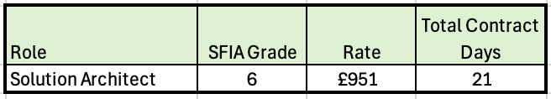

1.2 The Supplier will provide a detailed breakdown of its Charges to enable the Buyer to verify the accuracy of any invoice submitted to be billed monthly on a Time and Materials basis.

●

**Annex 1 (Expenses Policy)**

**Not applicable**