**Community Reablement Service - Soft Market Testing**

**Background**

This document is intended for information purposes only and will be used by West Sussex County Council’s (WSCC) contracts and commissioning service to understand Provider interest. This document does not form a legally binding contract and is not a statement of intent to enter into a contract with any Provider.

Please note that this is not the commencement of a procurement process and Providers are expressing an interest to receive further information on these services and take part in soft market testing which follows on from previous activity earlier in the year. Should any procurement arise from this, a separate notice and information will be provided.

WSCC is anticipating that a procurement process will be undertaken in Summer 2024 with a view to new arrangements commencing on 1st April 2025. WSCC is seeking the views of registered support Providers to further ascertain the level of interest in providing support to customers who would benefit from Community Reablement Services within the county of West Sussex.

**Details of Services in scope**

*Community Reablement Service:*

A Community Reablement Service Provider will offer a countywide service and will receive referrals and provide reablement support within a customer’s home within 24 hours of acceptance. Those suitable for reablement will be from both the hospital discharge and community referral pathways. The customer will have a reablement plan that is asset-based and outcome-focused, to be implemented by the service provider with a move away from “time and task” activity.

The reablement package will be time limited (up to 6 weeks) and will:

1. Right-Size the package of care and, throughout the reablement period, reduce the package of care as the customer develops their resilience.
2. Provide reablement-focused support to promote independence, significantly reducing the support package and reabling the customer so they no longer need care and support to live at home.

A Community Reablement Service Provider may also have to provide domiciliary care for people who have some ongoing care needs at the end of their reablement period whilst a suitable package of care is sourced from the WSCC Domiciliary Care Framework.

**Aims**

The aim of this Market Engagement Questionnaire is to support the re-commissioning of the Community Reablement Service that supports a WSCC and NHS jointly agreed vision and model for intermediate care services, seeking to improve how services are arranged and delivered operationally to provide the most effective service and the best use of combined assets.

The findings of this exercise will further inform our thinking around the opportunities for commissioning and procurement of the service. Any information provided will be treated as ‘Commercial-in-Confidence’ and will be considered by local authority commissioners in such a way as to ensure that it is non-attributable to any particular provider. Opportunities for group based or individual organisation discussion with Providers who respond may follow this exercise.

Please can you respond to the questions listed below by latest, **12pm on Wednesday 5th June 2024.** Please submit your completed document via email to [acdcescontractmanagement@westsussex.gov.uk](mailto:acdcescontractmanagement@westsussex.gov.uk) including “Soft Market Testing” in the subject line.

**Name of Provider submitting response:** ………………………………………………

**Name of person submitting response:** …………………………………………………

**Email address for future contact**: ……………………………………………………….

1. **Price and Volumes**

Please provide your price per hour for the corresponding number of reablement hours per week to be delivered to customers. A range is acceptable. It is requested that you base the prices you insert below on an all-inclusive cost for standalone, county wide Community Reablement provision (please see Appendix 1 for Map of West Sussex) for a multi-year contract between 4-6 years in duration.

|  |  |
| --- | --- |
| **Hours per week** | **Price per hour** (approximate – sharing a range is acceptable) |
| 500 | **£** |
| 1000 | **£** |
| 1500 | **£** |
| 2000 | **£** |
| 2500 | **£** |
| 3000 | **£** |

1. **Factors influencing price**

Please outline any factors that have influenced the prices per hour you have inserted in Question 1, e.g. what kind of minimum contract length these would apply to.

1. **Other considerations**

Please outline any other considerations you would have in reviewing a potential opportunity for Community Reablement Services, that you would like to raise as part of your survey response.

Thank you for your engagement and participation. The Council will provide alerts regarding the tendering of services via the Procurement portal.

***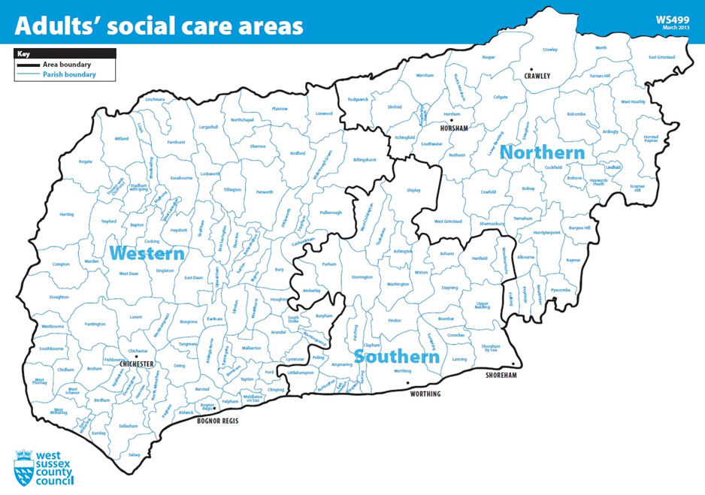*Appendix 1: Map of West Sussex – Adults’ Social Care Area**