Wednesday, 23 January 2019
The Charles Burrell Museum is seeking costs for an architect to work with the Trustees and Historic England to restore the Charles Burrell Museum which was a former paintworks

TTC/19/100
The Charles Burrell Trustees have been invited to apply for a development grant from Historic England for the renovation of the Charles Burrell Museum (Formerly Listed as: Workshop to SW of No.8 (later Lambert's Coach Works). Grade II. MINSTERGATE (South West side). Thetford Town Council will be managing the project on behalf of the Trustees and Breckland District Council who are supporting the project.

Historic England have advised that the Trustees initially appoint their lead adviser and then put in the application for the development grant based on the figures provided by the selected architect/surveyor. The successful candidate will need to be conservation-accredited by one of the following bodies:

The AABC (Architects Accredited in Building Conservation)
The RIBA (accreditation category SCA or CA, depending on the listing grade of the building)
The RICS (Royal Institution of Chartered Surveyors)
The CIAT (Chartered Institution of Architectural Technologists)

The Partners are looking for a price to cover the two stages, beginning with what is known as project development, and then the following second stage which is the completion of the actual repairs.

The purpose of the project development stage is to identify as accurately as possible what the building defects are, the urgency and cost of dealing with them, and any constraints that might apply.

Most of the costs in the project development stage will be the fees for professional advisors. For simple projects, only one may be needed, such as an Architect or Surveyor, but others may also require a Structural Engineer, a Quantity Surveyor, or other specialists. Where more than one advisor is needed, the Architect or Surveyor will be the Lead Advisor, co-ordinating their work.

Providing a range of surveys such as a condition survey accompanied by investigation of the building (i.e., opening up and examining unseen or previously inaccessible areas).

Any further specialist surveys to confirm whether factors exist which could affect the way the repairs are carried out, or their timing, or which could pose problems during the repair stage such as danger to the workforce, delays, and additional costs. For example, the presence of bats, asbestos, or a defective electrical and heating system.

Identifying the repairs needed, drawing up a specification, and obtaining tenders for them either as one phase of work, or the first of several more to follow.

In some cases, there may be a need for some emergency work that cannot wait until the main repairs begin, such as propping a collapsing wall. This can be included in the project development phase.
Presenting the results of the tenders methodically in a Tender Report, accompanied by all the other reports resulting from the surveys.
Confirming all the costs of the intended repairs and the professional services associated with them.
A percentage fee for managing the completion of any works including ensuring all health and safety legislation is complied with throughout the project.
Quotation Requirements
Please can you complete the following table
FEE QUOTATION OR TENDER from
please complete each box with bold outlines
Date:
VAT charged
Yes*/No
* if yes, please
include
in figures below
Condition Survey
£
incl VAT
Drawings
if in-house
£
incl VAT
Drawings
by others?
Yes*/No
*if by others, no cost needed at present
Fee % for normal services on the whole
project
(development and repair)
Actual fee for normal services
in the development
assuming repair costs…
stage only
↓
Up to £50,000
%
£
incl VAT
Up to £100,000
%
£
incl VAT
Over £100,000
%
£
Incl VAT
Fee Apportionment
% (e.g: 60/40)
development/repair stage
/
Expenses
if additional to above:
£
fixed/up to?
incl VAT

Additional essential information for shortlisting
- Details of how your company and the staff you employ meet the requirements for Architects laid out by Historic England. Evidence to include CVs, and details of accreditations and membership of professional bodies.
- Minimum of 2 examples of projects completed on historic buildings particularly working with Historic England and details of two referees.
- A costed quotation for the works which gives a breakdown of costs for development and implementation phase (See table above).
- The council requires a copy of your public liability insurance, and a copy of health and safety policy, and samples of risk assessments.
- Costs of any additional surveys/works not included in the table above.

Failure to supply any of the information requested in the attached specification will result in the Tender being rejected.

Please note at this point no funds have been secured for this project and it will not start until a development grant has been received from Historic England

Contact name and number: Roz Barnett, Amenities Land and Property Officer, 07553 388552 (01842) 754247.

Quotations to be received by noon, Friday 22th of February 2019.

Tender to be sent in sealed inner envelopes to be clearly marked
‘Tender – Charles Burrell Museum Architect
For the Attention of the Town Clerk, Thetford Town Council

Postal Address The Carnegie , Thetford, Norfolk, IP24 2DS
Tel: (01842) 754247

Details of the winning contract will be published IAW Local Government Transparency Code 2014.

Should you require further information over and above the tender requirements then please do not hesitate to call.

Yours sincerely

Tina Cunnell BSc (Hons)
Town Clerk

THETFORD, Charles Burrell Museum (Formerly Listed as: Workshop to SW of No.8 (later Lambert's Coach Works). Grade II. MINSTERGATE (South West side)
Listing description: Paint and finishing shop to Burrell & Sons, Engineers. Now a museum. 1846-7. Brick, flint and ashlar with a metal-framed front facade supporting 7 bays of double timber doors. Frame is tensioned by adjustable cross bars. Felt roof. The double doors each have 4 glazed upper panels. Continuous clerestory on 3 sides of upright glazed panels. Segmental roof. INTERIOR: roof is supported on Belfast trusses. (Crosby: A History of Thetford: Chichester: 1986-: 114).

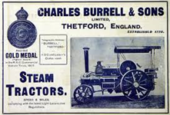

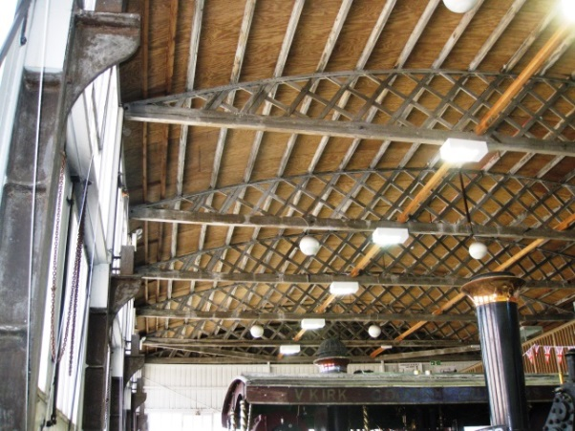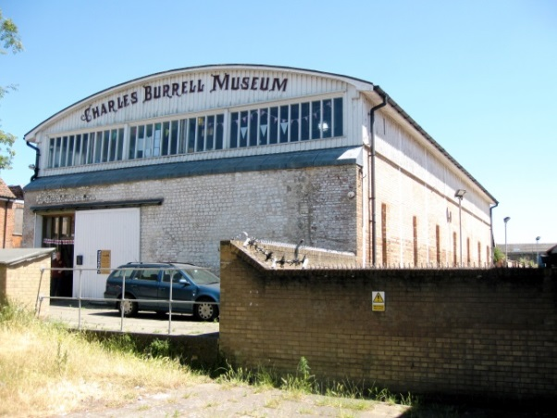
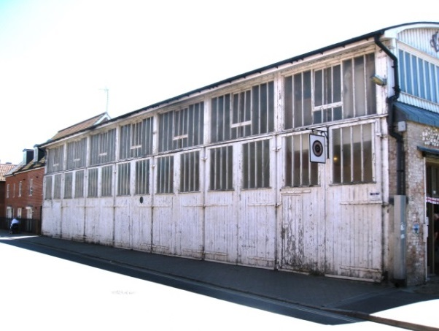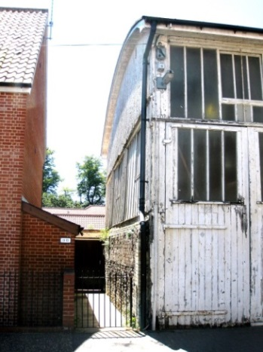

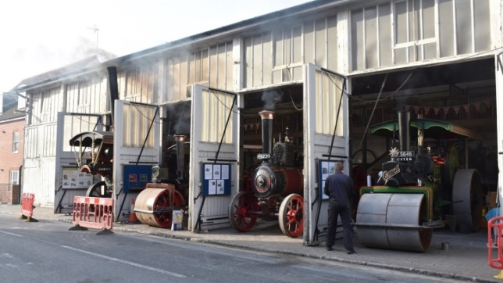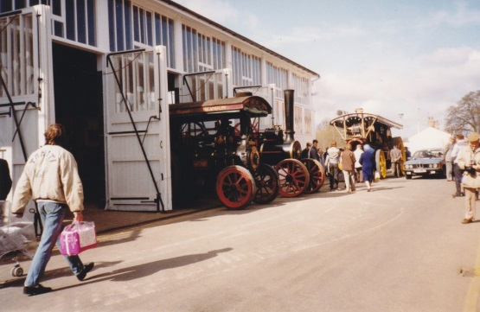

Note – the “ashlar” is coursed clunch blocks. The building is within a Conservation Area “at risk”. More of Burrell’s Factory survives opposite the Museum, but of a different character: brick with pantiled roofs.

There are concerns about the poor condition of the timberwork (rotting on street elevation) and rotation (leaning) of the south wall. The condition of the felt roof is unknown (The original roof may have been felt).

Interventions to the interior (the café, entrance lobby, viewing and exhibition gallery) are identifiable as additions, are reversible, and have not involved the removal of any structure.

If the dating is correct and the roof structure is original, this could be the earliest known example of this type of roof truss, and possibly justify an upgrading to 2*. The first known reference to a true “Belfast truss” is 1866 in The Dublin Builder, although present writers have referred to the development of a variety of timber truss types early in the C19. Separate notes on this are available.

This is an early example of how functional requirements influenced construction technology and design. The results were new forms of buildings that in the C20 were recognised as progressive architecture in their own right and ended the distinction between architecture and engineering – or, to put it another way, engineering was recognised as the language of a new architecture.

Consider…
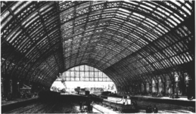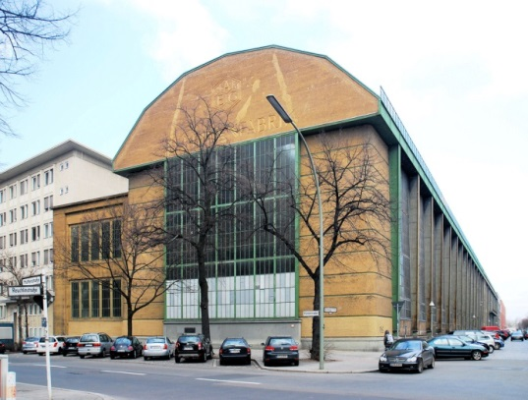
William Barlow’s train shed, 1868 ( St Pancras), Peter Behren’s AEG buildings 1909/1911(Berlin),

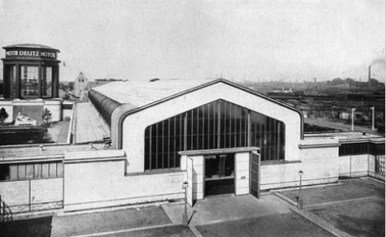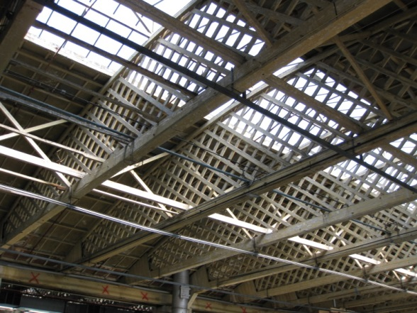
Gropius and Meyer’s Model Factory, 1914 (Cologne) WW1 hangers with similar “Belfast” trusses, eg Hooton (Wirral) which HE as EH has grant aided. Others exist, e.g at Duxford (Cambs).

MS
Version 25.10.18

