Employers Requirements

- LDNPA Design Principles and Concepts

- LDNPA Standards and materials

- LDNPA Style Guide
  - Trail Surfacing
  - Bollards and Signage
  - Gates and Fences
  - Drainage

- Contractors Design – Bespoke elements

- Health and Safety

LDNPA Design Principles and concepts
Route will be designed as predominately hard surfaced, accessible path. Design considerations are:
- Safety – access / egress points to and from highway
- Alignment – follow the landscape and use natural lines to blend in
- Structures – bridges / ramps, fit with surroundings
- Surfacing – suitable for horses, cycles, push chairs and mobility scooters
- Drainage – surface water - as appropriate for ground conditions
- Access furniture, gates – ease of use, bridleway width
- Way marking and signage – easy to follow, appropriate warning signage
- Materials – local province for stone
- Disturbance – Minimise and mitigate by:
  - Restoration and rebuilding the route on existing infrastructure
  - Creating new build sections through areas of lowest ecological value
  - Retain historic features

Standards and materials
Construction standards and materials will conform to the relevant British Standard or Eurocode.
Stone is to be non-calcareous and of a local geological provenance for the area. Stone must come from quarries with appropriate planning permissions.
Timber is to be sustainably sourced, hard or softwood as appropriate and treated. Graded as appropriate for end use.
Steels and fabrication to be supplied and undertaken by appropriately certified companies
Recycled materials:
- Road plainings, scalping and other recycled stone products are not considered appropriate.
- Recycled rubber surfacing may be appropriate for small sections of path in high wear areas – where used this will be an appropriate and approved proprietary product.
- Recycled plastic products may be used in geogrid and for bridge decking

Style Guide -
- Trail surfacing
Aggregate Path
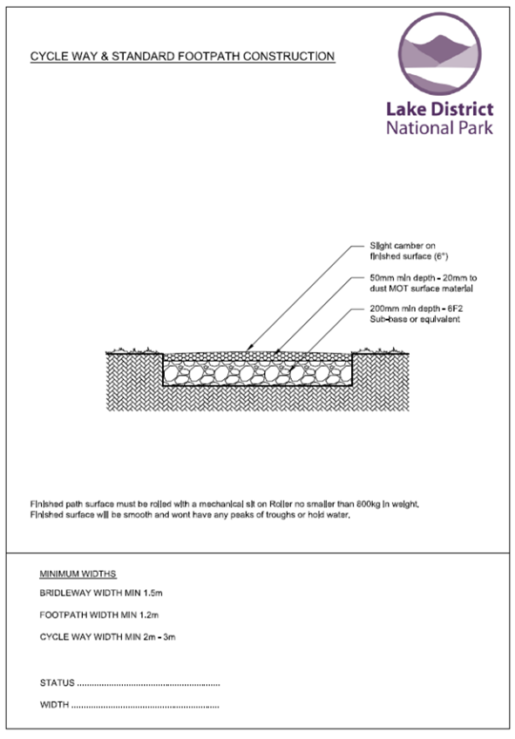 | 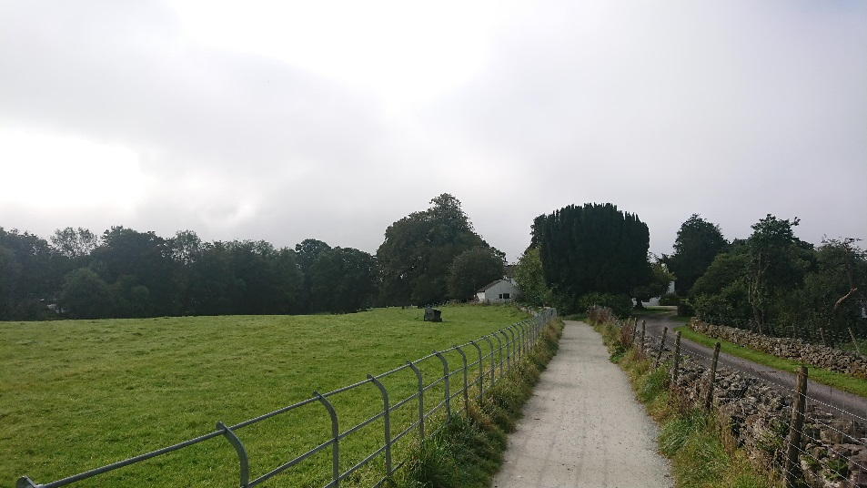
 | 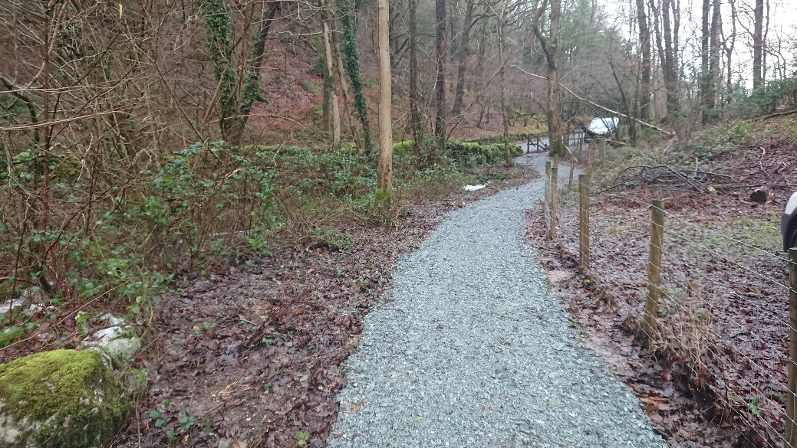
Open country – fields / lanes, new build and restoration | Examples – Cycleway / Bridleway (fencing type indicative only - specified seperately)

Root Protection Path
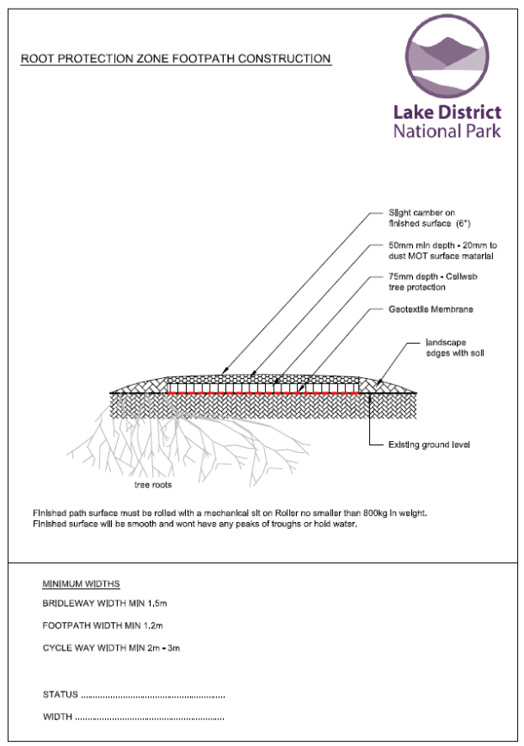 | 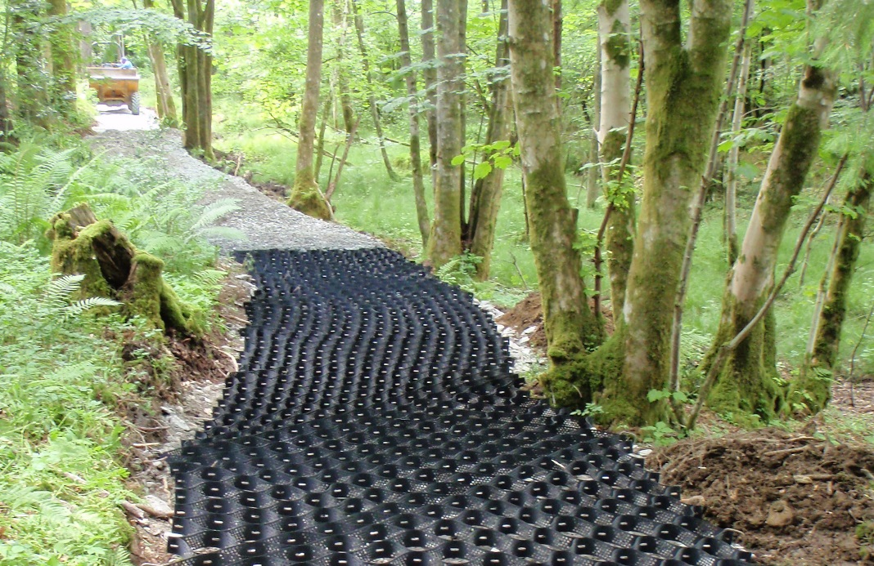
 | 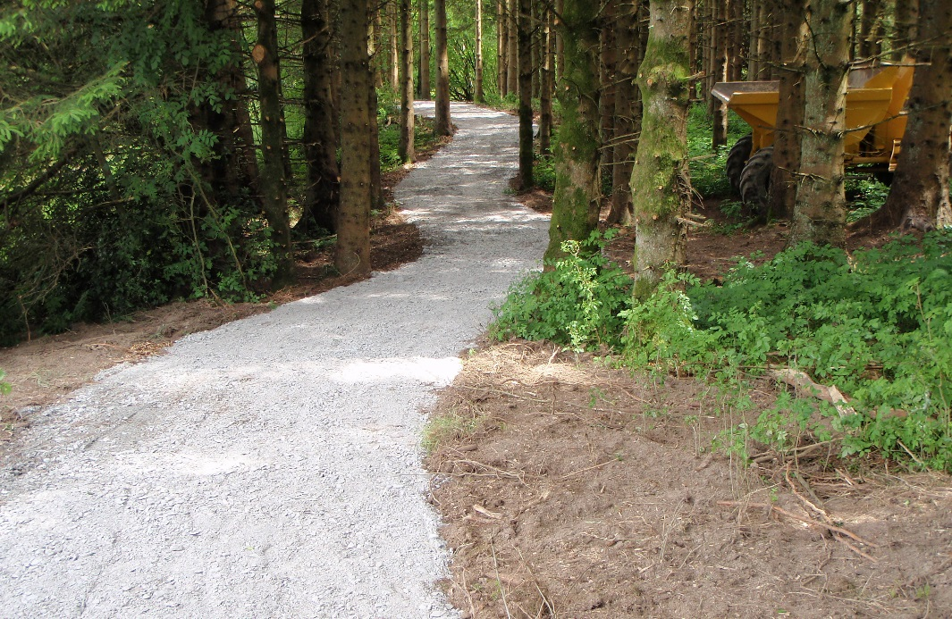
Woodland areas | Root protection path – under construction (top) and finished (bottom)

- Bollards and Signage
Timber Bollard / Warning Sign
Warning signs  1400mm  Steel sleeve  Routed Lettering  1400mm  600mm  150mm  1500mm  1500mm  Bollard from roadside access to prevent vehichle access. If bollard is to be removable then a steel sheeve will be added below ground level and a lock / bolt mechanism on the bollard. Gap between bollards and wall / fence = 1500mm.  Timber will be sustainably sourced hardwood / softwood as appropriate. 150x150mm weather topped. | 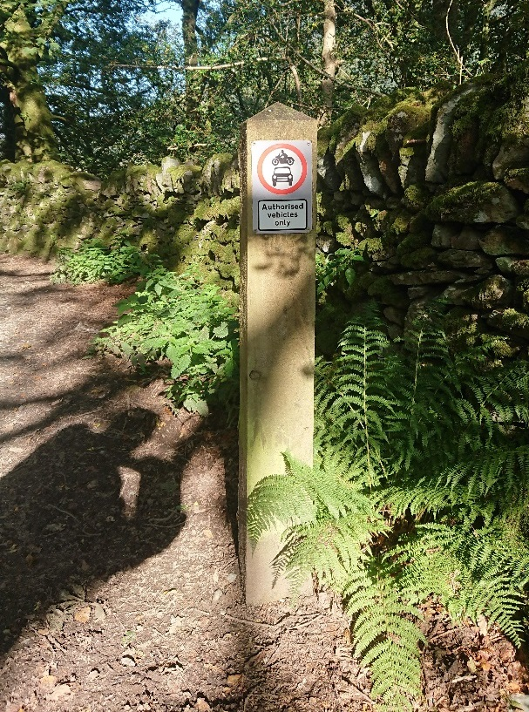
 | Warning Sign
 | 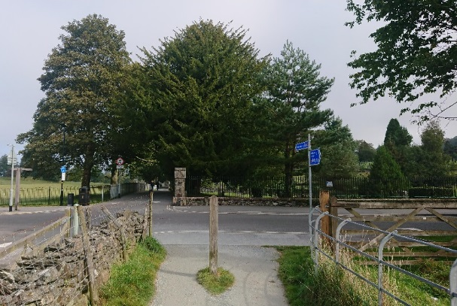
 | Bollard at end of section / Road junction (gaps 1500mm)
Directional Sign / Waymarking
Finger Post  Height as appropriate for location – use LDNPA guidance.  Site and height to reduce risk to trail use  Post 100mm x 100mm – weather topped  Fingers routed  Fixed by mortice and dowel  750-900mm depending on ground conditions  Packed / back fill  Waymark Post  Waymark Disc  1000mm  500mm  Packed / back fill | 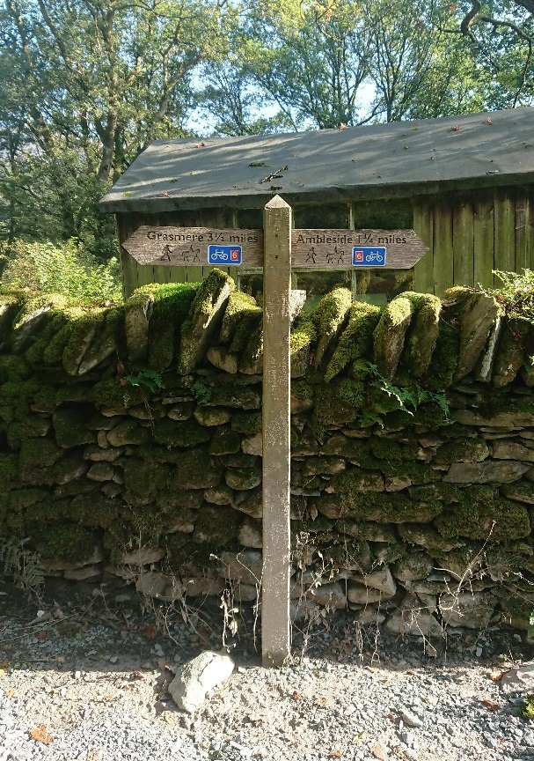
 | Directional sign – lower height as set back against wall. | Way marking – Named Trail Roundal (top) bridleway destination & distance (bottom)
 | Directional sign at junction – showing fingers attached on adjoining faces of post. Set above head height as sticks out into trail.
Interpretation Panels
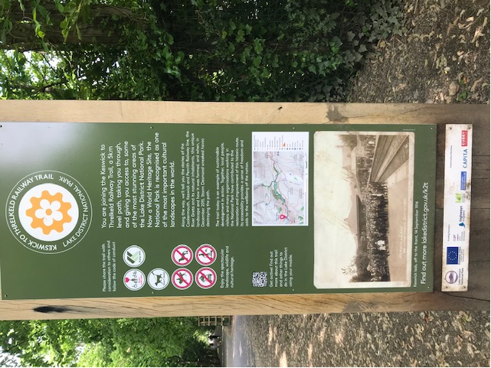  Examples of Interpretation Panels used on K2T  Interpretation: Specific to particular visitor destinations, route maps, historical features such as the L & HR railway, or natural features such as areas of semi-ancient natural woodland. Information to explain how this trail will help support the sustainable travel agenda. | 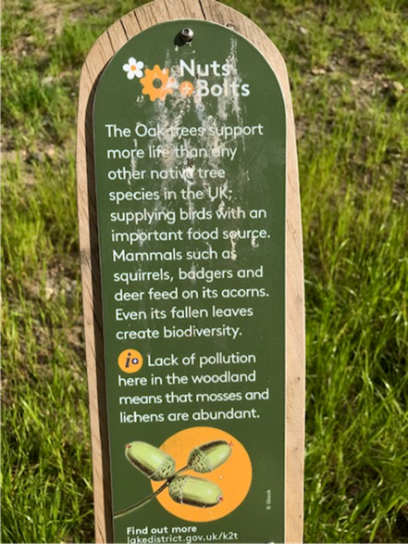
- Gates and fences
Two way bridle gate | One way bridle gate | Field gate
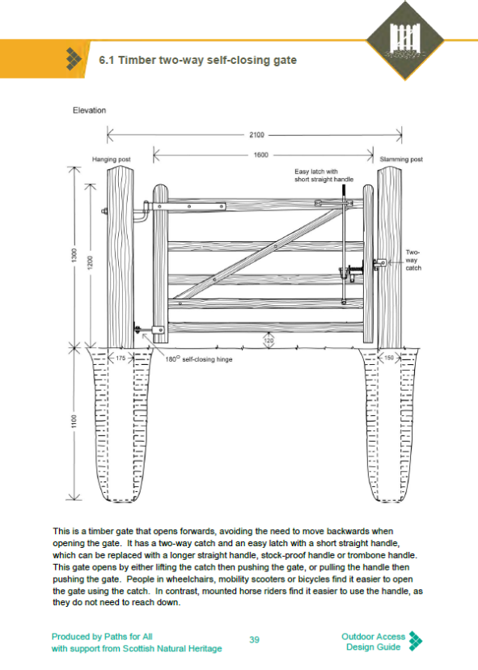 | 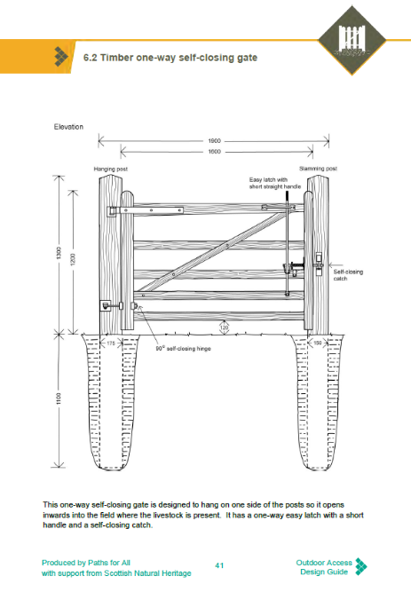 | 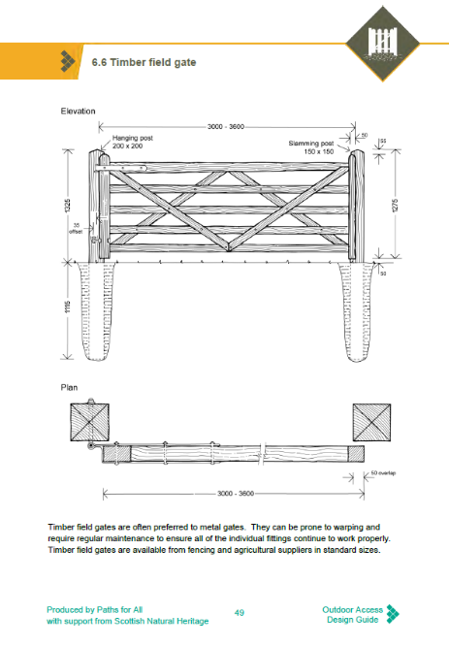

Post and wire fence (plain) | Stock Netting – Single top wire (plain)
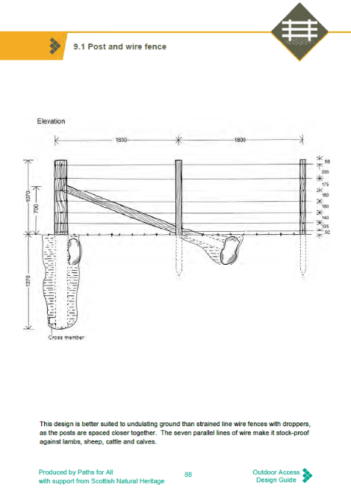 | 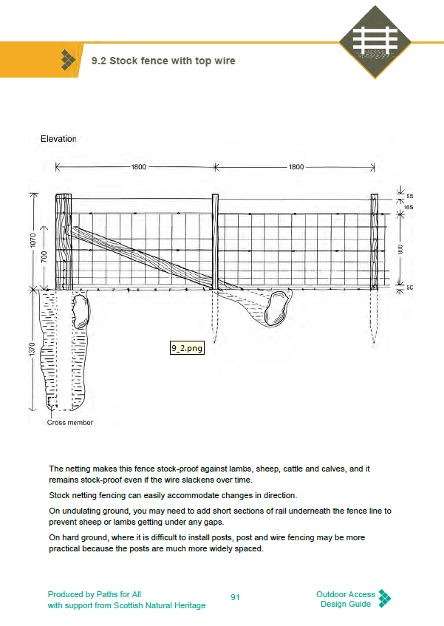
Fences to be strained seperately from gates and stiles. | Variations:  - Double top wire and single running wire at ground level  - Barbed top wire

- Culverts / low and overland flow
Culverts – twin wall plastic pipe with headwalls | Culvert with headwalls in turf lined ditch
© SNH Upland Paths Handbook | Culverts will be single pipe only.

- Bridges – Timber / Timber with steel main beams (Standard Design <9m)
Timber Bridge | Bridge and Ford on Cycle Trail / Bridleway
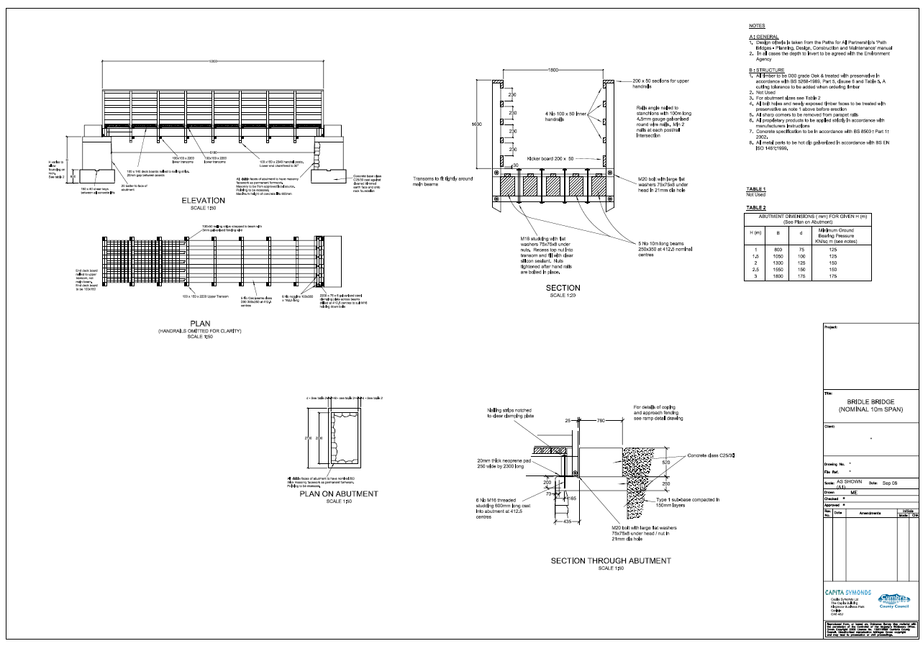  Main beams will be steel | 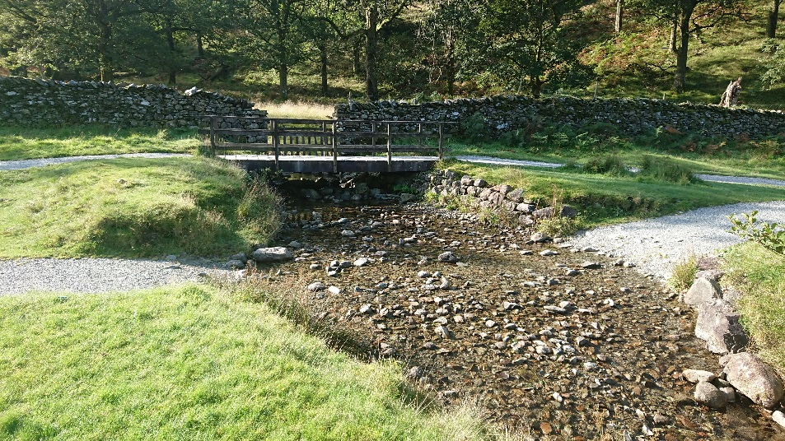  Timber Bridge with ford to downstream side
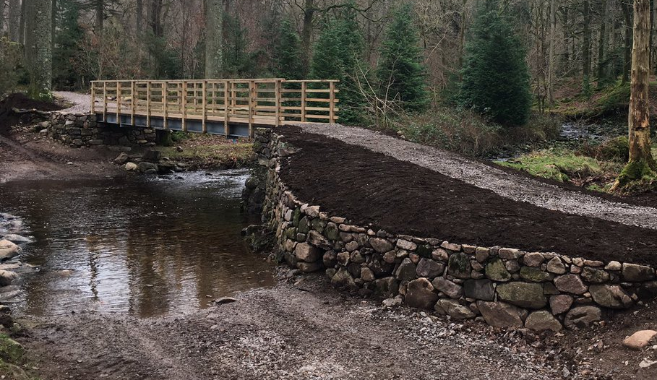
Steel beam / timber deck bridge with ford
- Bespoke Bridges/Boardwalks

Drawings contained within this application
HT1195.1.101 HT Path Area 5 REV A High Stott ParkBlack Hole Wood Ramp EXTG Alternative
HT1195.1.101 Path Area 5 REV A High Stott ParkBlack Hole Wood Ramp PROP Alternative
HT1397.1.101 Ramps Crossing YMCA Car Park

Contractors Design – Bespoke elements
HT1195.1.101 HT Path Area 5 REV A High Stott ParkBlack Hole Wood Ramp EXTG Alternative
HT1195.1.101 Path Area 5 REV A High Stott ParkBlack Hole Wood Ramp PROP Alternative
HT1397.1.101 Ramps Crossing YMCA Car Park

Health and Safety Requirments
The contractor will be required to comply with the following Health and Safety standards:
LDNPA Contractor Health and Safety Code of Practice V1 (Annex 10)
Compliance with CDM Regulation 2015

The contractor will be expected to produce the following Health and Safety documentation:
Pre-Construction Information
Construction Phase Health and safety Plan
Risk Assessments and Method Statements
Health and Safety File

