
E-tendering portal guidance
July 2017

Of interest to organisations that want to access to our e-tendering portal.

Contents
- How to register on the Skills Funding Agency e-tendering portal.
- Hints and tips.

Part A – How to register on the Skills Funding Agency e-tendering portal.

If you are unsure if your organisation already has an account, please contact help@bravosolution.co.uk for advice.

1. If your organisation has not already done so, please register on the e-tendering portal.

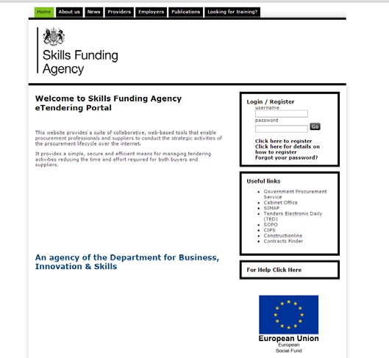

Select ‘Click here to
register’.

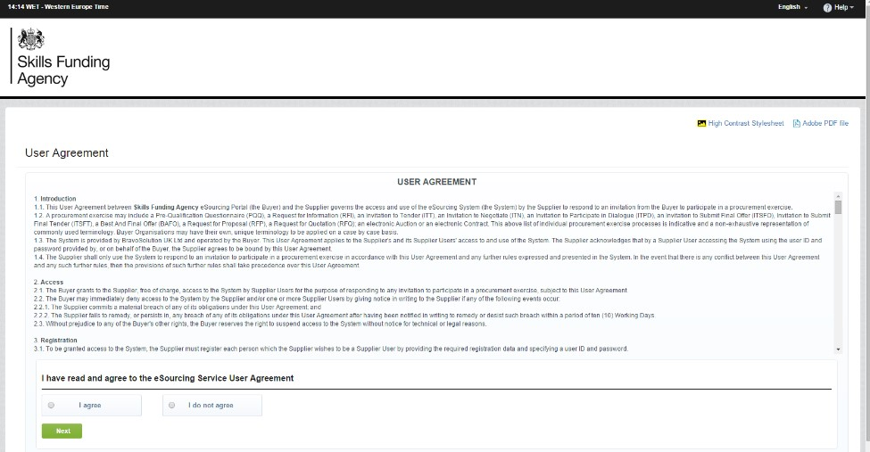
2
.
Read through the ‘User Agreement’.

Click ‘I agree’
and click ‘Next’
to continue.

3. You are then directed to the registration form, which has two sections.
i. Organisation details.
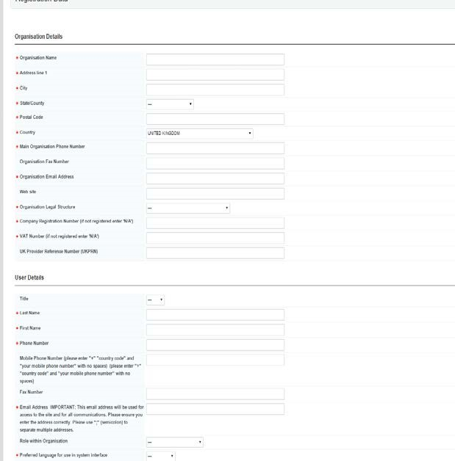
ii.
User details.

Complete the form
and check that all
your details are
correct, then save the
form.

T
ips
:

Your organisation’s
name should be
exactly as it appears
on the UKRLP
website.
You can add more
than one email
address to receive
alerts by adding a
semicolon (;) after
each address you
enter.

- You will then receive an email from Bravo Solution containing your chosen username and a unique password. They will send this to the email address you entered as part of your registration.
Tip: If you have not received the registration email, please check your ‘spam’ or ‘junk’ folder: anti-spam software may have blocked it. Add the sender to your ‘safe sender’ list to prevent future messages from being blocked.

- When you log into the e-tendering portal for the first time you will need to change your password; you have then successfully registered on the e-tendering portal.
Tip: It is your responsibility for keeping your registration details up to date, the Department for Education cannot alter Bravo registration details on your behalf.

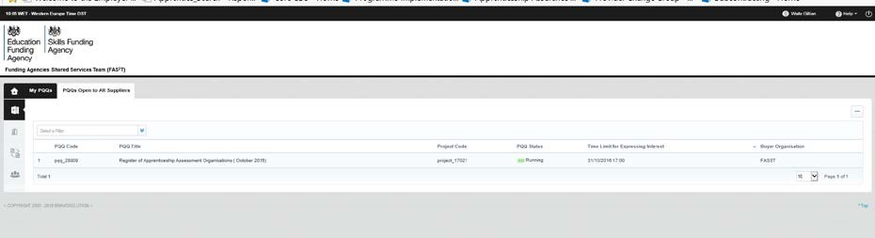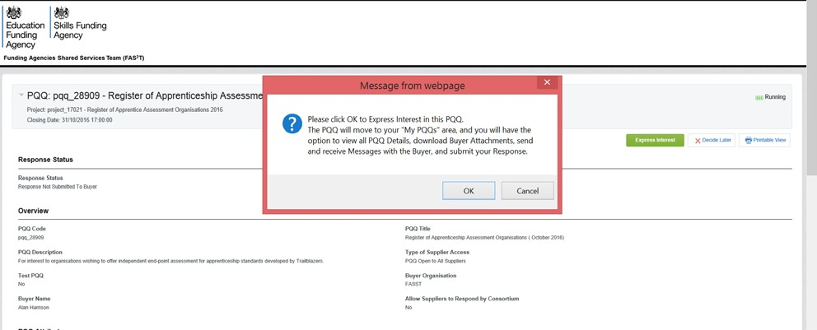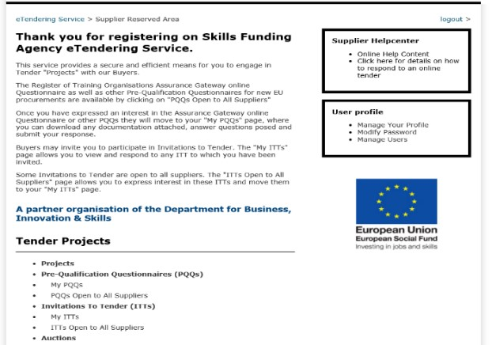

Click Express interest

Select either “My PQQ’s or My ITT’s

On the main page,
select the ‘PQQs/ITT’s open
to all suppliers’, option
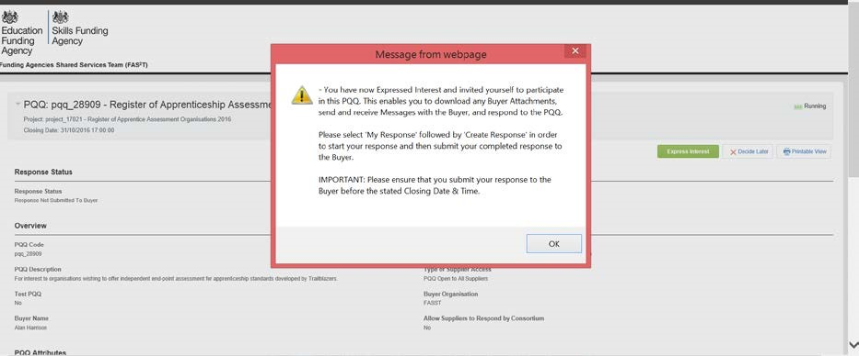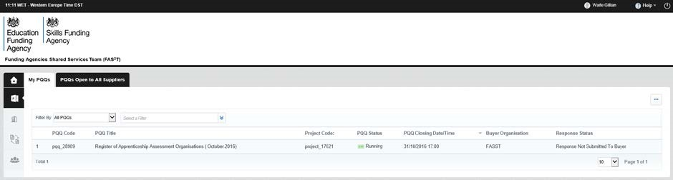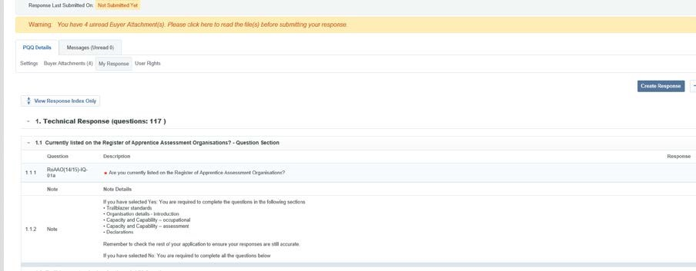

Click OK then click
‘the relevant PQQ or ITT on “My PQQ’s or My IITT’s
Or ITToror

Click Create
Response and
complete the
application

Remember to submit your final responses before the closing date and time.

Hints and tips
Please read the following useful hints and tips when you access the e-tendering portal.

How to retrieve username details and a forgotten password
If you have forgotten your username or password, you will need to send an email to help@bravosolution.co.uk as Bravo Solution manage the e-tendering portal. A member of the team will then help you get back into the system.
We also send messages to you through the message board, and you are able to respond in the following way:

- Log on to the e-tendering portal and select ‘My PQQs’ option, then select the relevant PQQ.

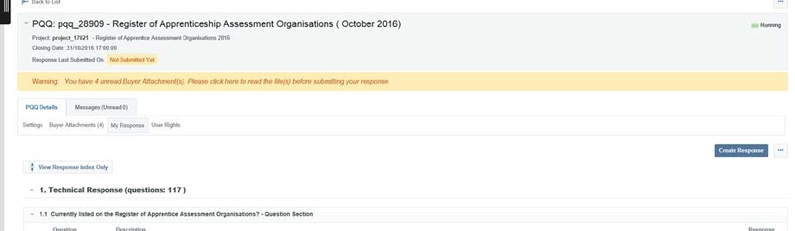

To view your received messages,
hover your mouse
over the ‘
Messages Unread
’ tab and click ‘
Received
Messages
’

- You will then be able to view your messages, including when the message was sent, when you opened the message and when you replied.

How to add a user to your Bravo e-tendering account
To ensure you do not miss any information sent through the e-tendering portal, we recommend that you add another user/s to your organisation’s registered account.
These users will then receive any automated email alerts.

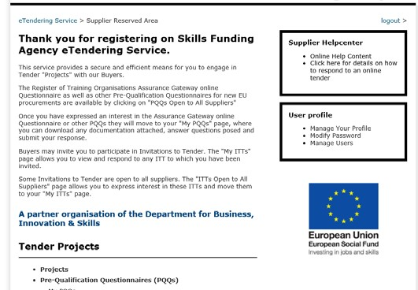

On the main page, click
‘
Manage Users
’.

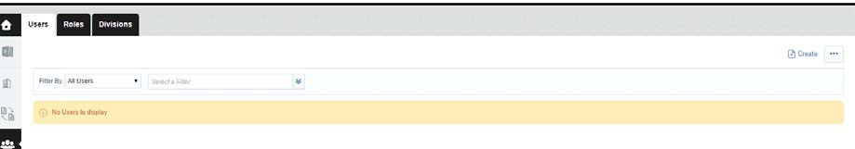

Click ‘
Create
’
.

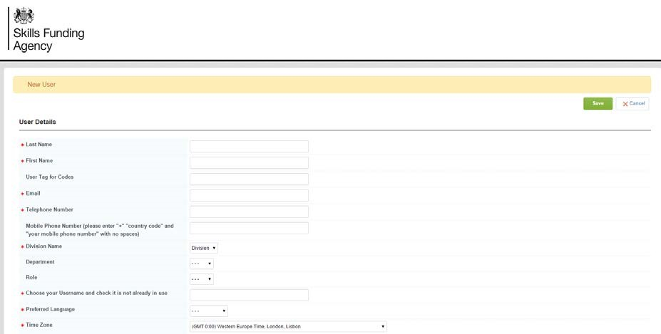

Complete the ‘
user details
’
fields. Once you have checked
the details are correct, click
‘
save
’
.

Now that you have added a new user, you will need to assign the appropriate rights to their user account.

Select ‘View User Rights’.

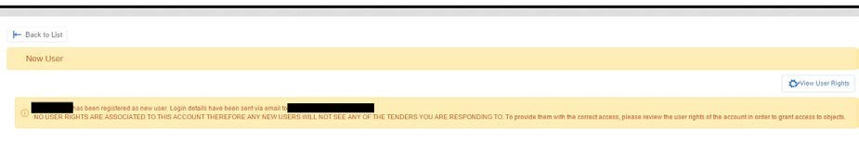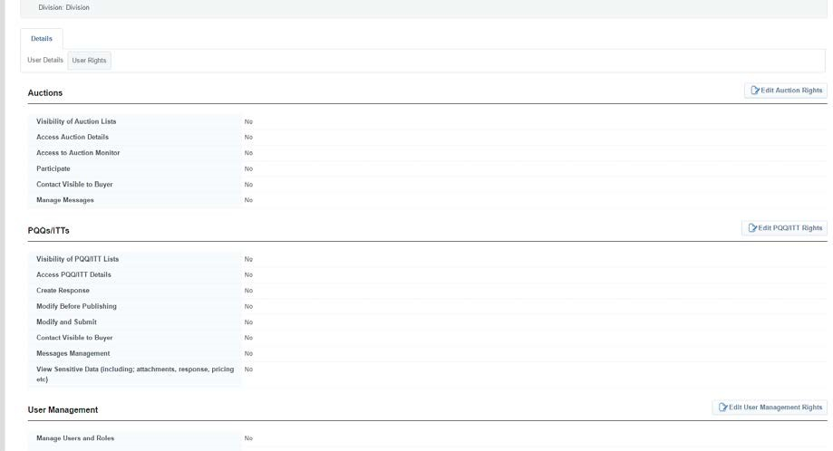

Select ‘Edit PQQ/ITT Rights’.

Note:

Please do not amend the

‘edit auction rights’, ‘edit supplier
management rights’ and ‘edit directories rights’ options.
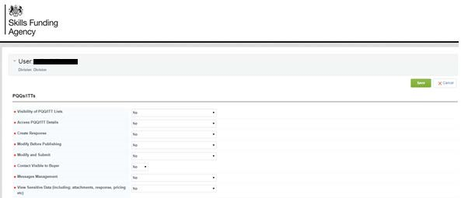

You can select the
appropriate user rights from
the dropdown lists. Once
you have completed your
selection, review the rights
you have selected and click
‘Save’.

Tip: access rights explanation
See PQQ/ITT: ability to view active procurement opportunities through the

‘PQQs/ITTs Open to all Suppliers’ links. [Note: If there are no opportunities

available at a certain point in time, nothing will be visible.]
View PQQ/ITT Details: ability to click on active procurement opportunities ^{through} the ‘PQQs/ITTs Open to all Suppliers’ menu, and view details. Create response: ability to express an interest and begin the process of completing a PQQ/ITT.
Modify before publishing: ability to log in and make amendments to active PQQ/ITT responses.
Publish and modify: ability to submit a response on behalf of your organisation and make amendments to PQQs/ITTs.

Contact visible to the buyer: if we need to contact you, the contact details of

this user will be visible to us.

Messages management: ability to access message boards of a PQQ/ITT. The

user will be able to review messages that we send and also send messages to

us.
View sensitive data: ability to view attachments that you upload as part of your ^{responses} to PQQs/ITTs. For example, organisations charts that you upload when completing an application to the register of apprenticeship training providers.

--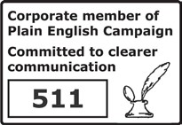
© Crown copyright 2017
You may re-use this information (excluding logos) free of charge in any format or medium, under the terms of the Open Government Licence. To view this licence,
visit http://www.nationalarchives.gov.uk/doc/open-government-licence/ or e-mail:psi@nationalarchives.gsi.gov.uk.
Where we have identified any third party copyright information you will need to obtain permission from the copyright holders concerned.

If you have any enquiries regarding this publication or require an alternative format, please contact us info@sfa.bis.gov.uk

