Tender 2 Diagram
Weed killer applied to verges on vehicular access.
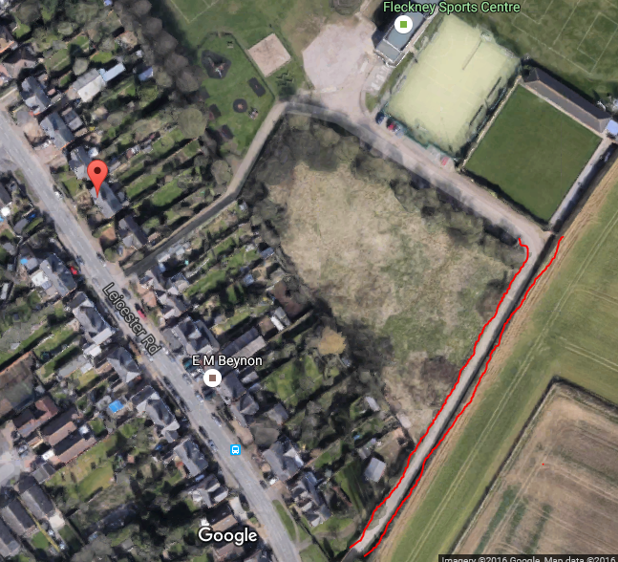

Weed killer applied to hedge.
