Building Specification

Martello Toilets Facility Esplanade, Seaford, East Sussex, BN25 1JH

Proposed conversion and refurbishment of existing toilet block to include kitchen and seating area and the provision of mixed use, ambulant and accessible use WC’s.

Prepared by STC in conjunction with:
Challinor Hall Architecture
19 Willingdon Park drive, Eastbourne, BN22 0BS
(T): 01323 411 933 (W): www.challinorhall.co.uk

Description of Project
The work comprises the general refurbishment, including demolition work where required, of the existing Martello Toilets building to accommodate new toilets and include a new kitchen/café area.
During the work the existing café kiosk alongside the Martello Toilets is to remain operational and any services (electrical, water etc) derived from the Martello Toilets building are to continue to be provided or temporary services provisions shall be made.
A second stage of work includes the provision of a self-contained Changing Places Pod to be sited in the location of the existing café kiosk (to be removed as part of the second stage of work).
Note, this is a design and build project and the contractor will be required to provide all installation necessary drawings, details and equipment/materials selections for approval prior to commencement of work.

Preamble
- All works on this site must be carried out in strict accordance to the Building Regulations and all other relevant and up to date Trade and British standards.

Compound
- Allow for a safe forming of an area to allow for working on the site keeping members of the public away from the site along with all welfare facilities; precise location to be confirmed however suggest an area on opposite side of the Esplanade; this will result in temporary loss of parking spaces but not considered a major issue as it’s out of season.

Demolition
- Allow for careful demolition and removal from site of all PVC guttering, and flat roof., interior walls, ceilings and part of external brickwork and all services including removal of tiles to outside walls.
- Maintain a temporary electrical and water supply on site and to the nearby café kiosk.
- Cutting out of new openings for windows, doors and serving hatch

Structural Elements
- See enclosed structural engineer’s (SE) report with detailed design (see enclosed).
- Any additional strengthening or deviation from SE report to suit site conditions and is to be agreed with the Local Building Control Officer. See also enclosed the Building Control conditions 1-5 which need to be delivered.
Drains
- See enclosed drain survey and recommendations (to follow).
- Undertake work as per the survey recommendations. If drains pass through foundations, bridge over with concrete P.S. lintels and provide minimum 50mm polystyrene pipe surround.
- Drains with less than 600mm cover to be provided with pea beach bed and surround, and a concrete topping.

External Walls
- Check DPC condition; allow for repairs/replacement.
- Allow for removal of all existing redundant cabling, trunking, poles masts etc from walls.
- Remove existing hard render from wall back to existing brickwork.
- Apply a waterproof self-coloured render in strict accordance with manufacturer’s recommendations. Colour to be confirmed.
- Existing solid walls coloured/shaded grey in image below to be internally fixed with DPC strip vertically against walls with 25x47mm softwood timber battens at 600 centres and 72.5mm Kingspan Kooltherm K118 Insulated Plasterboard (60mm insulation + 12.5mm plasterboard) with 3mm skim coat finish. All joints to be sealed with self-adhesive tape to create a vapour control layer and seal all perimeter abutments with a suitable silicon sealant. Solid wall Minimum 'U' Value of wall construction to be 0.30W/m2K (Refurbishment).

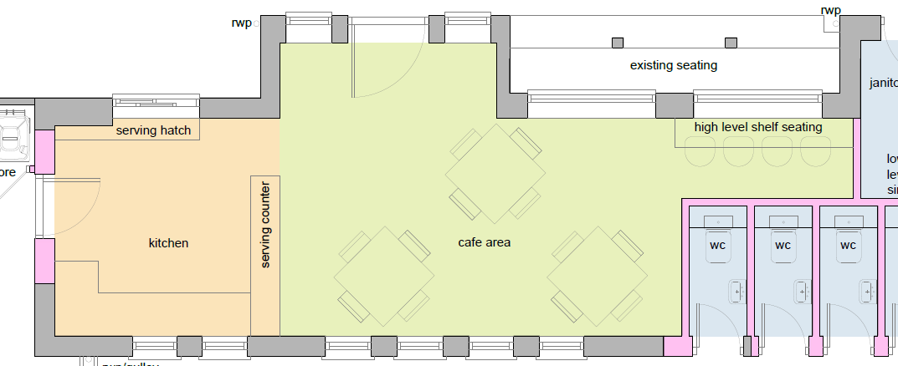

Internal Walls
  - Internal partitions coloured/shaded pink on image below to be 50x100mm softwood studs at 400mm centres with 1no. layer 12.5mm lined with Whiterock walling system over 18mm ply. 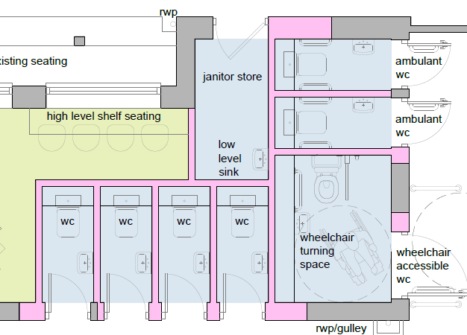
  - Provide 100mm Rockwool Flexi slab acoustic quilt between studs to deaden sound. Provide 50x100mm softwood sole and head plates, top and bottom with softwood noggins at mid-span.
  - Noggins to be provided to provide support for fixing of services and sanitary ware
  - Where walls run parallel to ceiling joists, provide double joists above and below, to be well bolted together.
  - Minimum mass per unit area, excluding finish, to be 10Kg/m2. All joints are to be fully sealed. Plaster or plasterboard lining with a set coat finish, to both sides of the partition.

Roof/Rainwater goods
- Investigate the existing roof construction, strengthen and support as necessary prior to removal of any existing struts and bracing.
- Where necessary, provide 100mm ROCKWOOL Roll insulation running between ceiling joists and 170mm insulation quilt running perpendicular to ceiling joists (270mm insulation total) to achieve minimum 'U' Value of 0.16W/m2K.
- Reroof all flat roofed areas in built up felt to extreme location specification including lead work paying particular attention to roof facing sea.
- Replace fascias and soffits with white UPVC style (tbc). Soffits to be perforated to facilitate natural ventilation of roof space.
- Replace all rainwater pipes, gutters etc with black upvc. Re-route all down pipes on prom side to esplanade drainage system via sealed gullies and underground piping.
- Allow for removal of all existing redundant cabling, trunking, poles masts etc from roof space.
- Allow a PC sum of £5,000 for repairs after agreed intrusive works.

Windows
- Any new or replacement windows are to be UPVC double-glazed sealed units with marine grade ironmongery, with minimum 4mm thick low-E glass and 16mm sealed air space (see enclosed suggested Eurologic spec/standard).
- Windows with glazing less than 800mm and doors/sidelights less than 1500mm above finished floor level are to be glazed with toughened safety glass to B.S. 6206, 1981.
- All windows are to be draught stripped.
- Windows fronting the Esplanade are to be bottom hung and fitted with suitable opening limiters, to restrain window. Window opening devices to comply with Building Regulation requirement K5.3.
- Minimum 'U' Value of windows to be 1.6W/m2K with a solar tint?
- Provide a cost to include louvred internal perforated blinds on south facing elevation (café area only).
- External Shutters; supply Galvanised Shutters marine grade to windows and serving hatch to café with electrical locking; facing sea only.
Doors
- Entrance door to Café to be Powder coated Aluminium with bottom panel complete with new Automatic open and closing device.
- All other external doors; supply and fix new Timber Framed Ledged and Braced doors and Frames in treated timbers complete with stainless ironmongery and fixtures including door closers.
- Rebuild walls to form openings for doors.
- All doors are to be draught stripped.

External Items
- Construction of ramps and raised area to disabled side of building including handrails and barriers.
- Allow for new Galvanised Gates and frames to bin and ambulant WC areas (architect to confirm)

Flooring
- Hack up existing floor covering, and relay to provide level finish to receive Altro floor covering.
- All floors to be covered in Altro with coved skirting up to 100mm (colour tbc, probably grey/diffuse).
- Make good floor where walls and existing services were removed.

Ceiling
- Existing ceiling has ACM (Asbestos Containing Material), see enclosed report, therefore allow for complete removal by approved Asbestos contractor and replacement in all ceiling areas with Whiterock and plasterboard (12.5mm acoustic plasterboard type D).
- Access panels and roof access to inspect roof space services/fabric to be provided; number and locations tbc. Roof access hatch in store room.
Seating (external)
- Construct new seating to be an exact like for like finish in Treated Timber complete with new structural posts all painted finish.

Kitchen Fittings
- Construct new kitchen comprising Howden base and wall units complete with work tops including high level seating area and serving hatch.
- All work surfaces to be covered with a stainless-steel work top.
- Incorporating a sink located under window.
- All walls to be tiled floor to ceiling with White 5 mm thick tiles incorporating low level seating from floor to underside of work surface.
- Serving Counter to have 500 mm wide base units with a stainless-steel work surface.
- Area facing Café to have 18 mm plywood including decoration.
- Hatch area to have stainless steel work surface incorporating a wash hand basin (not currently shown on the drawings).
- Extract hood to be externally vented.

Decoration
- Carefully prepare and apply all surfaces to receive emulsion on all walls and ceilings in strict accordance manufactures recommendations comprising 3 coats colour to be decided.
- Woodwork; prime, knot undercoat and 2 coat gloss

Plumbing & Drainage
  - Note location of incoming mains/meter and pipe size (details needed).
  - Vent pipes for drainage to discharge at roof ridge level.
  - Note findings and recommendations of drainage survey, see above.
  - Investigate positioning of existing drainage connections previous to work commencing. Alter and adapt existing manhole and drainage pipework as necessary and replace/repair any defective sections of pipework passing beneath the proposal and encase in concrete. All new below ground drainage to be 100mm dia. Hepsleve laid at 1 in 40 falls and surrounded in pea beach.
  - Existing drainage runs and chamber locations to be checked prior to construction.
  - Kitchen: Connect sink to new back inlet gully as shown on plan, to discharge using 40mm dia. PVC waste pipe via 75mm deep seal traps. New back inlet gully to connect to existing chamber via 100mm dia. pvc waste pipe).
  - WC’s: Wash basin to connect direct to stub stack/SVP via 40mm dia. pvc waste pipes via 75mm deep seal traps. WCs to connect direct to stub stack/SVP via 100mm dia. ‘P’ trap waste. Stub stacks to be fitted with air admittance valve. Stub stacks to connect to new SVP via 100mm dia. waste pipe. New SVP to discharge into existing chambers via 100mm dia. waste pipe.
  - TMVs to be installed for safe temperature of hot water supply to taps.
  - New SVP to be weather proofed accordingly to stop water ingress. To be a minimum 900mm above opening windows within 3m of the pipe and be fitted with a bird cage.
  - All plumbing to have rodding eye access at all changes of direction.
  - Conceal cisterns/pipework etc to WCs.
  - Dual flush cisterns to be installed.
  - Provide water sub meter for café concession.
  - Refitting of water Refill station position as existing
  - Supply and fix complete with Twyford Sanitary wear with Ideal standard stainless-steel fittings complete with PVC waste fitting.
  - 4 Number Conveniences including WHB handrails.
  - 2 Ambient Convenience including WHB with handrails and baby changing facility.
  - 1 Disabled Wheelchair convenience to agreed layout Part M building regulations.
  - Sluice to janitor space with 5 rows of tiles for splash back
  - I Small stainless-steel sink to hatch for washing of hands (not shown on architect’s drawings)
  - 1 Standard sink to kitchen area (architect shows a ‘two-basin’ sink)
  - Also provide cost for providing stainless steel sanitary ware (e.g., Sissons); examples below:
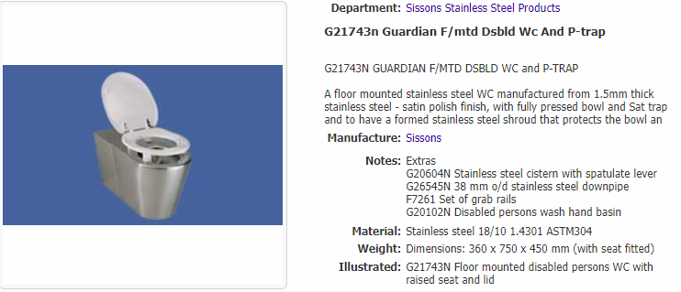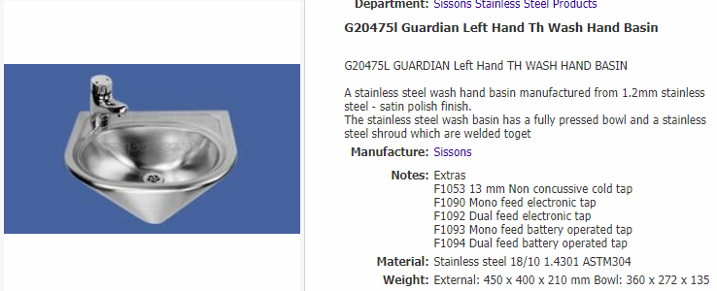
Electrical Installation
- Incoming mains located on outer wall on Esplanade façade adjacent to storeroom entrance; 60A single phase. Allow for upgrade, details to be confirmed; please note that the mains power will also need to be future proofed to supply a new Changing Places facility on the site of the adjacent kiosk; this will need circa 50A so it’s inevitable that an upgrade to 3 phase 60A will be required to cover both buildings.
- Provide new distribution board with separate outgoing ways for new WCs, Café/kitchen and future Changing Places facility.
- The electrical installation is to satisfy the requirements of the Building Regulations/IEE regulations and must be designed, installed, inspected and tested by persons competent to do so.
- An appropriate electrical installation certificate is to be issued for the work by a competent person.
- Power for hand dryers in all WCs.
- Power sockets required in café and kitchen areas; details tbc however suggest 2xdouble 13Ain café and 5xdouble 13A in kitchen. Include high level 13A switched fuse outlet for e.g., wall mounted heaters.
- Kitchen; supply and fix complete 6 number double socket outlets, kitchen hob and extractor (PC sum £600) with 2 number 1500 W covers radiators.
- All fixtures to be MK double socket white finish.
- Café Area; 4 number, sockets with 4 number 1500 W radiators on timers and overriding switch in kitchen.
- Supply and fix complete all electrical lighting and ventilation and electrical covered radiators to all Conveniences and (janitor area with one socket outlet).
- Powered auto locks on ext WC doors.
- Provide sub meter for café concession.

CCTV/Wi-Fi
- Allow for CCTV installation by Chrome Vision (ext cameras) linked by 4/5G to Police network (x4 external on each corner).
- Connectivity and access point for Wi-Fi in café area.

Heating and Hot water
- Hot water installation for WCs and kitchen to be designed by specialist contractor; provide details prior to installation, provide provisional sum for installation; assume electric water heaters.
- No space heating.
- Provide trace heating linked to frost stat for internal pipework to prevent freezing.

Ventilation
- Ventilation to be provided in strict accordance with Building Regulation Approved Document F (2021 edition), and as detailed in Table 1.1.
- WC’s will require mechanical ventilation.
- Mechanical Ventilation systems are to be provided in strict accordance with Building Regulation Approved Document F2 – (2021 edition), and must be designed, installed, tested and commissioned by competent and accredited persons.
- All fixed systems and controls must be commissioned by testing and adjusting as necessary by an Approved Person, the results together with an approved commissioning certificate are to be provided to the Building Control Officer not later than 5 days after the work has been completed.
- The contractor is to provide the Town Council as building owner with sufficient information, details and documentation about the ventilation system/units, together with the maintenance requirements, so that the ventilation system can be operated in such a manner as to provide adequate ventilation in accordance with Approved Document F. This information is to be provided not later than 5 days after the works have been completed.
- The testing of the mechanical ventilation air flow rate is to be carried out in strict accordance with the procedures approved by the Secretary of State, and as detailed in Approved Document F1(2).
- Any flexible ducting used is to be a maximum length of 1500mm, provided with suitable support to prevent sagging and reduction of effective clear area, and is to be fitted with suitable easy bends at any change of direction.
- Mechanical Extract Ventilation to be designed by specialist.
Security Provisions of Door and Windows
- Radar keys for wheelchair/ambulant?
- All ext toilet doors to have timed autolocks (see 11f).
- Provide secure entrance doors and windows in accordance to Part Q Security and unauthorised access in Section 1 and 2 of the approved Documents for Building regulations. In accordance with the British standards; BS EN 356, BS 3621, BS 8621, BS 10621.

Access to and within the building
- Access to and inside the building is to be in accordance with the Building Regulations – Approved Document M (2015 edition) Volume 2, and in line with Guidance as shown in BS 8300-1:2018 and 8300-2:2018 ‘Design of an accessible and inclusive built environment. Buildings and external environment - code of practice’.

Switches, Outlets and Controls
- To be in accordance with Requirement M1 of the Building Regulations; only needed in store, say double 13A socket?

Lighting
- 100% of the overall number of internal light fittings must be energy efficient, provide compact LEDS which provide a luminous efficacy greater than 45 lumens per circuit watt. The contractor is to prepare designs for consideration prior to installation.
- Provide ceiling mounted flush light fittings in kitchen and café area; number/locations tbc; manually switched on wall near access points.
- Provide x2 ceiling mounted flush light fittings per WC cubicle on PIR sensors (one to be an Maintained Emergency Light).
- Lighting to comply with minimum levels of lighting on a working plane.
- External Lighting; provide vandal proof lighting on a timer around the building comprising 4 on each on long elevations and 2 on each end.
- Including lighting to external bin area and to external access to ambulant WCs, outside of ambient area and loft space.

Fire Alarm System
- Fire alarm system for café/kitchen area to be designed by specialist to comply to BS5839 Cat L1. Ensure that sounders can be heard throughout the building.
Design Criteria/Notes
- All dimensions are in millimetres unless otherwise stated and should be checked on site, by the contractor, from the actual work wherever possible and not scaled from the drawing.
- These construction notes are to be read in strict accordance with Challinor Hall Limited drawings and specifications together with any revisions and/or amendments.
- Any discrepancies found on site arising between the drawings and the actual work, the contractor is to inform Challinor Hall Limited in the first instance. Challinor Hall Limited will not accept responsibility for any works that do not comply during or after completion of the works.
- Contractor should be aware that existing roof timbers and construction may need to be altered and adjusted to suit the new proposals. The Contractor is to investigate the existing construction and be satisfied that they have sufficient information and details so as to proceed with the works.
- Any product name referred to or methods of construction indicated in this schedule should be regarded as suggested constructional details, as the contractor may wish to adopt some other solution giving compliance with the Building Regulations.
- It should be noted however that it is important that the works are constructed using the materials specified and approved in the Building Regulation application, and that any variations to the specified materials must be advised to the Local Building Control Officer listing the specification changes.
- The proposed works should not be commenced until such time as Building Regulation Approval has been granted.
- O&M manuals together with all signed off commissioning data to be provided on practical completion including as-built plans/Record Drawings, product data/info, services diagrams/schematic Drawings etc.
- Timber to be from sustainably managed source.

