Meeting Rooms Maps – Ground Floor Meeting Rooms – 1GC
(Meeting Room 1GB for reference only, not required in proposal)

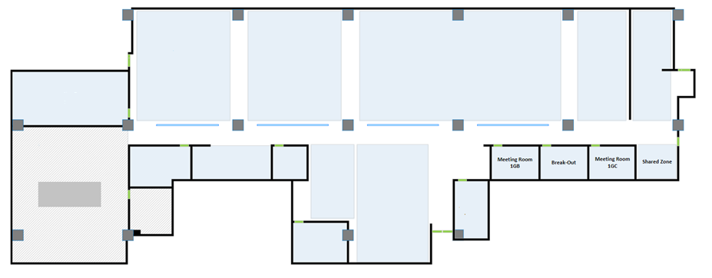

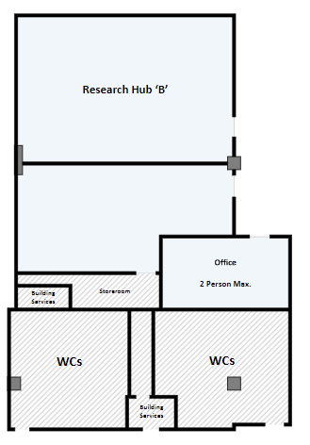
Meeting Rooms Maps – First Floor – Research Hub

Meeting Rooms Maps – Second Floor Meeting Rooms – 1GC
