INVITATION TO TENDER

Castle Hedingham Village Park and Play Provision
PROCUREMENT PROCEDURE: Tender

Specification

Status: | FINAL
Version: | V0.04
Date: | 30/09/2019

- Introduction
- Timings
- Background
- The Vision
- The Play provision
- Site Information
- Restrictions
- Budget
- Requirements
- Surrounding Open Space
- Community Engagement
- Delivery, Equipment and Installation
- Ground Works, Health and Safety and Site Supervision
- Identification of Existing Services
- Safety Surfacing and Pathways
- Fencing, Gates and Landscaping
- Inspection, Handover and Spare parts
- Price
- Payment
- Warranties
- Review of Tenders
- Pricing Matrix
Appendix 1: Community Engagement: Questionnaire and feedback
Appendix 2: Aerial Photograph of Castle Hedingham with site marked
Appendix 3: Map of area available under 25-year lease
Appendix 4: Map showing possible line of medieval inner bailey (archeological relevance)

1. Introduction
Castle Hedingham is a rural parish with approximately 1200 residents. It is also a busy tourist attraction due to its local heritage including Hedingham Castle, the Colne Valley Railway and a popular network of public footpaths for walkers. The village consists of a conservation area in the medieval centre and a range of more modern residential development making up the majority of the village, and Rushley Green which is an agricultural and rural residential area to the North of the Castle.
Castle Hedingham Parish Council invites you to submit a tender for providing a play offer at the new recreation open space, currently known as the old allotment field, adjacent to The Castle Hedingham Social Club and Memorial Hall.

Tenders should provide;

- Proposals for supply and installation of play provision.
- Proposals for landscaping and estate works for the wider site.

Tenders must be returned by the 18th November 2019
Prior to tendering all suppliers should arrange site visits through the Clerk to The Parish Council.
Following receipt of tenders and prior to awarding any contract, tenderers may be invited to present their proposal to the Parish Council’s Village Park working group to ensure clarity and understanding of the proposals.

2. Target Timings

Pre Tender Site Visits ………………… September/October 2019
Invitations to tender issued by ………………… 1st October 2019
Tenders Returned by ………………… 18th November 2019
Tender Evaluation ………………… November 2019
Presentations and Clarification ………………… before 9th December 2019
Tender Award …..…………….. January 2019 (To be confirmed)
Commencement of Works .……………….. February (Landscaping where appropriate) and March/April 2020 (for the play provision)
Completion of Works ………………… early May 2020

3. Background
The Parish Council is entering into a new 25-year lease for an area of land to provide a much needed recreational space for its residents.
The Parish Council does not own any suitable recreation land in Castle Hedingham
An Open Spaces study which was commissioned by Braintree District Council in preparation for work on the new Local Plan for housing development up to 2033 shows that Hedingham ward has a shortfall in the amount of public open space available.
Since the 1950’s Castle Hedingham has been able to offer an open space for recreation by having a lease on an area of land known as New park. The Parish Council was served notice to quit this lease in September 2018. The Parish Council agreed to vacate the recreation field at New park on the basis of a verbal commitment from Hedingham Castle to a 25yr lease at peppercorn rent on the old allotment field.
February 2019 saw the removal of the play equipment from the New Park recreation field. The play equipment removed was at the end of its life and was in a poor state of repair although maintained within appropriate safety standards.
The Parish Council is therefore committed to acting as swiftly as possible to develop The Old Allotment Site into a long awaited and much needed community open space. The Parish recognizes the urgent need to provide a facility that offers play provision for families and young children.
4. The Vision
To provide sustainable, safe, accessible and appropriately developed public open space to meet the community’s needs in an efficient and effective manner.
Aim
- Provide an open space that becomes a community hub for the residents of Castle Hedingham whatever their age and ability.
Objectives
- Enhance the physical character of the area
- Provide connected routes
- Protect and enhance the biodiversity of the site
- Provide for children’s and young peoples play
- Contribute to the creation of healthy places including quiet areas
- Improve opportunities for contact with the natural world
- Create a community garden/allotment for residents
5. The play Provision
To be located centrally on the site and providing for 3-7yr olds and 7-12 yr olds
The expectation is that the play should provide a minimum of 40 minutes play to the casual visits made by local residents.
All types of play should be considered. The use of loose-fill surfacing as part of the play experience will be viewed favourably when considering proposals put forward by tenderers.
The use of natural materials is preferred. Inclusion of locally sourced felled trees as part of the overall design is encouraged whether they be part of the play offer, provision of seating or general landscaping of the area.
The use of bright colours is not seen as appropriate for this site but there is an appreciation that the use of colour to highlight parts of the offer can compliment the natural feel of the open space.
It is not felt that the play offer requires fencing out of the open space area. The design should exploit the local topography of the site.
The wider design should identify any surfaced routes required along with fencing and gates to assist in the security of the site as well as providing access for maintenance.
Appropriate signage at the entrances and on the site to support appropriate use should be included in the design.
6. Site Information
The site allocated is known locally as the old allotment field. It is estimated to be 1.5 acres of rough grassland with an area of mounding creating a hollow towards the centre of the site. There are currently two well-used routes across and around the open space. These can be seen as worn grass footpaths established as desire lines to cross the area and walk dogs around the edge of the field.
The separately fenced area known as the Memorial Garden (marked D on the map at Appendix 3) is to be included in the lease, and so is included in the scope of this tender.
A community garden/allotment is planned for the site. It is anticipated this will be situated along the western boundary adjacent to the woodland.
7. Restrictions
There are overhead power lines crossing the site from an adjacent sub station.
There may be underground services crossing the site.
Historic buildings adviser notes that there may be ancient structures below the surface of the site in certain areas, including sections of the inner bailey of Hedingham Castle. Please see Appendix 4 for a map showing possible line of medieval inner bayley.
Vehicle access is required at certain times to allow supplementary car parking at the lower, northern end of the site for events held at the hall, club and church. Please see map at Appendix 3.
The Landlord will also require vehicle access across the northern end of the site to the willow plantation at the west for annual timber extraction
The draft lease currently being considered is for 25 years.

8. Budget

Works | Scope | Indicative Budget | Contract Start Date | Completion Date
Play Provision
 |  | £50,000 Allocated from Parish Capital fund | February 2020 | May 2020
Landscaping/  Estate works across site, to include creation of community garden/allotment |  | £50,000  (Subject to external funding applications being granted) | February 2020 | May 2020
9. Requirements
The play equipment
The proposals must offer challenging play, firing children’s imaginations, enabling social interaction and allowing development across the site for the users. The designs must take into account the 10 principles of designing Successful Play Spaces
http://www.playengland.org.uk/wp-content/uploads/2017/03/10-Play-Design-Principles.pdf
The site needs to be welcoming, engaging and accessible, offering elements of play to all the users and allowing for different ability levels. The equipment needs to be suitable for both younger and older children alike and the access points, equipment and footpaths need to be DDA compliant.
The chosen equipment needs to be durable and able to withstand heavy use and cope with the British elements, be low maintenance with regards to ongoing repairs and spares to be reasonably priced.
The proposal should be in keeping with the location. It should be predominantly constructed of wood. The design and layout must take into account the setting, and the local history.
We are looking to achieve maximum play value for the budget available.
All of the equipment proposed in the designs must be below 4 metres in height
The winning tenderer must include in their proposals, details of how they would engage with the local community prior to the commencement of works and during the contracted works.
Site visits will be arranged during the tender process and communicated via the Parish Clerk. It is highly recommended that companies looking to submit a tender attend these visits. It is imperative that contractors understand the nature of the site, proposed works, access, environmental factors and other local conditions before submitting a tender.
All equipment must be designed, manufactured and installed in accordance with the relevant BSEN Standard. All surfacing and layouts to comply in all respects with BS EN 1176 and that the surfacing must be tested in accordance with BS EN 1177 and independently certified.
10. Surrounding Open Space
The designs should encompass proposals for any surfaced access and include fencing and gates necessary to provide site users with a sense of security and sense of place. The proposals should include provision for a community garden/allotment. Tree planting, creation of wildflower meadow and general landscape and environmental improvements to the whole of the open space to ensure the Play proposal fits in with the wider site should be included in the proposal.
Tenderers should itemize these costs separately to enable the Parish Council to assess the viability of these proposals as well as consider whether to award this work to the successful tenderer. The council reserves the right to only award the contract for installation of the play equipment.
11. Community Engagement
Castle Hedingham Parish Council has attended the local Junior school, day nursery and toddler group to ascertain aspirations and expectations regarding play provision. The results can be reviewed in Appendix 1.
Further engagement, as described in previous paragraphs, with residents is planned once a preferred supplier has been identified.
12. Delivery, Equipment & Installation
The initial Contract start date will be agreed at the time of award.
The maximum period of this contracted works must be completed by the end of the first week in May 2020.
The Council must be notified of any intended subcontractor(s) being used for works as part of the tender submission. If any changes are made to this, the Council must be made aware immediately. Sub-Contractor(s) must be made aware of all the Council’s requirements.
The contractor will be responsible for the closure of the site to the public and the site will need to be fully secured for the duration of works.
New equipment is to be delivered directly to site and will remain the responsibility of the winning tenderer until the handover of the site following completion of all works. Security of material and equipment is the responsibility of the contractor until formal handover.
The wooden equipment included in the design must be responsibly sourced; structural posts must be planed without dead knots and pressure treated in accordance with EN35-1 & EN335-2 to ensure minimum environmental impact. Steel footings are preferable to ensure longevity and all wood used is to have the FSC responsible Forestry Seal of Approval.
Tamper proof fixings are to be used across all equipment installed
13. Ground Works, Health & Safety & Site Supervision

All ground works and reinstatements must be completed as part of the project and shown in the costings of the tender.

All works are to be carried out in accordance with the current Health & Safety at Works Act and other relevant Acts, Regulations, Rules and Health & Safety of Employees under the CDM Regulations if relevant.
The site will need to be secured from the public from the morning of the installation date until the project is signed off. It is the responsibility of the winning tenderer to ensure this takes place.
All HSE requirements are the responsibility of the winning tenderer and all relevant regulations must be adhered to on site. All contractors on site must be wearing the required PPE.
Contractors need to ensure that any vehicles parked do not cause an obstruction or nuisance to local residents and pedestrians.
Quotes must be inclusive of all necessary security measures to ensure the site is safeguarded and to prevent unauthorised access. The site remains the responsibility of the contractor until the works are approved and signed off by the Parish Council supervising Officer.
The winning tenderer must ensure sufficient site supervision. A qualified site supervisor needs to be employed by the contractor who will liaise directly with the supervising officer. Meetings, updates and progress reports need to arranged when appropriate.
The Council will be attending the site on a regular basis and have the right to communicate directly with contractors if the site supervisor is not available.
The winning tenderer must provide a method statement and risk assessment prior to works commencing on site.
14. Identification of Existing Services
Excavation is expected to be required for this work. Where excavation or exploratory work is required, the winning tenderer should, to satisfy themselves of the location of underground services, use cable detectors or other means before any excavation work takes place. Please refer to map at Appendix 4 for possible line of medieval inner bailey structure below ground.

15. Safety Surfacing & Pathways

Surfacing must be included in the design and tender and be supplied in compliance with BSEN1177 & BS7188. Critical fall heights and surface thickness must be adhered to. Surfacing must have the appropriate aggregate sub-base and geotextile. Where appropriate it should be encompassed and used as part of the play experience.
Where there are impact areas identified below equipment there should be Tiger bark/wet pour installed which may be dressed with a loose fill product.

Any surfaced footpaths must have a suitably prepared base – 150mm compacted type one or equivalent laid over geotextile membrane. Finish level of surfacing to be level/flush with existing/surrounding grass surface. Particular attention must be paid to enable access for all.

16. Fencing, Gates & Landscaping
Landscaping where appropriate should be included within the design. It would need to enhance the site as a whole and be very low maintenance. Grass mounds if part of the play experience need to be easy to maintain and be able to be cut by machine. Excavation spoil can be reused onsite but would need to be finished with turfing or wildflower seed. The contractor would need to liaise closely with the Council regarding these works.
(All site measurements will need to be checked onsite prior to submitting a tender, CHPC takes no responsibility for issues regarding onsite measurements.)

17. Inspection, Handover & Spare Parts

A satisfactory post installation report will need to be provided by a registered 3rd party. This report should be commissioned, paid for and supplied to the Council by the successful tenderer.

The site will be in a pristine condition and ready for use upon completion of works. Damage to the site and surrounding area must be kept to a minimum including access points and shall be reinstated at the cost of the winning tenderer.

A fully itemised list of all spare parts along with delivery costs must be included as part of the tender. The cost of spare parts must be fixed for a period of 12 months post installation.

18. Price
The price must include:
- Full design of the new Play Area
- Purchase of new play equipment
- Full installation
- All ground works and reinstatements
- Safety Surfacing
- Fencing where required
- All relevant Health & Safety requirements including Heras fencing, safety signage and welfare facilities during the construction stage
- Post installation safety inspection of equipment & handover.
- Training of Parish Council officers in recommended inspection regime and basic ongoing maintenance requirements
- All landscaping proposals for the wider site, community garden/allotment

19. Payment
Final payment of invoice will not be authorised until the Council receives written evidence of the successful independent inspection and all snagging is complete. The cost of the Post Installation Inspection is at the expense of the contractor.
20. Warranties
The equipment is to have a guarantee of a minimum of 15 years with the manufacturer being responsible for any significant failure of the structure as a result of design or failure of materials
21. Review of Tenders
This is a fixed price tender. The Parish Council’s Village Park working group shall review the tenders based on the proposals fulfilling the criteria outlined throughout the specification. A final decision will be made by the full council. The proposals will be scored against the following;
- The 10 principles of designing Successful Play Spaces
- Designed for the site
- Well-located
- Makes use of natural elements
- Provide a wide range of play opportunities
- Accessible to both disabled and non-disabled children
- Meet community needs
- Can be used flexibly
- Built in opportunities to experience risk and challenge
- Sustainable and easily maintained
- Allows for change and evolution

Specific consideration shall also be given to;
- Value for money.
- Use of appropriate materials
- Types of material used for safety surfacing
- Overall design proposal for the whole site
- Clarity of understanding the brief
- Accessibility across the whole site

22.
Pricing Matrix

The Pricing Matrix is to be completed as part of the return of tenders along with designs and specifications for the proposal.
The council shall consider all of the proposals and pricing of all elements. The council may award all of the works as one contract to the successful tenderer or may award any one or more of the works as detailed below along with the Play provision. Please bear this in mind when pricing the works.
All prices should include an appropriate level of contingency.

 | Description where appropriate if not already denoted in the design documents | Price per metre where appropriate | Price
Supply and installation of Play equipment
Please ensure individual items of play equipment are priced for supply and installation
Safety Surfacing
Please provide details of prices for loose-fill and tiger bark where required (or equivalent) separately
Retaining structures
Where any revetment or edging is proposed please provide separate pricing for this.
Independent Inspection
Staff training
Contingency
Sub Total

Tree planting; Numbers, species and types of planting stock proposed ie standards/whips
Fencing and Gates;
Types of fencing proposed and length of fencing (priced per metre)
Types of gates/barriers proposed
Signage;
Number of signs, types of material used, size and how mounted/presented on site
Seating;
types of seating proposed, materials and design
Footpaths;
length of surfaced footpath, type of surfacing and construction specification. Priced per metre and total price.
Community Garden/Allotment
To include fencing, footpaths, retaining structures and ancillary items
Other
Any costs not covered above or any proposals would add value to the projects objectives i.e. importing of felled trees as mentioned in the specification.
Contingency
Sub Total
Total

Appendix 1
Community Engagement:

Appendix 1 a: Survey of 8-10 year olds at Primary School. April 2019

- Do you visit any other playgrounds? Which is your favourite and why?

Why?
Many children commented about liking the zip wire and climbing frame in Sible Hedingham. There was also comments about liking it as it was newly built. The ‘Rec’ in Sible was also popular for its skate park, tennis courts and football pitch. Many children mentioned that the distance to travel was also key for their choice, with comments such as ‘it’s close to where I live’ or ‘I go there after swimming.’

- Do you go to the park alone or with your parents?
Majority go with parents: 27 children go to the park with parents and 16 go alone.

- What type of games do you like to play the most?

- What games do you like to play at the park? Tell us about them…
“I like playing who can swing the highest on the swings”
“I like to run around the park”
“I practice my gymnastics moves”
“We choose animals and act them out”
“I like to go to the park and play on the roundabout with my friends. I also like bulldog, manhunt and infection”
“Manhunt – it is quite a relaxed running game”
“I love to play dragons in the park”
“Hide and seek”
“I play football and cops and robbers”
“Have a picnic and be a video game character”
“I play a game called ‘monster’, where someone is a monster and if they touch you then you’re the monster”
“Dragons, animals, games”
“Me and my friends like making up games”
“Write comics and draw”
“Basketball”
“Tennis, manhunt and golf”
“We play schools sometimes”
“Playing on my trampoline, sandpit, lego and drawing”
“I like to ride around the park. I run around the park. I also love playing by myself”
“Play on the equipment”
“I love this dragon game, we play how to train your dragon”
“I sometimes play mum’s and dad’s with my sister. We made up a game called throw your shoe and I like doing a race on the swing”
“I play freeze tag”
“I like to play dragon games where I’m rose gold night fury”
“I like playing sticky toffee because I like running”
“I like playing imaginary gun games”
“I pretty much like to play any game”
“Drawing with my friends”
“I like to play adventures, where you can just walk and look around the playground”
“We play follow the leader or bulldog”
“We play imaginary Pokemon, we do book battles where we use our Pokemon books to do Pokemon battles”

- What type of equipment is your favourite?

Appendix 1 b: Survey of parents & carers at Castle Nursery and the Village Toddler group. June 2019

24 parents or carers with children attending either Castle Playgroup or Castle Nursery completed this survey.

- How often did you used to visit the previous playing area at New Park?

Daily | 0%
Weekly | 21%
Occasionally | 54%
Not often | 12.5%
Never | 12.5%

Comments included:
We didn’t visit the playing area often as my child didn’t like the equipment there.
The playing area was too far away and didn’t have any toilets.

2) How did you get to the previous playing area?

Walk | 72%
Cycle | 0%
Car | 28%

3) Do you visit any other play areas? Which is your favourite and why?

Recreation ground – Sible Hedingham | 8%
Sudbury Park | 12.5%
Bloor Estate (new housing estate playground in Sible Hedingham) | 37.5%
Discovery Centre - Braintree | 8%
Gosfield | 21%
Ridgewell | 13%

Comments included:
Our favourite is Belle Vue in Sudbury. There is a range of equipment for different ages including sand and water play.
Gosfield Park has toilets, shop, coffees, field to run with picnic tables and a zip wire. There;
Bloor Estate is convenient as I live opposite the library. It’s safe and enclosed. We like the size, range of equipment and the style (wooden).
Ridgewell has varied equipment and lots of it. Plus picnic benches etc.
Sudbury Park because they have a sand area and the zip wire.

4) What types of games does your child like to play? Which is their favourite and why?

Running Games | 32%
Imaginary Games | 31%
Ball Games | 23%
Sitting / Relaxing Games | 14%

5) What play equipment is your child’s favourite?

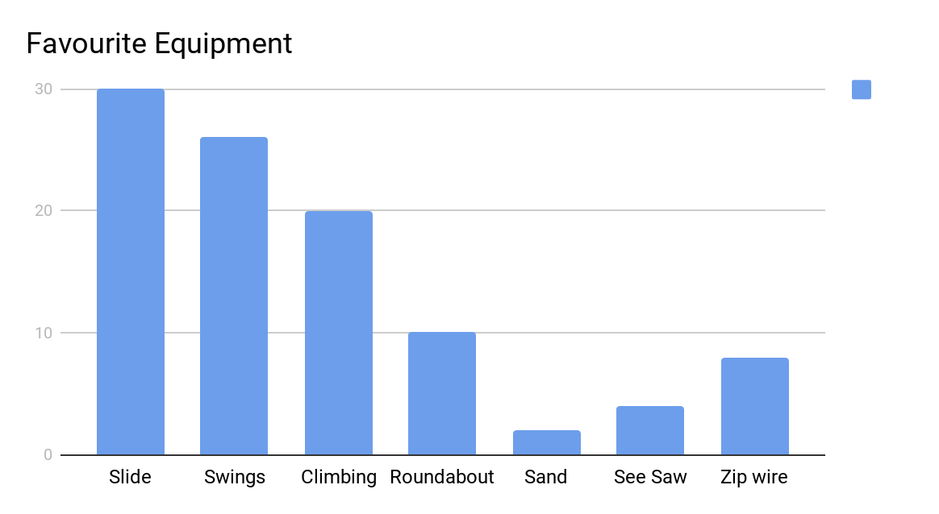

6) When you are at a playground and your child is playing, what do you tend to spend your time doing?

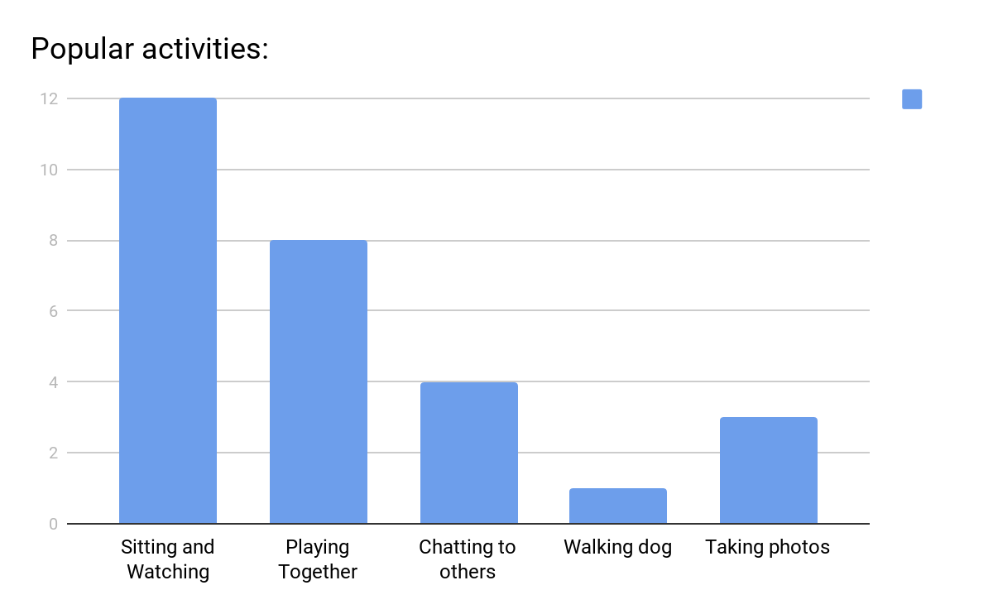
7) When visiting a play area, do you tend to go alone with your child or with others?

Alone with child | 52%
With others | 48%

What would make your experience of visiting a playground even more enjoyable?

Findings:

Many adults commented that comfy seating is very important.
Lots would like to see tables and picnic areas.
A safe, enclosed space was also often mentioned as being important.
Toilets, bins and a clean area is important.
Equipment which adults can also go on, so that they can play together.
A cafe serving hot drinks was also suggested.

Appendix 1 c: Correspondence from resident following Community meeting, April 2019 (included as an example of feedback from an older resident)
I am the head teacher of a special school in Cambridgeshire and I live in Castle Hedingham. I have some experience of play space layouts and although my own children are too old for a play space I hope one day I will be taking my grandchildren to play in Castle.
My starting point would be, how will the space really be used? Obviously by children, but also by the adults taking them: playgrounds are great meeting points for parents who can sometimes be isolated and really need to meet other adults, especially if they are not working. For this reason I would suggest some adult seating (benches), just outside the fenced play area, for supervision whilst adults meet and chat: that works very well in the play park I used in Colchester.
There needs to be some space for older children: I wonder if it would be allowed to make a cycle path outside the fenced area as a safe place to teach local children how to ride a bike: the mound lends itself to that brilliantly and it would be a natural progression from there to cycling around the village. It would also be a great skateboarding path for 10 to 13 year olds to learn to use boards safely.
There needs to be at least one or two items that could be disability accessible for bigger children with mobility problems. Birds nest swings/hammock swings are great for that
Families will mix where refreshments are available: there is a great opportunity for a cafe service from the social club or perhaps ‘pop up’ catering tents/ ice cream van parking in the summer months.
Children parties are expensive and there is a lot of pressure on families to provide them. The new play area, with access to the hall and catering would be a fantastic local venue: I don’t know what use is made currently of the hall for children parties but if not much, then that might be a good thing to publicise for local families who could hire their own performers or just use the hall for party games and food with an outside play space available free.

Appendix 2

Aerial Photograph of Castle Hedingham
Key:
Site A. Old recreation Area known as the New Park recreation field
Site B. Area retained by the landlord for potential new housing development
Site C. Site for new play area and open space (Village Park)

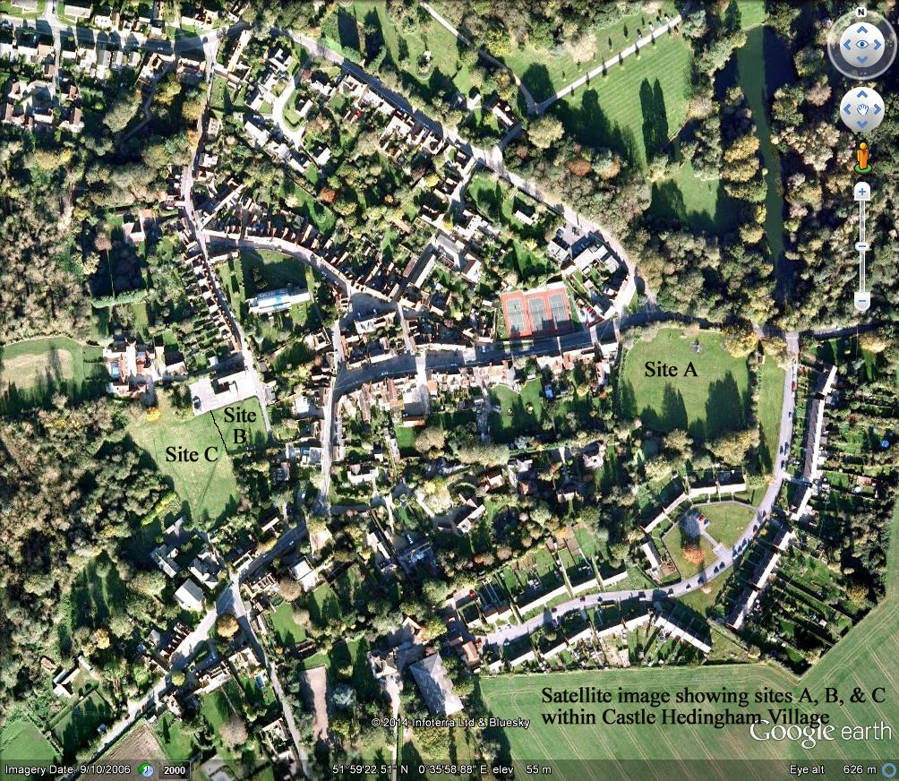

Appendix 3: Map of site offered under lease for 25 years
Key:
A – Main site of Village Park and play area
B – Village Hall and Social Club, leased to Parish Council until 2051
C – Land retained by landlord for possible housing development
D - “Memorial Garden” – also available under the new lease to the Parish Council as confirmed by the landlords at a meeting on 18th September 2019
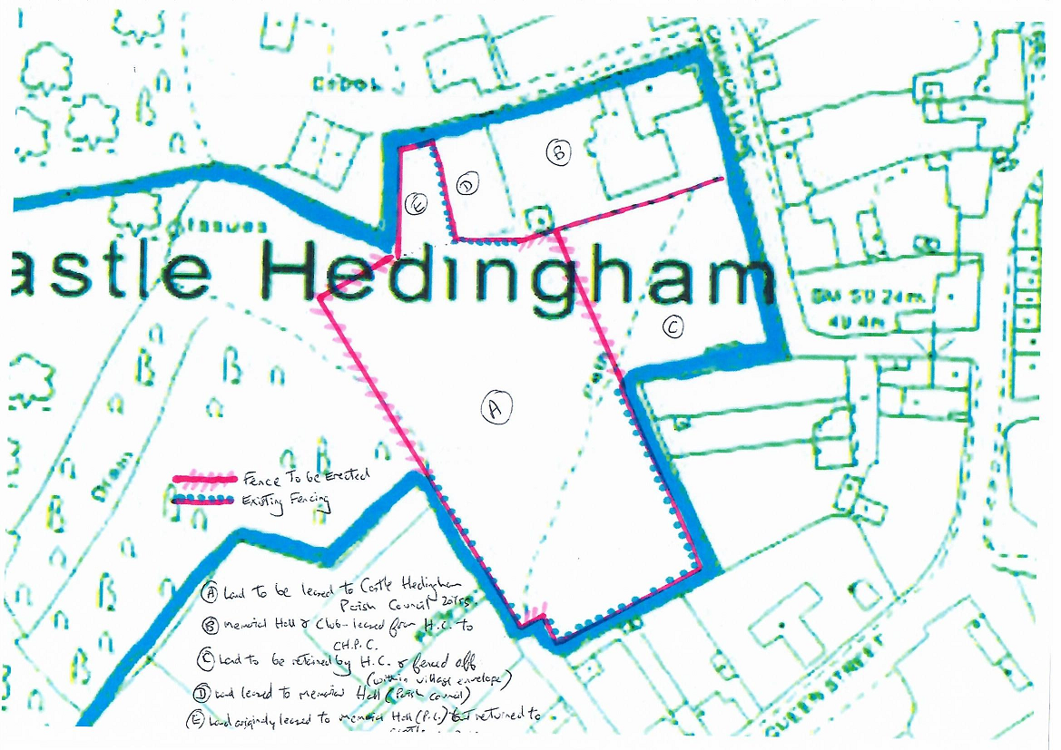
E – Additional land available under the new lease to the Parish Council

Appendix 4: Map showing possible line of medieval inner bailey
(Approximate site area highlighted in green)

