

Ref: ENV0007624C Weather and Soil
Date: 9th January 2025

Contract Ref: | ENV0007624C Weather and Soil
Contract Title: | Cam Nature-based Solutions Weather and Soil Monitoring Equipment

You are invited to quote for the above in accordance with the enclosed documents.

Instructions on what information we require you to provide is in Section 4 of the following Request for Quotation document.

Your response should be returned to the following email address by midday 24th of January 2024 – please include “Cam Nature-based Solutions Weather and Soil Monitoring Equipment” within the subject title.

Email – elanor.hodkin@environment-agency.gov.uk

Please confirm, by email, receipt of these documents and whether you intend to submit a quote.

If you have any queries, please do not hesitate to contact me.

Yours sincerely,

Elanor Hodkin

E-mail: elanor.hodkin@environment-agency.gov.uk

Mobile: 07468708079

Request for Quotation
Ref: ENV0007624C Weather and Soil
Title: Cam Nature-based Solutions Weather and Soil Monitoring Equipment

Section 1

Who is the Environment Agency?
We are an Executive Non-departmental Public Body responsible to the Secretary of State for Environment, Food and Rural Affairs. Our principal aims are to protect and improve the environment, and to promote sustainable development.

Further information on our responsibilities, Corporate Plan and how we are structured can be found on our website.

https://www.gov.uk/government/organisations/environment-agency/about

What do we spend our money on?
We are a major procurer of goods and services within the UK, spending circa £600M per annum, our major spend areas are:

- Flood and Coastal Risk Management (design, construction and maintenance)
- ICT and Telecommunications
- Vehicles and Plant
- Environmental Consultancy and Monitoring
- Temporary Staff and Contractors
- Facilities Management, Energy and Utilities
- Flood Management and Water Related Services

What do we need from our suppliers?
Suppliers are vital in supporting the delivery of our corporate plan. We aim to support the economy and society whilst delivering more environmental outcomes for every pound we spend. In many areas we are leading the way on environmental and technical developments. It is our role to ensure that suppliers clearly understand our corporate aims and objectives and know that we are committed to delivering the best value most sustainable solutions, taking into account the whole life cost of our procurement decisions. We promote diversity and equality and treat all of our suppliers fairly.

Our procurement strategy may be of interest to you as a potential supplier. It sets out our priorities and key commitments in a range of areas such as delivering our corporate plan, Government policy, supplier management and sustainable procurement:

https://www.gov.uk/government/organisations/environment-agency/about/procurement#procurement-strategy

Government changes and collaboration
Since 1 April 2013, the Environment Agency is no longer responsible for delivering the environmental priorities of Wales. This is now the remit of Natural Resources Wales (NRW).Further information can be found here:

http://naturalresources.wales/splash?orig=/

By bidding for this requirement, you may also be approached by other members of the Defra network, NRW or other government departments that are specifically named in the tender document.

Further information
For further information and to see our commitments to Diversity and Equality, please visit our website.

https://www.gov.uk/government/organisations/environment-agency/about/procurement
https://www.gov.uk/government/organisations/environment-agency/about/equality-and-diversity

Also, are you up to date on environmental legislation? See links below for further information.

Waste and Environmental Impact - https://www.gov.uk/browse/business/waste-environment
Environmental Regulations - https://www.gov.uk/browse/business/waste-environment/environmental-regulations’

Section 2

The Customer

Summary

The Contract will be managed as follows:

Project Sponsor: | Leonore Frear, Deputy Director, Environment & Business, Water Quality & Investment
Project Executive: | Huw Richards, Manager, East Anglian Area Environment Planning team
Contract Manager: | Mark Whiteman, Senior Advisor – Groundwater Resources, Environment and Business Directorate, Groundwater Team

The E&B Groundwater Team is responsible for delivering clean and sustainable groundwater as part of a healthy, rich, and diverse environment for present and future generations. The Groundwater Team leads on groundwater quality and groundwater resources across England.

Contract Length

It is anticipated that this contract will be complete when all monitoring equipment is delivered to the Environment Agency. Prices will remain fixed for the duration of the contract award period.

The Environment Agency Conditions of Contract for Services Standard goods and services terms and conditions (£10,000 to £50,000) - GOV.UK (www.gov.uk) shall apply to this contract (Appendix C).

This contract shall be managed on behalf of the Environment Agency by Mark Whiteman.

Contact Details and Timeline

Mark Whiteman will be your contact for any questions linked to the content of the quote pack or the process. Please submit any questions by email and note that both the question and the response will be circulated to all tenderers.

Contact details are:
E-mail: elanor.hodkin@environment-agency.gov.uk
Mobile: 07468708079

Key elements of the process have been reviewed. Anticipated dates for planned activities are below:

Activity | Due Date
Supplier Clarification Questions | ASAP, by 22nd January at the latest
Supplier Responses for Request for Quote | 24th January 2025 (midday)
Evaluation of Request for Quote Submissions | 27th – 29th January 2025
Award of Contract | 30th – 31st January 2025
Delivery date of all Monitoring Equipment | ASAP, preferably by end of February
Project/Contract End Date | Upon delivery of equipment

It should be noted that these timescales and activities may be subject to change.

Section 3

Evaluation Criteria

We will award this contract in line with the most economically advantageous tender (MEAT) as set out in the following award criteria:

- Price – 60% - Please identify individual equipment costs and costs for the overall number of monitoring equipment that is required (Appendix D and Appendix E). Please also include any discounts that are available in Appendix A.

- Quality – 40% - The following quality criteria are weighted in accordance with the importance and relevance attached to each one. Please only supply a maximum of 5 pages of response in your tender document.

Non-Price Criteria | Weighting
Programme (1 page maximum in tender response)  - Delivery – Can all of this monitoring equipment be delivered to Tetra Tech, (Atlantic House, Greenwood Close, Cardiff Gate Business Park, Pontprennau, Cardiff, CF23 8RD) by mid-February (or as close to)?  - Risks - Top three supplier-owned risks and how these will be mitigated. | 30
Technical Specification (2 page maximum in tender response)  - Longevity – What is the lifetime of your equipment?  - Waterproof – Is the entire unit waterproof or just some part of the equipment?  - Supplier’s back-up – Will we be able to maintain access to ask questions and supply replacement equipment in the future? Can you give us examples of your installation and ongoing installation support services? Can you give us examples of your daily rate?  - Modular – Is the equipment straight out of the box or do we need your continued support to install this monitoring equipment?  - Transferability – Is it easy to remove this equipment to another project or do we need additional support?  - Accuracy – How accurate are the pieces of kit? Do they produce accurate data to be able to be used for EA projects?  - Telemetry – What telemetry system will be used? How will the data be linked to the cloud? What will we see online? Will datasets be downloadable? | 30
Previous Experience (1 page maximum in tender response)  - Experience - Please name three similar projects that you have supplied with similar equipment. | 30
Social Value (1 page maximum in tender response)  - Social Value - What social value measures are your company undertaking?  - Net Zero - What net zero contributions are you making? | 10

The criteria listed above will be assessed on a 0 to 10 basis and will reflect the following judgements:

Rating of Response  The tenderer provides a response which in the opinion of the evaluators is: | Score
Excellent: Addresses all of the requirements and provides a response with relevant supporting information which does not contain any weaknesses, giving the Agency complete confidence that the requirements will be met. | 10
Very Good: Addresses all of the requirements and provides a response with relevant supporting information, which contains very minor weaknesses, giving the Agency high confidence that the requirements will be met. | 8
Good: Addresses all of the requirements and provides a response with relevant supporting information, which contains minor weaknesses, giving the Agency reasonable confidence that the requirements will be met. | 6
Satisfactory: Substantially addresses the requirements and provides a response with relevant supporting information which may contain moderate weaknesses, but gives the Agency some confidence that the requirements will be met. | 4
Weak: Partially addresses the requirements, or provides supporting information that is of limited relevance or contains significant weaknesses, and therefore gives the Agency low confidence that the requirements will be met. | 2
Nil: No response or provides a response that gives the Agency no confidence that the requirements will be met. | 0

Section 4

Information to be returned

Please note, the following information requested must be provided. Incomplete tender submissions may be discounted.

Please complete and return the following information:
- completed Pricing Schedule (Appendix A);
- completed Prior Rights Schedule (Appendix B);
- confirmation that terms and conditions are accepted. Please see Standard goods and services terms and conditions (£10,000 to £50,000) - GOV.UK (www.gov.uk) and Appendix C - note that the terms cannot be amended later.

Within the submission you will need to include your responses to the non-price criteria listed above.

Section 5

Specification

Background to Requirement

This monitoring equipment is required to build our evidence base in support of investments through programmes including PR24 and the new Environmental Land Management schemes. The monitoring equipment includes pressure transducers, data loggers and other needed equipment to identify the water resource benefits of nature-based solutions.

Working with nature involves restoring the natural function of catchments, rivers, floodplain, and coasts. On rivers, it can include restoring rivers and floodplains, creating wetlands, capturing runoff in the uplands and in low-lying ponds and planting trees in the right places. Actions that work with natural processes (often called nature-based solutions) can promote infiltration and groundwater recharge, improve groundwater quality, help store water and slow down the rate at which it enters river systems.

Nature-based solutions (NBS) are already in use for natural flood management in the UK, supported by an extensive evidence base. The Environment Agency aims to further develop and improve the evidence base for water resources, and this monitoring equipment will allow us to better improve evidence.

The purchase of this equipment will provide the Environment Agency with important data to assess NBS contributions to water resources across different geologies and to better model NBS features. For example, how quickly a runoff attenuation feature drains into the soil (Figure 1). If we had this data from the monitoring equipment we are buying, this would allow us to properly model the water resources benefits of NBS based on representative data.

Placing this equipment over different geologies will also help us better understand where NBS would be most effective and stop us placing NBS in the wrong areas, which is a waste of time and money.

Specific Objectives/Deliverables

The monitoring equipment is intended to be used to assess the performance of runoff attenuation features (Figure 1 below) to:

- Enhance infiltration to groundwater, and
- Improve low flows in rivers by slowing the flow and lengthening flow pathways.
Figure 2 shows a schematic map of the proposed monitoring for a single intervention, in this case a cascade of earth bunds placed along a small ditch which may experience intermittent flow. The monitoring consists of:

- Upstream and downstream flow meters to measure changes in surface water flow as a result of the intervention
- A weather station to enable calculation of rainfall and evapotranspiration
- Water level measurement (in stilling wells) in each pond created by the earth bunds
- Water level measurement in two transects of shallow piezometers measuring changes to the water table
- An array of soil moisture probes to measure infiltration of water to the water table beneath one of the ponds.
The scope of this procurement is limited to the weather station and soil moisture measurement equipment.

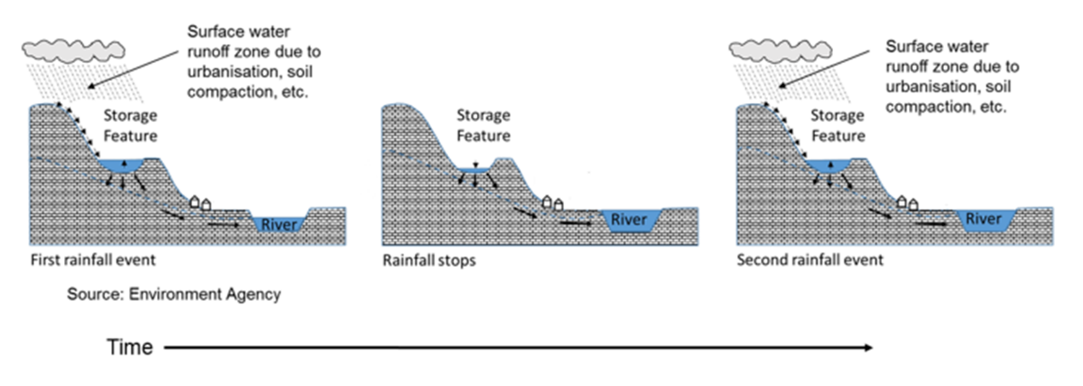
Figure 1: Conceptual diagram showing concept of runoff attenuation feature to enhance infiltration to groundwater.

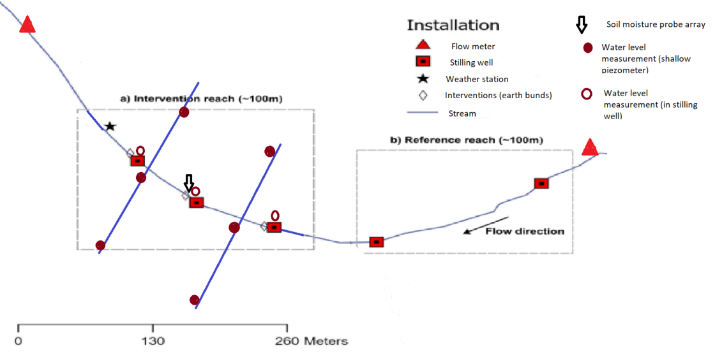
Figure 2: Schematic map showing proposed monitoring for runoff attenuation features (a cascade of earth bunds).

Monitoring data is expected to be uploaded to off-site cloud data storage automatically. The supplier should price for this method of data capture.

The requirement is for equipment to monitor up to 3 sites. The Environment Agency may let a contract for all or part of the equipment.

Task 1 – Delivery of monitoring equipment identified in Appendix D. This equipment must be compatible with existing equipment in Appendix E and fit the outline for Appendix F.

- Purpose of task - Delivery of monitoring equipment listed in Appendix D.
- Task Description - Delivery of monitoring equipment identified in Appendix D for the situation outlined in Appendix F
- Summary Task Products - The delivery of the equipment outlined in Appendix D to this address (Atlantic House, Greenwood Close, Cardiff Gate Business Park, Pontprennau, Cardiff, CF23 8RD) by mid-February 2025.

Timescales/Deadlines

The supplier must provide all the equipment by mid-February 2025 to the above address. If this is not achievable for you, please provide your earliest date for delivery.

The use of Subcontractors

We are happy for companies to work together to supply all of this monitoring equipment listed in Appendix D. We would request that we deal with one main company for the tendering exercise and for the Purchase Order number.

Section 6

Contract Management

This contract shall be managed on behalf of the Agency by Mark Whiteman

E-mail:mark.whiteman@environment-agency.gov.uk

Mobile: 07799 256327

We will raise purchase orders to cover the cost of the services and will issue to the awarded supplier following contract award.

Invoices will be paid after all the equipment has been delivered.

Before the invoice is issued, a fee note must be emailed in advance to the contract manager for approval. All invoices must quote the purchase order number in order to be processed. A file copy invoice must be provided to the contract manager, on request. The timescale for payment of invoices will be up to 30 days after we have received a valid invoice.

Section 7

Sustainability Considerations

We are committed to continually improving our sustainability performance. The Environment Agency has set itself tough objectives as a clear commitment and contribution to sustainable development throughout England. The Agency recognises that this can only be achieved through commitment from all sectors of society, and it is intent on raising awareness amongst industry and commerce.

Contractors must adopt a sound proactive environmental approach, designed to minimise harm to the environment.

Environmental criteria should be considered as part of your tender submission with credit given for innovation. Factors to be considered could include areas such as:
    - Paper use: All documents and reports prepared by consultants and contractors are produced wherever possible on recycled paper containing at least 100% post-consumer waste and printed double sided.
    - Travel: use of public transport, reduce face to face meetings by using email and videoconferencing. Meetings to be held in locations to minimise travel and close to public transport links.
    - Packaging: should be kept to a minimum. Re-use and disposal issues must be considered.
    - Efficient Energy and Water Use.
    - Disposal of Waste: Whilst on site the contractor is responsible for the disposal of their own waste and can only use client facilities with express permission from the on-site facilities officer.
    - Whilst on site, contractors should comply with the local environmental policy statement which will be made available to you in advance or on arrival.

Diversity and Equal Opportunities
We are committed to promoting equality and diversity in all we do and valuing the diversity of our workforce, customers and communities. As a public body, we publish regular information about what our equality objectives are and how we’re meeting them.
https://www.gov.uk/government/organisations/environment-agency/about/equality-and-diversity

Health and Safety
Contractors will be responsible for making sure all required health and safety aspects including risk assessments are undertaken and required management measures are in place to protect worker exposure. This includes management of all partners, consortium members and subcontractors.

IEM2020:

Sustainability Objectives

As the Environment Agency, our overarching aim is to protect and improve the environment for people and wildlife. Over the last 10 years we have achieved significant reductions in our environmental impacts that occur through our everyday operations. This included a 40% reduction in our carbon emissions and a 37% reduction in the number of miles we travel. This year we have launched our new Internal Environmental Management strategy to take us through to 2020, building on these successes and widening our ambition.

Supply chain

Our 2020 approach will have a very strong emphasis on the indirect impacts of our supply chain.

Our supply chain accounts for over 70% of our total environmental impacts.

Working with our supply chain we want to be world class in the area of environmental management. The environmental impacts of our work and that delivered by and through our supply chain must be reduced; environmental risks must be effectively managed and opportunities for enhancements investigated.

As an organisation, our environmental management system (EMS) is accredited to ISO14001 and EMAS standards. Our procurement activities form part of this system; driving environmental performance improvements across the value chain.

Section 8

Additional Information

Copyright and confidentiality

Unless otherwise indicated, the copyright in all of the documentation belongs to the Environment Agency, and the documentation is to be returned to us with your tender. The contents of the documentation must be held in confidence by you and not disclosed to any third party other than is strictly necessary for the purposes of submitting your quote. You must also ensure that a similar obligation of confidentiality is placed upon any third party to whom you may need to disclose any of the documentation for the purposes of the tender.

Accuracy of documentation

You should check all documentation; should any part be found to be missing or unclear you should immediately contact us at the address given in the covering letter. No liability will be accepted by the Environment Agency for any omission or errors in the documentation which could have been identified by you.

Amendments to documentation

Prior to the date for return of tenders, we may clarify, amend or add to the documentation. A copy of each instruction will be issued to every Tenderer and shall form part of the documentation. No amendment shall be made to the documentation unless it is the subject of an instruction. The Tenderer shall promptly acknowledge receipt of such instructions.

Alternative Offers

Alternative offers may be considered if they constitute a fully priced alternative and are submitted in addition to a quotation complying with the requirements of the Invitation to Quote Documents. If, for any reason you wish to submit an alternative offer without a fully compliant tender please contact us in accordance with the details in the covering letter.

Continuity of personnel

The Contractor shall employ sufficient staff to ensure that the Services are provided at all times and in all respects to the Project Standard. It shall be the duty of the Contractor to ensure that a sufficient reserve of staff is available to ensure project delivery in the event of staff holidays, sickness or voluntary absence.

The Environment Agency will be notified immediately of any changes to personnel associated with the project. The Contractor will ensure that every effort is made to replace outgoing staff with personnel of equal calibre and expertise. All new members of staff undertaking work for the Project will need to be agreed by the Environment Agency prior to commencement.

At all times, the Contractor shall only employ in the execution and superintendence of the Contract persons who are suitable and appropriately skilled and experienced.

Intellectual property rights

All results, including material and tools produced, developed or paid for under this contract shall be the property of the Environment Agency.

References

The Environment Agency may request recent and relevant references prior to the award of the project.

Contract award

This Request for Quote is issued in good faith, but we reserve the right not to award any or all of this work.

DATA PROTECTION ACT ADDENDUM TO SPECIFICATION

Protection of personal data

In order to comply with the Data Protection Act 1998 the Contractor must agree to the following:

- You must only process the personal data in strict accordance with instructions from the Environment Agency.

- You must ensure that all the personal data that we disclose to you or you collect on our behalf under this agreement are kept confidential.

- You must take reasonable steps to ensure the reliability of employees who have access to personal data.

- Only employees who may be required to assist in meeting the obligations under this agreement may have access to the personal data.

- Any disclosure of personal data must be made in confidence and extend only so far as that which is specifically necessary for the purposes of this agreement.

- You must ensure that there are appropriate security measures in place to safeguard against any unauthorised access or unlawful processing or accidental loss, destruction or damage or disclosure of the personal data.

- On termination of this agreement, for whatever reason, the personal data must be returned to us promptly and safely, together with all copies in your possession or control.

APPENDIX A - PRICING SCHEDULE

ALL COSTS QUOTED MUST BE EXCLUSIVE OF VAT
All costs must be quoted on this schedule. Any costs not detailed will not be paid.

Staff Costs
Please detail the day rates of your proposed personnel in the table below.
(Please also advise how many hours you constitute a working day)

Please detail your task costs in the table below.

 | Cost Proposal (To be completed by Supplier)
Equipment | Individual  Cost | Combined  Cost
Subtotal for Task 1
Total Cost |  | £### ex VAT

Other costs
Please state any other costs that will need to be taken into consideration.

Expenses and Other Costs (To be completed by Supplier)
Equipment costs | Cost
Subtotal for Task 1
Total Expenses and Other Costs | £#####

Discounts, rebates and reductions
Please detail below any discounts, rebates and other reductions you are prepared to offer and the basis of those incentives

Discounts, Rebates and Reductions (To be completed by Supplier)
Equipment | Rebate
Equipment supplied for 3 sites – cost as quoted in appendix D | 0%
Total Discounts, Rebates and Reductions

Total Overall Cost
Please detail the total fixed cost for the project

Total Overall Cost (To be completed by Supplier)
Total Staff Costs

Total Expenses and Other Costs

Total Discounts, Rebates and Reductions

Total Overall Cost | £#### ex VAT

The following limits will be applicable to all claims for travel and subsistence under this contract:

- Travel by rail: standard class should be used at all times
- Travel by car: 45 pence/mile

Hotel bookings should be made through the Environment Agency’s corporate travel contract. Details of this contract are available from the Corporate Contracting Team.

When making reservations you should state that you are a contractor working on Environment Agency business.

Hotel charges must not exceed a maximum limit per night bed and breakfast (VAT included) of: £140 in London; £100 in Bristol; £90 in Warrington; £85 in Reading; £75 in Aberdeen, Birmingham, Belfast, Cardiff, Coventry, Edinburgh, Glasgow, Harlow, Leeds, Manchester, Middlesbrough, Newcastle, Oxford, Portsmouth, Sheffield and York; and £70 in all other destinations. Please note that these hotel ceiling rates are subject to change throughout the life of the contract.

Expenditure on dinner during an overnight stay must not exceed a maximum limit of £25, including a drink.

Receipts for all rail travel, hotel and food expenses will be required as proof of expenditure and will be reimbursed at cost. No profit or additional cost shall be applied by the contractor to such personal expenses.

APPENDIX B - PRIOR RIGHTS SCHEDULE

Details of Prior Rights held by the Parties (To be updated as Rights are introduced during the period of the Contract)
Prior Rights owned or lawfully used by a Party, whether under licence or otherwise, which it introduces to the Project for the purposes of fulfilling its obligations under the Contract

Held by the Environment Agency

Name and description of Prior Rights | Extent of proposed use in the Project | Proprietary owner of the Prior Rights

Held by the Contractor

Name and description of Prior Rights | Extent of proposed use in the Project | Proprietary owner of the Prior Rights

Explanation of Contractor's Prior Rights
All Intellectual Property Rights owned by or lawfully used by the Contractor, whether under licence or otherwise before the date of this Contract. It can also mean any invention and know how or other intellectual property (whether or not patentable) owned by one of the parties prior to the commencement of the Project, or devised or discovered by one of them only in the course of other projects during the Project period and not arising directly from the Project.

APPENDIX C – ACCEPTANCE OF TERMS AND CONDITIONS

I/We accept in full the terms and conditions (Standard goods and services terms and conditions (£10,000 to £50,000) - GOV.UK (www.gov.uk)).

Company Name:

Signature:

Print Name:

Position:

Date:

APPENDIX D – REQUIRED MONITORING EQUIPMENT FOR 3 SITES

Monitoring Equipment for Cam NbS trials | Required
Soil moisture probes and associated power source and data loggers (7 probe array x 3 sites)(see Appendix G) | 3
Weather station: essential parameters are rainfall, and those required to determine Penman Monteith reference evapotranspiration (temperature, relative humidity, wind speed, solar radiation). | 3
Waterproof kiosk and solar panel, regulator and battery for weather station | 3
Supplier deployment, maintenance and software | Y

APPENDIX E – EQUIPMENT COMPATIBILITY

Equipment provided must be compatible with existing monitoring equipment including:

- 3 x weather stations – Model: WS700-UMB Smart Weather Station
- 3 x telemetry outstation - XLink 500 logger with battery and solar regulator
- 3 x Solar Panels – Model: 20W Ameresco Solar PV Panel 420J
- 3 x cloud hosting for weather stations - Hydromet Cloud Station Setup
- 3 x Mount Kits for the Solar Panel
- 6 x water level monitoring – OTT Orpheus Mini logger with pressure transducer with a measuring range of 0-4m with 15m of cable – with the intention for measuring water level to convert to flow. But may not be suitable and therefore, will be used for GW levels, as required,
- 9 x water level monitoring – OTT Orpheus Mini logger with 15m probe cable – for use of measuring water levels
- 9 x water level monitoring – OTT Orpheus Mini logger with 20m probe cable - for use of measuring water levels
- 9 x water level monitoring – OTT Orpheus Mini logger with 30m probe cable - for use of measuring water levels

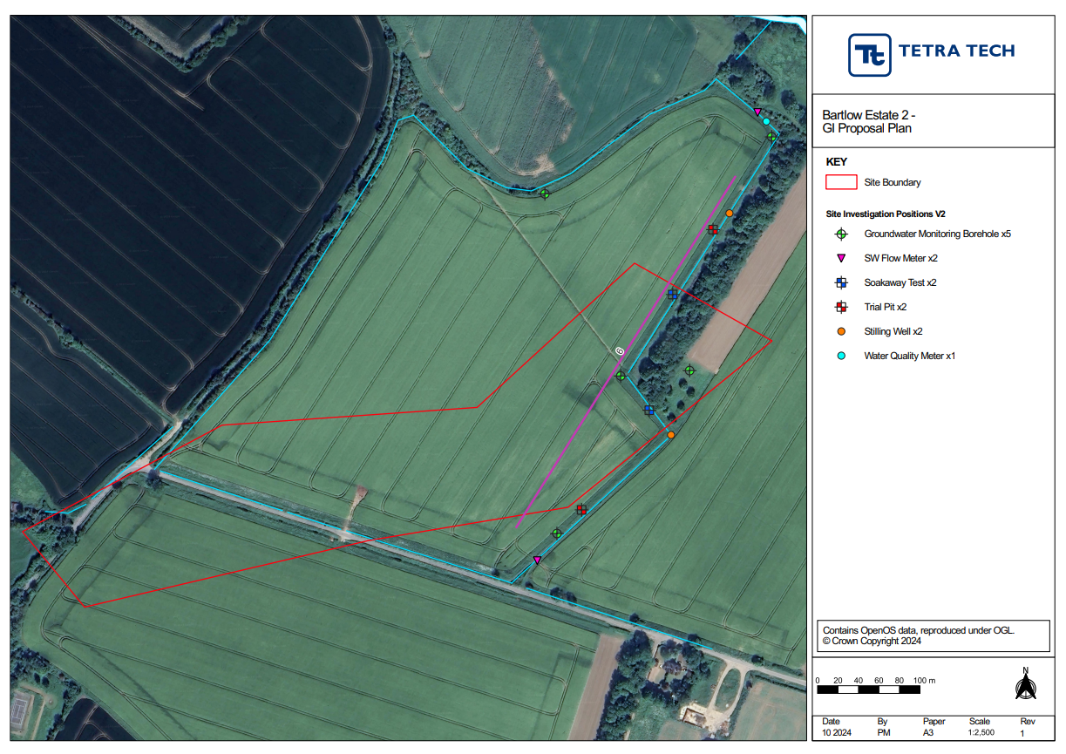
APPENDIX F – MONITORING PLAN SITE EXAMPLE

APPENDIX G – Soil Moisture Probes

Soil Moisture Probes - Background
The requirement is to measure a profile of soil moisture measurements at various depths within the soil profile. At each site multiple soil moisture probes will be installed close to each other but at different depths. The table below indicates the number of probes per site and probe depths. The most cost-effective method for storing the data and powering the loggers is sought. Data is expected to be uploaded automatically by telemetry to cloud data storage. Data loggers should be enclosed in tamper proof waterproof box.

Sites | Number of soil moisture probes per site | Total probes | Soil moisture probe depths (m)
3 | 7 | 21 | 0.25, 0.5,1.0,1.5,2.0,2.5,3.0
Overall total |  | 21

