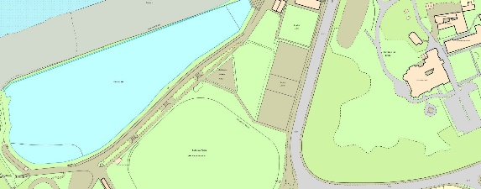
Current Facilities
The area is part of the Salthouse Field Park, 3 years ago it was used as the works compound for the renovation of the Marine Lake.
Access to the Site
Access is from Elton Road across the Salthouse Field and North Somerset Council’s Land.
The contractor will be expected to protect the land and member of the public using the area.
The Site.
The Skatepark is located at Salthouse Fields, Elton Road, Clevedon. Nearest Postcode BS21 7RH.
The land is owned by North Somerset Council, and will be leased by Clevedon Town Council. The area is located between the Skatepark and the Tennis Courts & Multi Use Games area.

The Project
The project is to build a new pump track utilising the full extent of the agreed area. The vision for the new pump track is as follows.

- The Users
- The facility must accommodate, scooters & bikes.

- Progression
- The facility must provide the opportunity for absolute beginners of any age and ability. This includes young people with disabilities, such as wheelchair users.

- Users with more skills and experience must have opportunities to test themselves on challenging elements of the site.

- Transition
- The facility must have a flow which allows for laps of the site,.

- Design Concept
- It is important that the pump track has a unique look and feel, both as a pump track and as a public space. Tenderers are encouraged to suggest design concepts which reflect the character of the Town and the location.

Images of types of desired structures

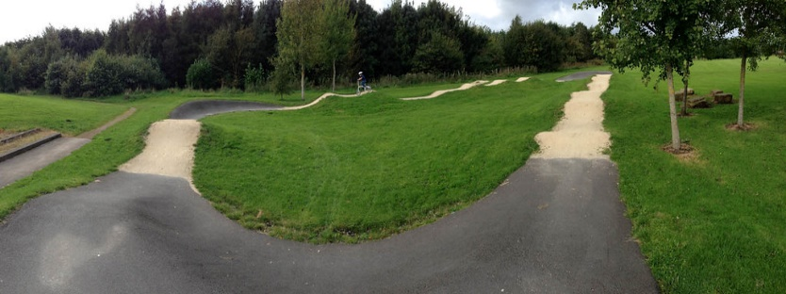
This Photo by Unknown Author is licensed under CC BY
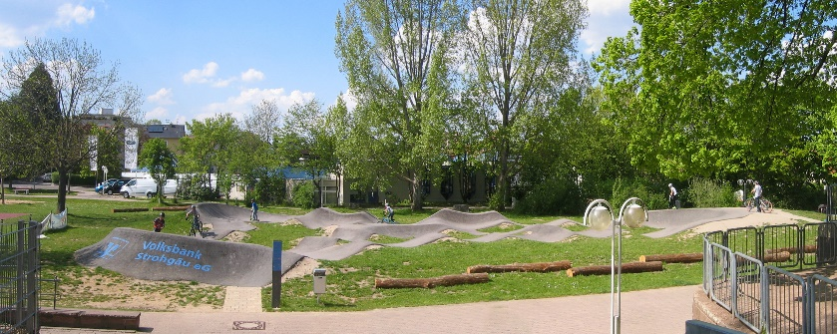
This Photo by Unknown Author is licensed under CC BY-SA-NC
This Photo by Unknown Author is licensed under CC BY-SA

Removal of Existing Equipment
The tenderer should include costs to prepare the ground and dispose of waste materials in line with current legislation.

Fencing
Tenderers should include provision to install such fencing or barriers to protect users of the park and footpaths adjacent to the site. Consideration must be given to the proximity of the Bristol Channel and the effect of sea spray.

