Solar Panel Tender - Project Number: 001
Gul Skills Community Hub Project

Questions & Answers

Question 1a:
We have come across your open tender and I am just looking in to whether we will take part.
There are a couple of major design queries I have and I want to cross check whether these have already been considered or not as it has the potential to drastically improve or be of detriment to the benefit the end system to the centre.

I assume if the existing system has a FIT on it that you have been claiming this? I would imagine that this would have the potential to be a significant amount of money and if it was installed in 2008 there would still be 9 years to go it. Historic feed-in tariffs from this sort of period can be around 50p/per KWH but the FIT is based on the panels that the FIT was registered to so you wouldn’t want to remove these and instead you would generally optimise them to ensure the maximum output and then add a secondary system alongside it.
Can I ask if this has been considered?

Answer 1a:
Unfortunately, two of the three current solar inverters are not working so we have been unable to claim much FIT for a while. We also know the panels aren’t of a good quality.
The advice we have received is that the cost of repair of these would not be as cost effective as replacing the whole system with the grant funding we have secured for this.
However, if there is a way to retain the FIT I’d be interested to see this in your proposal.

Question 1b:
Can you just cross check what the FIT value is per KWH as I genuinely believe this is where you would make the most money for the Centre by trying to keep this alive. If you can find the documents (even if it has been a low number of KWH whilst 2/3rds of the system has been working), and the dates its eligible to/what the current panels are. There are a few different ways you could potentially do this and I can help and advise with this info. It may mean that your overall spec would change and I appreciate you need like for like quotes, but this is definitely worth checking out as you could still end up with a larger solar array and your batteries but with a potential significant sum being paid to the centre for 9 years on top (which you could use to fund other good things in the Centre). I take it its not too late to amend the spec for all tenderers if it was found to be beneficial?
Happy to offer advice with this as always good to see local initiatives getting the absolute best possible value.

Answer 1b:
Are the following two documents enough information for you to work with?

Question 1c:
I’ve just been looking in to this as you say the install was 2008 but I don’t believe feed-in-tariffs were until 2010. I expect this is a migrated RO which has a current rate of 14.9p
At 14.9p, you should be able to get at least a 1000KWH/KWP which is worth nearly £2000 PA to the Centre. It will be worth speaking to your FIT supplier just to check what the current rates are, when the system was registered and when the feed-in-tariff ends.
There are then a few possibilities:
- You could upgrade the inverter system on the existing system with optimisers and Solaredge, keep this section connected to your existing generation meter to claim the FIT on this element and then have a 2nd system. Batteries would still benefit the whole of the installation.
- They often allow you to upgrade the panels on this element of the installation but this part kept separate and the KWP of the system kept the same. 63no 210W panels = 13.23KW (this could be with 28 x 475W panels as opposed to the current ones.
- They often allow you to have a larger system all connected to the same system but then the FIT is paid on a pro-rata basis (EG- you have a 45KW total system, and 29% of the system is paid with FIT and the remainder isn’t)

May I suggest you speak to SSE to confirm if they would accept (ideally option 3, if not option 2 or if not option 1).

I appreciate this is a bit of a faff but I do think its important this is all considered to make sure the system is as profitable as possible for you.

Answer 1c:
Thank you for your proposal. We will investigate further and get back to you next week.

Conclusion
Thank you very much for contacting us regarding the tender.
After much consideration we have decided to proceed with the Tender as published and choose a supplier.
We are still waiting for a response from Ovo who have taken over our SSE account and can not delay the tender further due to our grant funding timescales.
Please include your suggestions in your tender document and we will consider them when choosing our supplier.
Thank you again for getting in touch.

Question 2

With reference to our phone conversation yesterday regarding the tender for a Solar PV installation at the above premises. If you go ahead with this you will lose you FIT and Export payments, as you must have permission from OFGEM for any changes in the original equipment installed in 2008.
OFGEM will only agree to changes in equipment if a qualified installer reports that a particular item of equipment cannot be repaired. This is only likely to apply to an inverter as there are no moving parts on a panel. The only time they might agree to change a panel is if there has been a fire. There is no reason why your panels should not still be 80-85% effective as long as they have been wired correctly. I would suggest that they need a clean and that the trees be removed or at least pruned below gutter level to prevent any shading and loss of generation. There are still 10 years left of FIT and Export payments which I have calculated could amount to at least £25,000. Because your EXPORT payments are based on 50% of your generation you can still install a AC inverter with a battery ( Subject to DNIO approval) and this will not affect those payments. Should you require any further information or survey, please contact me at any time.

Answer 2:
We are investigating this further. We will be back in touch with an update soon.

Question 3:
Out of interest how much do you charge for a full survey of the equipment we have which will identify the problems both in the inverters and our ROC meter which stopped giving readings last month.
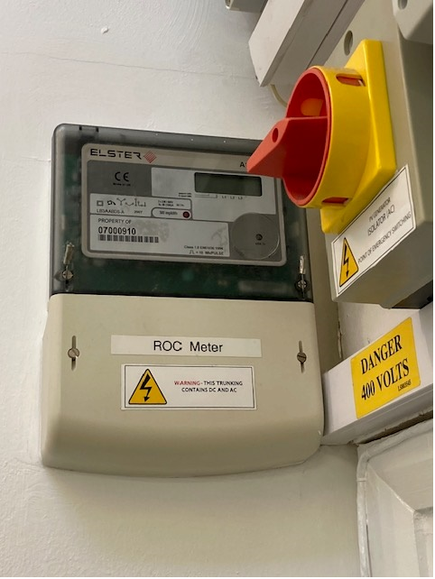

Answer 3:
We could do a full service report on your installation for £585 plus vat. Please let me know if we can be of any further help.

Conclusion
Thank you very much for your emails and offer of support.

After much consideration we have decided to proceed with the Tender as published and choose a supplier.

Question 4:
Just to be clear, you want all the existing panels and inverters removed and new panels replaced in the same position. If so, is the height of the tree in front of the premises to be lowered.
Answer 4:
Yes we are currently looking at employing a tree surgeon to remove the tree.
We require everyone to quote against the specification to compare quotes, but if there is anything else you’d like to include in your tender response please do.

Question 5:

Can you please confirm if the requirement to remove the existing panels & inverters, and dispose.

Answer 5:

See Section 8.6 Page 44 of tender document.

8.6 Waste Disposal
All waste, rubbish or litter arising from the installation shall be removed as it accumulates and disposed of by the Contractor.

The costs for this can be listed under “Other Costs”

Question 6:

Can you provide your annual usage kWh and the price p/kWh.

Answer 6:

This is based on circa 53,000 kWh a year.

