

Date: October 31st 2022.

Dear Sir or Madam,

TENDER FOR 1) SHINGLE HABITAT RESTORATION, 2) INSTALLATION OF BRUSHWOOD FENCING AND 3) INSTALLATION OF PREDATOR EXCLUSION FENCING, LONG ISLAND, LANGSTONE HARBOUR

Suppliers can bid for one of more of the three lots outlined above.

Period February/March 2023 (preferred) or September 2023 (September works subject to license extension).

You are invited to tender in competition with others to provide the goods and/or services specified above to the RSPB.

The following documents are enclosed and must be, where applicable, completed and signed on behalf of the supplier.

Document A | Instruction and Information
Document B | RSPB: A Brief Introduction
Document C | Specification of Goods / Services
Document D | Company Information
Document E | Form of Offer
Document F | Terms and Conditions
Document G | Certificate of Bona Fide Offer

Your tender response should be emailed to wez.smith@RSPB.org.uk by 23:59 Sunday December 5th 2022.

Only tenders submitted in accordance with the RSPB’s Terms and Conditions will be considered. Any tenders that are incomplete, or received after the time indicated, may be disregarded.

If you wish to discuss any aspect of this tender prior to tendering, please email Wez.Smith@rspb.org.uk or David.Whelan@rspb.org.uk.

If you do not wish to tender on this occasion, please let us know.

Yours faithfully

David Whelan – Warden, RSPB Langstone Harbour Reserves
Wez Smith – Senior Project Manager, LIFE on the edge
 | Document A  Instructions and information

- This document is designed to be completed electronically. You are required to mark boxes, insert information or submit additional documentation in response to the questions herein. Whilst the text boxes should expand as you add text, if there is insufficient space for your response please attach a separate document clearly marked with the name of your Company, the reference number and the number(s) of the question(s) to which it relates. Please ‘sign’ this document by adding your name to the end of Document G.
- If you are unable to comply with a request for information or provide documentation requested then a written account explaining the absence of the information must accompany the return of this tender. Please be aware that the failure to respond to any of the questions, without a written reason, may result in a negative evaluation of that element within the overall evaluation of this questionnaire.
- The RSPB may require supplementary information or clarification or further evidence of the information given. The RSPB may wish to visit reference sites given as evidence of relevant experience.
- The RSPB may request interviews with all or a selection of applicants or none. Applicants will be notified in due course. The ability of suppliers may also be determined by, amongst other factors, references, certification, site visits and ‘mystery shopping’.
- Please answer the questions specifically for your company, NOT for the group if you are part of a group of companies. Please note the term “Company” refers to: Sole proprietor, partnership, incorporated company, co-operative, or voluntary organisation as appropriate.
- During the term of this agreement and for 1 year thereafter, neither party shall solicit to work for it any person who is or was employed by the other party and who has been involved in the provision of the Services at any time during the preceding 12 months. For the avoidance of doubt, if a person who is or was employed by the other party at the relevant time responds to a publicly advertised recruitment campaign, the recruiting party shall not be deemed to have solicited that person from the other party. If either party is in breach of this it shall pay to the other party an amount equivalent to the gross salary paid by that other party to the relevant employee for the final 12 months of employment.
- No charge will be made to the RSPB by applicants for any preparation costs accrued during the tender process, whether the applicant was successful or not.
- You are invited to submit your best offer for the work as detailed below. The RSPB reserves the right to undertake post-tender negotiations.
- If you require any further information or clarification regarding this tender, please email Wez.Smith@rspb.org.uk or David.Whelan@rspb.org.uk
- It should be noted that in any contractual relationship that is subsequently entered into, reference will be made to the detailed information provided in the formal response to this tender document provided by the successful organisation. Thus, answers and information given in your reply will become a binding part of the contractual obligations between yourselves and the RSPB.

- Timetable

Invitation to Tender document sent out | October 31st 2022
Tender documents to be returned | December 5th 2022: 11:59pm.
Award of contract | December 2022 (dependent on permissions being in place).
Commencement of works | February-March 2023
End of contract | On site completion

- The RSPB does not bind itself to accept the lowest or any Tender and reserves the right to accept part only of a Tender. RSPB reserves the right to procure individual elements of the required solution from one or more supplier as appropriate.
Whilst the RSPB aims to provide feedback on failed submissions this may not always be possible, and the RSPB is under no obligation to do so.

- Tender Evaluation Process

Tenders that fail to meet essential requirements may be excluded from consideration.

Tenders that fulfil essential requirements will be evaluated on the basis of the most economically advantageous tender. Weightings as detailed below.

Criterion | Weighting
Ability to meet the tender criteria, setting out a proposed methodology for its completion. | 30%
Cost of services and any added value. | 40%
Health & Safety plus Environmental considerations | 30%

Document B

A Brief Introduction

For details on the RSPB’s challenges and achievements in the previous financial year please go to How the RSPB is Run | About Us - The RSPB.

For an overview of the RSPB please go to: About the RSPB - The RSPB

Background context to the project and site

The low-lying coastlines of north-west Europe support globally important numbers of breeding, migrating and wintering waterbirds. These birds and their habitats are protected within an extensive network of SPAs, but are nevertheless under great and growing pressure. This is due partly to natural erosion and deposition, partly to climate change-induced sea-level rise, and partly to developmental and recreational impacts. The RSPB Sustainable Shores report (2018) highlighted the past losses, poor quality of remaining, and predicted future losses of coastal habitat and recommends a programme of habitat management/creation to address this. The report highlights where losses will be greatest, and where the best opportunities occur to address these problems. This project builds on these recommendations and aims to bring significant benefit to multiple breeding and wintering shorebird species locally by safeguarding a uniquely used area of shingle habitat and where possible, improving upon its availability.

The RSPB has secured funding via ‘LIFE on the edge’, our core charitable funding and potentially others, to carry out habitat creation and restoration for shore birds both at our Langstone Harbour reserve in Hampshire. The reserve comprises of a series of shingle and saltmarsh islands within the northern part of Langstone Harbour. These islands currently provide vital breeding and wintering habitat for a host of species but hold the potential for further productive and resilient habitat for breeding little tern, sandwich tern, oystercatcher, ringed plover and a wide range of migrating and wintering species.

Long Island is one of the northern most islands of the reserve and has an extensively vegetated shingle and soil ridge on it’s north eastern side, currently not useable for shingle nesting or roosting birds. By depositing fresh shingle on part of this ridge, we aim to create ideal condition for breeding and roosting coastal birds. This shingle habitat restoration/creation will be coupled with the erecting of a predator exclusion fence as foxes accessing from the west are a known factor further lowering shore nesting bird productivity in these areas.

Langstone Harbour has been designated a SSSI, SPA, Maritime SAC and Ramsar site, The RSPB have been liaising with Natural England, Marine Management Organisation and licensing/permissions have been granted to carry out works. A planning permissions application is currently being processed with Havant Borough Council.

This project is part of an ongoing and wider plan to improve habitat for beach nesting and roosting birds throughout southern England and to make the Langstone Harbour islands more resilient to climate change and rising sea levels. The works being tendered for are part of a set of two projects taking place in 2023 which the RSPB are aiming to follow with a further eight similar projects of larger and smaller scale throughout the Solent before 2028.

BRIEF DESCRIPTION OF WORKS

The information below is not intended to limit creative or original thinking in the preparation of proposals.

The primary aim of this project is to deliver and use shingle to increase the height of a ridge on Long Island in Langstone Harbour by 0.7m. This will be accompanied by a brushwood fence on the ridges west side and a surrounding predator exclusion fence. Tendering parties may wish to bid on all parts or selected parts.

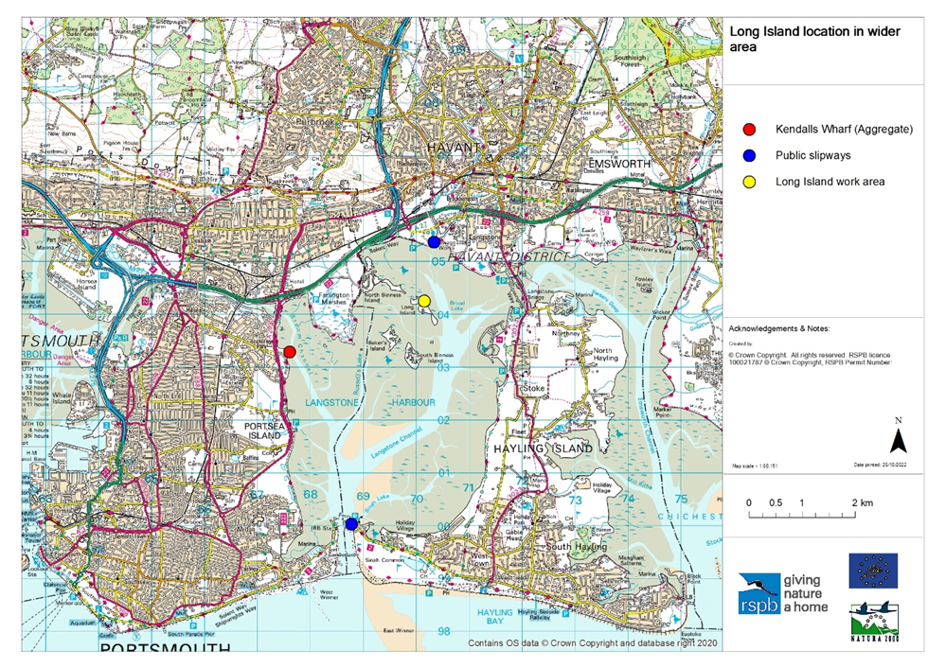
Figure 1: A map showing the work site within the wider area and highlighting potential slipways to use and the Kendalls Aggregate Wharf.

Subject to the relevant permissions being finalised in November/December 2022, it is envisaged that works will take place in February and/or March of 2023. There is the potential that works may need to take place during September 2023 but this would require further permissions. These windows of opportunity have been selected in order to limit the disturbance to the designated birdlife for who the project is being carried out

Flexibility in how our aims are achieved is open to the tendering party, but a brief is set out in section 4.2 of the attached shadow HRA.

The proposed works are being tendered on three scales:

- The delivery and placement of 2000 tonnes of shingle forming a ridge approximately 200 metres long, 10 metres wide and 0.7m high. In this case the brushwood fencing would be approximately 210 metres long and the predator exclusion fence would be approximately 450m in perimeter. (This is our preferred option).
- The delivery and placement of 1000 tonnes of shingle forming a ridge approximately 100 metres long, 10 metres wide and 0.7m high. In this case the brushwood fencing would be approximately 110 metres long and the predator exclusion fence would be approximately 250m in perimeter.
- The delivery and placement of 500 tonnes of shingle forming a ridge approximately 50 metres long, 10 metres wide and 0.7m high. In this case the brushwood fencing would be approximately 60 metres long and the predator exclusion fence would be approximately 150m in perimeter.

Our vision for the shingle placement is to have the bulk of material being larger cobbles which are more resistant to wave action, with a heavy capping of smaller shingle more suitable for nesting and roosting bird use. An approximate ratio of larger to smaller shingle would be 85/15%.

Our initial vision is the use of a vessel with a crane to offload shingle to Long Island via a shallow draft pontoon. Plant machinery such as tracked dumpers and/or light weight excavators could then distribute the shingle evenly across the project area. During a high spring tide, the fully loaded vessel could depart Kendall’s Wharf after loading with shingle (Grid reference SU 67594 03232, https://www.kendalls.co.uk/ ) and land on the east side of Long Island (Grid reference SU 70184 04260, marked in red on Figure 3). From there, the shingle could be offloaded and the vessel returned to be reloaded and ready for the next high tide. Because of the amount of shingle required for the Long Island project area, it is expected that multiple marine deliveries will be needed to complete the operation (depending on the size of the vessel and option scale).

In order to meet the condition of our marine licence, vessel landings must be undertaken during high spring tides only and protective matting / bog mats must be placed over the route between the landing site and placement area so that the foreshore is protected from compaction and truncation. Spring tides in the proposed period take place approximately Feb 7th-9th, Feb 19th-25th, March 8th-11th and March 20th-25th.

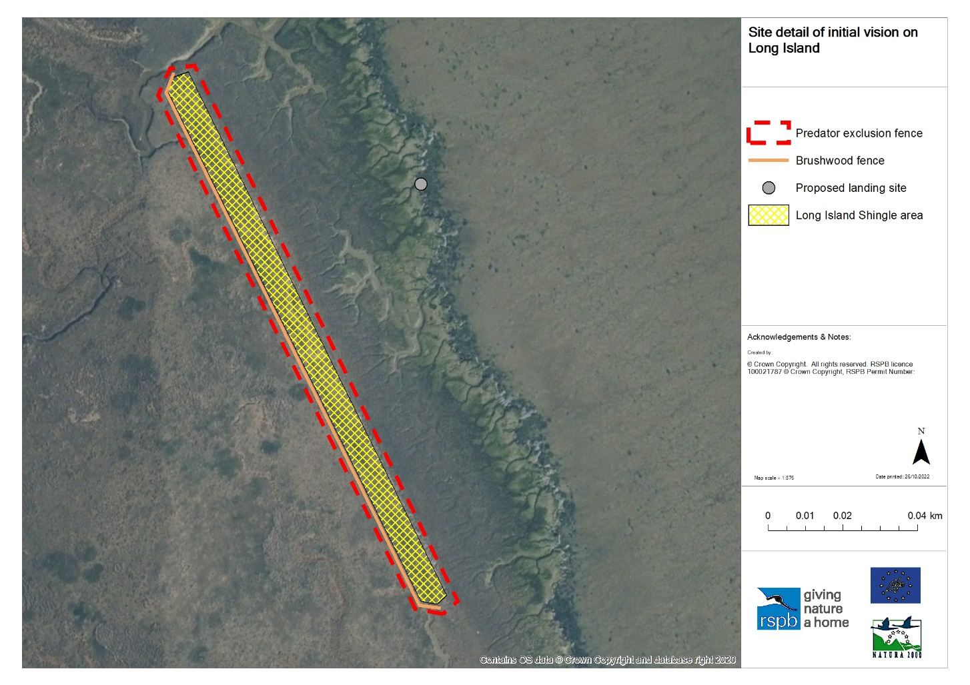
Figure 2: A map of the site components to be created/installed on Long Island (option A).

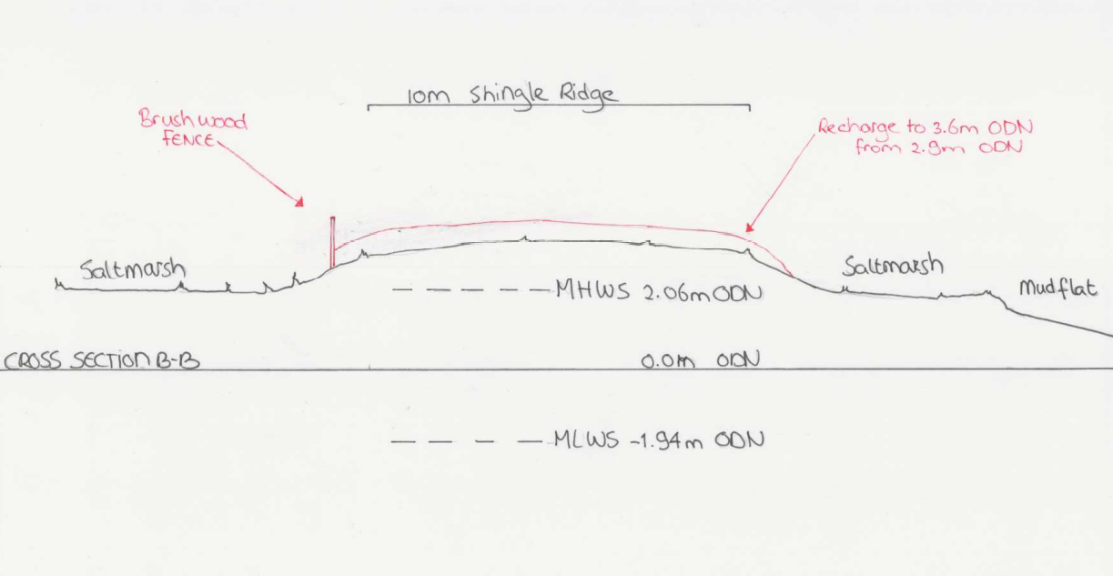
Figure 3: cross section of the proposed works on Long Island.

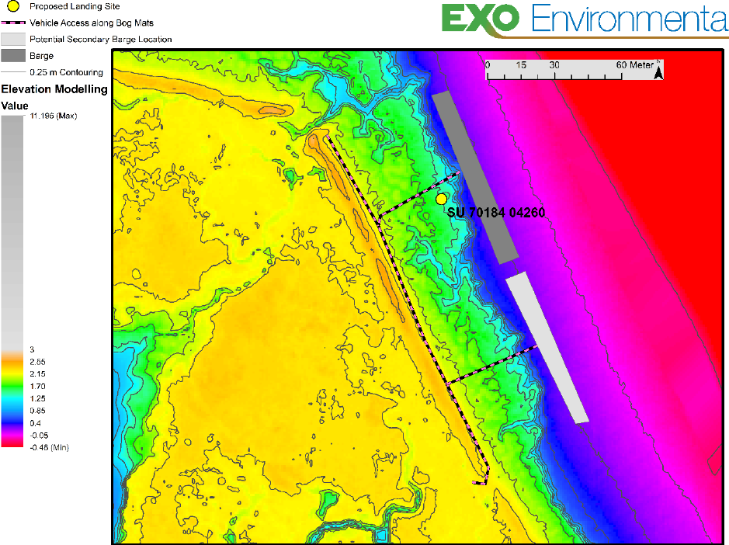
Figure 4: Elevation map showing potential access and bog mat placement for option A (from attached HRA document).

A brushwood fence must be erected on the west side of the newly created shingle ridge. This will prevent the shingle from encroaching on and smothering coastal saltmarsh, a protected habitat. This simple solution will be created by inserting poles into the ground and filling the middle with brushwood faggots. Some additional side supports may be needed (see figure 5 and attached HRA).
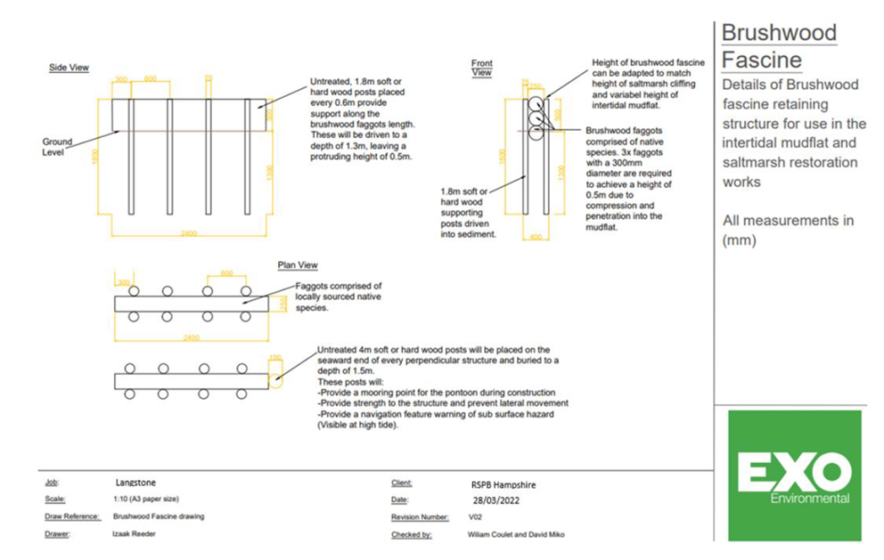
Figure 5: A diagram of the proposed brushwood fence.

Predator exclusion fencing is to be erected around the circumference of the shingle ridge and brushwood fence. The envisioned spec is as follows:

Wire mesh: Tornado RL 23/240/5 C5.

Wooden posts: sweet chestnut (better) treated with a wood preservative safe for marine environment. Forest Stewardship Council (FSC) certified, ideally locally grown and manufactured. 2.4 metre full round 100mm posts at 4 metre intervals. Full round 150mm 3 metre strainer posts where needed at changes of direction. Minimal external fence features, such as strainer post stays.

Electric wire:
- Live strand (1) 0.60-0.65m above ground and off-set by 80mm
- Live strand (2) c.8cm above the top of the mesh fence
- Earth/neutral strand (1) c.18cm above the top of the mesh fence
- Live strand (3) c.30cm above the top of the mesh fence

Electric fence gate: Bespoke gates (1.5m wide) within the perimeter. Meshed as per fence. Electric wires as per fence and isolator steel springs across gates for safe access. 30cm wire netting apron butted against the gate lying flat on the ground surface and pegged at intervals.

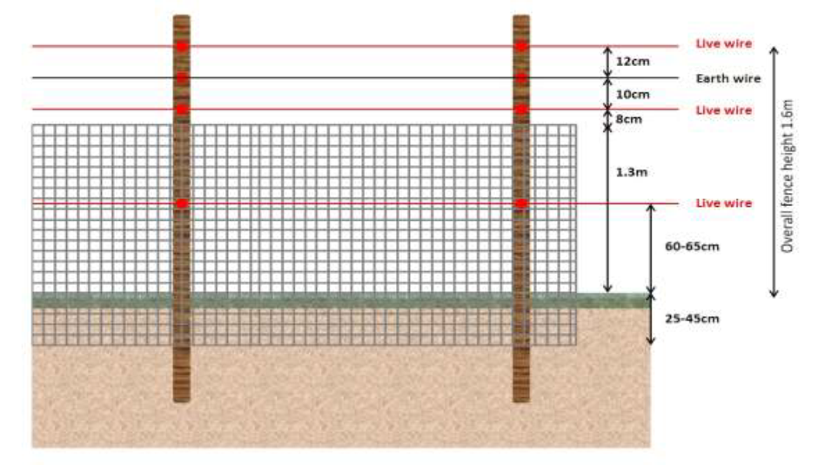
Figure 3: A diagram of the envisioned predator exclusion fence set up

Each tendering party may wish to bid for all three parts of this tender (shingle delivery/placement, brushwood fencing and predator exclusion fencing) or just selected parts.

Langstone Harbour has the following designations:
- Special Protected Area (SPA)
- Special Area of Conservation
- RAMSAR site
- Site of Special Scientific Interest (SSSI) https://designatedsites.naturalengland.org.uk/SiteDetail.aspx?SiteCode=s1001182

We expect the selected contractor to manage their operations within the law and spirit of those environmental designations and leave minimal trace of presence upon completion of the task. We expect contractors to co-operate with us throughout the period for which they are working on the project and an atmosphere of openness and trust whereby all parties communicate issues and risks promptly and involve themselves in appropriate and timely resolution.
We will require to see proof of contractors’ insurances, relevant qualifications including those related to health and safety.

We expect all people working on the project:
- To be responsible for their own and others’ health and safety.
- As this is a nature reserve designated SSSI, SPA, SAC and Ramsar to take extreme care not to harm the environment and to minimise wildlife disturbance.
- To act appropriately as a representative of RSPB on a site that is visible to the public.
- To respect our deadlines (as they are conditions of funding) and the requirements of working on a nature reserve.
- To comply with Construction Design Management Regulations 2015 as well as all other relevant HSE regulations.
- To identify where costs can be saved or where opportunities arise to deliver more within our budgetary constraints.

Document C

Specification

The successful supplier/suppliers will supply a service to which the following points will apply.

You may bid for one or more lots.

All tendering parties must complete section 4. If multiple contractors are required to carry out the project at the same time, it is expected that the supplier of the shingle habitat creation (Lot 1, the most significant works) will be the principal contractor.

The information below is a statement of minimum requirements and is not intended to limit creative or original thinking in the preparation of proposals.

Lot one: The delivery and placement of shingle on Long Island.

- Liaising with the RSPB and the aggregate supplier, the tendering party must collect and deliver shingle (which the RSPB has procured) to the project site via a suitable vessel or vessels. The amount of shingle to be transported will be either a) 2000 tonnes (our preferred, full option), b) 1000 tonnes or c) 500 tonnes. The proposed landing site is at grid ref SU 70184 04260. Shingle procurement is not finalised but for the purpose of the tender can be costed as being loaded and transported from Kendell’s Wharf (grid ref SU 67600 03270).

Are you able to meet this specification in full? If so please give details below
If not please state any differences in service offered
Specification met? Yes /Part met / No (tick as appropriate)
Details

- Using the shingle delivered, the supplier must raise a prescribed area (to be marked out by the RSPB) by 0.7m. The area covered will depend on the amount of shingle but will be either a) 200 metres in length by 10 metres in width b) 100 metres in length by 10 metres in width, or c) 50 metres in length by 10 metres in width. In your tender, please identify the cost for placing each option. The shingle will consist of two sizes, with the base layer (approx. 85% of the delivery) being larger cobbles and the surface (approx. 15% of the delivery) being smaller shingle. Protective matting / bog mats must be placed over the route between the landing site and placement area to protect the site beneath.

Are you able to meet this specification in full? If so please give details below
If not please state any differences in service offered
Specification met? Yes /Part met / No (tick as appropriate)
Details

Lot two: The installation of a brushwood fence on the west side of the raised shingle ridge (this will need to take place shortly before/during or after the shingle habitat works).

- The supplier must be able to install a brushwood fence, as per the HRA and MMO licence, along the western side of the shingle deposit. Depending on the amount of shingle used, this will either need to be a) 210m in length, b) 110 metres in length or c) 60m in length.

Are you able to meet this specification in full? If so please give details below
If not please state any differences in service offered
Specification met? Yes /Part met / No (tick as appropriate)
Details

Lot three: The installation of a predator exclusion fence around the raised shingle area on Long Island.

- The supplier must be able to erect predator exclusion fencing, envisioned as per the specification on the HRA, around the perimeter of the shingle area. Depending on the amount of shingle used, this will either need to be a) 450m in perimeter, b) 250 metres in perimeter or c) 150m in perimeter.

Are you able to meet this specification in full? If so please give details below
If not please state any differences in service offered
Specification met? Yes /Part met / No (tick as appropriate)
Details

Section 4 (all tendering parties to complete):

- The supplier must comply with all of the conditions set out within the attached draft Marine Licence. This includes the limiting of vessel landings to high spring tides, the use of protective matting / bog mats on the route between the landing site and placement area and the need to adhere to the Clean/Check/Dry code and supply a brief on how this will be done.

Are you able to meet this specification in full? If so please give details below
If not please state any differences in service offered
Specification met? Yes /Part met / No (tick as appropriate)
Details

- The project is working to tight timescales where you will have to work closely with a shingle supplier and potentially other contractors (subject to specifications bid for). This could coincide with challenging weather conditions (health and safety is of utmost importance, and works may need to be rescheduled if weather conditions are too extreme). The supplier should be able to deliver the needed works in February or March 2023 (subject to planning permission being granted in November/December 2023). It is feasible that works may need to take place in September 2023 if there are unavoidable delays, but costs should be quoted assuming works will take place in Feb/March 2023 at this stage. Please outline your ability to meet these timelines.

Are you able to meet this specification in full? If so please give details below
If not please state any differences in service offered
Specification met? Yes /Part met / No (tick as appropriate)
Details

- The supplier must meet the Construction (Design & Management) Regulations irrespective of whether or not the project is notifiable to the HSE and also be able to share appropriate health and safety documentation/planning via an exchange of information before commencement. For the purpose of this project, the supplier of the shingle delivery and placement will take on the role of principle contractor if other parts of the project are delivered by a separate party at the same time.

Are you able to meet this specification in full? If so please give details below
If not please state any differences in service offered
Specification met? Yes /Part met / No (tick as appropriate)
Details

- As part of the tender, the supplier must set out in a brief their proposed scheme of works to meet these specifics above (1 to 7). Please use this opportunity to set out your proposed approach to the project, details of the machinery, method etc. We’d also welcome an introduction to the supplier’s company and their existing experience if appropriate. New or original solutions to the projects aims are welcome.

Are you able to meet this specification in full? If so please give details below
If not please state any differences in service offered
Specification met? Yes /Part met / No (tick as appropriate)
Details

Document D

Company Information

 | 1.0 | General
 | 1.1 | Registered Name  Trading Name (if different)
 | 1.2 | Correspondence Details  Name of person applying on behalf of the company  Address:  Telephone:  Mobile:  Email:
 |  | Registered office Address (if different from above)
 | 1.3 | Company Registration No (if applicable)  VAT registration number (if applicable)
 | 1.4 | Date company was founded (if a limited company, date of incorporation)
 | 1.5 | Company structure and nature of company  Please outline the nature of the company, whether it is a partnership, sole trader, plc etc.  Is the company proposed as party to the contract part of a larger organisation? If so please explain the relationship between the various parts of the organisation, up to the ultimate holding company.  Current number of full time equivalent staff currently employed by the company (not larger parent company)
 | 1.6 | Accreditation by / Membership of Trade Association(s)  Is your Company registered with any industry accreditation body? YES NO  If yes, please provide details:  Is your Company on any public sector Framework agreements? YES NO  If yes, please provide details:  Please state membership of any professional bodies/ other associations below:
 | 1.7 | Quality Assurance  Is all / part of your company ISO9001 Quality Assured? YES NO  Is all / part of your company ISO14001 Quality Assured? YES NO  If yes please provide copy of certification  Do you have any other Quality Assurance? If Yes, please summarise details below
 | 1.8 | Environmental Commitments  Is all / part of your company registered under Science Based Targets (https://sciencebasedtargets.org/net-zero), Business Climate Hub (https://businessclimatehub.org/uk/) or equivalent? YES NO  If Yes, please summarise details below

 | 2.0 | Financial & Business Probity
2.1 |  | Judgements etc.  Are there any judgements, claims or suits pending or outstanding against your company?  Yes No If Yes, please provide full details  Has your company ever failed to complete a contract?  Yes No If Yes, please provide full details
2.2 |  | Please answer all of the following questions as they apply to your Company’s circumstances. Please confirm that:  1) being a company, no resolution has been passed or Order of the Court made for the company’s winding up otherwise than for the purposes of bona fide reconstruction or amalgamation, nor has a receiver, manager or administrator on behalf of a creditor been appointed in respect of the company’s business or any part thereof, nor is it the subject of any proceedings for any of the above procedures, nor is it the subject of similar procedures under the law of any other state.  Confirmed Not confirmed Non-applicable  2) being a partnership, it has not granted a trust deed or become otherwise apparently insolvent, or it is not the subject of a petition presented for sequestration of its estate.  Confirmed Not confirmed Non-applicable  3) being an individual, you are not bankrupt, or have not had a receiving order or administration order made against you, or have not made a composition or arrangement or trust deed with or for the benefit of your creditors, or have not made any conveyance or assignment for the benefit of your creditors, or have not had a petition presented for sequestration of your estate or do not appear to be able to pay or to have no reasonable prospect of being able to pay a debt within the meaning of the Insolvency Act or any similar procedure under the law of any EC member state.  Confirmed Not confirmed Non-applicable  4) no Directors, Partners, Associates or the Company Secretary have been involved in any Company which has been liquidated or gone into receivership.  Confirmed Not confirmed Non-applicable  5) none of the Directors, Partners, Associates or the Company Secretary have been convicted of a criminal offence relating to the conduct of their business or profession.  Confirmed Not confirmed Non-applicable  6) neither the Company nor any of the Directors, Partners, Associates or Company Secretary has committed an act of grave misconduct in the course of their business or profession.  Confirmed Not confirmed Non-applicable  7) all obligations relating to the payment of taxes under the law of any part of the United Kingdom or the EC member state in which the Company is established has been fulfilled  Confirmed Not confirmed Non-applicable  8) all obligations relating to the payment of social security contributions under the law of any part of the United Kingdom or the EC member state in which the Company is established have been fulfilled.  Confirmed Not confirmed Non-applicable  If you have ticked ‘Not confirmed’ for any questions above please give details here

2.3 | Please list the names of any Director, Partner, Associate or Company Secretary who have been employed by the RSPB, giving department and dates.  Please give details of any Director, Partner, Associate or Company Secretary who have a relative who is employed by the RSPB at a senior level.  Please list the names of any Director, Partner, Associate or Company Secretary who have any involvement in other Companies who provide services to the RSPB  Is any work being undertaken or likely to be undertaken during the next three years by the Company or staff within it which could give rise to a conflict of interest through acting for third parties or otherwise? If yes, please explain the actual or likely circumstances and how such potential conflicts of interest would be handled.

2.4 | Insurances (a scanned copy of each certificate may be requested)
 |  | Insurer | Policy No | Value of Cover | Expiry Date
 | Employers Liability
 | Public Liability
 | Prof. Indemnity
All Risks
(if applicable)

2.5 | Has your company (or any building/project you have undertaken) won any awards, accolades or recognition?  YES NO If yes please provide full details.

3.0 | Health & Safety and Environment
3.1 | Has your company been served with any enforcement or prohibition notices or been prosecuted in the past 5 years for breaches of health & safety legislation?  YES NO If yes please provide full details.
3.2 | Has your company been served with any enforcement or prohibition notices or been prosecuted in the past 5 years for breaches of environmental legislation?  YES NO If yes please provide full details.
3.3 | Has your company been served with any enforcement or prohibition notices or been prosecuted in the past 5 years for breaches of data protection legislation?  YES NO If yes please provide full details.
3.4 | Have any restrictive clauses in relation to your company’s Employer’s Liability, Public Liability or Professional Indemnity Insurance policies been enforced in the last 5 years due to past Health & Safety performance?  YES NO If yes please provide full details.

Document E

Form of Offer

Cost

Please set out below a breakdown of your tender quote for each option.

For supplier bidding for multiple lots, please state (under assumptions, below) if you would be prepared to carry out this lot as a standalone piece of work, or only in conjunction with other lots bid for. Also please state if carrying any of these lots requires you to sub-contract.

Please state your costs assuming work to be carried out in Feb/March 2023. If the work is delayed until September 2023 the successful supplier(s) will be given an opportunity to revise their prices if necessary.

Indicate full details of expected payment terms including any upfront payments required to cover the cost of equipment/materials.

Lot 1: The delivery and placement of shingle on Long Island:

Cost of completing project as outlined in specifications (Document C) for option A (2000 tonnes of shingle delivered/ 2000 square metres shingle area creation). Please provide a breakdown of costs. | £ + VAT
Cost of completing project as outlined in specifications (Document C) for option B (1,000 tonnes of shingle delivered/ 1000 square metres shingle area creation). Please provide a breakdown of costs. | £ + VAT
Cost of completing project as outlined in specifications (Document C) for option C (500 tonnes of shingle/ 500 square metres shingle area creation). Please provide a breakdown of costs. | £ + VAT
Assumptions:

Lot 2: The installation of a brushwood fence on the west side of the raised shingle ridge:

Cost of completing project as outlined in specifications (Document C) for option A (a brushwood fence of 210m length). Please provide a breakdown of costs. | £ + VAT
Cost of completing project as outlined in specifications (Document C) for option B (a brushwood fence of 110m length). Please provide a breakdown of costs. | £ + VAT
Cost of completing project as outlined in specifications (Document C) for option C (a brushwood fence of 60m length). Please provide a breakdown of costs. | £ + VAT
Assumptions:

Lot 3: The installation of a predator exclusion fence around the raised shingle area on Long Island.

Cost of completing project as outlined in specifications (Document C) for option A (a predator exclusion fence of 450m perimeter). Please provide a breakdown of costs. | £ + VAT
Cost of completing project as outlined in specifications (Document C) for option B (a predator exclusion fence of 250m perimeter). Please provide a breakdown of costs. | £ + VAT
Cost of completing project as outlined in specifications (Document C) for option C (a predator exclusion fence of 150m perimeter). Please provide a breakdown of costs. | £ + VAT
Assumptions:

Added Value

As well as any charity rate that you may be able to offer, the RSPB is always open to corporate partnerships that deliver benefit to your organisation, the RSPB and nature. Working as part of your CSR agenda we can provide opportunities for fundraising, secondments, interns and volunteering, offering your staff both personal and career development opportunities. We also welcome all forms of gifts in kind as valuable contributions to our work.

Suppliers should provide details of any associated added value features/services/gifts in kind available to the RSPB under the terms of this Tender. (Attach separate document if needed).

Please note, added value donations will not be part of the criteria we use to decide on which supplier to choose.

References
Suppliers are requested to provide details of three references from their existing clientele, supplying full name, address, telephone number, email address, contact name, period of Contract and the estimated annual value of the Contract. In supplying this information, Suppliers shall have granted the RSPB permission to seek such information as deemed necessary, in relation to the Suppliers performance with their nominated references.
Reference 1
Company Name
Address
Telephone No |  | Ext
Email
Contact |  | Dates of work
Nature of work done |  | Value of contract

Reference 2
Company Name
Address
Telephone No |  | Ext
Email
Contact |  | Dates of work
Nature of work done |  | Value of contract

Reference 3
Company Name
Address
Telephone No |  | Ext
Email
Contact |  | Dates of Work
Nature of work done |  | Value of contract

Document F

RSPB Terms and Conditions

The basis of the contractual agreement between RSPB and the applicant is detailed in the ‘RSPB Terms and Conditions of Purchase of Goods and Services’ – please click on this link to download. In applying for this tender you are explicitly agreeing to be bound by these Terms and Conditions for the duration of the contract. If you require any alterations to these Terms and Conditions please state your issues below. (Attach separate document if needed)

The RSPB expects that all suppliers it works with to adhere to certain ethical and environmental standards. Please download the RSPB Ethical and Environmental Procurement Policy and tick this box if you agree to be bound by its terms and conditions

Document G

Certificate of Bona Fide Offer

We certify that this offer is made in good faith, and that we have not fixed or adjusted the amount of the offer by or under or in accordance with any agreement of arrangement with any other person. We also certify that we have not, and we undertake that we will not:

1 a) communicate to any person other than the person inviting these offers the amount or approximate amount of the offer or proposed offer, except where the disclosure, in confidence, of the approximate amount of the offer was necessary to obtain insurance quotations required for the preparation of the offer;
b) enter into any agreement with any other person that s/he shall refrain from making an offer or as to the amount of any offer to be submitted;

2 pay, give or offer or agree to pay or to give any sum of money or other valuable consideration directly or indirectly to any person for doing or having done or causing or having caused to be done in relation to any offer or proposed offer for the goods/services any act or thing of the sort described in 1 a) or 1 b) above.

We acknowledge that if we acted or shall act in contravention of this certificate, the RSPB will be entitled to cancel the agreement and to recover from ourselves the amount of any loss and expense resulting from such cancellation.

I state that everything in this tender submission is truthful, that if found to be untruthful the RSPB can terminate any agreement between the RSPB and the company formed on the basis of this tender, and we will pay to the RSPB any loss or expenses the RSPB suffers as a result of such untruthfulness, whether an agreement is entered into or not.

In this certificate, the word “person” includes any persons and any body or association, corporate or unincorporated; “any agreement or arrangement” includes any transaction, formal or informal, and whether legally binding or not.

Signed
On behalf of
Date

Please note: a name added in an electronic document is functionally equivalent to a signature.

