Existing Website: [www.localactioncornwall.co.uk](http://www.localactioncornwall.co.uk)

Main landing page

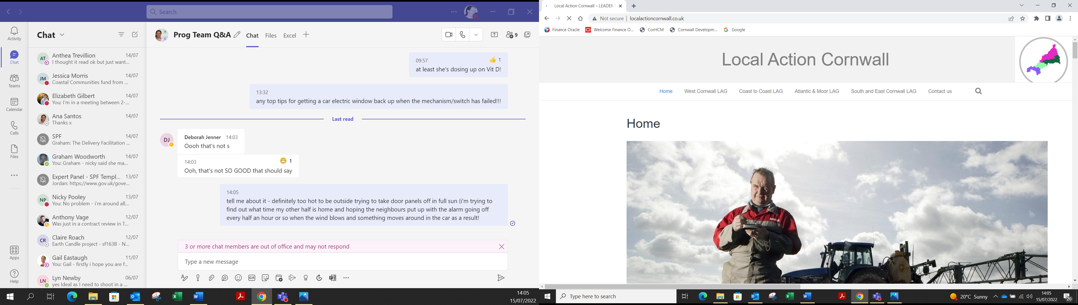

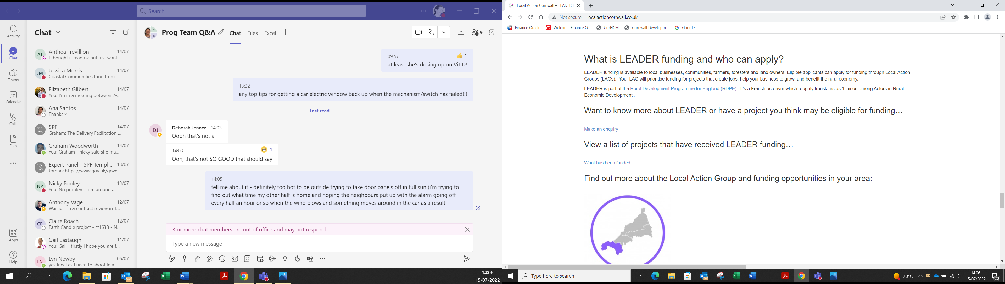

Work required

* Refresh of main landing page, including resolving issues with the images and changes in text to reflect the programme is not open to applications anymore
* Refresh of wording in “What is LEADER funding” section
* Remove the enquiry for projects but leave in ability to make an enquiry about the programme i.e. If you want to know more about what LEADER has achieved…
* Updated list of projects (list to be provided by us)
* Create an area for the evaluation and cornwall wide case studies (videos and hard copy) – currently this will say the scheme is being evaluated but area to be updated once evaluation complete with headline information and a link to the full evaluation document.
* Map showing project locations - with pins to indicate project locations with click on pin to reveal brief project information
* Updated logos – remove CDC logo and registered office details and replace with Cornwall Council’s details

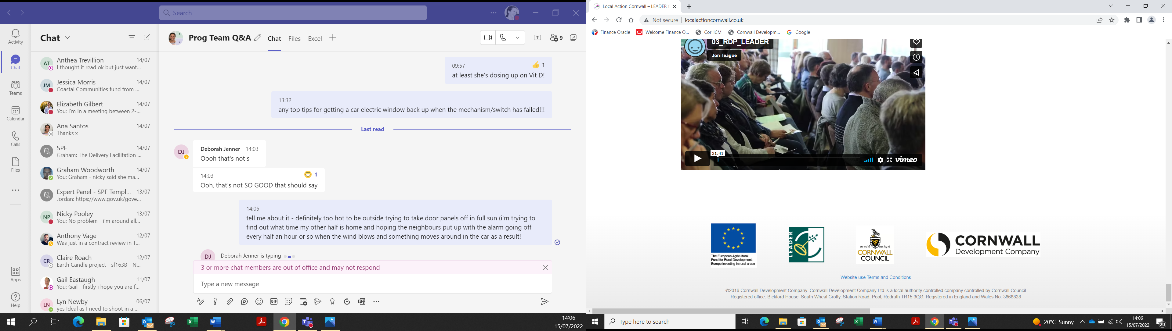

Refresh for each individual LAG area page (only WCLAG example shown)

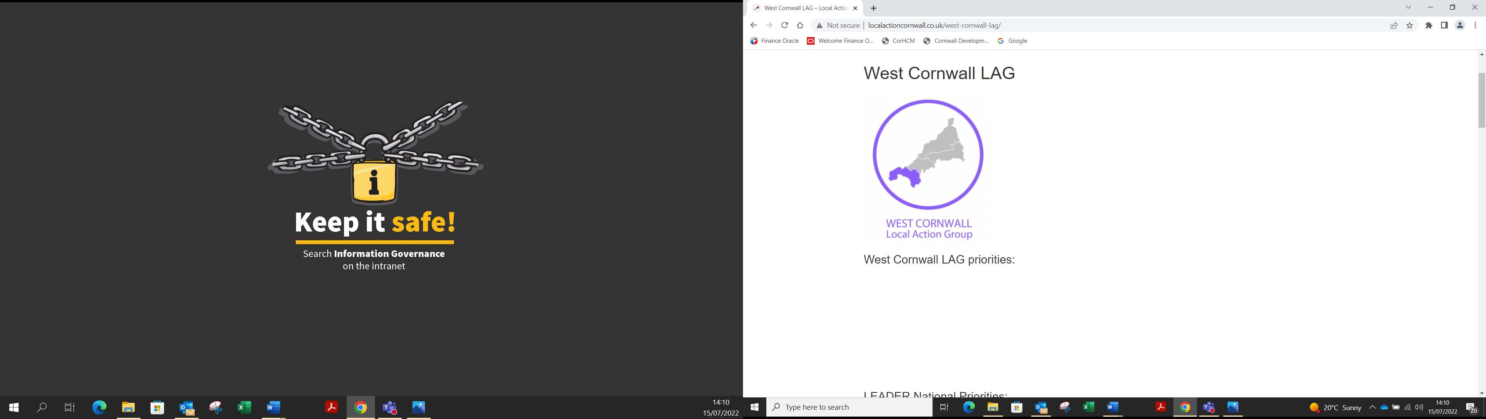

Resolve formatting issues eg WCLAG priorities currently showing under the statement re LEADER now being closed. Wording of priorities etc to be refreshed to reflect scheme no longer open. Wording to be supplied by CCES.

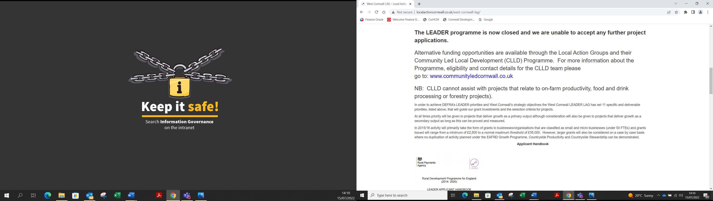 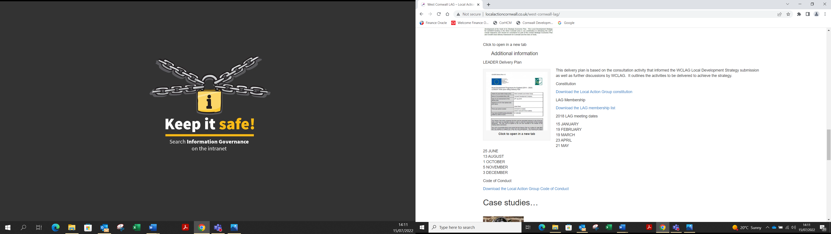

Updated copy of constitution and code of conduct to be accessed by links – remove old

Remove reference to LAG meeting dates

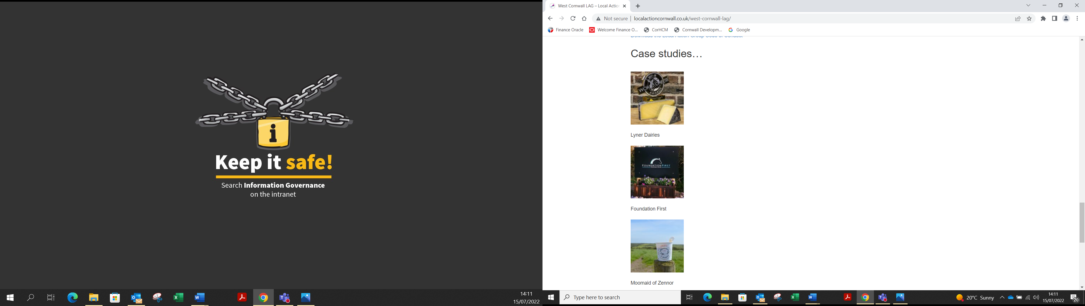

Additional case studies to be added – these will be produced over the next few months so allowance made for a final updates to the website in December 2022 to add any final case studies/films etc.

Training to be provided to enable CCES staff to make basic updates of the website, including text changes, addition of new case studies, see ITT4.7, 4.9 and 4.14).

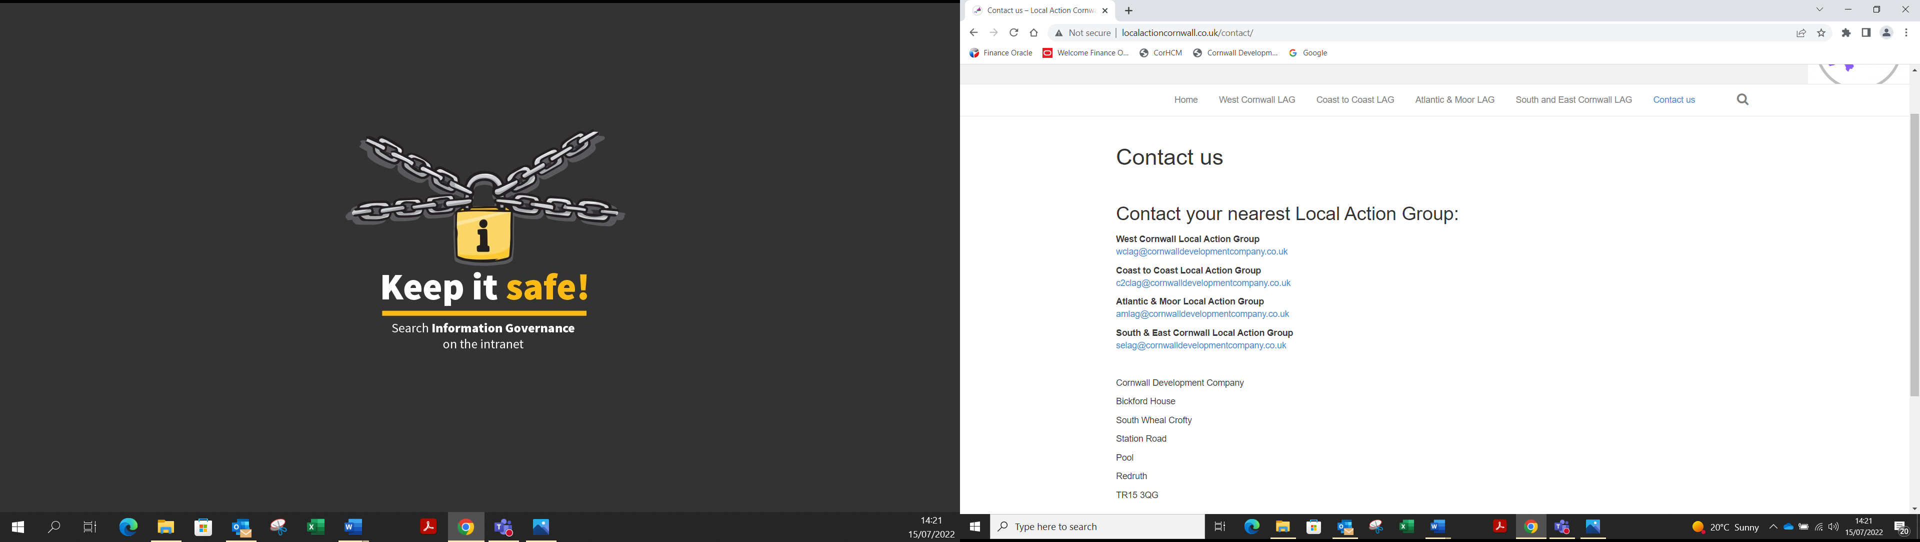

Update contact us page with new emails:

[wclag@cornwall.gov.uk](mailto:wclag@cornwall.gov.uk), [c2clag@cornwall.gov.uk](mailto:c2clag@cornwall.gov.uk), [amlag@cornwall.gov.uk](mailto:amlag@cornwall.gov.uk), [selag@cornwall.gov.uk](mailto:selag@cornwall.gov.uk) etc and remove reference to Cornwall Development Company changing to Cornwall Council