**Knollend site map**

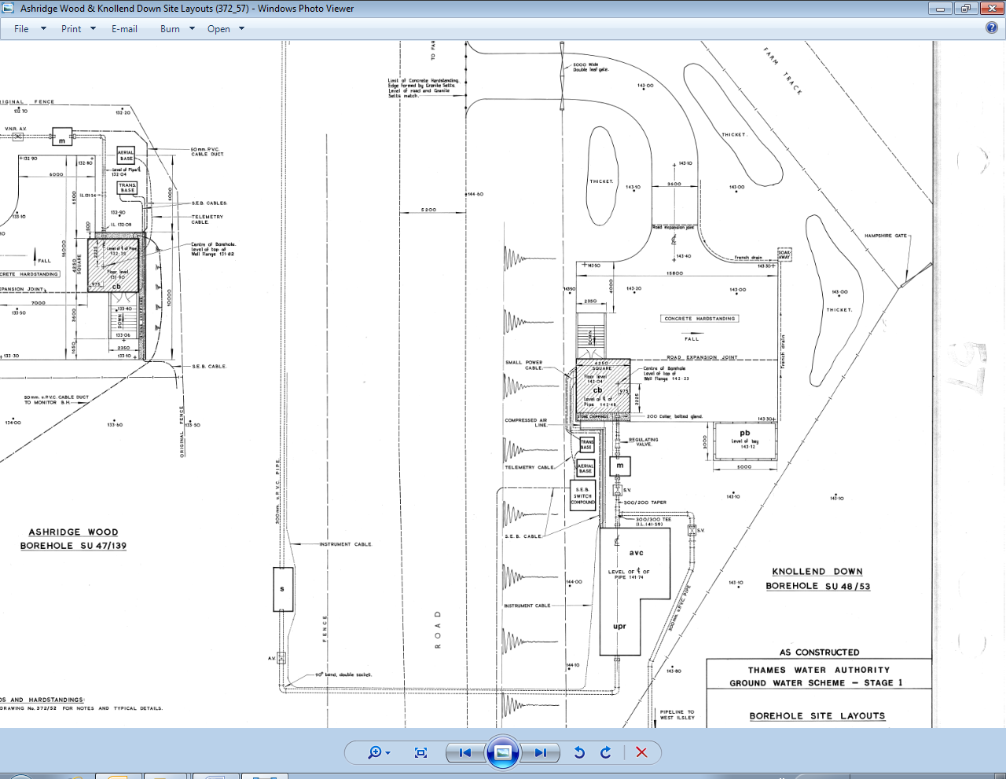

Surge vessel seen below

**Knollend surge vessel**

