**Inward Investment Programme market testing exercise for potential suppliers June 2021**

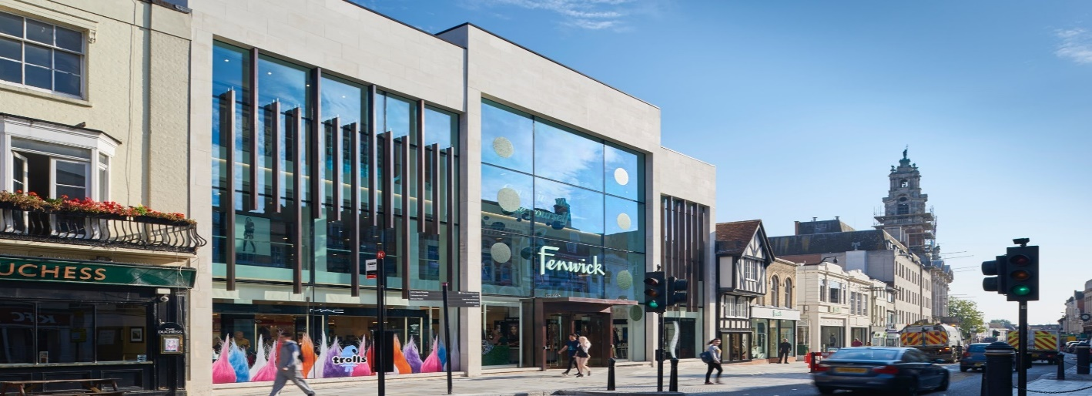

**Economic growth**, **Renewal, Equality and Ambition! We’re laying the foundations for growth.   
Collaborate with us to shape a stronger future for our residents.**

At Essex County Council we’re already making plans to ensure our county’s long-term economic recovery and we are guided by the core principles of Renewal, Equality & Ambition. These three principles will be embedded in all planned activities. We know many of our people, communities and industries have been hard hit by the pandemic and we want to help them bounce back. We’re taking this opportunity to create a greener, more productive and fairer economy that is stronger and more resilient than ever before.

We’re fostering a new entrepreneurial spirit within Essex. Growing our economy means working with local businesses to help them take advantage of new market opportunities. It means attracting investment to improve digital outreach across the county, supporting hard hit businesses to recover economic prosperity, whilst encouraging their plans for the future, as we drive investment into the revitalisation and regeneration of key places.

And it means helping the people of Essex to grow and develop or transfer their skills, ready to fulfil the needs of a vibrant new economy, where local manufacturers and suppliers meet the demands of market within UK and internationally.

**Context & background**

**Innovation in Essex**

Economic growth is the number one priority for Essex County Council. We want to establish Essex as a great location for the world’s top businesses and ensure that it’s the best possible place to live and work. Our rich mix of urban, rural and coastal economies, and our growing transport links including an international airport, Freeport East and Crossrail mean we’re poised for future success.

* Essex is a diverse economy with a GVA of £ 35.861 billion as per ONS (2013)
* Strong advanced manufacturing base and supply chain companies / trained workforce.
* Excellent transport infrastructure including overseas links through ports, airports and proximity to London & Cambridge.
* Post pandemic bounce back, post Brexit and new technology enabled opportunities.

It has however been highlighted that Essex:

* Does not access the levels of Innovate UK Funding that other areas do
* Is well below the UK Government target of 2.4% GDP spend on R&D
* Lags in terms of productivity growth.

We want to ensure that Essex matches the best in terms of implementing and exploiting Innovation within its businesses leading to economic growth.

ECC is preparing a Sector Development Strategy that drives the economic recovery and enables Essex to fully exploit the growth sectors of the future to create a more sustainable, equal, and productive economy that works all in the long term, and Innovation is one of the core pillars deliverable under this strategy.

An interim report will be published in July 2021 setting out the core sectors of focus and we will be engaging with partners to get their input as we work up a final strategy. Green Growth underpins all elements of Sector Growth, and we want Essex to be known as a Centre of Excellence for the Green Economy.

**The ask & collaborative approach**

Our Economic Growth team is excited to be developing a new proactive, commercially astute and tech savvy inward investment service fit for a post Covid and post Brexit Essex. We want to understand Essex’s strengths, its competition and how inward investment decision making has been impacted by current economic and environmental conditions and wish to work collaboratively with inward investment specialists to shape and deliver a world class service. We are planning to go out to tender for:

* a comprehensive assessment of the current innovation support landscape in Essex.
* to benchmark Essex against peers and best practice areas both in UK and further afield.
* to recommend an approach to address the perceived Innovation support shortcomings within Essex based on a ‘gold, silver & bronze’ type approach weighing in estimated associated costs and benefits.

In July the UK Government published its UK Innovation Strategy, and this will need to be contextualised in any work, but the outputs required will be Essex specific.

The above should fully embrace a collaborative partnership approach across Essex.

Based on the above procurement requirements, we request potential suppliers to complete the below questionnaire in a brief manner   
(200-250 words max per section) as part of our market engagement for best results.

|  |  |
| --- | --- |
| **Supplier Questions** | **Answer / Feedback** |
| 1. Will you be interested to provide the above listed services, fully or parts of it? |  |
| 1. Have you delivered a similar service in the UK? If so whom and kindly provide list of some of your key clients and highlight in what areas did you help them? |  |
| 1. How long has your business operated in this area? What is the size of your team? Any areas of specialisations or technical expertise? |  |
| 1. Have you previously worked with Essex County Council, local authorities in Essex or neighbouring counties? If so, please name the project? |  |
| 1. What are your initial thoughts about the proposed approach? Or what do you perceive is missing? |  |
| 1. How quickly can you mobilise and deliver the whole contract or parts of it? Please indicate some approximate timescales. |  |

**Next steps**

As a specialist in Innovation and economic development; this is your opportunity to guide us, develop our thinking and help us implement our ideas.

We are part of the Sustainable Growth Directorate, a new team keen to learn from your experience and deliver a successful programme for the County. Based on your responses to our questionnaire, we will contact you by the end of July regarding the next stages of the procurement process.

Thanks for your time and response in advance.