**Sunnyside Football Changing Room Extension Project**

**Summary & Background**

This project is for the enhancement and extension of the existing Sunnyside Lane Changing Rooms.

The changing rooms are based at Sunnyside Playing Fields, Yate. Yate Town Council is both the owner and actioner (displayed within the red circle below).

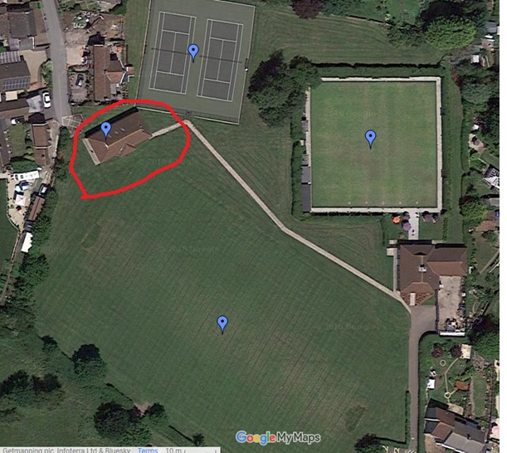

Developing Sunnyside changing facilities is part of our wider vision, for improving opportunities to engage in sport and physical activity within the yate area. Yate Town Council is also developing Yate Outdoor Sports Complex, to again increase capacity, offering high quality sports facilities within the town. This vision supports the work being carried out by South Gloucestershire Council around sport/physical activity and wellbeing.

Greater capacity and improved facilities will make the facility available for more people to use, both in terms of physical capacity, but also in mixed groups (so you could have a male and a female football game taking place – as you would have adequate changing facilities for each, currently it must be all one gender or the other due to lack of facilities). The enhancements will also make the changing rooms accessible to members of the community with restricted mobility, thus allowing a more diverse range of users to enjoy the facility.

We also have tennis courts at Sunnyside (refurbished about 4 years ago) and it is anticipated increased changing room capacity would also further increase the popularity and use of these - which again increases the opportunity for local people to enjoy the facilities.

The existing facilities are always booked to capacity use during the football season. We turn away booking enquiries due to not having enough changing room capacity (we have 4 pitches – but only 6 changing rooms). These enhancements would allow for another game to be played alongside the existing games on Saturdays and Sundays during the football season (so two more games across the weekend). This shows a clear need for more capacity.

Outside of the football season, there is evidence 3G pitch/es would allow year-round use for things like children’s parties and 5-a-side games, as well as previously unexplored avenues like hockey practice. The addition of 3G pitch/es is something which Yate Town Council aspire to provide in the future.

The improved changing and toilet facilities will also be popular with the users of the tennis courts too - this is always something which is requested by the various tennis clubs who use our facility, and would further increase the usage of this facility too.

**Brief**

The purpose of the project is to develop an oversubscribed existing community sports changing facility, to increase capacity for existing and future users of Sunnyside football pitches and Sunnyside Pavilion (Bowls and Tennis Club).

The project will deliver the following:

* Increased and enhanced changing room facilities;
* Designed to allow easy access for individuals with limited mobility;
* Improved and updated toilets (again, with at least one allowing for limited mobility access);
* Solar panels to be installed – to help provide hot water and aid with general sustainability.

**Timeline**

*The timeline for this project can be found in Appendix 1*

**Key Deadlines**

The Tender process will go live with final documents 13th April 2018 and the closing date will be 7th May 2018.

The project must be completed no later than November 9th 2018.

Yate Town Council will carry out end of project inspections to ensure the work has been completed to a satisfactory level. End of defects period will be part of the tender for contractors that take on this project.

Once practical completion is achieved and any snagging issues resolved, it should be possible for the building to be handed over to Yate Town Council for use straight away.

**Project outcomes**

Benefits will include:

* More capacity for local people to be able to use these sporting facilities;
* This would include capacity for one extra game to be played on each Saturday and Sunday throughout the football season (36 weeks of the year)
* It would allow for mixed gender games / or some teams of females and males to take place at the same time as the changing facilities would be able to accommodate this;
* It would offer facilities for users with limited mobility and other restrictions, allowing for them to easily and fully participate in sporting activities;
* Proper changing and toilet facilities available for users of the 2 tennis courts – improving their experience and leading to increased use of the existing facilities;
* Future proofing the changing rooms so that they will be able to deal with increased use year-round in the future with the addition of 3G pitches.

The building refurb will also include the addition of solar panels to the roof of the building to help with energy efficiency / sustainability of the facility.

No additional storage is required as part of the refurbishment. Security has recently been increased and it is anticipated the door shutters are retained. CCTV is not advisable in this facility due to the wider ranging community use (children getting changed in any area being monitored by CCTV is a safeguarding concern and best avoided).

If budget allows, the addition of rolling shutters to all windows on the building (in addition to the existing door shutter) could be considered.

**Deliverables / project outputs**

The purpose of the project is to develop an oversubscribed existing community sports changing facility, to increase capacity for existing and future users of Sunnyside football pitches and Sunnyside Pavilion (Bowls and Tennis Club).

The project will deliver the following:

* Increased and enhanced changing room facilities;
* Designed to allow easy access for individuals with limited mobility;
* Improved and updated toilets (again, with at least one allowing for limited mobility access);
* Solar panels to be installed – to help cover the ongoing energy costs and to aid with general sustainability. **(Specification to be confirmed by Architect)**

**Project outcomes**

Benefits will include:

* More capacity for local people to be able to use these sporting facilities;
* This would include capacity for one extra game to be played on each Saturday and Sunday throughout the football season (36 weeks of the year)
* It would allow for mixed gender games / or some teams of females and males to take place at the same time as the changing facilities would be able to accommodate this;
* It would offer facilities for users with limited mobility and other restrictions, allowing for them to easily and fully participate in sporting activities;
* Proper changing and toilet facilities available for users of the 2 tennis courts – improving their experience and leading to increased use of the existing facilities;
* Future proofing the changing rooms so that they will be able to deal with increased use year-round in the future with the addition of 3G pitches.

**Performance, quality measures and user acceptance criteria**

1. To increase availability of changing facilities for both female and male players using Sunnyside playing fields and Sunnyside Tennis club.
2. To increase user satisfaction of the facility.
3. To increase number of users at the facility.

**Access**

Access to the changing rooms is via the car park located at the bottom of Moorland Road, visitors park here and walk up to the changing rooms. Contractors will need to be mindful of this and supply matting or an alternative option to preserve the walkway and grass conditions during construction.

Deliveries will be via the car park only; Sunnyside Lane is not to be used as a way to access the facility.

Open times of the site to be finalised however would usually be Monday-Friday during the day time.

**(TO BE FINALISED BEFORE CONTRACTOR APPOINTED)**

**Provisional Item**

Yate Town Council hope to continue to hold Junior football fixtures on site during the construction phase, we are keen to receive provisional costs within final submissions to provide 2 portaloos including servicing from 1st September-9th November.

**Environmental Sustainability**

Yate Town Council is committed to environmental sustainability. We aspire to source and use environmentally sustainable materials wherever reasonably possible

**Residents**

There are residents within close proximity to the construction so contractors will need to be mindful of this.

**Structual Engineer**

Will be appointed by Yate Town Council, to undertake any necessary surveys before construction begins.

**Architect**

Yate Town Council has appointed an Architect who is finalising the plans and submitting to South Gloucestershire Council, for the building based on the specification as mentioned above. Construction will comply with the agreed final plans. Please see draft image of our preferred option below:

**Timeline**

*The timeline for this project can be found in Appendix 1*

**Key Deadlines**

The Tender process will go live with final documents 13th April 2018 and the closing date will be 11th May 2018.

Yate Town Council does require that tenders are received in a sealed envelope ‘*bearing the words `TENDER – DO NOT OPEN UNTIL (prescribed date for opening*)`,  the tender will remain sealed until the prescribed date for opening tenders for that contract, which will be 12 noon on Friday 11th May 2018. All tenders when received shall be endorsed with date and time of receipt.

The project must be completed no later than November 9th 2018.

Yate Town Council will carry out end of project inspections to ensure the work has been completed to a satisfactory level. End of defects period will be part of the tender for contractors that take on this project.

Once practical completion is achieved and any snagging issues resolved, it should be possible for the building to be handed over to Yate Town Council for use straight away.

**For Further Questions/Inquiries**

Please contact **Lori Ramsay- Community Projects Manager** at Yate Town Council on

01454 862595 or [info@yatetowncouncil.gov.uk](mailto:info@yatetowncouncil.gov.uk)

J:\Projects\S 106 monies\New Section 106 Documents 2017\Applications 201718\Sunnyside extension project\Sunnyside Extension\Future Opportunity attachment CF Sunnyside Changing Rooms .docx