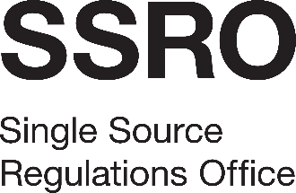

Board Management System
Appendix 2: Response to Tender Questions
[Name of bidder]

Introduction
This section sets out the questions that the SSRO requires to be addressed as part of its assessment of the tender requirement for the Quality/Technical section. This section carries a maximum overall weighting of 70 per cent. The SSRO encourages tenderers to present innovative methods of service delivery that will add value to the services. Such proposals are likely to attract the highest scores. Responses will be scored in accordance with the methodology set out in the Invitation to Tender document.

Quality/Technical Requirement (70%)
Software requirements |  | 50%
1 | Please provide a proposal detailing how your intended Board management software meets the SSRO’s requirements as set out in Appendix 1 sections 3.1 – 3.5 and Key Performance Indicators (Appendix 4). Please make reference to other organisations for whom you are providing a similar solution, if that would be helpful.  Maximum 2,000 words | 35
2 | Please demonstrate how you will set up and implement the software requirements in accordance with Appendix 1, in order to achieve service commencement by 1 October 2019. A project implementation plan (which is excluded from the wordcount) can be used to support the answer provided.  Maximum 500 words | 10
3 | Please demonstrate how your organisation will deliver initial training needs within the implementation timescales, and any ongoing training requirements as per section 4 of Appendix 1.  Maximum 500 words | 5

Information and security |  | 20%
4 | As per the requirements set out in Appendix 1 sections 3.7 – 3.20 and Appendix 4, bidders are required to provide technical architecture details and description of the proposed system(s) including physical location of data centres, connectivity, data at rest and in transit protection, and user identification and authentication.  Please confirm compatibility with SSRO systems, providing details of any software, hardware, configuration or network requirements for the SSRO. Please supply any relevant supporting documentation including diagrams.  Maximum 2,000 words | 10
5 | Please provide detail on your IT system management processes, including incident and change management, performance, availability and security management in relation to this contract. This must include details of the business continuity and disaster recovery arrangements that would apply to this contract. Please supply any relevant supporting documentation including diagrams.  Maximum 2,000 words | 10

