

www.gov.uk/naturalengland
Request for Quotation

Request for Quotation

Allonby Bay candidate HPMA drop-down camera and grab sampling survey: feature extent and seabed character assessment

Contact Details and Timeline
Camille Burton will be your contact for any questions linked to the content of the quote pack or the process. Please submit any questions by email and note that, unless commercially sensitive, both the question and the response will be circulated to all tenderers.

Action | Date
Date of issue of RFQ | 29/06/23
Deadline for clarifications questions | 12/07/23
Deadline for receipt of Quotation | 31/07/23
Intended date of Contract Award | 10/08/23
Intended Contract Start Date | 08/09/23
Intended Delivery Date / Contract Duration | 1/03/2024 (7months)

Glossary
Unless the context otherwise requires the following words and expressions used within this Request for Quotation shall have the following meanings (to be interpreted in the singular or plural as the context requires):

“Authority” | Means the Department for Environment, Food and Rural Affairs acting as part of Natural England
“RFQ” | Means this Request for Quotation and all related documents published by the Authority and made available to suppliers
“Contract” | Means the contract to be entered into by the Authority and the successful supplier.

Conditions applying to the RFQ
You should examine your response to the RFQ and related documents ensuring it is complete prior to submitting your completed quotation.

Your quotation must contain sufficient information to enable the Authority to evaluate it fairly and effectively. You should ensure that you have prepared your quotation fully and accurately and that prices quoted are arithmetically correct for the units stated.

The supplier by submitting a quotation is deemed to accept the terms and conditions in the RFQ. Failure to comply with the instructions set out in the RTQ may result in the supplier’s exclusion from this procurement.

Acceptance of Quotations
By issuing this RFQ the Authority does not bind itself to accept any quotation and reserves the right not to award a contract to any supplier who submits a quotation.

Costs
The Authority will not reimburse you for any costs and expenses which you incur preparing and submitting your quotation, even if the Authority amends or terminates the procurement process.

Mandatory Requirements
The RFQ includes mandatory requirements and, if you do not comply with them, your quotation will not be evaluated.

Clarifications
The Authority reserves the right to discuss, confidentially, any aspect of your quotation with you prior to any award of Contract to clarify matters.

Amendments
The Authority may amend the RFQ at any time prior to the deadline for receipt. If it amends the RFQ the Authority will notify you via Atamis and may extend the deadline for receipt in order to give you a reasonable time in which to take the amendment into account.

Conditions of Contract
The terms and conditions: Condensed Terms and Conditions will be included in any contract awarded as a result of this RFQ process. The Authority will not accept any material changes to these terms and conditions proposed by a supplier.

Specification
The Authority is Natural England. The Authority’s priorities are to secure a healthy natural environment; a sustainable, low-carbon economy; a thriving farming sector and a sustainable, healthy and secure food supply. Further information about the Authority can be found at: Natural England

Introduction
This survey will contribute to evidence gathering in year one of the Highly Protected Marine Areas (HPMAs) pilot project.
HPMAs are areas of the sea that allow for the protection and full recovery of marine ecosystems. By designating areas of sea with high levels of protection, HPMAs will allow nature to fully recover to a more natural state, allowing the ecosystem to thrive. They prohibit extractive, destructive and depositional uses, allowing only non-damaging levels of other activities to the extent permitted by international law. HPMAs will protect all species and habitats and associated ecosystem processes within the site boundary, including the seabed and water column. This means gathering comprehensive evidence of the effectiveness of the HPMA in delivering biodiversity recover will be critical.
The ecological monitoring of this Defra-funded programme will be led by Natural England and JNCC. Natural England’s marine remit includes biodiversity extending from the intertidal zone out to 12 nautical miles. Natural England will therefore gather baseline data and continue to monitor the inshore HPMA site Allonby Bay throughout the pilot project.

Survey Area
Allonby Bay candidate HPMA covers 27.6 km² of the southern region at the mouth of the Solway Firth (Figure 1). The boundary follows the Mean High-Water line along the shore from the western most building of Bank End Farm, Maryport to Christ Church south of Allonby and then extends seaward to approximately 5.6 km off the shore at its maximum width. The site has a maximum depth of 6.6m at lowest chart datum (Figure 2). The area is located within the 12 nm territorial sea limit of the Irish Sea region. It overlaps with Allonby Bay MCZ and the Solway Firth SPA and there is a very small overlap with the Solway Firth SAC and Upper Solway Flats and Marshes SSSI along the north-eastern boundary.

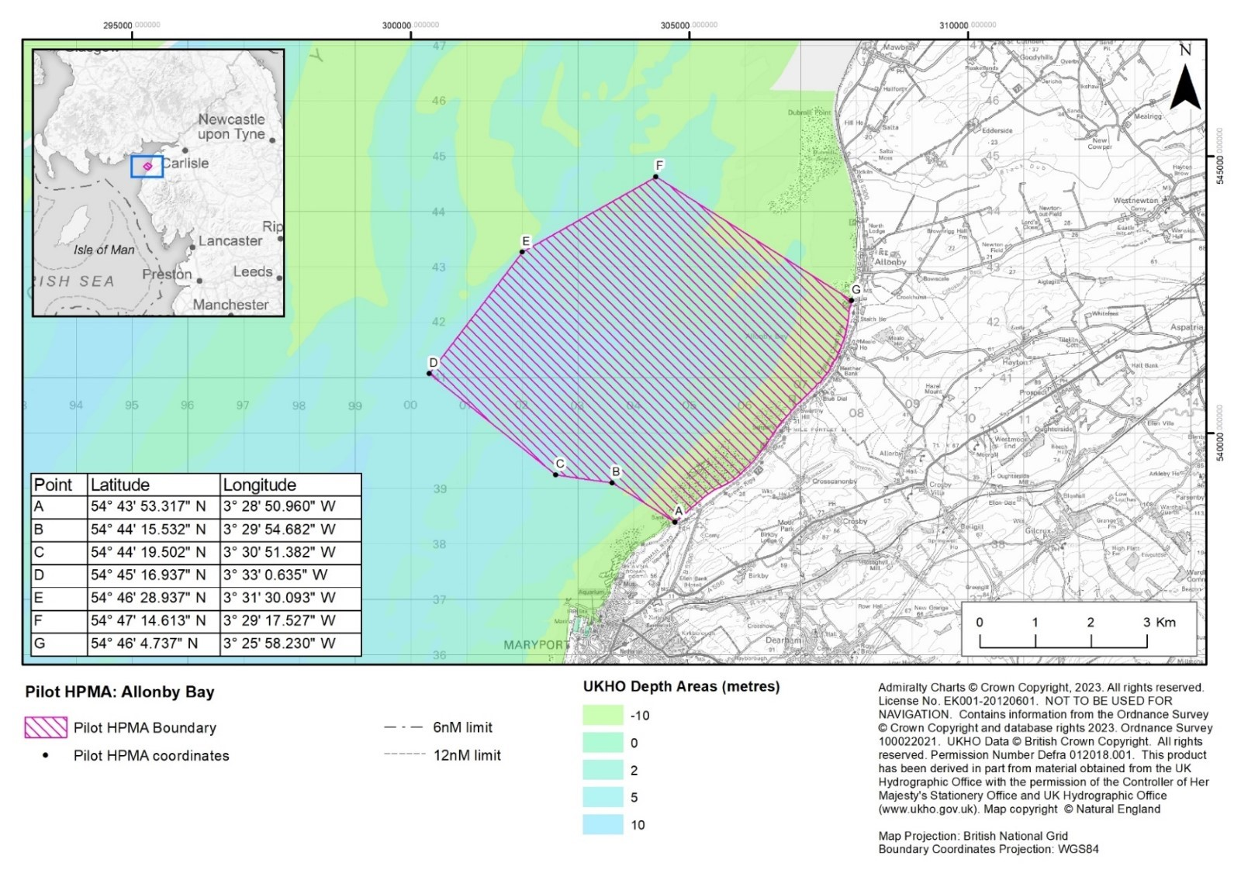
Figure 1. Candidate HPMA Allonby Bay proposed boundary and coordinates.
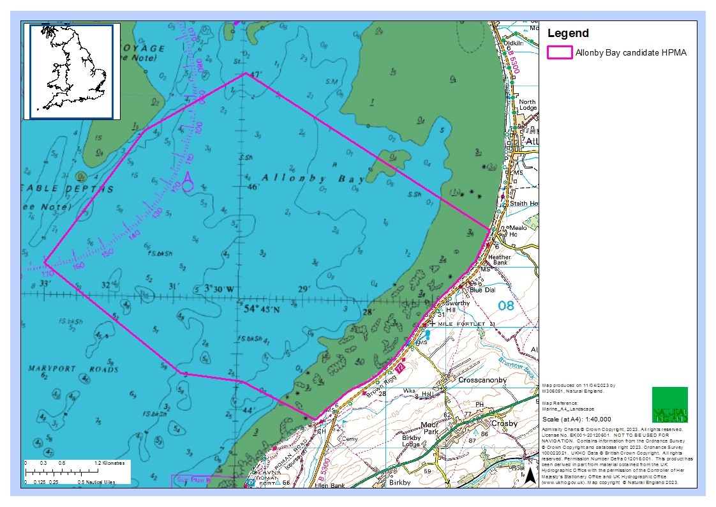
Figure 2. Candidate HPMA Allonby Bay chart datum.
Allonby Bay consists of a mix of habitats, characteristic of an environment that is subject to dramatic currents and tides. The seabed consists of a range of rocky habitats and sediment dominated habitats, including mudflats, sandbanks, reefs, peat and clay exposures, and biogenic reefs (Figure 3).

The nutrient-rich sediments, dense mussel beds and intertidal rocky habitats in this area attract large densities of shore birds including species such as curlew and oystercatcher. The biodiverse subtidal habitats here provide a food source for fish species, such as flat fish and nursery areas for other species such as bass, cod and herring. In turn, these fish species attract diving, foraging seabirds including guillemots, gannets and razorbills. There is also one of the best examples of honeycomb Sabellaria alveolata reefs in the UK within the site, creating a complex sediment network of tubes attached to rock creating vital habitat for crustacea and molluscs.

Previously recorded habitats in the Allonby Bay MCZ include:
- Moderate energy littoral rock
- Low energy littoral rock
- Features of littoral rock (rockpools/ ephemeral algae)
- Littoral sand and muddy sand
- Littoral biogenic reefs
- Features of littoral sediment (ephemeral algae)
- High energy infralittoral rock
- Moderate energy infralittoral rock
- Moderate energy circalittoral rock
- Sublittoral coarse sediment
- Sublittoral sand
- Sublittoral mud
- Sublittoral mixed sediments
- Sublittoral biogenic reefs

For full site details please see: Highly Protected Marine Areas (HPMAs) - GOV.UK (www.gov.uk) and the updated site narrative for the boundary to be designated in Appendix X.
A designation order covering a HPMA will set out the protected features and the conservation objectives applicable within the HPMA site boundary. The protected feature is: “The marine ecosystem, habitats and species of flora and fauna, abiotic elements, and their supporting ecosystem function and processes, including the seabed, water column and sea surface, within the site boundary.” The proposed conservation objective for all pilot HPMAs, including Allonby Bay is: “To achieve full natural recovery of the structure and functions, features, qualities and composition of characteristic biological communities present within HPMAs and prevent further degradation and damage to the marine ecosystem subject to natural change.”

Natural England and JNCC advise within an HPMA:
    - The ecosystem is allowed to fully recover in the absence of damaging activities such that:
• The ecosystem structure consists of a diverse range of benthic and pelagic communities, habitats and species, including biotic and abiotic components of the ecosystem. These fulfil a variety of functional roles, including supporting key life cycle stages and/or behaviours of marine species.
• The physical, biological and chemical ecosystem processes and functions proceed unhindered, so that the site realises its full ecological potential to deliver goods and services, including habitats and species considered important to the long-term storage of carbon, and habitats and species important for flood and erosion protection.
• The ecosystem is resilient to change and stressors.

    - Any ecosystem changes brought about by the process of removing anthropogenic pressures should be considered in the context of a naturally recovering ecosystem.

3. The HPMA supports our understanding of how marine ecosystems change and recover in the absence of impacting activities

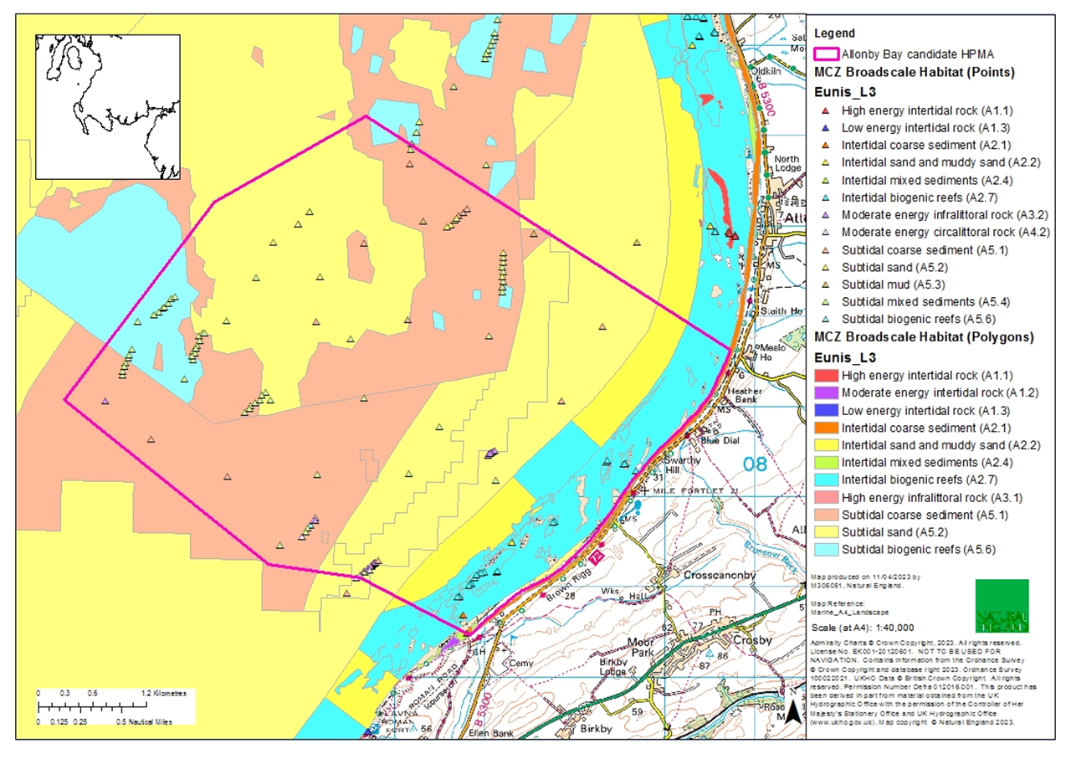
Figure 3. Current map of the broadscale habitats in Allonby Bay with the candidate HPMA boundary.

Previous Surveys
Previous bathymetry and backscatter data were collected in Allonby Bay in 2009 by Admiralty CHP (Figure 4 and Figure 5). Defra commissioned a number of surveys to provide supplementary information as part of the MCZ designation process. The Environment Agency carried out habitat characterisation surveys (grab sampling and drop camera) in February and March 2012 for Allonby Bay MCZ (Godsell & Fraser, 2013) (Figure 6 and Figure 7). The 2012 survey yielded insufficient data for the site; issues with the camera set up resulted in most images being discarded and the majority of grab samples were discarded as insufficient volume was collected. As a result, at most stations broad-scale habitats could not be defined. Natural England has confidence that both survey methodologies can be improved that would allow for an improved understanding of the extent and distribution of benthic habitats in Allonby Bay HPMA.
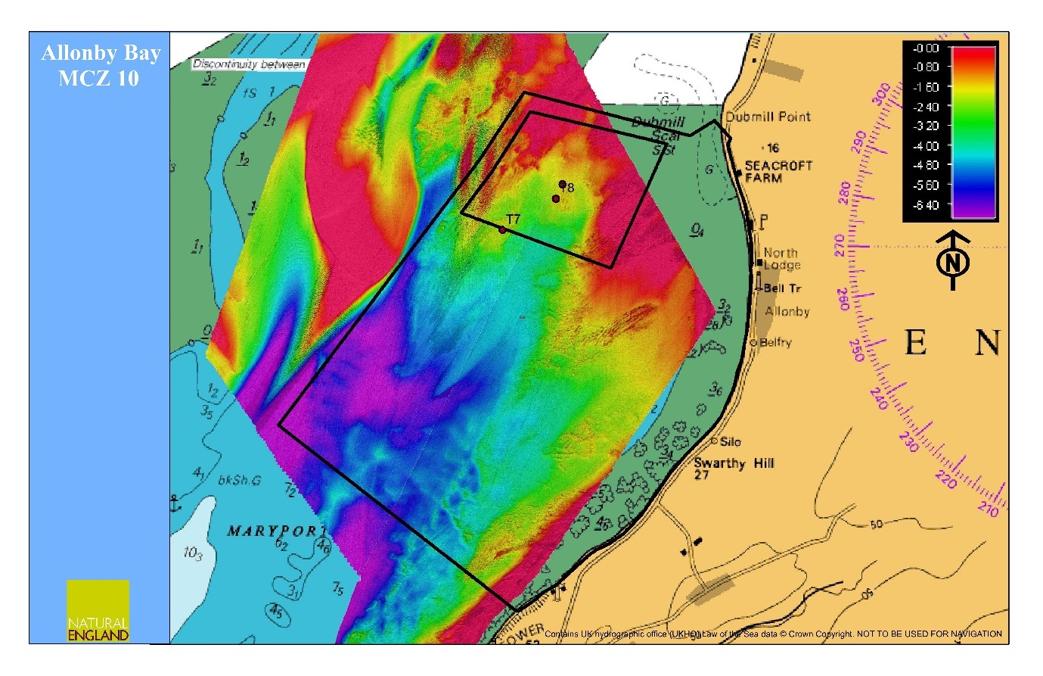Figure 4. Bathymetry for Allonby Bay MCZ (Admiralty CHP, 2009)
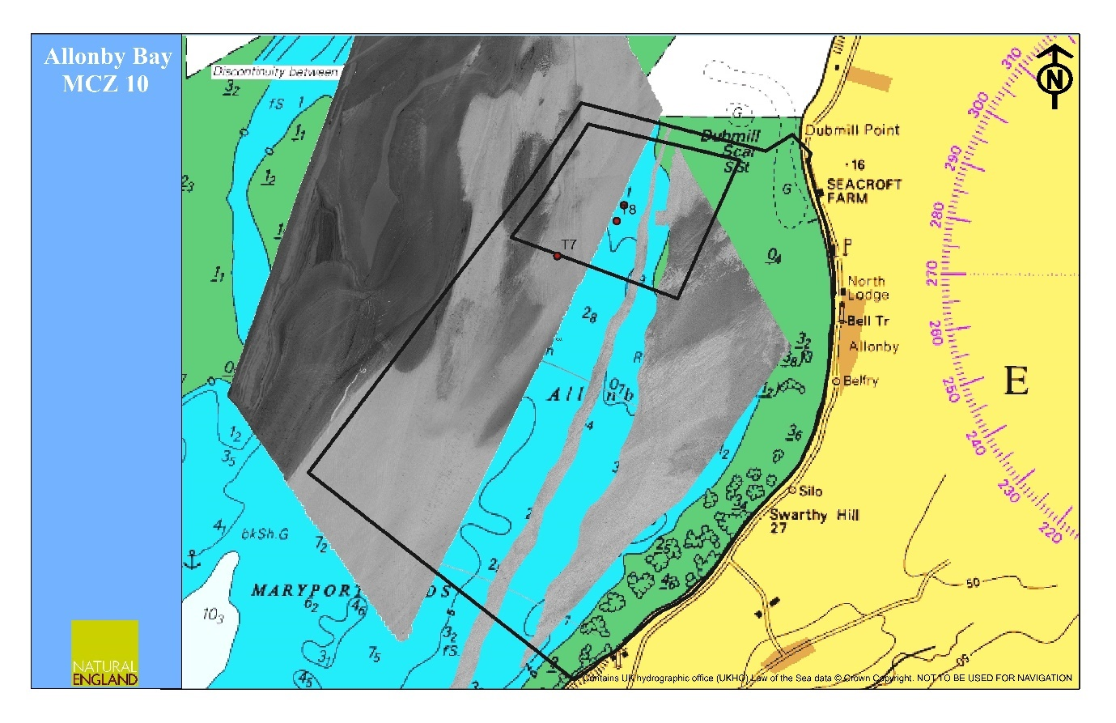Figure 5. Incomplete backscatter for Allonby Bay MCZ (Admiralty CHP, 2009)

Figure 6. Benthic habitat characterisation for Allonby Bay MCZ using drop camera data (EA, 2013)

Figure 7. Broad Scale Habitat (BSH) descriptions based on a modified Folk seabed sediment classification system recorded during the Allonby Bay rMCZ survey (EA, 2013)

Aims & Objectives

Natural England is commissioning ecological survey work in summer 2023 to understand the extent and distribution of subtidal broad-scale habitats in Allonby Bay candidate HPMA. This project will ground-truth subtidal habitat classification maps derived from acoustic survey work (which will be let as a separate tender in early summer 2023) using a combination of drop-down camera and grab sampling techniques.
The survey design should achieve the following:

  - Acquire high quality data to establish a baseline of the extent and distribution of the Subtidal habitats Multibeam and backscatter data collected in summer 2023 should be used to assist with this.
  - Acquire high quality biological data of suitable resolution to allow key indicators of condition to be assessed according to Common Standards Monitoring guidance for the sublittoral rock habitats (including biogenic reefs) and sublittoral sediment habitats. This data should be sufficient as to provide detailed baseline information.
  - Specify how the survey work will be carried out, including equipment to be used, improvements to previous methodologies (Godsell & Fraser, 2013), and how challenging conditions that occur within Allonby Bay cHPMA will be accounted for.

Survey work should be scheduled to be completed between July – September 2023.

Objectives
The main objectives of this contract are to, in collaboration with Natural England, plan, undertake and report on drop down video and grab survey work in the summer of 2023 to collect baseline data and inform future assessment of the recovery of subtidal habitats in Allonby Bay HPMA. Surveys should determine the presence and extent of subtidal habitats.

Environmental indicators have been identified to measure change and assess recovery over time in HPMAs. Biotic and abiotic attributes are set out for each indicator and consider a whole-site management approach (Annex 1).

Primary indicators to monitor in this survey:
  - Benthic habitats (extent and distribution)
  - Species (distribution, abundance, diversity)
  - Invasive species
  - Sediment biota (biomass)

Secondary indicators to monitor:
  - Shellfish

Under this specification contractors must:

- Develop, agree and implement, in collaboration with Natural England, a survey plan to collect data suitable for undertaking assessment of the direction of ecological change within the communities / habitats identified under this specification, integrating and interrogating previously obtained relevant data in the analysis.
- Where possible, ensure that newly collected data is compatible (analytically) with historical survey data, but at the very least will make reference to and utilise such historical data.
- In agreement with Natural England implement a statistically robust survey design to enable future collection of compatible data permitting quantitative long-term analysis.
- Ensure anthropogenic influences, potentially impacting subtidal habitats are identified and where possible quantified allowing analysis to focus on investigation of the potential impacts of these pressures.
- Provide an evidence based preliminary assessment of the condition of subtidal benthic habitats in Allonby Bay candidate HPMA, clearly stating out how the assessment is supported by the analysis of data collected. This should note any difference in observed condition between similar communities which are subject to varying degrees of anthropogenic pressures to focus analysis on investigating particular impacts.
- Provide fully detailed methodology for the work undertaken to ensure that methods can be repeated in the future, for example; camera equipment descriptions, camera/lights set up methodology, internal camera set up, photographic sampling frequency and vessel manoeuvring.
- Produce a concise field report
- Produce an evidence based technical report detailing the work undertaken, reporting the survey and analytical findings, discussing these in the light of any previous data and providing the preliminary subtidal habitats If drawing upon “expert judgement” in addition to the collected and analysed data, this must be clearly identified and presented separately from the core results of this survey work.
- Provide all data to the relevant standards including GI and Marine Recorder data (see details below).

Methods

Pre-survey deskwork
Before the survey is carried out the contractor will discuss any pre-survey work with the Nominated Officer, including:

- Acquisition and checking of sources of relevant information and gathering of local advice in preparation of a project plan
- Ways of working and close collaboration with NE in developing project plan, particularly development of a robust survey sampling strategy which should enable temporal comparisons to be made with previous datasets. Selection of survey sites, taking account of NE pre-survey scoping work and using appropriate methodologies.

Technical equipment

Image acquisition
Deployment of the video camera (including stills camera mounted on video frame will comply with guidance developed by MESH: ‘Recommended operating guidelines (ROG) for underwater video and photographic imaging techniques (http://www.searchmesh.net/PDF/GMHM3_Video_ROG.pdf). The ‘best practice guidance’ outlined in Section 12.1 will all be employed where relevant for the current project. Any proposed departure from this MESH guidance will be highlighted and reasons provided. Hitchens et al., 2015 epibiota sampling procedures from NMBAQA will also be adhered to.
Potential contractors should specify how survey methodologies and technical equipment might be improved from previous surveys (Godsell & Fraser, 2013) to acquire better data. This might include use of a freshwater lens to obtain higher quality images, which has been used on similar surveys in nearby areas (Morecambe Bay, Solway Firth). The contractor should provide full details on the lighting system and its positioning, as well as numerous sample images which they have been able to capture from extremely highly turbid environments using the systems proposed for deployment under this contract.
In addition, it is critical that laser scaling devices are used to effectively classify the habitats in the imagery. i.e., defining boulders/cobbles >64mm, see Irving 2009.

Grab sampling
Faunal sampling should conform to standard methodology ISO 16665:2014, and identification should be carried out in accordance to the NMBAQC quality control guidelines following Standard Operation Procedure ES-04.

Potential contractors should specify how survey methodologies and technical equipment might be improved from previous surveys (Godsell & Fraser, 2013) to acquire better data. For grab surveying, this might include a weighted mini-Hammond grab, and multiple attempts at each survey station. Contractor to specify minimum number of attempts per site) and any slight moving from target for additional attempts

Site access
The Nominated Officer should be contacted prior to commencement of any fieldwork.

Natural England will obtain permission from seabed owners or leaseholders for survey work on the seabed and will supply a copy of this permission to the contractor. Each member of the survey team must carry a letter from Natural England to confirm that they are doing this work on the behalf of Natural England. Survey work will not be able to begin until access permissions have been obtained by Natural England.

The removal of sediment samples from the seabed must meet the terms of a marine licence exemption set out in Article 17 of the Marine Licence (Exempted Activities) Order 2011 (as amended) . The MMO require notification of any exempted activities occurring; Natural England will be responsible for submitting the relevant information to the MMO for this.

Field survey
Survey work under the contract should be scheduled to be completed by the end of September 2023.

Surveys will be carried out in accordance with the technical specification provided for this lot referred to above. Alternative approaches will be considered if they meet the aims and objectives of the contract, demonstrate efficiencies and are agreed with NE prior to survey commencing.

Local conditions
As stated in sections 1 and 1.2 the working conditions at this site are highly challenging. Use of appropriate equipment and correct timing of the survey will be crucial if sufficient, useable data is to be collected.

Weather forecasts will need to be continually checked in the periods leading up to the survey. It is an additional requirement of this contract that the winning contractor liaise with a local contact, e.g., ABP (Associated British Ports) Barrow, whose hydrographic surveyors may be able to provide direct observations of local conditions and notification of clearer, less turbid conditions.

Invasive Non-Native Species
Invasive Non-Native Species (INNS) are considered to be one of the top five pressures directly driving biodiversity loss globally. Prevention is the key focus, particularly in marine environments. The contractor shall be aware of and work in accordance with standard good practice biosecurity measures to avoid spread of INNS:

- Equipment, clothes and boots should be clean before carrying out any work on site
- When on or near water it is important that equipment is drained after use and as far as possible dried
- Boats to be used in survey work should have their hulls cleaned on a regular basis. Best practice guidelines should be followed as outlined by The Green Blue.

INNS species previously recorded in this region and/or to particularly look out for during this survey. See GB non-native species secretariat.

The Contractor must report any records of INNS observed on site on Marine Recorder and to the Natural England project officer as part of the survey report. Any species currently listed as ‘alert’ species should be flagged immediately to the GB Non-Native Species Secretariat http://www.nonnativespecies.org/alerts/index.cfm. More information and guidance including ID guides can be found at www.nonnativespecies.org and the Marine Aliens Project.

Downtime
The works must be undertaken in summer when there is a low risk of exposure from westerly winds and swells. There may be some downtime incurred due to poor weather thus the tender must outline what proportion of downtime they predict throughout the course of the survey. This percentage downtime figure should be used to provide a lump sum costing which covers this risk and acts as an insurance against further unpredicted downtime. Natural England will not pay for downtime resulting from mechanical failure or personnel issues.

Natural England requires that the contract be assigned through an all-inclusive single price agreed at the outset of the project. The final quoted price should incorporate any potential weather downtime or risks likely to incur further costs after the contract has been awarded.

Survey outputs
This contract shall be managed on behalf of the Authority by Camille Burton

Reporting requirements
The successful contractor should produce a field report and a brief report outlining

- the survey methodology used,
- A timeline of events and actions
- Any difficulties encountered
- A brief discussion and interpretation of the data i.e., obvious features, areas of similar sediment type, areas of sediment change, identification of seabed features.
- Maps of habitats identified at biotope level where possible and higher level (e.g., L3) where this was not possible

Draft reports should be provided in electronic MS Office Word *.DOCX format for comment. A template and guidance exist for writing Natural England commissioned reports and will be sent to the contractor upon award of the tender. All reports should retain a clear suggested citation stating that it is a ‘Report to Natural England.’

Data requirements
Data must be interpreted, analysed and presented in light of the overarching hypotheses stated above. Contractors should pay particular consideration to the data and GIS required formats for information compatibility including MEDIN metadata standards and Marine Recorder provision. All datasets must have associated metadata and meet appropriate organisational metadata standards. Relevant metadata standards are a requirement for data which Natural England publishes externally.

All interpreted products following data analysis should accompany the draft report; these will include:
- All GIS datasets need to be provided in ESRI ArcGIS format compatible with ArcGIS 10.2 and have attached metadata.
- All GIS files containing habitat data for each individual survey need to be produced to the MESH translated habitat Data Exchange Format (DEF) to the most detailed EUNIS habitat level possible. MNCR (v15.03) data should be added to the ORIG_HAB column. The GUI provided by Natural England for each survey will be used, and as much information as possible (e.g., survey name, originally assigned feature/habitat name etc.) from the original dataset, as well as any documentation provided (where available) should be included in the resulting datasets to maintain a useful audit trail. As specified in the MESH DEF, data files must be provided as ESRI Shapefiles or as a feature class data within a geodatabase using the WGS1984 geographic coordinate system and lat/long coordinates. If not included in the GIS data layers listed above all sampling locations, vessels tracks, and links to data obtained should also be included as a single GI layer.
- A MESH data confidence assessment for each habitat map should be calculated and provided in a ‘MESH confidence scoresheet’ *.XLS file. The confidence assessment process is described and a template provided in the following MESH resources The MESH Confidence Assessment Scheme.
- Accompanying metadata for the data set must meet the MEDIN metadata discovery standard. Metadata derived as part of this project must be submitted to Natural England in an XML file which Natural England will archive through Data Archive Centres (DACs). Guidance ‘MEDIN Evidence for Contractors’ will be provided to the winning contractor.
- Copies of the original data spreadsheets or databases are to be provided in the appropriate Microsoft Office format
- Stills photographs to be provided in their raw format on CD/DVD or USB compliant external hard drives.
All sample data (e.g. grab sample analyses, video/still photography analyses, PSA analysis and biotope lists, biological taxon data) need to be entered into the latest version of Marine Recorder. NBN data and an exported snapshot file of the data should be provided for QA. Natural England will provide licence keys for Marine Recorder. Natural England will supply a ‘Marine Recorder guidance for contractors’ document to successful contractors.

The Contractor must report any records of Invasive and Non-Native Species observed on site on Marine Recorder and to the Natural England project officer as part of the survey report. Any species currently listed as ‘alert’ species should be flagged immediately to the GB Non-Native Species Secretariat Species alerts. More information and guidance including ID guides can be found at GB non-native species secretariat.

Copies of the original data spreadsheets or databases are to be provided in the appropriate Microsoft Office format. However please be aware that using MEDIN marine biodiversity data guideline spreadsheets (available online under the marine biodiversity tab at MEDIN data guidelines) will ensure that biological taxon data is prepared correctly for entry into Marine Recorder and will facilitate the efficient entry of data into this system and the data archiving process in general. Natural England welcomes and supports the provision of raw data spreadsheets in the MEDIN format and expects that all raw datasheets will contain the mandatory fields in the MEDIN guidelines, regardless of their format.

Standard survey imagery (stills and video) is to be provided in their raw format electronically or on USB compliant external hard drives (to be provided by the contractor).

High quality imagery which has been selected to form part of the image reference collection for the survey need to be labelled appropriately, including the habitat/species which is represented. These should be provided as a separate folder on the storage device to the standard survey imagery.

All data products and electronic files must be appropriately named so they sufficiently describe the contents and are not purely a numerical value. All products should be named appropriately so that they can be clearly linked to the report/project.

Any species lists submitted will be compliant with current taxonomic names and synonyms (e.g. Marine Species of the British Isles and Adjacent Seas (MSBIAS), World Register of Marine Species (WoRMS))

Video and still camera filenames must include the recording start date and time. Position data must be included within the overlay information.

The NE Project Officer will raise purchase orders to cover the cost of the services and will issue to the awarded supplier following contract award. Upon completion of the survey, the first of two staged payments for this contract will be released. Final payment will be issued upon completion of the final report.

Timeline for project delivery
Event | Date
Successful contract awarded | 24th August 2023
Finalise sampling design
Produce final project plan
Survey to be completed by
Submission of brief field/survey report by
Draft final report and associated products to be provided by
Final report, biotope maps and output to be delivered

Any delays to this timetable should be discussed with the Natural England Project Officer and delays not outside the control of the contractor will be penalised.

Other
In support of this contract NE will provide the winning supplier with:

- Project support from dedicated Project Officer
- Opportunity to feedback and discuss progress and the project
- Supporting GIS datasets (if required) under licence for use in this contract:
  - Base map data from Ordnance Survey
  - Aerial photography from Next Perspectives
  - S-57 vector data from the UK Hydrographic Office (in ArcGIS format) *
  - Raster charts from Oceanwise*
*(Not to be used for Navigation)

Please see the following site for information on how to obtain access to the GI datasets listed above: https://www.gov.uk/how-to-access-natural-englands-maps-and-data

- Additional reports to help with the analysis and report, such as those listed in Section 1.2

The intellectual property rights and copyright for all products (including photographs) will lie with Natural England. All data will be made available by Natural England under the Open Government Licence at the end of the project via www.data.gov.uk and the MEDIN Data Archiving Centres.

References
Davies, J., Baxter, J., Bradley, M., Connor, D., Khan, J., Murray, E., Sanderson, W., Turnbull, C. & Vincent, M., (2001). Marine Monitoring Handbook, 405 pp, ISBN 1 85716 550 0. Available online at: http://jncc.defra.gov.uk/page-2430

Godsell, N. & Fraser, M. (2013). Allonby Bay rMCZ Survey Report. Environment Agency. Project Code: C5784A

JNCC (2004). Common Standards Monitoring Guidance for Marine, Version August 2004, ISSN 1743-8160. Available online at: http://jncc.defra.gov.uk/page-2236

Contract Award Criteria
We will award this contract in line with the most economically advantageous tender (MEAT) as set out in the following award criteria:

Criteria | Weighting | Scores
Cost | 50% | Ranked in cost order
Availability/ capacity |  | Pass/fail
Quality of proposal based on the survey design, methodologies and improved technical equipment | 50% | Using scoring criteria set out below
The ability of the sampling strategy to be replicated in future years or for other applications | 0% | Using scoring criteria set out below

For a score of 100: Excellent - Response is completely relevant and excellent overall. The response is comprehensive, unambiguous and demonstrates a best-in-class thorough understanding of the requirement and provides details of how the requirement will be met in full.
For a score of 70: Good - Response is relevant and good. The response demonstrates a good understanding and provides details on how the requirements will be fulfilled.
For a score of 50: Acceptable - Response is relevant and acceptable. The response provides sufficient evidence to fulfil basic requirements.
For a score of 20: Poor - Response is partially relevant and/or poor. The response addresses some elements of the requirements but contains insufficient / limited detail or explanation to demonstrate how the requirement will be fulfilled.
For a score of 0: Unacceptable - Nil or inadequate response. The response fails to demonstrate an ability to meet the requirement.

Disclosure
All Central Government Departments, their Executive Agencies and Non-Departmental Public Bodies are subject to control and reporting within Government. In particular, they report to the Cabinet Office and HM Treasury for all expenditure. Further the Cabinet Office has a cross-Government role delivering overall Government policy on public procurement, including ensuring value for money and related aspects of good procurement practice.

For these purposes, the Authority may disclose within Government any details contained in your quotation. The information will not be disclosed outside Government during the procurement.

In addition, the Authority is subject to the Freedom of Information Act 2000 and the Environmental Information Regulations 2004, which provide a public right of access to information held by public bodies. In accordance with these two statutes, the Authority may be required to disclose information contained in your quotation to any person who submits a request for information pursuant to those statutes.

By submitting a quotation, you consent to these terms as part of the procurement.

Disclaimers
Whilst the information in this RFQ and any supporting information referred to herein or provided to you by the Authority have been prepared in good faith the Authority does not warrant that this information is comprehensive or that it has been independently verified.

The Authority does not:

- make any representation or warranty (express or implied) as to the accuracy, reasonableness or completeness of the RFQ;

- accept any liability for the information contained in the RFQ or for the fairness, accuracy or completeness of that information; or

- accept any liability for any loss or damage (other than in respect of fraudulent misrepresentation or any other liability which cannot lawfully be excluded) arising as a result of reliance on such information or any subsequent communication.

Any supplier considering entering into contractual relationships with the Authority following receipt of the RFQ should make its own investigations and independent assessment of the Authority and its requirements for the goods and/or services and should seek its own professional financial and legal advice.

Protection of Personal Data
In order to comply with the General Data Protection Regulations 2018, the contractor must agree to the following:

- You must only process any personal data in strict accordance with instructions from the Authority
- You must ensure that all the personal data that we disclose to you, or you collect on our behalf under this agreement are kept confidential.
- You must take reasonable steps to ensure the reliability of employees who have access to personal data.
- Only employees who may be required to assist in meeting the obligations under this agreement may have access to the personal data.
- Any disclosure of personal data must be made in confidence and extend only so far as that which is specifically necessary for the purposes of this agreement.
- You must ensure that there are appropriate security measures in place to safeguard against any unauthorised access or unlawful processing or accidental loss, destruction or damage or disclosure of the personal data.
- On termination of this agreement, for whatever reason, the personal data must be returned to us promptly and safely, together with all copies in your possession or control.

General Data Protection Regulations 2018
For the purposes of the Regulations the Authority is the data processor.

The personal information that we have asked you provide on individuals (data subjects) that will be working for you on this contract will be used in compiling the tender list and in assessing your offer. If you are unsuccessful the information will be held and destroyed within two years of the award of contracts. If you are awarded a contract, it will be retained for the duration of the contract and destroyed within seven years of the contract’s expiry.

We may monitor the performance of the individuals during the execution of the contract, and the results of our monitoring, together with the information that you have provided, will be used in determining what work is allocated under the contract, and in any renewal of the contract or in the award of future contracts of a similar nature. The information will not be disclosed to anyone outside the Authority without the consent of the data subject, unless the Authority is required by law to make such disclosures.

Annex I: Evaluation questions
EQ 1: To what extent has the designation and management of HPMAs achieved recovery in the designated areas
EQ 1.1: How has the marine environment in the HPMA and the species it supports changed since designation?
EQ 1.2: How do these changes represent a trajectory towards ‘recovery’ and achieving specific conservation objectives?
EQ 1.3: How has HPMA designation and management affected the ability of marine assets to deliver ecosystem services?
EQ 1.4 How has HPMA designation and management affected the ability of marine assets to deliver ecosystem services that were selection criteria for HPMAs?

Linked Factor | Indicators of Change
Benthic, biodiversity, abundance and function inside/outside the HPMA | Extent, diversity and distribution of habitats important for conservation and ecosystem services have changed e.g., sea grass beds, reef, blue mussel beds, intertidal rock, maerl beds, reefs, shallow subtidal sediment, shelf subtidal sediment, subtidal rock Including 'Essential Fish Habitat’ - i.e. habitat supporting key life stages of commercial fish species and flagship and rare species
Benthic, biodiversity, abundance and function inside/outside the HPMA | Abundance, diversity and distribution of benthic species important for conservation and ecosystem services have changed. Including flagship and rare species.
Benthic, biodiversity, abundance and function inside/outside the HPMA | Diversity of characteristic benthic communities within the site has changed Including flagship and rare species.
Benthic, biodiversity, abundance and function inside/outside the HPMA | Changes in the structure of habitats e.g., shoot density of seagrass
Benthic, biodiversity, abundance and function inside/outside the HPMA (Commercial) | Extent and distribution of biogenic reef or supporting habitat
Benthic, biodiversity, abundance and function inside/outside the HPMA (Commercial) | Sediment biota (biomass)
Benthic, biodiversity, abundance and function inside/outside the HPMA Commercial | Changes in the function of habitats and species e.g., Number of trophic levels and community composition in each level (Quality of the Ecosystem Services Flow)
Benthic, biodiversity, abundance and function inside/outside the HPMA (Commercial) | The list of Invasive Non-Native Species (INNS) has changed
Benthic, biodiversity, abundance and function inside/outside the HPMA (Commercial) | Shellfish and seaweed stock
Benthic, biodiversity, abundance and function inside/outside the HPMA (Commercial) | Quality of shellfish
Blue Carbon | Extent and distribution of (% cover) blue carbon habitats
Flood and Coastal Protection | Sediment supply/availability (including type, grain size)
Benthic, biodiversity, abundance and function inside/outside the HPMA | Extent and distribution of habitats with a role waste remediation e.g., seagrass, saltmarsh reef (kelp),

Appendix 1A: Technical Questions
Quotes will be evaluated for both technical and commercial merit using the evaluation criteria below to determine which quote is the most economically advantageous.

Ref: Allonby Bay HPMA DDV and Grab survey
Project: Allonby Bay HPMA monitoring

Technical questions – 50%

- 1. Please supply a proposed schedule of work, stating the timescales you will be able to execute and deliver the products specified above. See Section 6 Timeline for project delivery – Pass/Fail

- 2. Provide a statement on your availability & capacity to mobilise a survey team - Pass/Fail.

3. Detail your proposed survey design methodology, and in particular highlight any differences from that suggested above.

4. Provide a brief summary of what measures you would put in place to ensure successful collaboration with contractors under Lot 1 who will collect acoustic data

Appendix 1B: Costings

Ref: Allonby Bay HPMA DDV and Grab survey
Project: Allonby Bay HPMA monitoring

Commercial Questions 50%
Please create new lines where necessary.
Contractors should provide two alternative costings for 2 days of surveying (seagrass) and 3 days of surveying (seagrass and reef)

Costs
ITEM | SPECIFICATION TITLE | Staff to deliver work | No. of days | UNIT PRICE (ex. VAT) £ | TOTAL PRICE  (ex. VAT) £
1 | Project set up/design and review
2 | Pre survey planning and design
3 | Initial project meetings
4 | Equipment requirements and duration
5 | Field work
6 | Data analysis and mapping (if required)
7 | GIS data to electronic format
8 | Travel and subsistence
9 | Customer support/contract management
10 | Please detail any assumptions made during pricing
11 | Other – please detail, including contingency planning for weather downtime/equipment failure etc. A separate costing for any additional elements/effort that may be required to incorporate WER methodologies.
 | TOTAL COST

SUBMITTED BY:
Contractor name
Address
Email
Telephone

