

Supply and Installation of New Play Equipment
at Pockeridge Road Play Areas, Corsham

Background:

Pockeridge Road is situated at the southern edge of the Corsham settlement. The road, which splits in two, forms a self-contained housing estate which is bordered by the railway line to the north and Potley Lane to the south.

Pockeridge Road features two play areas:

- Pockeridge A, which covers approximately 1,322m2 is the larger of the two sites. Much of the space is on a steep slope, which places a constraint on the type of play equipment that might be installed. It currently houses a small multi-use games area and a single piece of play equipment: a small multi-play. The vast majority of the site is sloping grassland.

- Pockeridge B is the smaller of the two sites and covers just 121m2. The area is level and currently has a set of swings, a small multi-play and a bench. It has both tarmac and rubber-tile play surfacing which is in a poor state of repair.

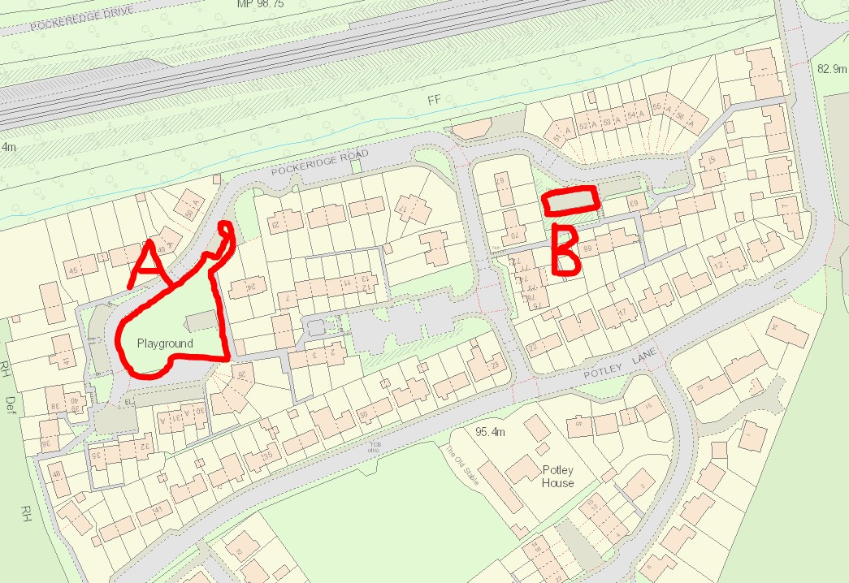

Until recently, both areas had been owned and managed by Wiltshire Council. However, in December 2022 Corsham Town Council took over the management of both sites when it entered into a seven-year lease. The Town Council expects to take permanent responsibility for them at some point during the course of the lease.

The Town Council feels that the play areas, and the Pockeridge Road area in general, tends to get forgotten about. Indeed, consultation with residents has revealed that parents often take their children to play areas elsewhere in the town as they feel that the two areas at Pockeridge Road have little to offer. The Town Council is keen to invest in both areas, to improve the play equipment and to provide facilities that local residents value and use.

Accordingly, the Town Council is now looking to invite specialist play equipment companies to visit the sites and to put together proposals for both play areas. Site visits are crucial in order to appreciate the constraints presented by the slope at Pockeridge A. Before making a decision on which scheme to take forward, the Town Council will consult with local residents to see which schemes meet with their approval and support.

Specification:

Corsham Town Council invites tenders for the following works:

- The removal of the following items:

Pockeridge A: Remove and dispose of (recycle) the multi-play.
Remove and dispose of the tiled safety surfacing.

Pockeridge B: Remove the multi-play (if nothing is wrong with the legs, Corsham Town Council will retain this item).
Remove and dispose of (recycle) the metal bench.
Remove and dispose of (recycle) the swing frame.
Remove and dispose of the tiled safety surfacing.
Remove and dispose of any tarmac that your design sets out.

- To design, install and appropriately surface new play equipment at Pockeridge A and Pockeridge B.

The layout and equipment should be interesting, fun and visually appealing. It should help create a place where children want to go and where parents want to take them.

The Town Council favours robust, metal-framed equipment which entails less maintenance and ensures greater longevity of use. In addition, the areas occasionally see some anti-social behaviour, so the proposed equipment needs to be reasonably resistant to the attention of vandals (surfaces from which it is easy to remove graffiti and equipment for which it is easy to source spare parts would be advantageous).

All equipment must conform to the ROSPA Code of Good Practice for Play Areas and to the British and European Standard for Playground Equipment: BS EN 1176. For each piece of equipment, the appropriate surfacing should be installed. All surfacing must accord with BS 7188 and EN 1177. More generally, the design should accord with BS EN 1176 with regard to minimum spaces around equipment and zones (spatial networks).

The successful company is expected to price for a ROSPA inspection of the sites before handing them over to Corsham Town Council. The company will be expected to address any issues identified in the inspection before handing the sites back to the Town Council and the receipt of payment.

Initial Consultation with Residents:

The Town Council does not wish to be too prescriptive on the type of equipment that companies put forward in their schemes (and is interested to see what different contractors come up with, and is opened-minded to new ideas). However, it might be worth noting that during our initial consultation with residents, the following requests/opinions were put forward:

At Pockeridge A, the following items were requested: large multi-play (possibly on the flat part of the site), mound slide, monkey bars, zip line, balance beam/trail, bench/picnic table.

At Pockeridge B, the following items were requested: swings, tub spinner, roundabout, trampoline, climbing frame, slide*, bench**.

Initially, the Town Council had envisaged Pockeridge B catering for younger children and Pockeridge A catering for older children. Our consultation with residents has shown that they don’t necessarily see an age split between the two areas. That said, the restricted space at Pockeridge B might mean that companies could look to make the most of the space by getting a number of small items in the space.

*Note: The area behind Pockeridge B has a slope where it might be possible to site a mound slide in future. The Town Council does not own this piece of land, but may look to acquire it for this purpose in the future. It would be helpful if designs for Pockeridge B left a small run-off area for children to safely get off a small slide.

**Note: It might save space for play equipment if any bench at Pockeridge B was located outside of the bow-top fencing. There is space at the front which might be appropriate to site a bench.

Site Visits:

Prospective contractors are strongly advised to undertake a site visit before submitting a proposal – this will be necessary to view the slope in Pockeridge A and make a judgement about the type of equipment that can be safely installed. Please contact James Whittleton (Head of Technical Services) to arrange a time/date: jwhittleton@corsham.gov.uk 07879 256215.

Submission of Tenders:

Tenders are to be sent by post or delivered by hand in an envelope clearly labelled “Tender – Pockeridge Road”, addressed to:

David Martin – Chief Executive
Corsham Town Hall
High Street
Corsham
Wiltshire, SN13 0EZ

Alternatively, tenders can be sent via email to dmartin@corsham.gov.uk AND mjones@corsham.gov.uk with “Tender – Pockeridge Road” in the title bar.

Tenders should be received no later than 12noon on Friday 26 January 2024.

The submission must include:

- A proposal/design for Pockeridge A and Pockeridge B, showing the pieces of equipment you propose to install, their proposed locations and any surfacing. (as the Town Council is planning to consult residents on the designs, it would be useful to have an A3 image of both Pockeridge A and Pockeridge B)

- Technical specifications for all proposed pieces of equipment.

- Details (material, specific product/supplier, thickness, extent, edging and colour) of any proposed safety surfacing.

- Confirmation that the proposed design conforms to the ROSPA Code of Good Practice for Play Areas; that all proposed equipment conforms to BS EN 1176 and that all surfacing conforms to BS 1788 and EN 1177.

- An overall price for all the proposed work – the removal of existing equipment and surfacing, the installation of new equipment and surfacing.

All costs are to be included in this price. Corsham Town Council does not expect to incur (and will not pay) costs which could have been reasonably foreseen by the contractor. Costs such as the disposal of materials, erection of fencing, storage, security or provision of welfare facilities should all be factored into the overall price. The contractor will also be expected to make good any ground damaged, dug up or rutted as a result of the works.

- Warranty details for the works and warranty details for each piece of equipment and surfacing.

- A copy of your company’s environmental policy.

- A proposed start date (which you will be expected to keep to).

The Town Council does not have a fixed budget for the project, but estimates that tenders will be in the region of £50-60,000 +VAT.

Before Starting Work:

Before the commencement of works, the chosen contractor will be required to provide a method statement for the entirety of the works as well as a risk assessment.

The contractor will also need to provide evidence that they hold public liability insurance of £5 million minimum (and that this is valid for the duration of the works) before starting work at the site.

Selection:

Corsham Town Council does not bind itself to selecting the lowest or any tender. Instead, it will conduct an assessment having regard to:

- The extent to which the proposals might improve the play areas.
- Value for money.
- The durability of the proposed equipment and the ease of maintenance.
- The views of local residents.

Corsham Town Council reserves the right not to award the contract if it feels that none of the proposals are suitable.

Corsham Town Council may reject any tender that does not supply the information asked for in the specification.

Timetable:

Notice and Specification issued: 8 December 2023.
Return date for Tenders: 12noon Friday 26 January 2024.
Council assessment decision: w/c 5 February 2024.

