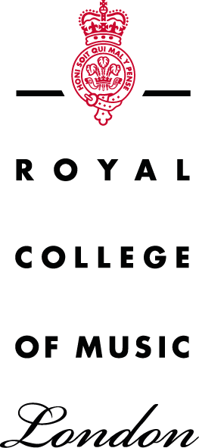
Here below are the 3 main themes for our permanent display, with a selection of objects from each area.

appendix 4: the museum collection
Permanent display

- Music is Creativity (Title still tbc)
Explore the secrets that have shaped Western music through some of the most significant instruments in our collection. Who built or owned them? What were the creative concepts or techniques they incorporated? And which instruments have left their mark?

Plucked, strummed and blown, the instruments here created distinctive musical sounds that inspired composers and performers. They span nearly three centuries and reflect their times and places of origin in fascinating ways. Today, instruments continue to change and evolve as new technologies and ideas emerge, influencing musicians, makers and audiences. Creativity in music is flourishing still.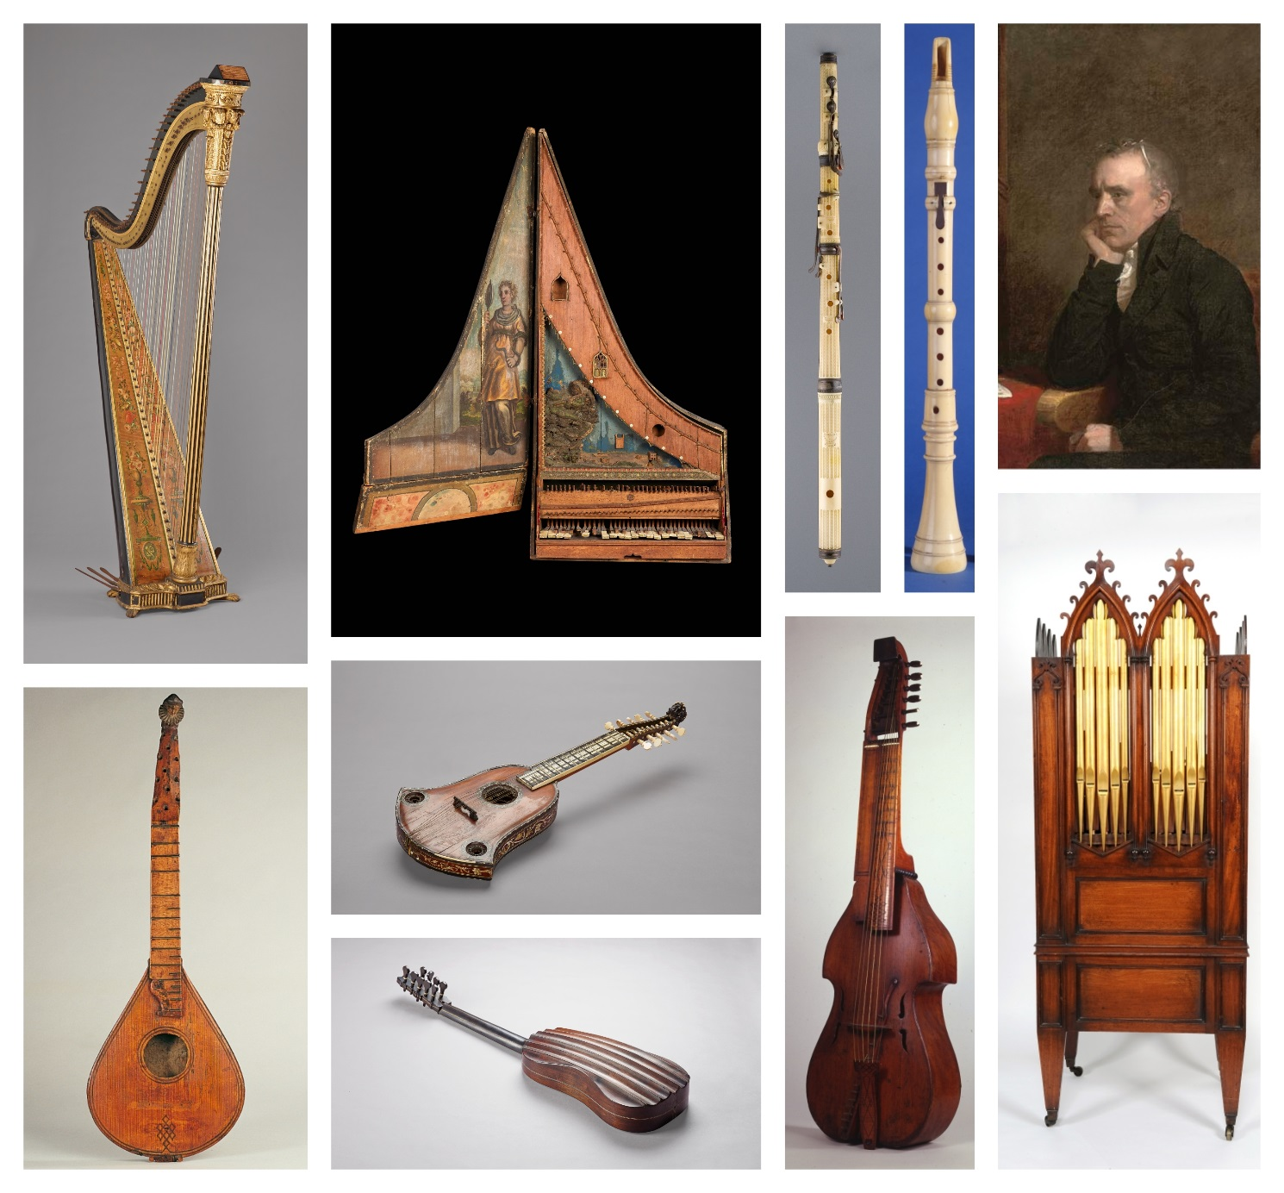
Music is Craft
Here we explore some of the most striking examples of craftsmanship from the RCM collections, looking at shapes, decoration and choice of materials, focussing on their relationship with the other arts and revealing links between music, musical instruments and the cultural context in which they were made.

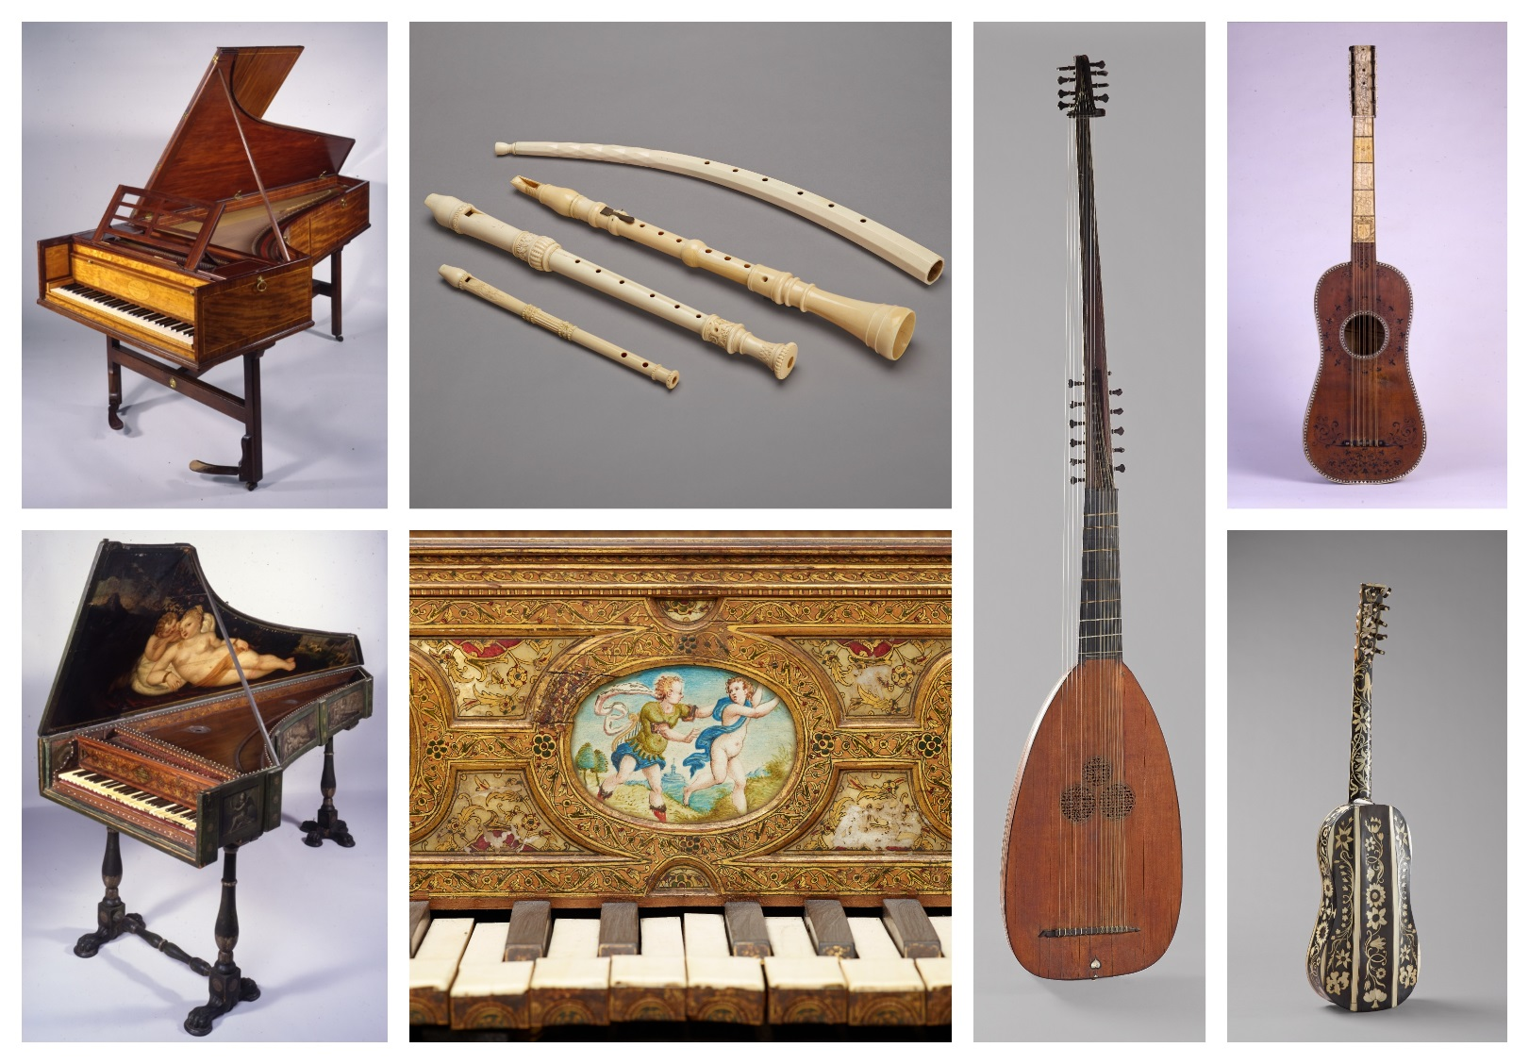

Music is Performance
Performance is the culmination of the creative musical process. It is also the moment when the interaction between a musician and their musical instrument becomes the most powerful.
Many of these instruments are still in playing condition and will be displayed outside of showcases and used for concert performances in the museum.
