**STRATTON ST MARGARET PARISH COUNCIL**

Please contact callam.greenwood@strattonstmargaret.gov.uk to arrange a site visit or ask any questions.

**Compact tractor and flail**

**Location:** Meadowcroft Community Centre, Addison Cres, Swindon SN2 7JX

**Budget:** Up to but not exceeding £45000

**Closing date:** 01/11/2024

**Request:**

We are looking for a compact tractor and small rotary flail that can be used to cut back small alleyways in hedges in built up residential areas.

* The tractor MUST be small enough to move up narrow alleyways. Please ensure you include the EXACT measurements in tender submission documents.
* Tractor must have cab
* 40HP tractor with a well-matched rotary flail (sidearm), not maxing out the tractor.
* Electronic control system is essential.
* Must be able to run a small vertidrain moving forward (e.g. VD7416)

**Examples of suitable tractors and flails:**

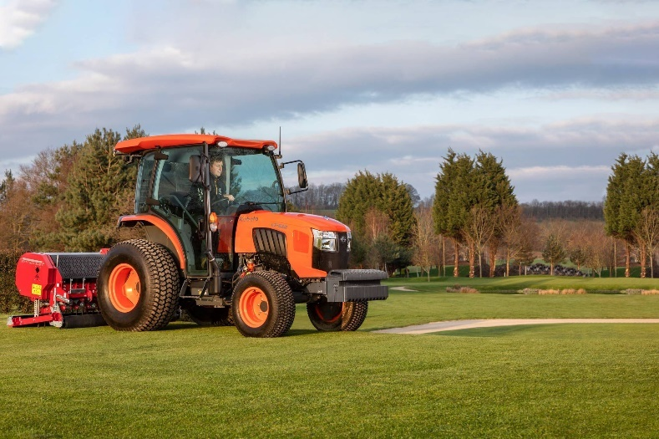

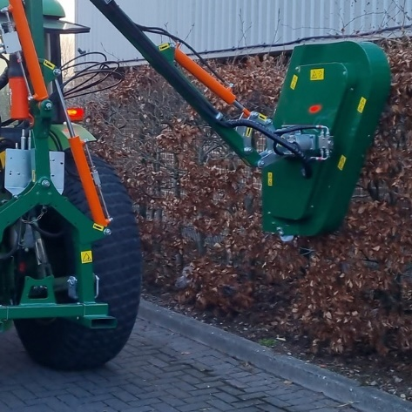

***Image 2:*** *Wessex CHT100RE rotary sidearm*

***Image 1:*** *Kubota L2522 with cab*

**Scoring criteria:**

Tender submissions will be scored on their price, suitability and availability of service/ spares.