

SCHEDULE 2 – THE SERVICES

A. Service Specifications

DRAFT

Service Specification No. | ---
Service | Health Inequalities Hub
Commissioner Lead | Camden Clinical Commissioning Group
Provider Lead | ---
Period | 1 April 2017 to 31 March 2019
Date of Review | 1 April 2018
Author(s) | Matthew Black (matthew.black@camdenccg.nhs.uk) and  Martin Emery (martin.emery@camdenccg.nhs.uk)

Population Needs

National/local context and evidence base
Camden Clinical Commissioning Group’s (CCG) vision is to work with the people of Camden to achieve the best health for all. In accordance with that vision, this service specification has been developed with involvement from the Camden public and patients, as well as with clinical expertise, and local provider networks.
The CCG’s objectives are to:
(A) Commission the delivery of NHS constitutional rights and pledges
(B) Improve the quality and safety of commissioned services
(C) Improve health outcomes, address inequalities and achieve parity of esteem
(D) Integrated and enable local services to deliver the right care in the right setting at the right time
(E) Work jointly with the people and patients of Camden to shape the services we commission
(F) Involve member practices and commissioning partners in key commissioning decisions
(G) Maintain financial stability and ensure sustainability through robust planning and commissioning of value for money services
(H) Build a high performing organisation that attracts, develops and retains a skilled and motivated workforce

The Health Inequalities Hub will support Camden CCG in achieving objectives (A), (C) and (H).

Outcomes

NHS Outcomes Framework Domains & Indicators
The Health Inequalities Hub will help Camden CCG to achieve the domains set out in the NHS Outcomes Framework. Specifically covering:
Domain 1 | Preventing people from dying prematurely
Domain 2 | Enhancing quality of life for people with long-term conditions
Domain 3 | Helping people to recover from episodes of ill-health or following injury
Domain 4 | Ensuring people have a positive experience of care
Domain 5 | Treating and caring for people in safe environment and protecting them from avoidable harm

Local defined outcomes
The service will deliver the six outcomes listed below. The performance of the measures against targets will be reviewed at a frequency agreed between the provider and commissioner.

Outcome | Measure | Target
1.  Increase access to services for hard to reach, marginalised, and black, minority, ethnic and refugee (BMER) communities to non-acute and health promotion services. | 1.1  Number of people accessing the service. | 1.1.a  No target for numbers of people accessing the service, however, a target may be set by the commissioner as the service matures.
 | 1.2  Number of referrals to other healthcare services by type of service and by ethnicity, age, etc. | 1.2.a  Percentage of those in the BMER group referred to other services should be 35% of the total activity.
1.2.b
Percentage of those with a learning disability referred to other services should be 1% of the total activity.
2.  Reduce social isolation and connect people to Camden groups and communities. | 2.1  Patient reported feedback: ‘Have you joined or accessed any local groups or community activities?’ | 2.1.a  Feedback must be obtained from 10% of those using the service. 90% of those accessing the service should answer ‘yes’.
 | 2.2  Patient reported feedback: ‘Do you feel your circle of friends has widened?’ | 2.2.a  Feedback must be obtained from 10% of those using the service. Using the scale, ‘not at all’, ‘somewhat’ and ‘very much’, 90% must be ‘very much’.
 | 2.3  Patient reported feedback: ‘Do you feel confident or more confident in joining in group activities or social events?’ | 2.3.a  Feedback must be obtained from 10% of those using the service. Using the scale, ‘not at all’, ‘somewhat’ and ‘very much’, 90% must be ‘very much’.
3.  Enable more people to connect to support services, e.g. Citizens’ Advice Bureau, etc. | 3.1  Patient reported feedback: ‘Did you make contact with the service you needed?’ | 3.1.a  Feedback must be obtained from 10% of those using the service. 90% report ‘yes’.
 | 3.2  Patient reported feedback: ‘Have you made use of non-clinical services and support available to you?’ | 3.2.a  Feedback must be obtained from 10% of those using the service. 90% report ‘yes’.
 | 3.3  Patient reported feedback: ‘Do you feel enabled to manage your own health and wellbeing?’ | 3.3.a  Feedback must be obtained from 10% of those using the service. Using the scale, ‘not at all’, ‘somewhat’ and ‘very much’, 90% report ‘very much’.
 | 3.4  GP practice feedback: ‘Has access to the signposting service for reduced the call on your practice staffs’ time to deal with non-clinical conditions and enquiries?’ | 3.4.a  Feedback must be obtained from 10% of those using the service. Using the scale, ‘not at all’, ‘somewhat’ and ‘very much’, 90% must be ‘very much’.
4.  Enable more people to get into work as a means to improving their confidence, self-esteem and general mental health wellbeing. | 4.1  Number of health advocates that have moved on to paid employment after leaving the service. | 4.1.a  50% of those leaving the service have moved on to paid employment within three months of leaving the service.
 | 4.2  Developed and embedded pathway to paid employment for local Camden residents which links recruitment and training of volunteers to an opportunity to apply for paid employment in delivering health and social care services within the borough. | 4.2.a  Development of pathway to be completed within two months of contract start date.
4.2.b
Embedding of pathway to be completed within four months of contract start date.
5.  Encourage people to live healthier lives. | 5.1  Number of people accessing the Expert Patient Programme. | 5.1.a  90% of people accessing the service and who are appropriate for the Expert Patient Programme should be referred in to the service.
5.  Encourage people to live healthier lives. |  | 5.1.b  90% of people referred into the Expert Patient Programme should still be registered with the service n months after first referral from the Hub.
5.  Encourage people to live healthier lives. | 5.2  Patient reported feedback: ‘Have you made use of non-clinical services and support available to you?’ | 5.2.a  Feedback must be obtained from 10% of those using the service. 90% report ‘yes’.
5.  Encourage people to live healthier lives. | 5.2  Patient reported feedback: ‘Do you feel enabled to manage your own health and wellbeing?’ | 5.2.a  Feedback must be obtained from 10% of those using the service. Using the scale, ‘not at all’, ‘somewhat’ and ‘very much’, 90% must be ‘very much’.
5.  Encourage people to live healthier lives. | 5.3  GP and practice staff feedback: ‘Has access to the service increased your awareness of the non-clinical services and support available to you to refer patients to promote their health and wellbeing?’ | 5.3.a  Feedback must be obtained from 10% of those using the service. Using the scale, ‘not at all’, ‘somewhat’ and ‘very much’, 90% must be ‘very much’.
6.  Enable more people from the local community to work in a healthcare setting and in particular to ensure the workforce better reflects the diversity of the borough. | 6.1  Employment destination, age and ethnicity of those health advocates that have moved on to paid employment after leaving the service | 6.1.a  Of those who have entered paid employment within three months of having left the Hub, 35% should be BMER.

Scope

Aims and objectives of service
The service will:
- Be a presence in GP practices and other community services bases
- Deliver advice to patients on what healthcare services are available
- Signpost patients to other services which may be of benefit
- Improve the general health and wellbeing of Camden residents

Service description/care pathway
The diagram overleaf sets out the expected patient journey.
Figure 1 Patient Pathway

Population covered
The Health Inequalities Hub will provide a service for people who are registered with a Camden GP. The borough border is provided below for information. Though it is a requirement that the Health Inequalities Hub has a physical presence in Camden, it should be noted that some patients accessing the service may not be resident in the borough, e.g. because of close proximity to the boundary, or because of patient choice in selecting their GP practice.
Figure 2 London Borough of Camden Boundary
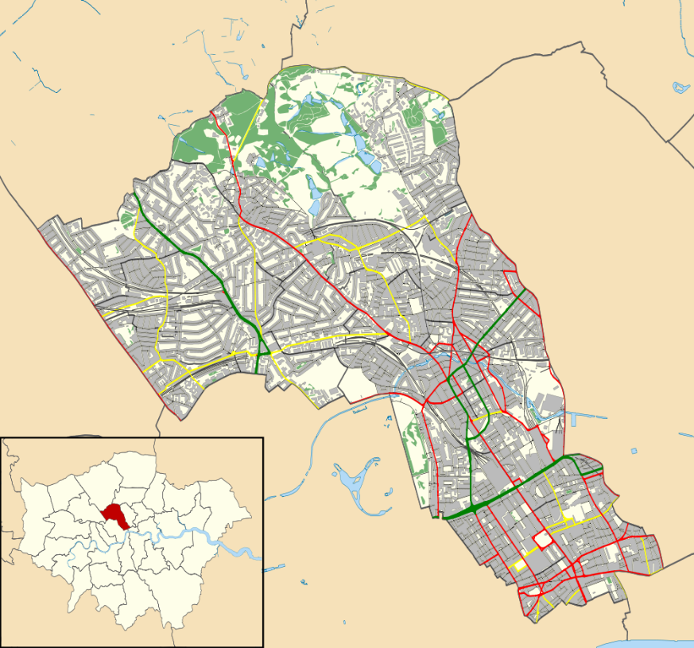
(Image courtesy of Wikipedia)

Camden had an estimated resident population of 225,140 people in 2013. Camden’s Joint Strategic Needs Assessment goes into full detail about the demographic of the Camden population, however, it is known that the population is expected to rise to 246,100 by 2023. People aged 45 years and over are expected to account for the largest rise. Nearly 35% of Camden’s overall population are estimated to be from a black minority ethnic group (BME) background. This figure excludes the White Irish community and other non-British white residents. 22% of Camden’s residents are from the non-British, white community.
The 2011 census suggests that specific ethnic group populations vary across wards. In seven of Camden’s wards, Bangladeshis form the largest minority group. Black Africans constitute the largest in six, ‘other Asian’ in four and Chinese in one.
A further reflection of Camden’s cultural diversity is seen in the variety of languages spoken. After English, the three most commonly spoken languages are Bengali (13%), French (8%) and Spanish (6%).

Any acceptance and exclusion criteria and thresholds
Referrals into the service can be made directly by Camden general practice staff, Camden community service staff, or the service can also Camden patients with the approval of their practice.
The service has no exclusion criteria.

Interdependence with other services/providers
This service is not wholly reliant on any other services, nor are any services reliant on this service. However, there will be many interfaces with other providers, such as:
- Camden GP practices
- Camden community health services
- Other community services and local groups within Camden

Applicable Service Standards

Applicable national standards (eg NICE)
There are no NICE standards applicable to this service. However NICE QS15 Patient experience in adult NHS services and QS14 Service user experience in adult mental health services set out some useful guidelines that the service should be aware of and conform to.

Applicable standards set out in Guidance and/or issued by a competent body (eg Royal Colleges)
There are none.

Applicable local standards
There are none.

Applicable quality requirements and CQUIN goals

Applicable Quality Requirements (See Schedule 4 Parts [A-D])
None from Schedule 4 Parts A-D of the NHS standard contract are applicable.

Applicable CQUIN goals (See Schedule 4 Part [E])
None from Schedule 4 Part E of the NHS standard contract are applicable.

Location of Provider Premises
It is expected the provider will have a regular base within Camden as well as being based at local GP practices and community services premises.
6a. GP Practices
A full list of the GPs in Camden is available at the NHS Choices website. As GP practices are independent providers, being able to be a presence at a practice will be dependent on cooperation from the practice themselves. It is expected that the Health Inequalities Hub will aim to have a presence at most if not all Camden GP practices during most of the term of the contract.
6b. Community Services
In order to provide as wide a reach to Camden patients as possible, it is expected the service will operate from a number of community services locations. As far as this is practicable, it is expected that this will cover an equitable amount of coverage in Camden.
6c. Other Premises
With agreement with the Commissioner, the service may provide a presence at other sites within Camden. This will be to increase equitable coverage across the borough.

Individual Service User Placement

Not applicable.

Cf., Number of Camden residents ‘known’ to Camden’s Learning Disability Service was 662 in 2013, taken from Joint Commissioning Plan for Adults with Learning Disabilities 2013-2016, available at http://www.camden.gov.uk/ccm/cms-service/download/asset?asset_id=3215987, accessed 22 September 2016.
https://commons.wikimedia.org/wiki/File%3ACamden_London_UK_location_map_2.svg; Contains Ordnance Survey data © Crown copyright and database right [CC BY-SA 3.0 (http://creativecommons.org/licenses/by-sa/3.0)], via Wikimedia Commons from Wikimedia Commons, accessed 22 September 2016.
Taken from Camden CCG’s Joint Strategic Needs Assessment, available at https://www.camden.gov.uk/ccm/navigation/social-care-and-health/health-in-camden/health-decision-making/joint-strategic-needs-assessment/;jsessionid=A5188B19122B219246B742412E10924D, accessed 22 September 2016. An ‘Executive Summary’ from 2014/15 is also available at https://www.camden.gov.uk/ccm/cms-service/stream/asset/?asset_id=3267679&.
Available at https://www.nice.org.uk/Guidance/QS15, accessed 22 September 2016.
Available at https://www.nice.org.uk/Guidance/QS14, accessed 22 September 2016.
http://www.nhs.uk/Services/Trusts/GPs/DefaultView.aspx?id=89632, accessed 22 September 2016.

