**REQUEST FOR INFORMATION**

**SUBMARINE DELIVERY AGENCY**

**Submarine Escape Survival Equipment**

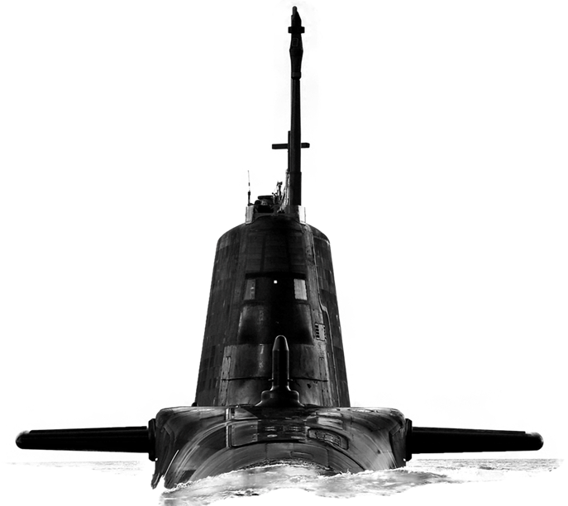

Version 1.0

**29 June 2023**

**CONTENTS**

Confidentiality..............................................................................................................3

Introduction..................................................................................................................3

Background…………...................................................................................................3

Purpose of the Request for Information (RFI).............................................................4

RFI Procedure............................................................................................................ 4

How to Delivery Responses to this RFI………............................................................4

Contacts......................................................................................................................4

Timeframe...................................................................................................................5

Annex A - Request for Information Questionnaire……….........................................A-1

**Confidentiality**

1. All information included in this Request for Information (RFI) is confidential and only for the named addressee. No information included in your response, or in discussions connected to it, will be disclosed to any other party.

**Introduction**

1. The Submarine Delivery Agency (SDA) is planning to procure Submarine Escape and Survival Equipment (SESE) to replace existing equipment as it reaches the end of life. This RFI is focussed upon the provision of operational SESE comprised of a suit and life raft and associated training equipment.
2. Provision of SESE is crucial to ensuring platforms are safe and available. The SDA is seeking to understand the market for the supply of SESE and the constraints upon supply in order that this can be taken into consideration to inform future procurement plans. We would like to invite your company to answer a few questions to inform our understanding
3. This RFI is not a bidding opportunity but a means by which industry can provide information. Any resulting procurement activity will be conducted competitively and advertised through the Defence Sourcing Portal.

**Background**

1. There is an enduring requirement to provide safe evacuation of Royal Navy (RN) Submarine personnel in the event of a Disabled Submarine (DISSUB).
2. The purpose of SESE is to allow submariners to evacuate from a disabled submerged submarine, without assistance, in a safe and controlled manner. The intention of the equipment is to keep the escapee dry and protected from the environment during ascent, and to provide buoyancy, freeboard, and thermal insulation at the surface.
3. SESE allow submariners to escape a disabled submarine from depths of up to 200 meters and gives them an anticipated surface survival time of 24 hours (achieved through the deployment of a single seat life raft).
4. The provision of sufficient survival suits for submarines meets the Navy Board’s policy statement on Submarine Escape Rescue Abandonment and Survival (SMERAS). It seeks to ensure that in the event of an accident leading to a submarine sinking or surface abandonment, then adequate resources and suitable procedures are available to maximise the saving of life.
5. The SESE is a whole-body suit comprising a one-size fits all Submarine Escape Survival Suit and a Single Person Life Raft all contained in a sealed system within a protective valise.
6. The Authority anticipates a planned demand of 4000 operational SESE and 100 training variant SESE supported by a contract of **5** years with through-life equipment support for the training suits.
7. The next generation SESE is to comprise of:
   1. Submarine Escape Survival Equipment (SESE) Suit.
   2. Thermal Protection
   3. Single Person Life Raft.
   4. Valise (Method of Containment for Components during storage).

**Purpose of the RFI**

1. The Department is using this Request for Information (RFI) to help inform the development of its strategy to procure and support submarine escape and survival equipment. This RFI provides an opportunity for Industry to comment on the outline requirements. This RFI is not a commitment by the Department to launch a formal procurement procedure. This RFI aims to achieve 3 outcomes:
2. To gather information about the current market offering for the provision of submarine escape and survival equipment;
3. To understand the potential lead times, underpinning supply chain and manufacturing issues and to consider the impact of these might have upon delivery schedules and size/frequency of batch deliveries.
4. Develop a procurement strategy that will deliver best value for money for Defence and enable delivery of the first batch of SESE by March 2025.

**RFI Procedure**

1. This Request for Information will be advertised on the Defence Sourcing Portal (DSP) and Contracts Finder and issued to all who request an RFI together with other companies whom the MOD believes may be able to provide useful intelligence on this requirement.
2. Responses to this RFI will be reviewed by subject matter experts from different functional areas within the Submarine Delivery Agency. Following receipt of responses to this RFI the Authority may initiate follow on engagement with either individual potential suppliers, groups of potential suppliers or all potential suppliers. This may be undertaken in writing or through virtual meetings.
3. Any details provided in response to this RFI or during subsequent engagement will be used for information purposes only and will not be used to determine the potential suppliers who will be invited to bid, should the Authority proceed to tender.
4. The results and analysis of this RFI shall not constitute any form of pre-qualification exercise. Any formal procurement process will be undertaken in accordance with EU Procurement Law.
5. Nothing in this RFI, or any other engagements with Industry prior to a formal procurement process, shall be construed as a representation as to the Authority’s ultimate decision in relation to the future requirement.

**How to deliver responses to this RFI**

1. To respond to this RFI please complete the form at Annex A and return electronically to [Sarah.Bulmer490@mod.gov.uk](mailto:sarah.bulmer490@mod.gov.uk). Responses will be acknowledged by email.

**Contacts**

1. Please raise questions relating to this RFI by email to [Sarah.Bulmer490@mod.gov.uk](mailto:Sarah.Bulmer490@mod.gov.uk)

**Timeframe**

1. This is the timeframe for the RFI and follow-on activity:

29 June 2023 - RFI Published on Defence Sourcing Portal.

13.00 –21 July 2023 – Last date for submission of answers to RFI.

Supply of Submarine Escape Survival Equipment

**Request For Information – Supplier Response**

|  |  |
| --- | --- |
| **Question** | **Answer** |
| Company Name |  |
| Company Address |  |
|  |  |
| Name of Company representative completing the RFI |  |
| Contact details (e-mail and telephone number) |  |
| Company web site address |  |
|  |  |
| Main products/services/line of business |  |
| Main market sector/customers |  |
| Number of years in this market sector |  |
|  |  |
| Lead time, batch size and delivery frequency. | |
| 1. Are there any risks or concerns specific to this market that the SDA should be aware of? |  |
| 1. Are there any materials which are used to manufacture SESE which are known to be limited in supply, for which a long lead time is anticipated or where supply is insecure. What impact would these issues have upon your ability to fulfil an order? |  |
| 1. Does your organisation manufacture SESE or would you rely upon a third party for manufacturing in order to fulfil this contract? If so, does this present challenges? |  |
| 1. Based upon current production arrangements please state the maximum number of SESE units which can be manufactured/supplied per month. |  |
| 1. Please provide an estimate of the lead time for delivery of SESE once an order is received. |  |
| 1. Please state minimum, maximum, and preferred delivery batch sizes along with any reasoning for these. |  |
| 1. Please state the frequency with which batches can be delivered once supply has commenced. |  |
| 1. Does your organisation offer a training variant SESE with similar fit, form and function? |  |
| 1. Could your organisation undertake repairs of SESE? |  |
| 1. Please outline any technical challenges which may be relevant to the manufacture and supply of SESE which you think the Authority should be aware of. |  |
| 1. Please outline any management challenges which may be relevant to the manufacture and supply of SESE which you think the Authority should understand. |  |
| 1. Would your organisation be interested in competing for a contract to supply SESE to the SDA. Please give details of any factors which might affect your decision to bid. |  |
| 1. Please provide any other comments which you feel are relevant but are not covered by the above. |  |
| Social Value | |
| 1. Central Government seeks to identify opportunities to increase social value across its contracts. What opportunities for added social value are relevant to the SESE and how could your company work with the SDA in pursuit of these as a direct result of this Contract. Further information on the Government’s approach to Social Value can be found on gov.uk |  |