

REQUEST FOR TENDER
(SNTC-OA-001-23)

Provision of New Accessible Play Equipment and supporting infrastructure

To be submitted no later than 28th February 2023
Late submissions will be disregarded.

General Enquiries
Ian Webb
St Neots Town Council
Ian.webb@stneots-tc.gov.uk

Site Location: Brickhills/Henbrook Play Area, Howitts Lane, Eynesbury,
St Neots, PE19 2PE

RESPONSIBLE PARTIES

The Organisation
St Neots Town Council
Council Officers
Priory Lane
St Neots
PE19 2BH

Contracts Administrators
Chris Robson – Town Clerk, St Neots Town Council
Ian Webb – Operations Manager, St Neots Town Council

CONTENTS
1 | Introduction to the Council ……………………………………………………………………………….. | 3
2 | Brief Description of Services ………………………………………….………………………………….. | 3
3 | General Information ………………………………………………………………………………………….. | 3
4 | Design and Cost …………………………………………………………………………………………………. | 4
5 | Specification of Works, Supplies and Services …………………………………………………… | 5
6 | Supporting Images of Site ………………………………………………………………………………….. | 7
7 | Tender Timelines ………………………………………………………………………………………………. | 10
8 | Return of Tender ……………………………………………………………………………………………….. | 10
9 | How you Tender is Assessed ……………………………………………………………………………… | 10
10 | Scoring Criteria ………………………………………………………………………………………………….. | 11
11 | Scoring System ………………………………………………………………………………………………….. | 11
12 | Exclusion (Discretionary Exclusion Criteria) ……………………………………………………….. | 12
13 | Help and Support ………………………………………………………………………………………………. | 12
 | APPLICATION DOCUMENTS
14 | Part A - Basic Details of your Organisation ………………………………………………………… | 13
15 | Part B - Suitability Assessment Questions …………………………………………………………. | 14
16 | Preamble to Pricing Schedule ……………………………………………………………………………. | 16
17 | Part C – Pricing Schedule …………………………………………………………………………………… | 17
18 | Special Terms ……………………………………………………………………………………………………. | 18

Introduction to the Council

The Council is a town council within Huntingdonshire in the county of Cambridgeshire, England. St Neots Town Council is an elected statutory body of 21 members with legal powers to provide services for the community of St Neots, Eynesbury and Eaton Socon. The Council works with partners, such as Huntingdonshire District Council, to help improve local service delivery. The town has an approximate population of over 32,000.

Brief Description of Services

You are invited to tender on a contract to work in partnership with St Neots Town Council for the extension of fencing to and existing play area and the recommendation, provision and installation of new accessible play equipment and pathways as part of that extension.

As part of the tendered work the Council would also like to install pathways at the existing play area to allow accessible movement through what is currently a grass matt-based play park.

Site Location: Brickhills/Henbrook Play Area, Howitts Lane, Eynesbury, St Neots, PE19 2PE

General Information

Please check this document together with all accompanying documents, particularly the Specification, and if any pages are missing, duplicated or the text is indistinct, please notify the Council, as we will accept no liability for such errors or omissions.

All items in the Pricing Schedule should be priced. Our Payment terms are 30 days after approved invoice. This must be replicated as a maximum for subcontractors used on this project.

For the proper comparison of Tenders, it is important that no unauthorised alterations have been made to the Tender documents. Tenders containing unauthorised alterations or qualifications may be rejected. If you consider that changes are necessary, your proposals please contact the Town Clerk.

You are welcome to enclose any documents, brochures or other materials you believe will support your tender. You must retain the sequence of the questions and the numbering in your response.

Bids shall remain open for acceptance for a minimum of 90 days from the date that the Tender return is posted. The Council expects to decide award of contract by 1st March 2023.

The Council is not bound to accept a Tender or make an award from this Invitation to Tender.
The contract will be awarded on the basis of the Most Economically Advantageous Tender, based on the award criteria as set out below subject to satisfying the Council’s requirements set out in Part A (Suitability Assessment Questions). Acceptance of the tender by the Council shall be in writing and on the Council’s terms and conditions which are supplied as part of our Tender requirements.

Design and Costs

The Council wishes to appoint a partner to bring forward the installation of new accessible play equipment at one of its play areas. The Council wishes to see as many additional play elements for children with accessibility challenges as is possible for the space and funding available. There should be a focus on equipment that can be used by children in wheelchairs, as well as children of all other abilities.

The design and costing will need to take into account the extending of the current fence line to create the new play section. The design should also include accessible pathway through to al wheelchairs to move through the play area.

A separate cost is asked for the installation of pathways to connect the extension to the existing park and allow users to progress through that park.

The existing equipment is installed on grass matting. A wet pour or mulch surfacing is preferred for the equipment in the new extended area.

The Council has a budget of £80,000 confirmed for the works and tenders are asked to work within the scope of that budget.

Specification of Works, Supplies and Services

This specification is a requirement for the design, provision and installation of new accessible play equipment, safety matting and a pathway, along with the extension of existing fencing to incorporate the new equipment.

Site Location: Brickhills/Henbrook Play Area, Howitts Lane, Eynesbury, St Neots, PE19 2PE

The project seeks to improve the existing children’s play area at Brickhills, St Neots. The Council has recently invested in the replacement/upgrading of existing equipment in the play area, and now wishes to increase play value by extending the site and installing equipment with a specific focus an accessible play that can include use by wheelchair users. The council also recognises that sensory play is an important part of play value and where possible sensory elements should be incorporated into the design of the extended play area.

The Council has a budget of £80,000 for the works set out in this specification. Tenders should be based on the following requirements;

- Play Equipment and Play Elements

The project should include as many play elements for accessible play as is possible within the scope of the site and the budget available. Play values should include;

- Rotating  - Rocking  - Swinging | - Role play/imagination/story telling  - Sound, touch and visual sensory play

Tenderers are invited to put forward equipment they feel provide the all or some of the above play elements. The Council would like to see numerous bits of equipment that can be used by children of differing capabilities, including;

- Sensory play panels
- Visual play, such as mirrors, colours or shapes
- Items of equipment that can be used be both wheelchair users and provide motion, such as trampolines, roundabouts or see-saws
- Items of play that provide roll play or story telling play for children of all abilities, including wheelchair users.

- Surfacing
Safety surfacing should be considered in terms of accessibility for wheelchair users and pushchairs. For this reason, grass matting should be avoided, with a preference for wet pour, eco-mulch or artificial grass. Where possible any play value that could be increased through the use of coloured, or themed surfacing would be beneficial in adding overall play value.

- Pathway
Installation of a pathway through the new play area, which allows access from the existing gate through to the equipment for wheelchairs and pushchairs. The pathway should lead to a new secondary gate to provide an alternative exit/entrance. It is important that each item of new equipment is accessible by the pathway and safety matting.

The Council would like to include sensory benefits for play where possible and incorporation of a sensory play pathway which could contribute towards creative and imaginative play would be of major benefit to the overall project.

- Fencing
Extension of the existing play park fence line to incorporate the area required for the installation of the new play equipment. Work to include;

- removal/relocation of existing fence panels as required
- purchase and installation of new/additional fence panels as required.

New fencing panels should match the existing galvanised bow top fencing at 1.2m high.

Supply and install 1 x 1.2m wide 1.2m high yellow self-closing gate (not lockable), and 1 x 3.1m wide
high yellow combination gate c/w lockable for maintenance access.

- Additional Pathway
Cost for installing a connecting path through the existing play equipment, helping to link up the original play area and the extension and making access around the play area easier for wheelchairs and pushchairs. If possible, this pathway would also provide some sensory benefits.

- Bins and Benches
The tender does not need to include provision of bins and benches.

- Installation and Completion
- The installation works shall provide a finished state, suitable for use immediate use by users, subject to ROSPA sign off. The site shall be left clean and tidy at the end of the contract and must be handed over in pristine condition.
- Damage to surrounding areas shall be minimised and any damage within or outside of the completed site shall be reinstated to the satisfaction of the Council. Any reinstatement of grass areas shall be with turf.

- Post Installation Inspection
- A post installation inspection will be arranged by St Neots Town Council to be conducted within 7 days of installallation completion through ROSPA to ensure BS EN1176/7, BS EN7188 are met.
- Completion of any remedial works highlighted in the post installation report to be conducted within 14 days of report completion.

All tenders should include a breakdown of costs, details of individual items of equipment and visuals/mock-ups of the proposed play area/equipment.
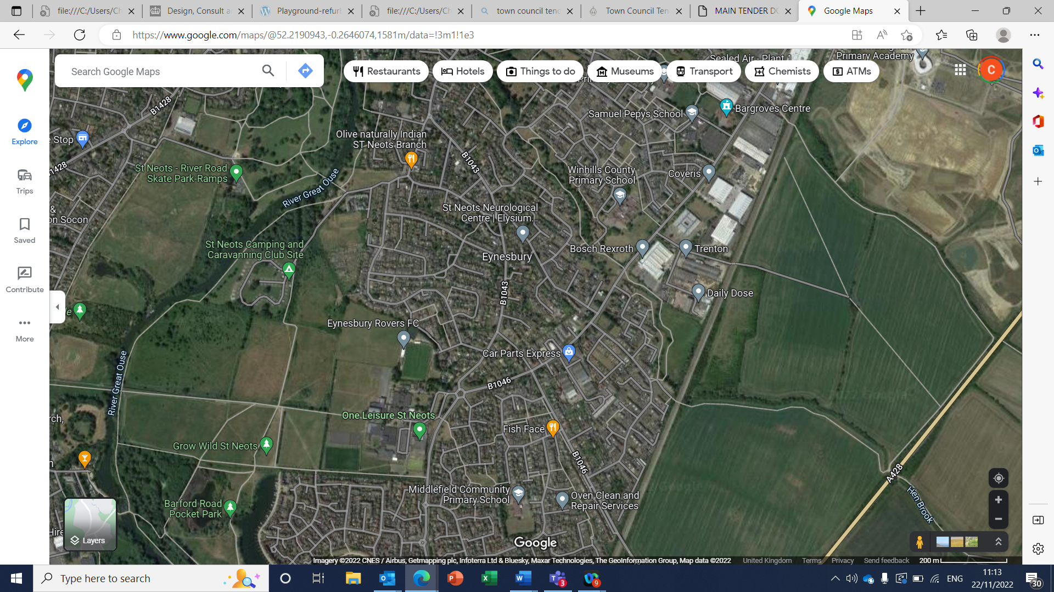
Play Site (Henbrook/Brickhills)
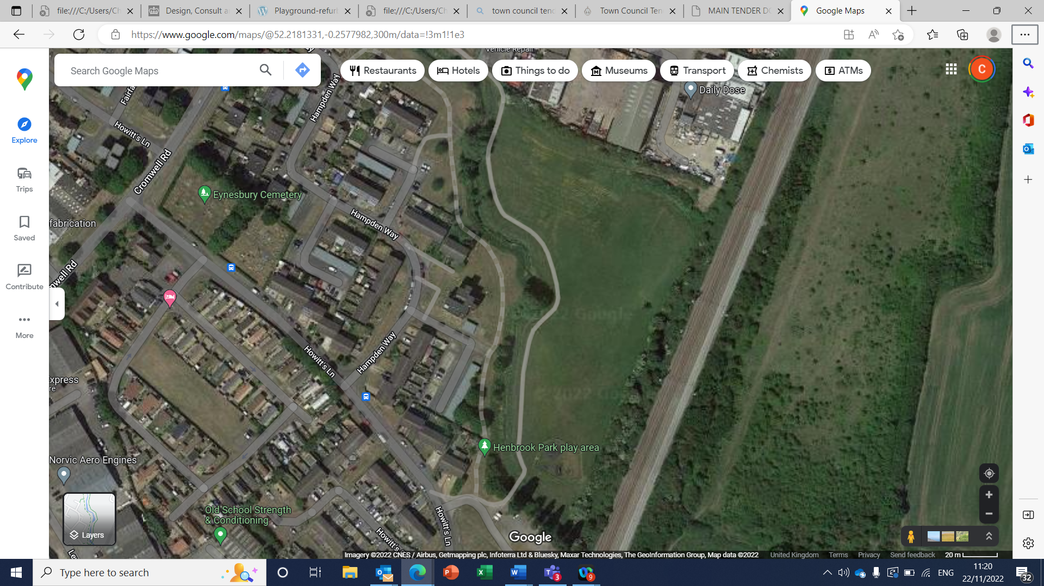
Existing Play Area

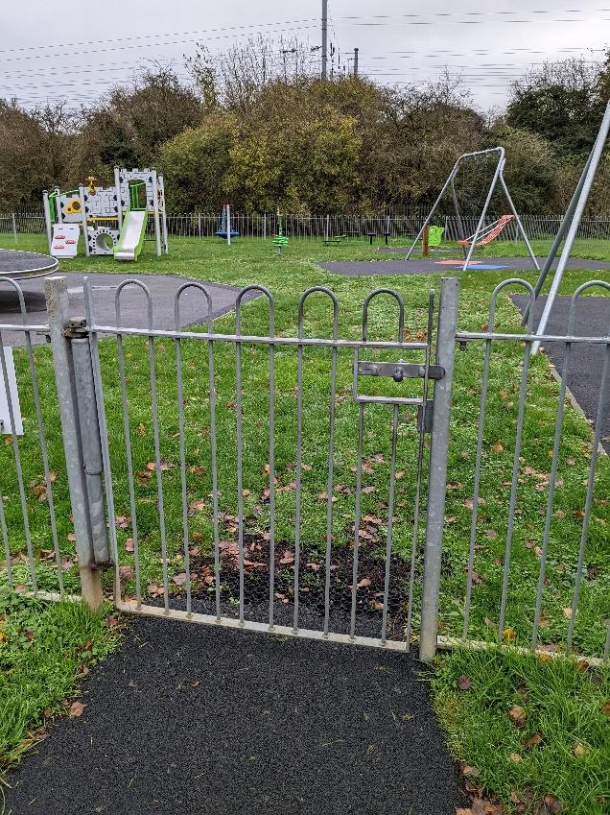
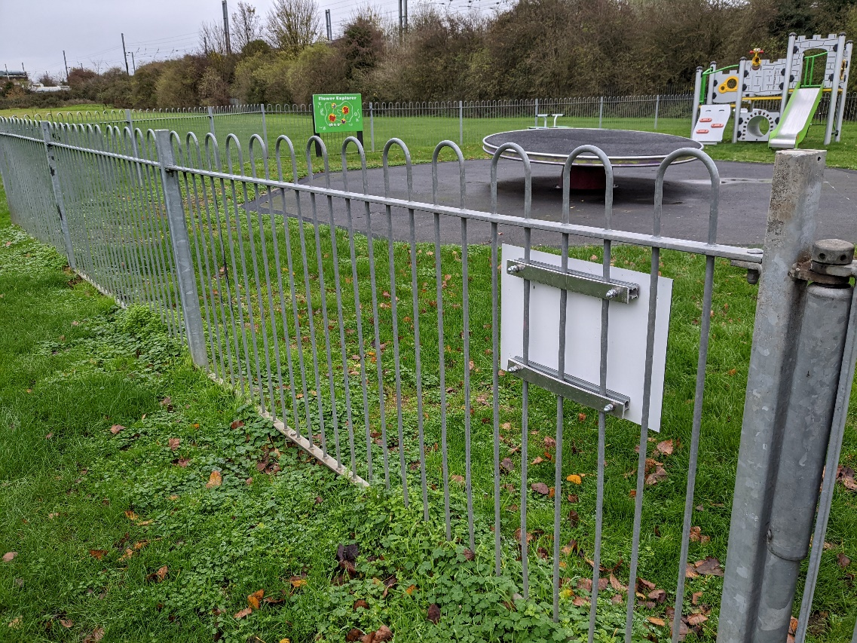
Existing galvanized fencing and gate

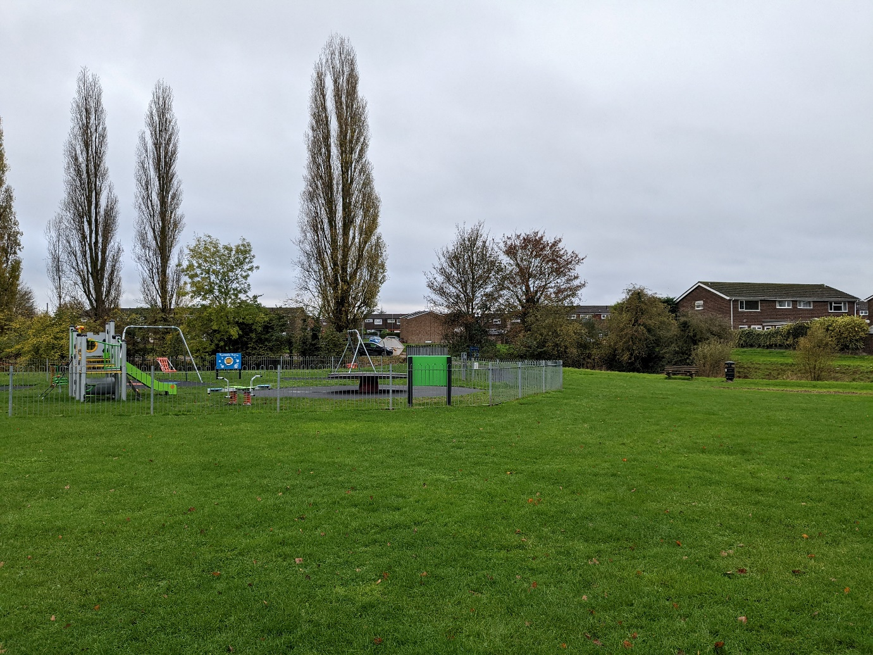
Existing play area and surrounding open space for extension / new equipment

Tender Timelines

Below is an indication of this Tender timeline which may change, and Sandy Town Council will not be liable for any changes.

ACTIVITY | DATE
Tender goes live | W/C 9th January 2023
Last date for receiving questions or points of clarification | 23rd February 2023
Deadline for receipt of Tenders | 28th February 2023
SNTC to resolve appointment of preferred contractor | 28th March2023
Award of contract | 29th March 2023
Target contract commencement date or delivery date | Commencement of installation work after post 18th April 2023

Return of Tender

Completed Tenders and attachments should be submitted via email by the due date, or by hard copy to the Council offices, Priory Lane, St Neots, Cambriedgeshire, PE19 2BH

Your Tender must be submitted by no later than 17:00 noon on 28th February 2023. Tenders received after that time will be excluded.

How Your Tender is Assessed

All submissions will be assessed in line with St Neots Town Council financial regulations. The tenderers must be able to answer yes to the following three screening questions:

1. Has the contractor confirmed that they have visited the site? YES/NO
2. Has the contractor confirmed that they can meet the deadline? YES/NO
3. Has the contractor provided evidence of similar projects in the past? YES/NO

The Council will evaluate all essential requirements above and disclosed in the business questionnaire (Part A/ B) on a ‘pass’ or ‘fail’ basis. Tenders failing any of the essential criteria will be rejected at this stage of the evaluation.

Full evaluation will then be based upon the following criteria for;

Design = 75% (including functionality, maintenance, number of pieces of equipment and suitability for children with disabilities, integration with existing play park)

Price = 25% (including total costs and discounts applied)

Scoring Criteria

CRITERIA | WEIGHTING | DETAILS
Quality of design:  Play value  Aesthetics  Innovation | 40% | - Compliance with design brief.  - Variety of equipment offering imaginative play.  - Variety of equipment offering accessible play.  - Quantity and quality of play values (activities).  - Aesthetics and colour of equipment.  - Layout of area/efficient use of the space available.  - Quality of materials used/suitability for the environment.
Presentation | 15% | - The presentation score will be assessed by the quality of the materials submitted i.e scale plan showing location of equipment, visual design artwork.  - Clarity of the scheme being offered and how it will integrate with the remaining equipment.
Maintenance /  Warranties | 10% | - Quality of materials used / expected life-span of equipment. Maintenance requirements / estimated annual cost.  - Length of warranty cover.  - Deliverance of project aftercare service.
Environmental Impact | 10% | The council is committed to reducing impact to the environment through its project works. Evidence of a sustainable approach and details of how waste is managed.
Price /  Value for money | 25% | Value for money offered – cost of scheme vs quality/quantity of play opportunities offered.

Scoring System

Each criterion will be awarded a score in accordance with the scoring scale below i.e 0-5

Score | Criteria for Award
5 | Exceptional demonstration of understanding of the project aims. Response is above expectations in meeting project requirements
4 | High standard, but falls just short of excellent
3 | A comprehensive response that clearly meets most of the project’s aims/requirements
2 | Some reservations – the response suggests shortcomings of understanding/ approach
1 | Basic compliance only – significant shortcomings to understanding/ approach
0 | Fails to meet the minimum standards (bid rejected)

Exclusion

You will be excluded from this procurement process if you meet any of the grounds for exclusion contained in Part B.

If the Council finds conflicting or false information has been provided in a Tenderer’s submission the Council reserves the right to reject the bid at any stage.

The Council may exclude a bidder from this procurement if the Council establishes that it is unable to answer “No” in respect of any of the discretionary exclusion criteria set out below.

DISCRETIONARY EXCLUSION CRITERIA
Bona fide (Genuine / in good faith) Tender
Any Tender submitted must be bona fide and without canvassing or soliciting any member or employee of St Neots Town Council or fixing the rates with another supplier. By submitting a Tender, you are agreeing this is a Bona fide Tender.
Do you have any reason or basis to consider that your tender is not a Bona fide Tender | Yes / No
You should also declare if anyone in your company has a family or close friend who works for the Council or is a member of the Council. You must advise their role and if they have any connections to this Tender. The Council will undertake its legal obligation to mitigate and manage any conflict of interest to enable your tender to proceed.
Do you have family or close friends who either work for the Council, or are Members of the Council?  If Yes, please detail their names and roles below and how you would manage that conflict of interest. | Yes / No

Help and Support

The Council will provide as much support and information as it can in order to help guide you through the Tender process. Questions asked together with the Council’s response will be made available to all tenderers to ensure a fair and consistent approach to all. Site visits are welcome and can be arranged with the Council’s Operations Manager Mr Ian Webb.

If there is anything you are not sure of or need clarification on, please contact the Town Clerk.

TENDER SUBMISSION FORM
ST NEOTS TOWN COUNCIL
T-001

Supplier Name:

Tender for |  | Our Ref | SNTC/XXXXX
Contract Location |  | Tender submission deadline

PART A (suitability assessment questions)

1. | BASIC DETAILS OF YOUR ORGANISATION
1.1 | Name of the organisation in whose name the tender would be submitted:
1.2 | Contact name for enquiries about this bid:
1.3 | Contact position (Job Title):
1.4 | Address:  Post Code:
1.5 | Telephone number:
1.6 | e-Mail address:
1.7 | Website address (if any):
1.8 | Company Registration number (if this applies):
1.9 | Charities or Housing Association or other Registration number (if this applies). Please specify registering body:
1.10 | Date of Registration:
1.11 | Registered address if different from the above (including post code)
1.12 | VAT Registration number:
1.13 | Is your organisation:  (Please indicate one) | i) a public limited company? Yes / No
 |  | ii) a limited company? Yes / No
 |  | iii) a partnership Yes / No
 |  | iv) a sole trader Yes / No
 |  | v) other (please specify) Yes / No
1.15 | Name of (ultimate) parent company (if this applies):

PART B (suitability assessment questions)

2. Question | Response
2.1  Financial - The Council requires your organisation’s turnover to be at least twice the estimated annual value of the Contract and evidenced by your organisation’s last two years accounts which should be attached to your tender response.  If your organisation has been established for less than two years, please provide a business plan for the whole organisation, including the profit and loss account, cash flow forecast and projected balance sheets covering at least the period of the contract. | Is your turnover at least  twice the annual  value of the Contract?  Yes/No
(a)  A statement of the turnover, Profit and Loss Account/Income Statement, Balance Sheet/Statement of Financial Position and Statement of Cash Flow for the most recent year of trading for this organisation. | Yes/No
(b)  A statement of the cash flow forecast for the current year and a bank letter outlining the current cash and credit position. | Yes/No
(c)  Alternative means of demonstrating financial status if any of the above are not available (e.g. forecast of turnover for the current year and a statement of funding provided by the owners and/or the bank, charity accruals accounts or an alternative means of demonstrating financial status). | Yes/No
2.2  Financial - Has your organisation met the terms of its banking facilities and loan agreements (if any) during the past year? | Yes/No
3.
Professional and Technical Ability - Please provide details from two recent contracts (within the last 3 years) that your organisation has undertaken which are relevant to St Neots Town Council’s requirement.

Details should include the following:
- The organisation’s name & contact details, including email, for a Reference.
- Details of the contract, explaining why the contract is relevant to St Neots Town Council’s requirement, when and where the contract was performed, and whether the outcomes were successfully achieved.
- Please also confirm the contract value.
4.
Insurance - Please self-certify whether you already have, or can commit to obtain, prior to the commencement of the contract, the levels of insurance cover indicated below:

Employer’s (Compulsory) Liability Insurance = £ 5,000,000.00
Public Liability Insurance = £ 10,000,000.00

Professional Indemnity Insurance = £ 5,000,000
*It is a legal requirement that all companies hold Employer’s (Compulsory) Liability Insurance of £5 million as a minimum. Please note this requirement is not applicable to Sole Traders.

PART C (Supporting Questions)

1. | Resources - Detail the resources and your technical ability (inclusive of sub-contractors) to carry out the service.  Provide Information on:  - The workforce to be employed for performance  - The service and level of experience  - The level of resources to be used e.g. time.
2. | Monitoring - Provide information on monitoring of the contract and installation works to ensure how you will ensure how required outcomes are met.
3. | Communication - Provide information on how you will effectively communicate with the Council and where applicable the community and your procedure for responding to a complaint. Please include any relevant names, position and contact details.
4. | Risk - Identify any risks involved in the project and how you suggest these could be managed effectively
5. | Play Value – Please outline how your proposal and the equipment/design might offer the play and social elements the Council wishes to achieve for increased accessible play.

Preamble to the Pricing Schedule

Please see below ‘Pricing table’ and complete accordingly.

This preamble forms part of the Pricing Schedule. The Supplier where applicable should visit the area to satisfy himself as to the local conditions, the full extent and character of the operation, parking and general traffic level conditions, the supply and conditions affecting labour and all other factors which could affect the execution of the Contract generally, as no claims on the grounds of lack of knowledge will be entertained.

- The Supplier is to read the preambles in conjunction with the Pricing Schedules and all other Contract documents.
- The Supplier is notified that all quantities given are approximate and given for guidance purposes only. No claim from the Supplier will be entertained by the Council for any mistakes in the information given.
- The Supplier shall price all items. Prices should exclude VAT –
- The rates to be inserted in the Pricing Schedule for works are to be the full inclusive costs. Labour rates must include all overheads, supervisory and administrative costs, together with an element of profit. No additions to these rates will be allowed other than in accordance with the method of review detailed in the Conditions of Contract.
- The prices and/or rates stated in this Price Schedule constitute the only reimbursement and profit to the company for providing the Services. The prices are deemed to cover all costs, expenses and profit incurred directly or indirectly by the Supplier in providing the Works, Supplies or Services.
- All administration costs including overheads, printing, posting, copyright etc. are included within the prices tendered below.
- The actual price to be paid will be a product of the rates detailed in this document. All work shall be authorised in advance in writing by the Council’s authorised officer.
- All sums payable by or to the Council or the Supplier are exclusive of Value Added Tax (“VAT”). Where VAT is chargeable on such sums, the payer shall pay, upon production of a valid VAT invoice by the payee, such VAT in addition to such sum

Pricing Schedule– Play Park Extension and Accessible Play Equipment

Description  Please use a line for each item as identified in the specification  (Specify all stages of the project where a cost will be incurred eg: consultation, design, surveys, planning approval, supply and install, site safety etc) | Cost per  Item £ | Total Price £
Total Sum of Work |  | £

TENDER COMPLETED BY (an authorised employee of your company)
Company |  |  | Name:
Position
(Job Title):
Date: |  | Address
Telephone number: |  | Email Address

SPECIAL TERMS

Clarifications about the Contents of the Tenders

The Council reserves the right (but shall not be obliged) to seek clarification of any unclear or ambiguous aspect of a supplier's Tender during the evaluation phase where necessary for the purposes of carrying out a fair evaluation. Suppliers are asked to respond to such requests promptly. For the avoidance of any doubt, the Council will not provide opportunity to submit revised bids or improved submissions.

Confidentiality and Freedom of Information

This ITT is made available on condition that its contents (including the fact that the Supplier has received this ITT) is kept confidential by the Supplier and is not copied, reproduced, distributed or passed to any other person at any time, except for the purpose of enabling the Supplier to submit a Tender.

As a public body, the Council is subject to the provisions of the Freedom of Information Act 2000 (“FOIA”) and Environmental Information Regulations 2004 (“EIR”) in respect of information it holds (including third-party information). Any member of the public or other interested party may make a request for information.

The Council shall treat all Suppliers ' responses as confidential during the procurement process. Requests for information received following the procurement process shall be considered on a case-by-case basis, applying the principles of the FOIA or the EIR.

While the Council aims to consult with third-party providers of information before it is disclosed, it cannot guarantee that this will be done.

Suppliers should be aware that, in compliance with its transparency obligations, the Council routinely publishes details of its contract(s), including the contract values and the identities of its suppliers on its website.

Publicity

No publicity regarding the Services or the award of any Contract will be permitted unless and until the Council has given express written consent to the relevant communication. For example, no statements may be made to the media regarding the nature of any Tender, its contents or any proposals relating to it without the prior written consent of the Council.

Suppliers Conduct and Conflicts of Interest

Any attempt by Suppliers or their advisors to influence the contract award process in any way may result in the Supplier being disqualified. Specifically, Suppliers shall not directly or indirectly at any time:

• Devise or amend the content of their Tender in accordance with any agreement or arrangement with any other person, other than in good faith with a person who is a proposed partner, supplier, consortium member or provider of finance.
• Enter into any agreement or arrangement with any other person as to the form or content of any other Tender or offer to pay any sum of money or valuable consideration to any person to effect changes to the form or content of any other Tender.
• Enter into any agreement or arrangement with any other person that has the effect of prohibiting or excluding that person from submitting a Tender.
• Canvass the Council or any employees or agents of the Council in relation to this procurement.
• Attempt to obtain information from any of the employees or agents of the Council or their advisors concerning another Supplier or Tender.

Suppliers are responsible for ensuring that no conflicts of interest exist between the Supplier and its advisers, and the Council and its advisors. Any Supplier who fails to comply with this requirement may be disqualified from the procurement at the discretion of the Council.

Council's Rights

The Council reserves the right to:
• Waive or change the requirements of this ITT from time to time without prior (or any) notice being given by the Council.
• Seek clarification or documents in respect of a Supplier's submission.
• Disqualify any Supplier that does not submit a compliant Tender in accordance with the instructions in this ITT.
• Disqualify any Supplier that is guilty of serious misrepresentation in relation to its Tender, expression of interest or the tender process.
• Withdraw this ITT at any time, or to re-invite Tenders on the same or any alternative basis.
• Choose not to award any Contract as a result of the current procurement process.
• Make whatever changes it sees fit to the Timetable, structure or content of the procurement process, depending on approvals processes or for any other reason.

Bid costs

The Council will not be liable for any bid costs, expenditure, work or effort incurred by a Supplier in proceeding with or participating in this procurement, including if the procurement process is terminated or amended by the Council.

Council’s Values

The Council expects its suppliers to deliver works, services or goods with due regard to environmental protection, health and safety and equalities legislation.

Branding

St Neots Town Council branding should where possible be incorporated on any publicity materials that may be produced on our behalf by contractors, after approval. This branding should be the Town Council’s log. Please contact the Town Clerk at chris.robson@stneots-tc.gov.uk or call 01480 388911 to obtain the logo and obtain further information.

