Invitation To Tender

Sycamore Drive Play Area Renewal

Introduction
An existing, but run-down play area at Sycamore Drive, Bishopdown, Salisbury was removed by the current landowner in January 2023. Laverstock and Ford Parish Council has an opportunity to transform an adjacent greenfield area, of approximately 400sq metres, into an exciting and inclusive play space for children aged 0-12. We are inviting tenders to provide completely new facilities from the ground up.

The tender pack includes:

Appendix A Red Line and Indicative Site Location Plan
Appendix B Sycamore Drive Site Overview
Appendix C Sycamore Drive Shelter (for removal and Relocation)
Appendix D Tender Submission Document
Appendix E Terms and Conditions

Site Details
The site is located at the following area:
- Sycamore Drive, Bishopdown, Salisbury (51.088843, -1.783108) (SP1 3GY) shown at Appendix A. The location for the new area is marked by a red circle. The new play area must be within the red line area which is owned by the Parish Council. The site of the previous play area shown is outside of our boundary and cannot be used.
- The site for the Sycamore Drive Play Park is Parish Council owned and The Town and Country Planning (General Permitted Development) (England) Order 2015 applies. Tenderers should ensure their designs comply with Part 12 Development by Local Authorities. If they do not, it is the Tenderers responsibility to obtain full planning permission, including all associated planning matters.
- The site is currently an open grassed area. The intended size of the finished play area is approximately 400 square metres. Tenders can design their preferred shape for the play area but should be careful not to intrude on the adjacent playing field. Site shown Appendix B

Design Principles

- Principle Requirements of Play Environment

- Shall be fair –
  - Will enable children of different ages to play together
  - Shall appeal to people of ages specifically between 0 and 12 years and of all abilities
  - Will be designed so that it can evolve as children grow
  - Play equipment shall offer a choice of different ways to access equipment
- Shall be inclusive –
  - Will allow able bodied and less able to play together
  - Will include accessible equipment
  - Play equipment shall not inhibit inclusion
  - Will include a playground communication board
- Shall be independent -
  - Provide a wide range of play experiences for all the senses
  - Should build in opportunities to experience risk and challenge
- Shall be safe -
  - Shall be a safe space where everyone feels welcome and safe
  - Any swings shall incorporate an anti-wrap mechanism
- Shall be active -
  - Will enable children to play in different ways
  - Will encourage active lifestyles
- Shall be comfortable -
  - Children should be able to move freely and easily from one part to another
  - Shall be designed to enhance surroundings
  - Play area will be fun for all and offer freedom for everyone

- The works within the quotation shall include the supply and installation of the following elements:
- A new safety surface, the new safety surface must not be bark or loose fill.
Note: If the tenderer proposes to use grass matting in and around play equipment, this must be grass matting on turf. Grass matting on seeded topsoil will not be considered.
  - Design, supply and installation of play items conforming to BS1176/77 as recommended
- Sycamore Drive Play Area should be an accessible play area (examples of equipment includes wheelchair accessible roundabout, high backed swings, sensory equipment). If equipment suggested is timber, it must have metal feet and a lifetime guarantee.
- When setting out the play space, the designer shall consider the noise and visual effects the equipment may impose on the surrounding residential properties, whilst providing a safe play environment.
- The Sycamore Drive Play Area must have a metal fence surrounding the play area perimeter, with pedestrian and maintenance access gates. Gates must not open onto the roadside of the play area.
- Remove and relocate, in close proximity to but outside of the play area, an existing metal shelter as shown in Appendix C.

Bids in excess of £90,000 excluding VAT will not be considered.

Note: The above list is the minimum requirement for the play area. If the contractor wishes to include additional equipment, this will be scored favourably during the evaluation against value for money and play value.

- The follow schedule is to be followed for parties wishing to submit a tender:
Invitation to Tender issued | Friday 20 January 2023
Deadline Notification of Intention to Tender (by email to parish-clerk@laverstock-ford.co.uk) | Monday 20 February 2023
Deadline for clarification questions | Monday 20 February 2023
Response to Questions | Friday 24 February 2023
Deadline for Submission of Tenders | Friday 10 March 2023
Evaluation | Monday13 March to Friday 17 March 2023
Notification of shortlisted bidders | Monday 20 March2023
Oral Presentation by shortlisted bidders | An evening appointment between Monday20 March 2023 and Friday 24 March 2023
Preferred supplier selected; Notification to Bidders | Monday 27 March2023
Initial Project Meeting with Parish Council,  Contract Administrator and Site Manager | w/c Monday 3 April 2023
Local Community Public Presentation | w/c Monday 3 April 2023
Contract signature  Contract Start | Monday 17 April 2023
Works Start | Monday 24 April 2023
Contract Completion | Friday 11 August 2023

Note: If the Parish Council considers any question or requests for clarification to be of material significance, both the query and the response will be communicated in a suitably anonymous form to all service providers/suppliers who have responded.

Tenderers who do not submit an Intention To Tender may still submit a formal tender by the Deadline for Submission of Tenders however, it should be noted that those tenderers will not receive copies of the Parish Council response to clarification questions.

In addition to the tender, the following must be provided:
- A scale layout plan of the play area
- An artist/CAD colour interpretation of the scheme (this must not feature people)
- Information regarding guarantees for each item of equipment including safety surfaces
- An outline of the schedule of works detailing the anticipated delivery and installation period
- Copies of public liability, professional liability, product liability and employer’s liability insurance which must specify the level of indemnity
- Provide evidence that the contractor can meet the necessary requirements of the CDM Regulations. Necessary risk assessments and method statements must be provided.
- Details of any proposed subcontractors
- Detailed breakdown of the prices showing:
- Unit price per item of equipment
- Detailed cost of all sundry items including fencing and surfacing
- Installation costs per item of equipment and sundry item
- Details of any additional items such as security, delivery and storage
A presentation will be made to the Parish Council and public by the successful Contractor w/c Monday 3 April 2023. The format and location will be agreed between the Contractor and the Parish Council. The presentation will enable members of public to provide feedback on the final design. Contractors will be expected to consider how feedback from members of the public can be incorporated into their design
It must be noted that the Parish Council may decide to omit certain priced items or install equipment in phases. Where this occurs, discounts offered on the whole scheme shall be reduced by the proportionate percentage.

- Scoring Criteria
Each written tender will be scrutinised by a panel of Parish Council staff and 3 Parish Councillors. Each scoring will be awarded points out of 10 according to the following scale:

Score | Criteria for awarding score
0 | No response or response is unacceptable
1 | Response is very weak and almost unacceptable, and/or inconsistent or in conflict with other responses and does not represent value for money.
2 | Response is weak, and falls well below expectations in a number of respects
3 | Response is weak and below expectations, not meeting the required standard in most respects, and/or is lacking/inconsistent in others
4 | Response is below expectations but meets the required standard in some respects
5 | Response meets expectations regarding the required standard
6 | Response slightly exceeds expectations regarding the required standard
7 | Response is good and is well above expectations in most respects
8 | Response is very good and is well above expectations in most respects
9 | Response is outstanding and meets the required standard in all respects and exceeds some or all of the major requirements and represents value for money.
10 | Response is exceptional and meets the required standard in all material respects and exceeds all the major requirements and represents significant value for money.

As the available funding for the project is fixed (£90,000) and the quality of the design and installation is paramount, price will be scored against a criteria of value for money. Any bids that exceed the available funding will not be evaluated.

Section Headings | Weighting
Equipment/Materials
- Play Value | 2
- Design | 1.5
- Design Specification | 1.5
- After Care and Spare Parts | 1.5
- Inclusivity | 1
- Environmental Impact | 1
Installation
- Programme of works | 1
- Skills and experience | 1
- Safety management | 1

PLEASE NOTE that A NOTIFICATION OF INTENTION TO TENDER should be submitted no later than Monday 20 February 2023

The Notification should include the Bidder’s name and contact details and be submitted either by email to parish-clerk@laverstock-ford.co.uk or by hard copy sent by Recorded Delivery. Notification of Intention to Tender should be addressed to: Laverstock and Ford Parish Council, C/O the Clerk Trudi Deane, 3 Pilgrims Way, Laverstock, Salisbury, Wiltshire, SP1. The electronic copy must not be copied into any other parish councillor or employee in accordance with Section 31 of the General Terms and Conditions at Appendix F.

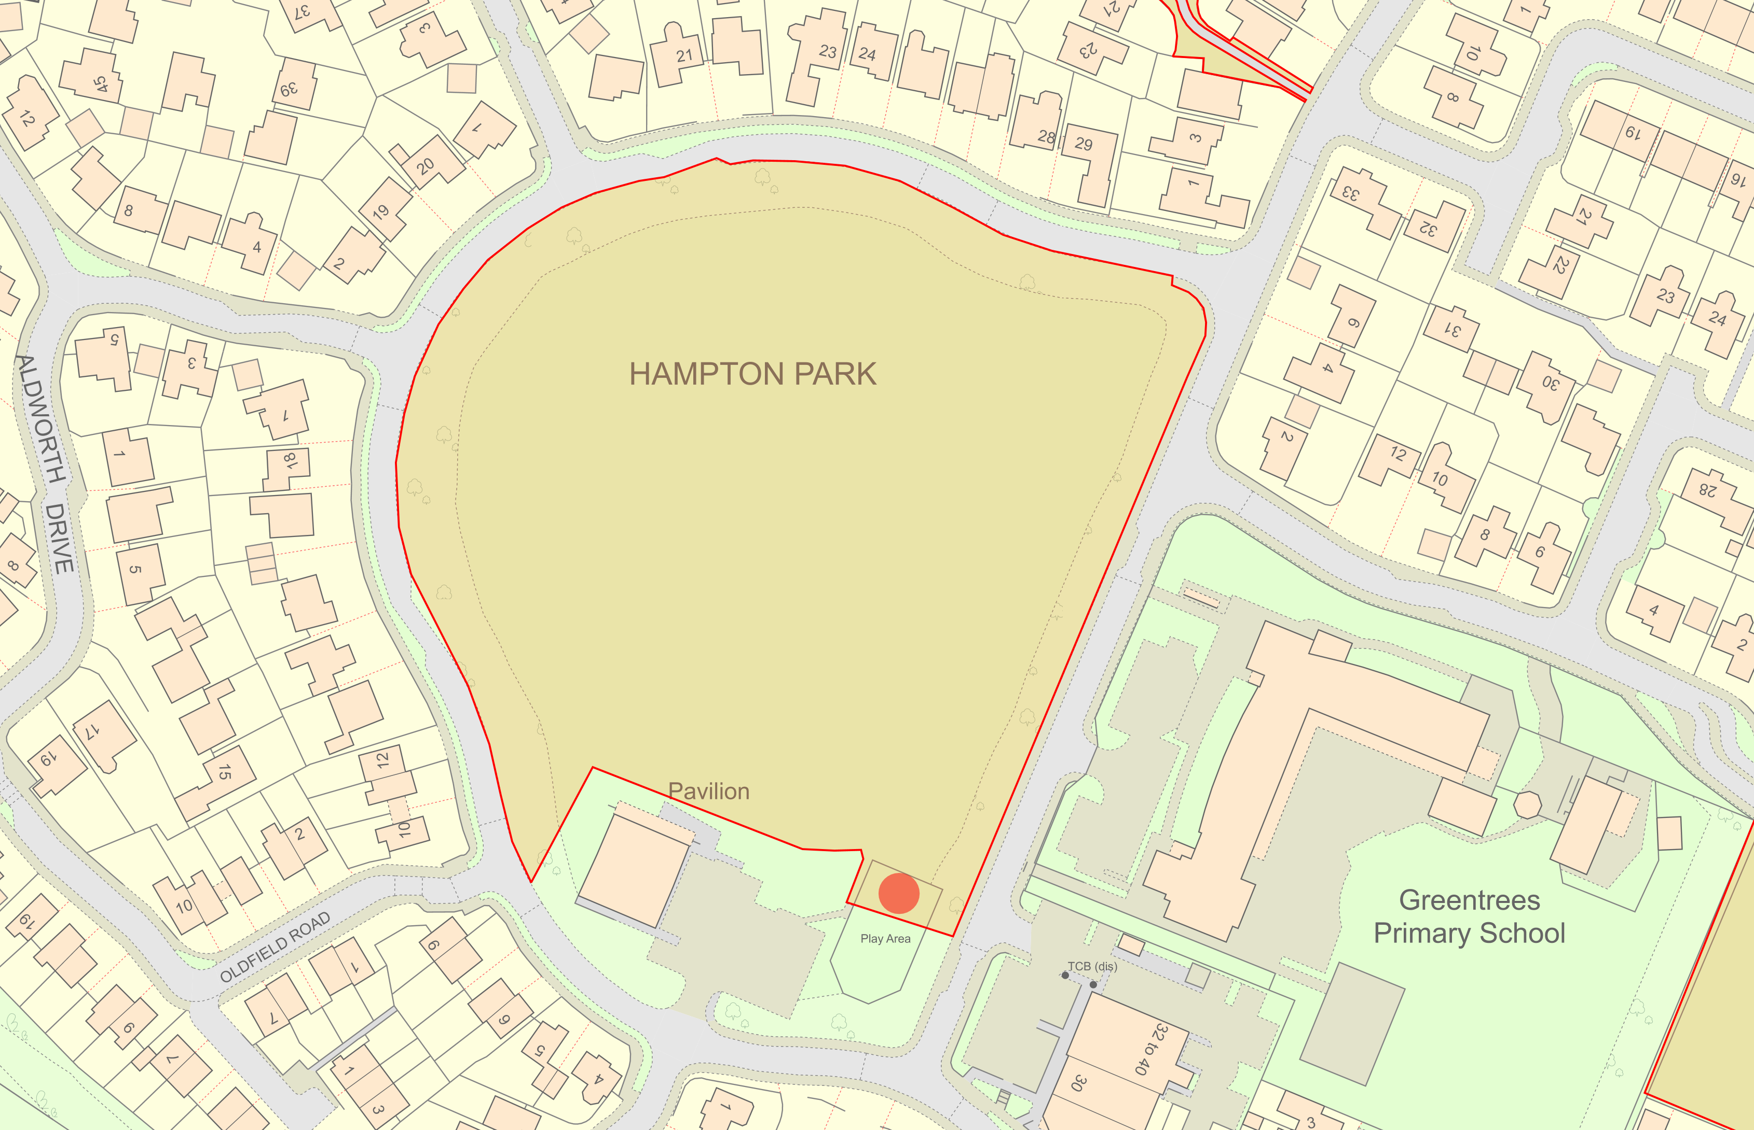
Appendix A
19/01/2023
Date:
Author:
Red Line Plan and Indicative Site Location
Scale: 1:1250
Laverstock
© Crown copyright and database right. All rights reserved (100050991) 2023,Contains OS data © Crown copyright and database right 2023

Appendix B
Sycamore Drive Site Overview

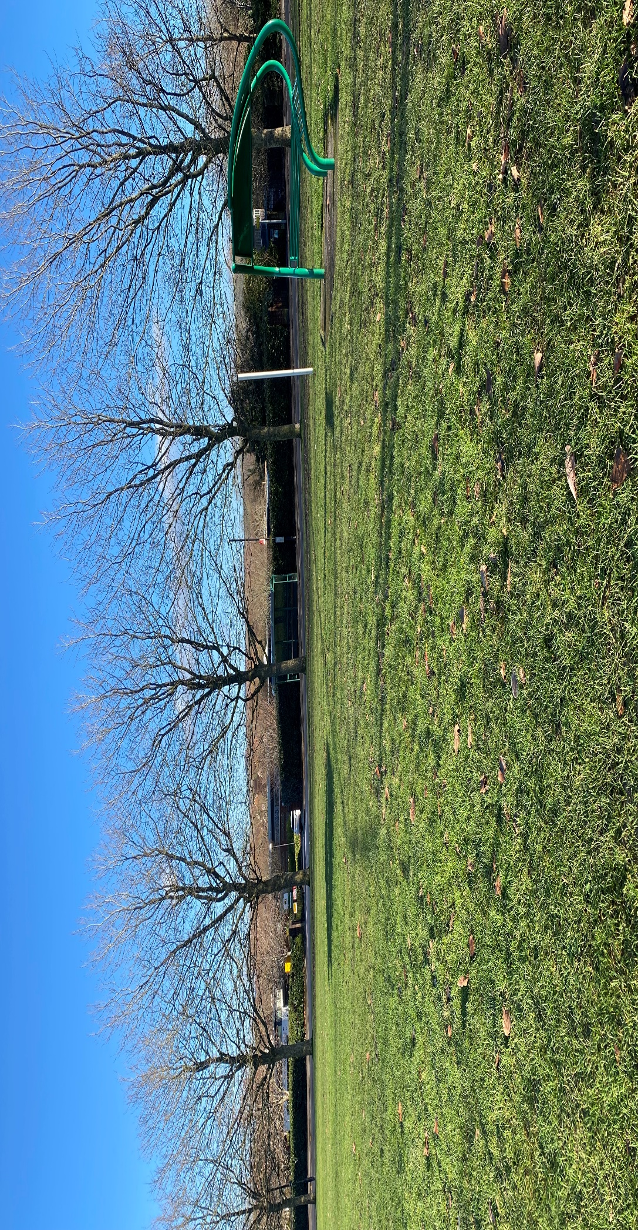

Appendix C
Sycamore Drive Shelter

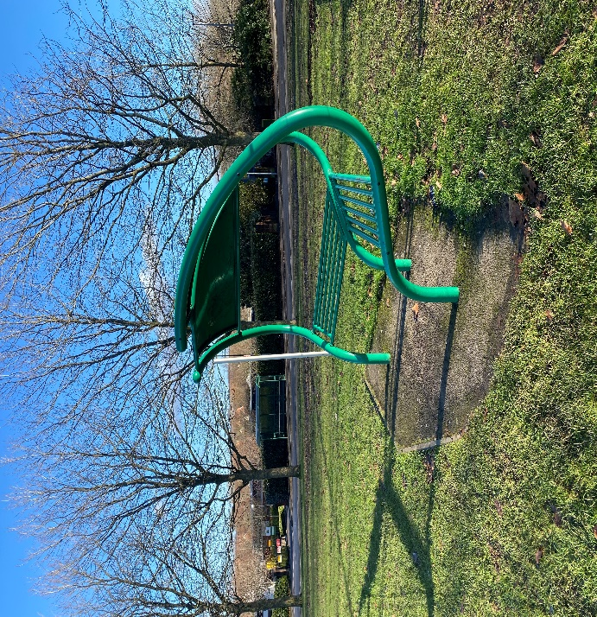
Appendix C (Continued)
Sycamore Drive Shelter

APPENDIX D

Tender Submission Document

Laverstock and Ford Parish Council

All parties wishing to submit a tender must complete and submit the following details, questions and provide documents no later than 12pm on Friday10 March 2023. Please note that all answers and documents provided will form part of the Terms and Condition if successful.

Tenders should be submitted by Recorded Delivery and clearly marked ‘TENDER RESPONSE: SYCAMORE DRIVE PLAY AREA (Private and Confidential)’.

Tenders should be addressed to: Laverstock and Ford Parish Council, C/O the Clerk Trudi Deane, 3 Pilgrims Way, Laverstock, Salisbury, Wiltshire, SP1 1RZ.

Supplier Details | Answer
Full name of the Supplier
Registered company address
Registered company number
Registered charity number
Registered VAT number
Name of immediate parent company
Name of ultimate parent company
Please mark ‘X’ in the relevant box to indicate your trading status | i. a public limited company Yes ☐ No ☐  ii. a limited company Yes ☐ No ☐  iii. a limited liability company Yes ☐ No ☐  iv. other partnership Yes ☐ No ☐  v. sole trader Yes ☐ No ☐  vi. other (please specify) Yes ☐ No ☐
Please mark ‘X’ in the relevant boxes to indicate whether any of the following classifications apply to you | a. Voluntary, Community and Social Yes ☐ No ☐  Enterprise (VCSE)  b. Small or Medium Enterprise (SME) Yes ☐ No ☐  c. Sheltered workshop Yes ☐ No ☐  d. Public service mutual Yes ☐ No ☐

Bidding Model
Please mark ‘X’ in the relevant box to indicate whether you are;
Bidding as a Prime Contractor and will deliver 100% of the key contract deliverables, yourself | Yes ☐ No ☐
Bidding as a Prime Contractor and will use third parties to deliver some of the services  If yes, please provide details of your proposed bidding model that includes members of the supply chain, the percentage of work being delivered by each sub-contractor and the key contract deliverables each sub-contractor will be responsible for. | Yes ☐ No ☐
Bidding as Prime Contractor but will operate as a Managing Agent and will use Third Parties to deliver all of the services  If yes, please provide details of your proposed bidding model that includes members of the supply chain, the percentage of work being delivered by each sub-contractor and the key contract deliverables each sub-contractor will be responsible for. | Yes ☐ No ☐

The following documents must be provided as part of the tender process. Each applicant must submit two hard copies of all documents in addition to a USB containing electronic copies. These documents should be in a sealed envelope. Please ensure that all plans and supplementary evidence submitted for evaluation do not have logos or company names on the documents. Responses to questions should be no more than 500 words.

Document | Please tick to confirm document’s inclusion in submission
A scale layout plan of the play area
An artist/CAD colour interpretation of the scheme (this must not feature people)
Information regarding guarantees for each item of equipment including safety surfaces
An outline of the schedule of works detailing the anticipated delivery and installation period
Copies of public liability, professional liability, product liability and employer’s liability insurance which must specify the level of indemnity
Provide evidence that the contractor can meet the necessary requirements of the CDM Regulations. Necessary risk assessments and method statements must be provided.
Details of any proposed subcontractors
Detailed breakdown of the prices
Detailed breakdown of annual maintenance costs
Three examples of references and contact details. If you are unable to provide references, you must provide an explanation of why references are not available.

Please describe the play value users will experience from each play area once installed, including any social experiences?

Please explain how the play area design allows for inclusive play for all children.

Please explain how your firm will limit the environmental impact of the scheme and how your firm limits its environmental impact.

I declare that to the best of my knowledge the answers submitted to these questions are correct. I understand that the information will be used in the selection process to assess my organisation’s suitability to be invited to participate further in this procurement, and I am signing on behalf of

(Insert name of supplier here)

I understand that the Authority may reject my submission if there is a failure to answer all relevant questions fully or if I provide false / misleading information. I have provided a full list of any Appendices used to provide additional information in response to questions.

I also declare that there is no conflict of interest in relation to the Authority’s requirement.

TENDER SUBMISSION DOCUMENT COMPLETED BY
Name
Role in organisation
Date
Signature

Appendix E

Terms & Conditions

Laverstock and Ford Parish Council

The general Terms and Conditions which apply to this tender and the ensuing Contract are set out in the section below.
The Project
- Name: Sycamore Drive Play Area
- Nature: Design, supply, construct and install various play equipment as per Specification.
- Location: Sycamore Drive, Bishopdown
- Employer: Laverstock and Ford Parish Council
- Contract Administrator: Trudi Deane, Laverstock and Ford Parish Clerk
- Drawings: the contractor to source re existing utilities and services.
- Access to the site: see maps Appendices A - C
- Limitations:
- General highway restrictions
- No designated access from the highway
- Grass areas susceptible to inclement weather
- Parking Restrictions for contractors and employee’s vehicles:
- Minimum number of vehicles
- No parking on paths
- No obstruction of residential driveways
- Observe the Highway Code
- Minimise impact on busy estate roads
- Do not use the site for any other purpose other than carrying out the works.
- The health and safety hazards at the site may include:
- Underground low voltage electricity cable serving existing street-lighting columns
- Other underground or overhead services
- Soil may have raised water levels
- The area is a well-used place by the public to walk dogs
- The area is well used as a public playing field
- The area is directly opposite the local primary school and is popular with localchildren
However, this is not an exhaustive list, and it is the responsibility of the tendering company to make a full assessment.
- PLEASE NOTE that the accuracy and sufficiency of this information is not guaranteed by the Employer or the Employer’s representative. Bidders must ascertain if any additional information is required to ensure the safety of all persons and the works.
- Bidders must ascertain the nature of the site, access thereto and all local conditions and restrictions likely to affect the execution of the works of their own accord.
- There are no additional works to be carried out under a separate contract and completed before the start of the work for the contract.
- The works cover the design, supply, construction and installation of the Play Park as set out in the Specification.
- The Employer is Laverstock and Ford Parish Council.
- The Contract will be signed by the Laverstock and Ford Parish Council.
- Any Dispute Resolution will be by arbitration as per the terms of the Contract.
- The Payment Schedule for the Contract:
- First Payment of 90% upon satisfactory completion and receipt of Independent Safety Inspection Report.
- 10% subject to satisfactory snagging report 6 months after completion
- These conditions are supplementary to those stated in the Invitation to Tender (ITT) and Tender Response Document (TRD).
- The tender procedure is in accordance with the ITT.
- No guarantee is offered that any tender will be recommended for acceptance or be accepted, or that reasons for non-acceptance will be given.
- No liability is accepted for any cost incurred in the preparation of any tender.
- The tender will be open for consideration for not less than 45 days.
- All information relating to costs should be submitted as part of the tender. Do not alter or qualify the priced documents without written consent. Tenders containing unauthorised alterations or qualifications may be rejected.
- Measurements: Contractor to source.
- Deemed included: Costs relating to items, which are not priced, will be deemed to have been included elsewhere in the tender.
- Tenders must cover all work described in the tender documents as a whole or clearly apparent as being necessary for the complete and proper execution of the works.
- All design drawings must be a maximum of AO size (841x1189mm)
- Bidders must retain, make available for inspection and supply on request information reasonably required to allow response to requests made under the provisions of the Freedom of Information Act.
- Bidders must not supply information outside the project participants without express written permission.
- PLEASE NOTE ALL PARTIES MUST MAINTAIN CONFIDENTIALITY AT ALL TIMES.
- Definitions: terms, derived terms and synonyms used in the preliminaries / general conditions and specification are as stated therein or in the appropriate British Standard or British Standard glossary.
- Communication: Includes advise, inform, submit, give notice, instruct, agree, confirm seek or obtain information, consent or instructions or decide. All communications should be in writing addressed to The Clerk – Laverstock and Ford Parish Council unless specified otherwise. Do not proceed until a response has been received.
- Products: Materials, both manufactured and naturally occurring, and goods, including components, equipment and accessories, intended for the permanent incorporation in the Works. Includes: Goods, plant, materials, site materials and things for incorporation into the Works.
- Site equipment: All appliances or things of whatsoever nature required in or about the construction for completion of the works but not materials or other things intended to form or forming part of the Permanent Works. Includes: Construction appliances, vehicles, consumables, tools, temporary works, scaffolding, cabins and other site facilities.
- Contractor’s choice: Selection delegated to the Contractor, but liability to remain with the specifier.
- Contractor’s design to be carried out or completed by the Contractor and supported by appropriate contractual arrangements, to correspond with specified requirements.
- Submit proposals: Submit information in response to specified requirements.
- Remove: Disconnect, dismantle as necessary and take out the designated products or work and associated accessories, fixings, supports, linings and bedding materials. Dispose of unwanted materials. Excludes taking out and disposing of associated pipework, wiring, ductwork or other services.
- Fix: receive, unload, handle, store, protect, place and fasten in position and disposal of waste and surplus packaging including all labour, materials and site equipment for that purpose.
- Supply and Fix: As above but including supply of products to be fixed. All products to be supplied and fixed unless stated otherwise.
- Keep for reuse: Do not damage designated products for work. Clean off bedding and jointing materials. Stack neatly, adequately protect and store until required by the Employer for use in the Works as instructed.
- Make Good: Execute local remedial work to designated work. Make secure, sound and neat.
- Replace: Supply and fix new products matching those removed. Execute work to match original new state of that removed.
- Repair: Execute remedial work to designated products. Make secure, sound and neat.
- Refix: Fix removed products.
- Ease: Adjust moving parts of designated products or work to achieve free movement and good fit in open and closed positions.
- System: Equipment, accessories, controls, supports and ancillary items, including installation, necessary for that section of the work to function.
- Manufacturer: The firm under whose name the particular product is marketed.
- Product reference: The proprietary brand name and / or reference by which the particular product is identified.
- If an alternative product to that specified is proposed, obtain approval before ordering the product. Submit reasons and relevant documentation for the proposed substitution including:
  - Manufacturer and product reference
  - Cost
  - Availability
  - Relevant standards
  - Performance
  - Function
  - Compatibility of accessories
  - Proposed revisions to drawings and specification]
  - Compatibility with adjacent work
  - Appearance
  - Copy of warranty / guarantee

- Alterations of adjacent work: if needed, advise scope, nature and cost.
- Manufacturers’ guarantees: if substitution is accepted, submit before ordering products.
Documents provided by Contractor/Subcontractor/Suppliers
- As built drawings and information: Contractor designed work to provide drawings / information at least two weeks before date for completion.
- Technical literature: Keep on site for reference by all supervisor personnel
  - Manufacturer’s current literature relating to all products to be used in the Works
  - Relevant British, EN or ISO Standards.
- Components and equipment: Obtain or retain copies maintenance instructions and equipment, registers with manufacturer and hand over on or before completion for use after completion.
- Provide telephone numbers for Emergency call out services for use after completion.

Management of the Works
- Accept responsibility for coordination, supervision, and administration of the Works, including subcontracts.
- Arrange, coordinate and monitor a programme with each subcontractor, supplier local authority and statutory undertaker, and obtain and supply information as necessary for coordination of the work.
- Before starting work on site submit insurance details, and/or policies and receipts for the insurance required by the Conditions of Contract.
- Notice: If any event occurs which may give rise to any insurance claim or proceeding in respect of loss or damage to the Works or injury or damage to persons or property arising out of the Works, immediately give notice to the Employer, the Clerk of Laverstock and Ford Parish Council and the insurers. Indemnify the Employer against any loss, which may be caused by failure to give such notice.
- Materials, including spoil, arising from alteration/clearance work become the property of the Contractor except where otherwise stated. Remove from site as work proceeds.
Programme of Works
- Immediately when requested and before starting work on the site, submit in an approved form, one copy of the master programme for the Works, which must include details of;
- Planning and mobilisation by the Contractor
- Subcontractor’s work
- Running in, adjustment, commissioning and testing of all engineering services and installations
- Work resulting from instructions issued in regard to the expenditure of provisional sums
- Work by others concurrent with the Contract.

- Provide a minimum of one week’s notice in advance of commencement of the works.
- Record progress on a copy of the programme kept on site.
- If any circumstances arise which may affect the progress of the Works submit proposals or take other action as appropriate to minimise any delay and to recover any lost time.
- Regular site meetings will be held every week to review progress and other matters arising from administration of the Contract. Ensure availability at the time of such meetings and inform subcontractors and suppliers when their presence is required.
- Chairperson (who will also take and distribute minutes) is the Contract Administrator.
- Give notice of the anticipated dates of completion of the whole or parts of the Works.
- Ensure necessary access, services and facilities for associated works are complete and provide minimum notice of one week. When a notice of the cause of any delay or likely delay in the progress of the works is given under the contract, written notice must also be given of all other causes, which apply concurrently.
- Details must be submitted as soon as possible including:
- Relevant particulars of the expected effects, if appropriate, related to the concurrent causes.
- An estimate of the extent, if any, of the expected delay in the completion of the Works beyond the date from completion.
- All other relevant information required.

Control of cost
- If a proposed instruction requests an estimate of cost, submit without delay and in any case within seven days.
Quality Standards/Control
- Where, and to the extent that products or work are not fully documented, they are to be:
- Of a kind and standard appropriate to the nature and character of that part of the Works where they will be used
- Suitable for the purposes stated or reasonably to be inferred from the project document
- Omissions or errors in description and / or quantity of contract documents shall not vitiate the Contract nor release the Contractor from any obligations or liabilities under the Contract.
- Appropriately skilled and experienced operatives for the type and quality of work shall be used and they must produce evidence of skills / qualifications when requested.
- Registered with the Construction Skills Certification Scheme.
- Supply each product from the same source or manufacturer and the whole quantity of each product required to complete the Works must be consistent kind, size, quality and overall appearance.
- Where critical, measure a sufficient tolerance to determine compliance.
- Prevent deterioration. Order in suitable quantities to a programme and use in appropriate sequence.
- Fix, apply, install or lay products securely, accurately, plumb, neatly and in alignment.
- Do not use different colour batches where they can be seen together.
- Check on-site dimensions.
- Finished Work without defects, e.g. Not damaged, disfigured, dirty, faulty, or out of tolerance.
- Location and fixing of products: Adjust joints to view so they are even and regular.
- Retain on site evidence that the proprietary product specified has been supplied.
- Submit evidence of compliance, including test reports indicating:
  - Properties tested
  - Parts / fail criteria
  - Test methods and procedures
  - Test results
  - Identity of testing agency
  - Test dates and times
  - Identities of witnesses
  - Analysis of results
- Inspection of any other action must not be taken as approval unless confirmed in writing referring to:
- Date of inspection
- Part of the Work inspected
- Respects or characteristics which are approved
- Extent and purpose of the approval
- Any associated conditions
- Provide all trades with necessary details of related types of work. Before starting each new type or section of work ensure previous related work is:
- Appropriately complete
- In accordance with the project documents
- To a suitable standard
- In a suitable condition to receive the new work
- Ensure all necessary preparatory work has been carried out.
- Comply with the manufacturer’s printed recommendations and instructions current on the date of the ITT.
- Submit details of changes to recommendations or instructions.
- Use those ancillary products or accessories supplied or recommended by main product manufacturer.
- Comply with limitations, recommendations and requirements of relevant valid certificates certified products.
- There is no access to water. The Contractor is responsible for sourcing this.
- Provide at all reasonable times access for the Contract Administrator to the Works and to other places of the Contractor or subcontractors where work is being carried out for the Contract.
Defects in Existing Works
- When undocumented defects are discovered immediately give notice. Do not proceed with affected work until response from the Contract Administrator has been received.
- Immediately any work or product is known, or appears, to be not in accordance with the Contract, notify the Contract Administrator and submit proposals for opening up, inspection, testing, making good, adjustment of the Contract sum, or removal and re-execution.
- Such proposals may be unacceptable and contrary instructions may be issued.

Works before Completion
- Make good all damage consequent upon the Works.
- Remove temporary markings, coverings and protective wrappings unless otherwise instructed.
- Clean the Works thoroughly inside and out, including all accessible ducts and voids. Remove all splashes, deposits, and efflorescence, rubbish and surplus materials.
- Use cleaning materials and methods as recommended by manufacturers of products being cleaned. Do not damage or disfigure other materials or construction.
- Obtain COSHH dated data sheets for all materials used for cleaning and ensure they are used only as recommend by their manufacturers.
- Touch up minor faults in newly painted work, carefully matching colour and brushing out edges. Repaint badly marked areas back to suitable breaks or junctions.
- Adjust, ease and lubricate moving parts of new work as necessary to ensure easy and efficient operation, including doors, windows, drawers, ironmongery, appliances, valves and controls.
- Contractors must ensure that they do not use products that are harmful to the environment where possible.
Security on Completion
- Only remove security fencing once the area has been certified as safe for use.
Hazards
- Common Hazards: Not listed. Control by good management and site practice.
Security
- Safeguard the site, the Works, products, materials, and any existing buildings affected by the Works from damage and theft.
- Take all reasonable precautions to prevent unauthorised access to the site, the Works and adjoining property.
Occupied Premises
- Existing residential buildings will be occupied and / or used during the Contract.
- Carry out Works without undue inconvenience and nuisance and without danger to occupants and users.
Employer’s representative Site Visits
- Submit details in advance, to the Employer of safety provisions and procedures (including those relating to materials, which may be deleterious), which will require their compliance when visiting the site.
Provide and maintain protective clothing and equipment on site for the Employer and other visitors to the site.
Pollution
- Protect the site, the Works and the general environment including the atmosphere, land, streams and waterways against pollution.
- If contamination occurs inform Employer immediately, including the atmosphere, land, streams and waterways against pollution.
Pesticides
- Use only where specified or approved, and then only suitable products listed on www.pesticides.gov.uk
- Restrictions apply for work near water, drainage ditches or land drains which must comply with the “Guidance for the use of herbicides on weeds in or near watercourses and lakes.”
- Comply with manufacturer’s disposal recommendations for containers. Remove from site immediately empty or no longer required.
- Operatives must hold a BASIS Certificate of Competence or work under supervision of a Certificate Holder.

Nuisance
- Duty to prevent nuisance from smoke, dust, rubbish, vermin and other causes.

Asbestos containing Material
- Prevent hazardous build-up of surface water on site, in excavations and to surrounding areas and roads.
- Duty to report immediately and in relation to suspected materials discovered during execution of the Works:
- Do not disturb
- Agree methods for safe removal or encapsulation

Dangerous or Hazardous Substances
- Duty to report immediately and in relation to suspected materials discovered during execution of the Works.

- Do not disturb
- Agree methods for safe removal or encapsulation

Antiquities
- Duty to report immediately any fossils, antiquities and other objects of interest or value discovered during execution of the Works.
- Keep objects in the exact position and condition in which they were found.

Fire Prevention
- Duty to prevent personal injury or death, and damage to the Works or other property from fire.
- Comply with Joint Code of Practice “Fire Prevention on Construction Sites” published by the Construction Confederation and the Fire Protection Association (The Joint Fire Code).
- Burning on Site is not permitted.

Moisture
- Prevent wetness or dampness where this may cause damage to the Works.
- Control humidity and the application of heat to prevent:
  - Blistering and failure of adhesion
  - Damage due to trapped moisture
  - Excessive Movement
Waste
- Includes: Rubbish, debris, spoil, surplus material, containers and packaging.
- Minimise production, Prevent accumulations. Keep the site Works clean and tidy.
- Collect and store waste in suitable containers. Remove frequently and dispose off-site in a safe and competent manner;
  - Non-hazardous material: in a manner approved by the Waste Regulation Authority
  - Hazardous Material: As directed by the Waste Regulation Authority and in accordance with relevant regulations.
- Recyclable material: Sort and dispose at a Materials Recycling Facility approved by the Waste Regulation Authority.
- Remove rubbish, dirt and residues before closing in voids and cavities in the construction.
- Retain waste transfer documentation on Site.
Invasive Species
- Prevent the spread of species (e.g. plants or animals) that may adversely affect the site of Works economically, environmentally or ecologically.
- Report immediately any suspected invasive species discovered during execution of the Works economically, environmentally or ecologically.
- Report immediately any suspected invasive species discovered during execution of the Works
- Do not disturb
- Agree methods for safe eradication or removal
Existing Services
- Notify all services authorities, statutory undertakers and / or adjacent owners of proposed works not less than one week before commencing site operations.
- Before starting work, check and mark positions of utilities / services. Where positions are not shown on drawings obtain relevant details from service authorities, statutory undertakers or other owners.
- Work adjacent to services:
  - Comply with service authority’s / statutory undertaker’s recommendations
  - Adequately protect, and prevent damage to services: Do not interfere with their operation without consent of service authority’s / statutory undertakers or other owners
- In identifying services:
- Below ground: Use signboards, giving type and depth
- Overhead: Use headroom markers
- If any damage to services result from the execution of the Works:
- Immediately give notice and notify appropriate service authority / statutory undertaker
- Make arrangements for the work to be made good without delay to the satisfaction of the service authority / statutory undertaker or other owner as appropriate
- Any measures taken to deal with an emergency will not affect the extent of the Contractor’s liability
- Replace marker tapes or protective covers if disturbed during site operations, to service authority’s / statutory undertaker’s recommendations.

Roads and Footpaths
- Maintain roads and footpaths within and adjacent to the site and keep clear of mud and debris.
- Make good damage caused by site specific traffic or otherwise consequent upon the Works to the satisfaction of the Employer, Local Authority or the owner.

Existing topsoil / sub soil
- Prevent over compaction of existing topsoil and subsoil in those areas which may be damaged by construction traffic, parking of vehicles, temporary site accommodation or storage of materials and which will require reinstatement prior to completion of the Works.

- Before starting work submit proposals for protective measures.

Retained Trees / Shrubs / Grassed Areas
- Preserve and prevent damage, except those not required.
- Mature trees and shrubs if uprooted, destroyed, damaged beyond reasonable chance of survival in their original shape, as a consequence of the Contractor’s negligence must be replaced with those of a similar type and age at the Contractor’s expense.

Retained Trees
- Protected area and unless agreed otherwise do not:
  - Dump spoil or rubbish, excavate or disturb topsoil, park vehicles or plant, store materials or place temporarily accommodation within an area which is larger of the branch spread of the tree or an area with a radius of half the tree’s height, measured from the trunk
  - Sever roots exceeding 25mm in diameter, if unintentionally severed give notice and seek advice
  - Change level of ground within an area 3m beyond branch spread.
Existing Features
- Prevent damage to existing footpaths, buildings, fences, gates, walls, roads, paved areas and other site features, which are to remain in position during execution of the Works.
Existing Work
- Prevent damage to existing work, structures or other property during the course of the work.
- Removal of minimum amount necessary and replacement work to match existing.
Existing Structures
- Check proposed methods of work for effects on adjacent structures inside and outside the site boundary.
- During execution of the Works:
  - Provide and maintain all incidental shoring, needling and other supports as may be necessary to preserve stability of existing structures on the site or adjoining, that may be endangered or affected by the Works
  - Do not remove until work is strong enough to support existing structure
  - Prevent overstressing of competed work when removing supports
Materials for Recycling / Reuse
- Sort and prevent damage to stated products or materials, clean off bedding and jointing materials and other contaminants.
- Give notice and details of intended siting. Stack neatly and protect until required by the Employer or for use in the Works as instructed. Alter, adapt and move as necessary. Remove when no longer required and make good.

Use or Disposal of Materials

- Appropriate disposal off-site.
Working Hours
- Specific Limitations:
  - Mon – Fri 8am – 5pm
  - Sat 8am – 1pm
  - Sun & Bank Holiday: Prohibited
Temporary Accommodation
- Submit proposals for temporary accommodation and storage for the Works two weeks prior to starting on site.

- Include details of type of accommodation and storage, its siting and the programme for site installation and removal.
The Site Manual
- The Site Manual is the responsibility of the Contractor.
- Obtain and provide comprehensive information for owners and users of the completed Works. Include an overview of the main design principles and describe key components and systems within the finished Works, so affording a complete understanding of the Works, to enable efficient and safe operation and maintenance.
- One copy must be provided to the Contract Administrator by the date of completion.
- The Manual must include:
  - Details of the site, the parties, operational requirements and constraints of a general nature
  - Design criteria, maintenance details, product details, and environmental and trafficking conditions of play equipment and surfacing
  - Guarantees, warranties, maintenance agreements, test certificates and reports

- The format of the Manual should be A4 size, plastics covered, loose leaf, four ring binders with hard covers, each indexed, divided and appropriately cover titled.
- Where larger than A4, selected drawings needed to illustrate or locate items mentioned in the Manual should be folded and accommodated in the binders so that they may be unfolded without being detached from the rings. The main sets of as-built drawings may form annexes to the Manual.

Installation Safety Report
- Obtain and provide an Independent Post Installation Safety Report and provide one copy to the Contract Administrator no later than Occupation.

