Request for Quotation

Analysis of Digital Aerial Survey Data for Multiple Marine Protected Areas collected for the marine Natural Capital Ecosystem Assessment Project

30th June 2023



# Request for Quotation

### **Ref:** **FM_WP1_Task1.1_DAS_Analysis_RFQ**

### **Title:** **Analysis of Digital Aerial Survey Data for Multiple Marine Protected Areas collected for the marine Natural Capital Ecosystem Assessment Project**

You are invited to submit a quotation for the requirement described in the specification, Section 2.

Please confirm by email, receipt of these documents and whether you intend to submit a quote or not.

Your response and quotation should be returned to the following email address by:

Email: andrew.harwood@naturalengland.org.uk

Date: 28/07/2023

Time: 12:00 BST

Ensure you include the name of the quotation and ‘Final Submission’ in the subject field to make it clear that it is your response.

### Contact Details and Timetable

Andrew Harwood will be your contact for any questions linked to the content of the quote or the process. Please submit any clarification questions via email and note that, unless commercially sensitive, both the question and the response will be circulated to all tenderers.

|  |  |
| --- | --- |
| Action | Date |
| Date of issue of RFQ | 03-07-2023 at 12:00 BST |
| Deadline for clarifications questions | 14-07-2023 at 12:00 BST |
| Deadline for receipt of Quotation | 28-07-2023 at 12:00 BST |
| Intended date of Contract Award | 11-08-2023 |
| Intended Contract Start Date | 14-08-2023 |
| Intended Delivery Date / Contract Duration | 15-12-2023 / 18 weeks (~4 months) |

## Section 1: General Information

### Glossary

Unless the context otherwise requires, the following words and expressions used within this Request for Quotation shall have the following meanings (to be interpreted in the singular or plural as the context requires):

|  |  |
| --- | --- |
| “Authority” | means Natural England who is the Contracting Authority. |
| “Contract” | means the contract to be entered into by the Authority and the successful supplier. |
| “Response” | means the information submitted by a supplier in response to the RFQ. |
| “RFQ” | means this Request for Quotation and all related documents published by the Authority and made available to suppliers. |

### Conditions applying to the RFQ

You should examine your Response and related documents ensuring it is complete and in accordance with the stated instructions prior to submission.

Your Response must contain sufficient information to enable the Authority to evaluate it fairly and effectively. You should ensure that you have prepared your Response fully and accurately and that prices quoted are arithmetically correct for the units stated.

By submitting a Response, you, the supplier, are deemed to accept the terms and conditions provided in the RFQ. Confirmation of this is required in Annex 2.

Failure to comply with the instructions set out in the RFQ may result in the supplier’s exclusion from this quotation process.

### Acceptance of Quotations

By issuing this RFQ the Authority does not bind itself to accept any quotation and reserves the right not to award a contract to any supplier who submits a quotation.

### Costs

The Authority will not reimburse you for any costs and expenses which you incur preparing and submitting your quotation, even if the Authority amends or terminates the procurement process.

### Self-Declaration and Mandatory Requirements

The RFQ includes a self-declaration response (Annex 1) which covers basic information about the supplier, as well as any grounds for exclusion. If you do not comply with them, your quotation will not be evaluated.

Any mandatory requirements will be set out in Section 2, Specification of Requirements and, if you do not comply with them, your quotation will not be evaluated.

### Clarifications

Any request for clarification regarding the RFQ and supporting documentation must be submitted via email no later than the deadline for clarifications set out in the Timetable. The Authority shall be under no obligation to respond to queries raised after the clarification deadline.

The Authority will respond to all reasonable clarifications as soon as possible but cannot guarantee a minimum response time. The Authority will publish all clarifications and its responses to all suppliers via email unless deemed commercially sensitive.

If a supplier believes that a request for clarification is commercially sensitive, it should clearly state this when submitting the clarification request. However, if the Authority considers either that:

* the clarification and response are not commercially sensitive; and
* all suppliers may benefit from its disclosure,

then the Authority will notify the supplier (via email), and the supplier will have an opportunity to withdraw the request for clarification by sending a further message requesting the withdrawal of the clarification request. If not withdrawn by the supplier within 2 working days of the Authority’s notification, the Authority may publish the clarification request and its response to all suppliers and the Authority shall not be liable to the supplier for any consequences of such publication.

The Authority reserves the right to seek clarification of any aspect of a quotation and/or provide additional information during the evaluation phase to carry out a fair evaluation. Where the Authority seeks clarification on any aspect of the quotation, the supplier must respond within the timeframe requested by the Authority.

### Amendments

The Authority may amend the RFQ at any time prior to the deadline for receipt. If it amends the RFQ the Authority will notify you via email.

Suppliers may modify their quotation prior to the deadline for Responses. No Responses may be modified after the deadline for Responses.

Suppliers may withdraw their quotations at any time by submitting a notice via the email to the named contact.

### Conditions of Contract

The Authority’s Standard Condensed Terms and Conditions (available at [Procurement at Natural England - Natural England - GOV.UK (www.gov.uk)](https://www.gov.uk/government/organisations/natural-england/about/procurement)) provided as part of the RFQ will be included in any contract awarded as a result of this quotation process. The Authority will not accept any changes to these terms and conditions proposed by a supplier.

Suppliers should note that the quotation provided by the successful bidder will form part of the Contract.

### Prices

Prices must be submitted in £ sterling, **inclusive of VAT**.

### Disclosure

All Central Government Departments, their Executive Agencies and Non Departmental Public Bodies are subject to control and reporting within Government. In particular, they report to the Cabinet Office and HM Treasury for all expenditure. Further the Cabinet Office has a cross-Government role delivering overall Government policy on public procurement, including ensuring value for money and related aspects of good procurement practice. For these purposes, the Authority may disclose within Government any details contained in your quotation. The information will not be disclosed outside Government during the procurement.

In addition, the Authority is subject to the Freedom of Information Act 2000 and the Environmental Information Regulations 2004, which provide a public right of access to information held by public bodies. In accordance with these two statutes, the Authority may be required to disclose information contained in your quotation to any person who submits a request for information pursuant to those statutes.

Further to the Government’s transparency agenda, all UK Government organisations must advertise on Contract Finder in accordance with the following publication thresholds:

* Central Contracting Authority’s: £12,000
* Sub Central Contracting Authority’s and NHS Trusts: £30,000

For the purpose of this RFQ the Authority is classified as a Central Contracting Authority with a publication threshold of £12,000 inclusive of VAT.

If this opportunity is advertised via Contracts Finder, we are obliged to publish details of the awarded contract including who has won the contract, the contract value, and indicate whether the winning supplier is a small and medium-sized enterprise (“SMEs”) or voluntary organisation or charity. A copy of the contract must also be published with confidential information redacted.

By submitting a Response, you consent to these terms as part of the procurement.

### Disclaimers

Whilst the information in this RFQ and any supporting information referred to herein or provided to you by the Authority have been prepared in good faith the Authority does not warrant that this information is comprehensive or that it has been independently verified.

The Authority does not:

* make any representation or warranty (express or implied) as to the accuracy, reasonableness or completeness of the RFQ;
* accept any liability for the information contained in the RFQ or for the fairness, accuracy or completeness of that information; or
* accept any liability for any loss or damage (other than in respect of fraudulent misrepresentation or any other liability which cannot lawfully be excluded) arising as a result of reliance on such information or any subsequent communication.

Any supplier considering entering into contractual relationships with the Authority following receipt of the RFQ should make its own investigations and independent assessment of the Authority and its requirements for the goods and/or services and should seek its own professional financial and legal advice.

### Protection of Personal Data

In order to comply with the General Data Protection Regulations 2018 the supplier must agree to the following:

You must only process any personal data in strict accordance with instructions from the Authority.

* You must ensure that all the personal data that we disclose to you or you collect on our behalf under this agreement are kept confidential.
* You must take reasonable steps to ensure the reliability of employees who have access to personal data.
* Only employees who may be required to assist in meeting the obligations under this agreement may have access to the personal data.
* Any disclosure of personal data must be made in confidence and extend only so far as that which is specifically necessary for the purposes of this agreement.
* You must ensure that there are appropriate security measures in place to safeguard against any unauthorised access or unlawful processing or accidental loss, destruction or damage or disclosure of the personal data.
* On termination of this agreement, for whatever reason, the personal data must be returned to us promptly and safely, together with all copies in your possession or control.

### General Data Protection Regulations 2018

For the purposes of the Regulations the Authority is the data processor.

The personal information that we have asked you provide on individuals (data subjects) that will be working for you on this contract will be used in compiling the tender list and in assessing your offer. If you are unsuccessful the information will be held and destroyed within two years of the award of contracts. If you are awarded a contract, it will be retained for the duration of the contract and destroyed within seven years of the contract’s expiry.

We may monitor the performance of the individuals during the execution of the contract, and the results of our monitoring, together with the information that you have provided, will be used in determining what work is allocated under the contract, and in any renewal of the contract or in the award of future contracts of a similar nature. The information will not be disclosed to anyone outside the Authority without the consent of the data subject, unless the Authority is required by law to make such disclosures.

### Equality, Diversity & Inclusion (EDI)

The Client is striving to create a diverse and inclusive working environment where every individual has equality of opportunity to progress and to apply their unique insights to making the UK a great place for living. The Service Provider is expected to respect this commitment in all dealings with Natural England staff and service users.

Suppliers are expected to;

* support Defra group to achieve its Public Sector Equality Duty as defined by the Equality Act 2010, and to support delivery of [Defra group’s Equality & Diversity Strategy](https://www.gov.uk/government/publications/defra-group-equality-diversity-and-inclusion-strategy-2020-to-2024/defra-group-equality-diversity-and-inclusion-strategy-2020-to-2024).
* meet the standards set out in the [Government’s Supplier Code of Conduct](https://www.gov.uk/government/publications/supplier-code-of-conduct)
* work with Defra group to ensure equality, diversity and inclusion impacts are addressed (positive and negative) in the goods, services and works we procure, barriers are removed and opportunities realised.

### Sustainable Procurement

Addressing global sustainability impacts and realising additional community benefits within commercial activity is core to Defra group’s approach, working with its supply chain is key to achieving sustainable outcomes. In addition to supporting Defra group to meet its outcomes we look to understand and reduce negative sustainability impacts associated with our commercial activity and realise benefits.

The Client encourages its suppliers to share these values, work to address negative impacts and realise opportunities, measure performance and success.

Suppliers are expected to have an understanding of the Sustainable Development Goals, the interconnections between them and the relevance to the Goods, Services and works procured on the Client’s behalf

### Conflicts of Interest

The concept of a conflict of interest includes but is not limited to any situation where an Involved Person or Relevant Body has directly or indirectly, a financial, economic or other personal interest which might be perceived to compromise their impartiality and independence in the context of the procurement procedure and/or affect the integrity of the contract award.

We expect suppliers to mitigate appropriately against any real or perceived conflict of interest through their work with government. A supplier with a position of influence gained through a contract should not use that position to unfairly disadvantage any other supplier or reduce the potential for future competition

Where the supplier is aware of any circumstances giving rise to a conflict of interest or has any indication that a conflict of interest exists or may arise you should inform the Authority of this as soon as possible (whether before or after they have submitted a quotation). Tenderers should remain alert to the possibility of conflicts of interest arising at all stages of the procurement and should update the Authority if any new circumstances or information arises, or there are any changes to information already provided to the Authority. Failure to do so, and/or to properly manage any conflicts of interest may result in a quotation being rejected.

Provided that it has been carried out in an open, fair and transparent manner, routine pre-market engagement carried out by the Authority should not represent a conflict of interest for the supplier.

## Section 2: The Invitation

Specification of Requirements

### Background to Natural England

The Authority is Natural England. The Authority’s priorities are to secure a healthy natural environment; a sustainable, low-carbon economy; a thriving farming sector and a sustainable, healthy and secure food supply. Further information about the Authority can be found at: Natural England.

### Background to the specific work area relevant to this purchase

During the first year (2022-23) of Defra’s 3-year marine Natural Capital Ecosystem Assessment (mNCEA) programme there was substantial collection of new data to inform natural capital assessment across several projects, including Digital Aerial Surveys (DAS) of inshore marine birds. Due to the timings of these surveys, and complexity of the tasks involved, detailed analysis of the data arising from these surveys was separated from the data collection and processing work carried out in year one. The purpose of this task is therefore to undertake the detailed analysis of the processed digital aerial survey data, place results in the context of other similar sources of data and to improve our understanding of potential evidence gaps and the suitability of available data for natural capital assessments.

### Requirement

Natural England is seeking a contractor to provide robust abundance estimates and spatial distribution maps of birds and marine mammals recorded during DAS of specific inshore marine protected areas commissioned under the mNCEA during autumn and winter 2022/23. **The core requirement will be to be analyse, and report on, five surveys**: four (two autumn and two winter) of the Greater Wash Special Protection Area (SPA) and one (winter) of the Solway Firth SPA. **We also request that a separate quote is provided for optional work to cover an additional analysis and reporting for a further survey** of Berwick to St. Mary’s Marine Conservation Zone (MCZ) conducted in March 2023. Details of surveys are provided in Section 3 below.

Raw images from these surveys have been processed by the providers to identify and geo-reference all target objects as far as possible. The successful contractor will be supplied with observation and effort data, including relevant GIS outputs, and associated survey reports. Natural England note that these surveys have been carried out by different providers, using different DAS methods, and that different analytical approaches are likely to be required.

The contractor will be required to apply survey-specific, design-based abundance estimation methods, with appropriate corrections, to derive population estimates for all bird and marine mammal species recorded in each survey. Abundance estimates should be generated for the entire study area and for sub-areas described in this RFQ (see Section 3.1).

An assessment of the species-specific identification rates achieved during each survey should be carried out and the results used to inform the apportioning of animals assigned to taxonomic groups (e.g. large auks) where they could not be identified to species-level (e.g. guillemot or razorbill) with a satisfactory degree of confidence. The outcomes of this should also feed into a brief evaluation of study performance. For species that spend some time submerged, corrections for availability bias should also be clearly defined and applied appropriately.

Maps should be produced illustrating the relative abundance of key species defined within this RFQ (see Section 3.2) using Kernel Density Estimation methods (KDE) where possible (see Section 3.2).

The contractor should produce a single report, using a Natural England template and following relevant guidance (see: [Natural England publishing standards for commissioned reports - NECR000](https://publications.naturalengland.org.uk/publication/5790636781600768)). This report should detail methods, results, and provide a discussion evaluating survey performance, analytical limitations and placing the abundance and distributions of relevant designated features in context with historic surveys and estimates. Relevant databases, analytical code, and GIS outputs produced during the analyses should be provided as deliverables.

For an example of the type of report we are seeking, lacking the discussion element, please see Harker et al. (2022), which provides a simple analysis of a previous Solway Firth SPA survey commissioned by Natural England and NatureScot (available at: [Digital video aerial surveys of marine birds and mammals at Solway Firth Special Protection Area (SPA): February 2021 - NECR439 (naturalengland.org.uk)](https://publications.naturalengland.org.uk/publication/6445178893369344)).

The evidence derived from this work will help inform SPA condition assessments, environmental impact assessments, habitats regulations assessments and, by improving understanding of potential overlaps between bird distributions and those of anthropogenic activities, inform place-based decision making by regulatory authorities. The evidence will also help inform future monitoring requirements including the role of volunteers and citizen science. The outcomes of these analyses will be discussed in relation to historic monitoring and, where possible, be placed in context with data for surrounding seas. These outcomes will be used to evaluate the efficacy of the surveys and inform future monitoring.

The following sections provide further details relating to: 1) the project background, 2) objectives, and 3) methods.

### 1. Background information

#### 1.1 Survey details

***Core survey analysis***

The core requirement of the work is to undertake the analysis of the following five surveys (summary details for each survey are provided in Table 1):

* Four Greater Wash SPA winter 2022/23 surveys for red-throated diver, common scoter and little gull. These surveys were undertaken using still camera methods. Whilst the survey coverage extended to cover The Wash SPA, and a 10 km buffer around the seaward side of the Greater Wash SPA, images collected in those areas have not been processed and therefore the required analysis will be limited to the extent of the Greater Wash SPA alone.
* One Solway Firth SPA winter 2022/23 survey targeting red-throated diver, common scoter, goosander, greater scaup, common goldeneye and great cormorant. The survey was undertaken using video methods to survey strip transects. The survey also included coverage of a 10 km buffer around the seaward extend of the SPA. The images from this buffer area have been processed and the resulting data are available for analysis. Complementary shore-based observations were also collected, and these will need to be considered when assessing the abundance and distributions of key species.

**Table 1. Summary of core surveys to be analysed by the Contractor.**

|  |  |  |  |  |  |  |  |  |
| --- | --- | --- | --- | --- | --- | --- | --- | --- |
| Survey description | Survey date(s) | Method | Ground surface distance (cm) | N nodes / transects analysed | Transect spacing | Transect orientation | Area of images analysed (km2) | Analysed coverage (%) |
| Greater Wash SPA 1 (autumn) | 02/10/2022 | Grid/node (stills, 3 cameras) | 1.5 | 3,549 nodes | 3.5 km  (nodes spaced @ ~285 m intervals along transects) | East-west | 413.9 | 11.7 |
| Greater Wash SPA 2 (autumn) | 18/10/2022  19/10/2022  22/10/2022 | 1.5 | 3,605 nodes | 420.4 | 11.9 |
| Greater Wash SPA 3 (winter) | 17/01/2023  18/01/2023  19/01/2023  20/01/2023  21/01/2023 | 1.5 | 3,349 nodes | 390.6 | 11.0 |
| Greater Wash SPA 4 (winter) | 21/02/2023  23/02/2023 | 1.5 | 3,606 nodes | 420.5 | 11.9 |
| Solway Firth SPA + 10 km buffer (winter) | 21/01/2023 | Strip transect (video, 4 cameras) | 2.0 | 70 transects | 1.412 km | Northwest – southeast | SPA: ~229  SPA+10 km buffer: ~337  (TBC) | ~17.56 (TBC) |

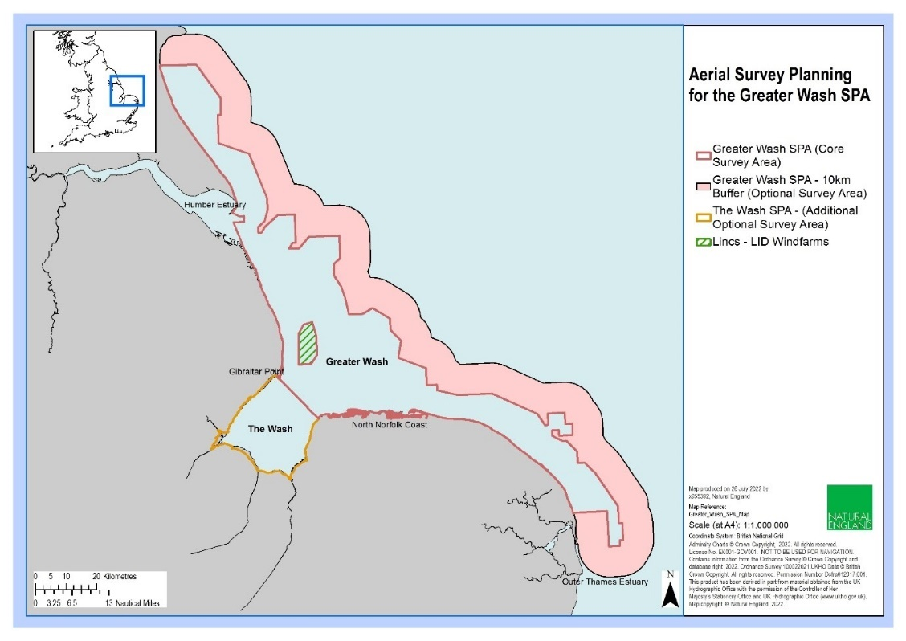

**Figure 1. Greater Wash Special Protection Area digital aerial survey study area. Note that whilst the additional areas surveyed by the contractor are shown (The Wash Special Protection Area & 10 km seaward extension of the Greater Wash SPA), images from these areas have not been processed. Thus, analyses will only be needed for the Greater Wash Special Protection Area with, and without, the Lincs, and Lynn and Inner Dowsing Offshore Wind Farm cut out.**

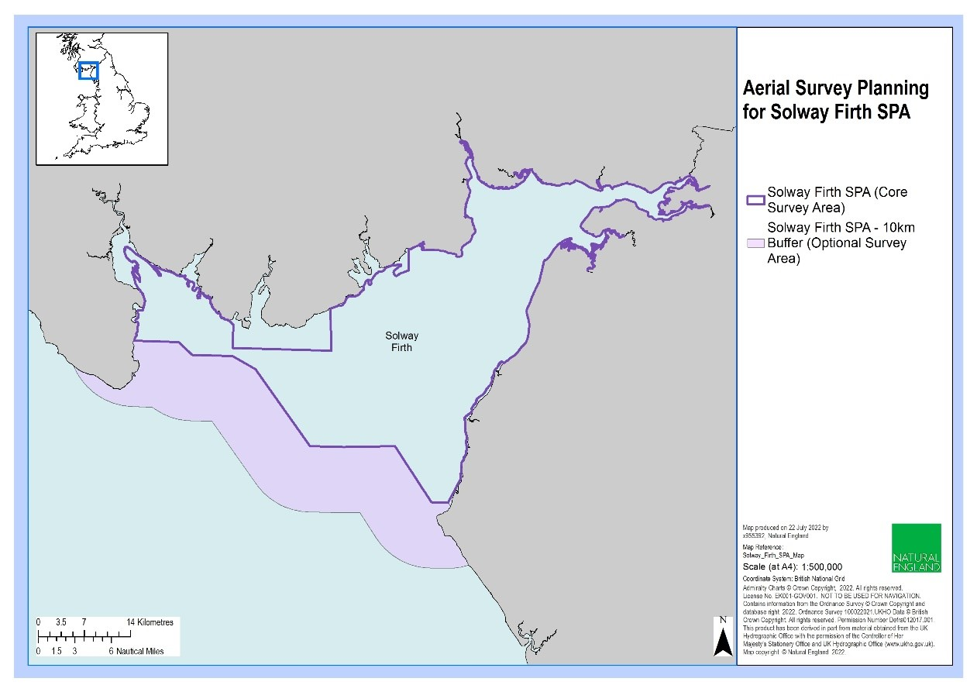

**Figure 2. Solway Firth Special Protection Area digital aerial study area including the 10 km seaward extension. This RFQ requires abundance estimates to be derived for the SPA independently and including the 10 km buffer and any other areas that were surveyed and sit outside the SPA.**

***Optional survey analysis***

We request bidders **supply a separate quote for the optional analysis**, to the same specifications required for the core surveys, **of a single survey of Berwick to St. Mary’s MCZ (and the adjoining Lindisfarne SPA)** carried out in March 2023 (Figure 3 and Table 2). Imagery has been processed to provide a comprehensive digital dataset from which robust estimates of the abundance and distribution of birds and marine mammals within the MCZ can be derived. **The quote for this additional work will not be used to evaluate the commercial element of the tenders but may be commissioned if sufficient budget is available.**

Natural England commissioned this survey to target the start of the common eider breeding season and sought to gather information on the distribution and abundance of each age/sex class separately. Whilst the priority was to collect data for common eider ducks, data was extracted for all species recorded during the aerial survey across the entire MCZ for all other bird and marine mammal species/species groups within the Berwick to St. Mary’s MCZ. Whilst additional surveys are planned through the summer, those data will not be available in time to be included in these analyses.

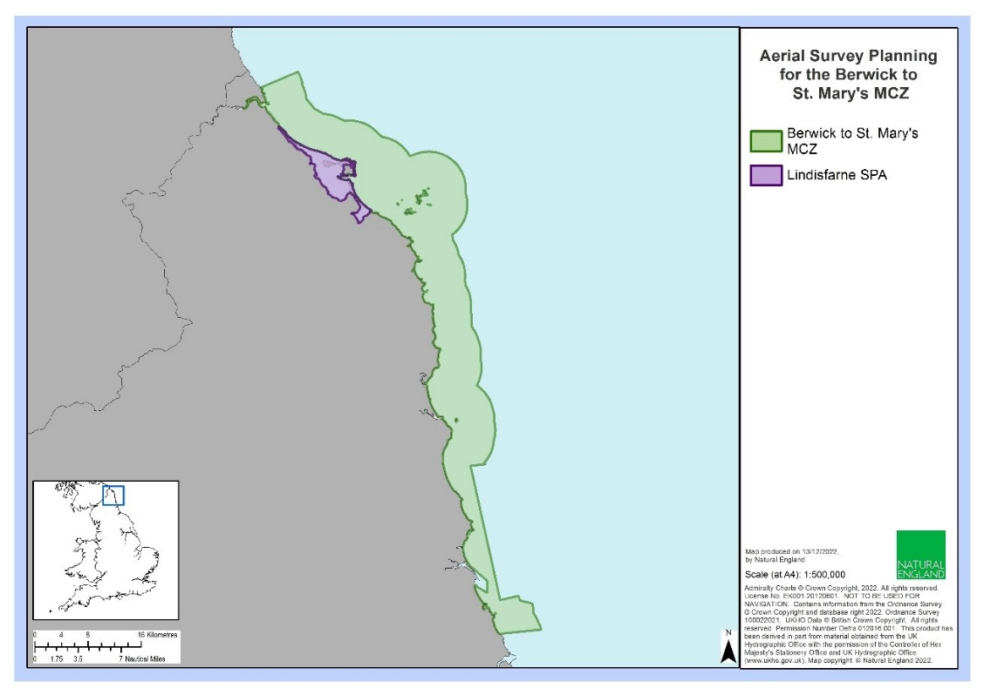

**Figure 3. Berwick to St. Mary’s Marine Conservation Zone study area and Lindisfarne Special Protection Area.**

**Table 2. Summary of optional survey to be considered for analysis.**

|  |  |  |  |  |  |  |  |  |
| --- | --- | --- | --- | --- | --- | --- | --- | --- |
| Survey description | Survey date(s) | Method | Ground surface distance (cm) | N nodes / transects analysed | Transect spacing | Transect orientation | Area of images analysed (km2) | Analysed coverage (%) |
| Berwick to St. Mary’s MCZ including Lindisfarne SPA | 17/03/2023 | Strip transect (video, 4 cameras) | 2.0 | 47 transects | 46 transects spaced at 2 km (one extra transect over the Farne Islands between adjacent transects) | Southwest to northeast | TBC | ~25 |

### 2. Objectives

#### 2.1 Core objectives

Natural England require the contractor to provide all aspects of digital aerial survey data analysis by suitably qualified and experienced data analysts and GIS experts. The contractor should use appropriate software and methods and provide a clear concise report and associated deliverables as detailed in this specification.

There are **six** **main objectives** for this contract. For each of the **core surveys** (covering the Greater Wash and Solway Firth SPAs), these objectives are to:

1. **provide robust design-based abundance estimates**, with associated confidence intervals, standard deviations, and coefficients of variation, for all bird and marine mammal species identified in all surveys using robust design-based methods, and appropriate adjustments (e.g. for animals not identified to species level and availability bias), for the areas specified in this RFQ (see Section 4.1 below);
2. **provide an evaluation of species-specific identification rates**, including associated levels of confidence and potential sources of uncertainty;
3. **provide spatial distribution maps**, using a suitable method, for key features of the relevant marine protected areas and additional species of conservation concern (see Section 4.2 below);
4. **compare abundance estimates with historic data** and qualitatively assess changes in the distribution of key features of respective marine protected areas;
5. **briefly evaluate survey design and performance** (considering power to detect changes where possible), for key features of respective marine protected areas, and
6. **produce a single comprehensive report** including survey methods, analytical methods, results, and a discussion. The contractor should also provide: i) a single Microsoft Excel workbook containing all results of the analyses, ii) any analytical code and associated data used in the analyses, and iii) all GIS outputs with associated metadata.

Section 3 provides further detail on the methodology required to deliver these objectives.

#### 2.2 Optional objectives

In addition to meeting the core objectives listed above, there is also an **option to include a further single survey of the Berwick to St Mary’s MCZ (and adjoining areas including Lindisfarne SPA)** within the analysis and reporting covered by the objectives listed above. This option may be pursued dependent upon costs. Bidders are asked to **quote separately** for additional work associated with meeting these optional objectives.

**If Natural England decide to commission the additional analysis of the Berwick to St. Mary’s MCZ data, we assume the contractor will adopt the same approach to the objectives as for the core surveys and incorporate the outcomes within the same report and any additional deliverables.**

### 3. Methods

The successful Contractor will need to apply suitable analytical methods to meet the project aims and objectives outlined above.

#### 3.1 Abundance estimation

Whilst it may be possible to apply model-based approaches to deriving abundance estimates for some species recorded during the suite of surveys to be analysed, in this instance, **Natural England only require the Contractor to produce design-based abundance estimates**, with associated confidence limits, standard deviations and coefficients of variation. When developing methods for deriving abundance estimates, consideration should be given to the following:

* Strip- (video) and grid-based (still images) survey designs have been employed for different surveys and methods for deriving abundance estimates should account for this;
* appropriate methods, for example non-parametric bootstrap methods with replacement (Buckland, et al. 2001), for deriving upper and lower 95% confidence limits, standard deviations and coefficients of variation should be described and justified;
* we suggest that appropriate software (e.g. R) and analytical packages should be used by the supplier to ensure efficient, reproducible, analyses are carried out, methods should be clearly outlined and, where code is scripted, Natural England request that it is suitably annotated and provided as a deliverable with any associated databases;
* we request estimates are derived for different parts of the study area (see below) and appropriate methods for sub-setting survey data (observations and effort) should be outlined;
* correction factors for bird and marine mammal species which spend time submerged should be applied where evidence allows, again noting there may be differences associated with the two survey methods;
* methods for assessing the potential for autocorrelation between transects, or nodes (still images), should be described and, if necessary, appropriate approaches to account for this detailed;
* methods for apportioning birds only assigned to a species group (e.g. large gulls, large auks) should be clearly described and **we request that** **an evaluation of species-specific identification rates and associated levels of confidence is included for each survey**;
* For the Solway Firth SPA, data from **shore-based counts**, undertaken at approximately the same time as the digital aerial survey, should, where deemed appropriate, be incorporated into final abundance estimates,
* whilst we require the Contractor to derive overall abundance estimates, including all behaviours, **we request that the ratios of birds exhibiting different behaviours are provided for each species in each survey**, and
* we require the Contractor to **provide a single Microsoft Excel workbook including all abundance estimates derived for this project**.

To maximise the value of this work, Natural England require the contractor to provide abundance estimates for several defined sub-areas for each survey. This will aid in our understanding of the relative importance of different parts of the wider study areas. We request that, for The Greater Wash and Solway Firth SPAs, in addition to providing abundance estimates for the entire SPA, abundance estimates for the SPA sea areas within 2 km of the coast and areas beyond 2 km are provided separately. This will allow consideration of the relative contributions to whole SPA population estimates for species which mostly utilise inshore or offshore habitats.

By spatially segregating the survey effort (transects or still image nodes), the contractor should provide an estimate of survey coverage and abundance estimates for the following species within these component parts of the **core survey** study areas:

***Greater Wash SPA surveys***

* 1. **All bird and marine mammal species** within the SPA boundaries **excluding** the Lincs, and Lynn and Inner Dowsing Offshore Wind Farm footprints.
  2. **Red-throated diver, common scoter and little gull** within the SPA boundaries, **including** the Lincs, and Lynn and Inner Dowsing, Offshore Wind Farm footprints.
  3. **Red-throated diver, common scoter, little gull, gannet, guillemot and razorbill** within the footprints of the Lincs and Lynn, and Inner Dowsing Offshore Wind Farms, and in each concentric 1 km buffer zone around the footprints out to 10 km and so within the SPA boundaries (please also provide sea areas of each buffer).
  4. **All bird and marine mammal species** within the parts of the SPA boundaries, **excluding** the Lincs, and Lynn and Inner Dowsing Offshore Wind Farm footprints, that fall within 2 km of the mean high-water level.
  5. **All bird and marine mammal species** within the parts of the SPA boundaries, **excluding** the Lincs, and Lynn and Inner Dowsing Offshore Wind Farm footprints, beyond 2 km of the mean high-water level.

***Solway Firth SPA survey***

* 1. **All bird and marine mammal species** within the whole SPA, up to its boundaries, as surveyed,
  2. **All bird and marine mammal species** within the areas surveyed outside of the SPA boundaries alone.
  3. **All bird and marine mammal species** within the parts of the SPA boundaries that fall within 2 km of the mean high-water level.
  4. **All bird and marine mammal species** within the parts of the SPA boundaries beyond 2 km of the mean high-water level.
  5. **all bird and marine mammal species** within the boundaries of the Allonby Bay Highly Protected Marine Area (HPMA), please refer to [hpma-boundary-maps.pdf (publishing.service.gov.uk)](https://assets.publishing.service.gov.uk/government/uploads/system/uploads/attachment_data/file/1139244/hpma-boundary-maps.pdf) for the extents of the HPMA.

For the **optional** analysis of the Berwick to St. Mary’s MCZ & Lindisfarne SPA survey, design-based abundance estimates (and accompanying descriptive statistics) are required for the following component parts of the study area:

1. **All bird and marine mammal species** within the boundaries of the Berwick to St. Mary’s MCZ.
2. **All bird and marine mammal species** within the 750 m buffer alone, up-shore of the mean high-water level of the Berwick to St. Mary’s MCZ.
3. **All bird and marine mammal species** within the boundaries of the Lindisfarne SPA.
4. **All bird and marine mammal species** within the 750 m buffer alone, up-shore of the mean high-water level of the Lindisfarne SPA.

**3.2 Mapping the spatial distributions of key features**

As with the abundance estimates, it may be possible and more desirable to provide model-based density surfaces of bird and marine mammal distributions. However, for simplicity, **Natural England request that Kernel Density Estimation (KDE) methods are applied** for this project. This method is commonly used to provide insights to spatial distributions of animals at-sea. For example, it has been used to help inform the delineation of Special Protection Area boundaries for red-throated diver (O’Brien, et al. 2012) and explore marine habitat use by seabirds (e.g. Perrow, et al. 2015; Lees, et al. 2016; Osborne, et al. 2020).

Where there are insufficient observations to adequately inform KDE analyses, or species are heavily constrained to the coast, alternative means of illustrating the spatial distribution of the key species defined below should be used (e.g. proportional symbols representing abundance within a defined transect section or still image node). Map figures should include the boundaries of relevant marine protected areas and any offshore wind farm, or any other offshore man-made, structures. These additional map elements do not need to be provided with GIS outputs.

We require the Contractor to produce spatial distribution maps of relative abundance for the entire study area, for each of the **core surveys**, for the following species, where recorded in surveys (note that key species for reporting are highlighted in red):

***Greater Wash SPA surveys*** (designated non-breeding features are shown in red)

* Red-throated diver,
  + Common scoter,
  + Little gull,
  + Guillemot,
  + Razorbill,
  + Unidentified large auks,
  + Northern gannet,
  + Great cormorant
  + European shag,
  + Black-headed gull,
  + lesser black backed gull,
  + Common gull,
  + Herring gull,
  + Great black-backed gull,
  + Slavonian grebe,
  + Red-necked grebe,
  + Velvet scoter,
  + Greater scaup,
  + Long-tailed duck,
  + Great northern diver.
  + Any cetaceans, and
  + Any pinnipeds.

***Solway Firth SPA survey*** (designated non-breeding features or key components of the non-breeding waterbird assemblage are shown in red)

* + Red-throated diver,
  + Common scoter,
  + Goosander,
  + Greater scaup,
  + Common goldeneye,
  + Great cormorant,
  + Guillemot,
  + Razorbill,
  + Unidentified large auks,
  + Northern gannet,
  + European shag,
  + Black-headed gull,
  + Lesser black backed gull,
  + Common gull,
  + Herring gull,
  + Great black-backed gull,
  + Slavonian grebe,
  + Red-necked grebe,
  + Velvet scoter,
  + Long-tailed duck,
  + Great northern diver.
  + Any cetaceans, and
  + Any pinnipeds.

For the **optional analysis** of the Berwick to St. Mary’s MCZ & Lindisfarne SPA survey, spatial distribution maps of relative abundance for the entire study area should be produced for the following key species (where recorded in surveys) (key species in red are relevant designated features of either the MCZ or SPA):

* + Common Eider,
  + Guillemot,
  + Razorbill,
  + Unidentified large auks,
  + Northern gannet,
  + European shag,
  + Black-headed gull,
  + Lesser black backed gull,
  + Common gull,
  + Herring gull,
  + Great black-backed gull,
  + Slavonian grebe,
  + Red-necked grebe,
  + Common scoter,
  + Velvet scoter,
  + Greater scaup,
  + Long-tailed duck,
  + Red-breasted merganser,
  + Great northern diver.
  + Any cetaceans, and
  + Any pinnipeds.

When considering methods for deriving spatial distribution maps, consideration should be given to the following:

* Any software or analytical packages which will be used by the Contractor should be described and justified and, where code is used, Natural England request that it is suitably annotated and provided as a deliverable;
* bandwidth, as a critical variable in KDE analyses (Wang, et al. 2020), should be selected using appropriate methods (i.e. not just arbitrarily setting it), and the bidder should outline a preferred approach (final bandwidths adopted should be included within the report);
* a suitable, ideally consistent, grid cell resolution and orientation, using a suitable projected coordinate system, should be proposed and agreed with Natural England;
* consideration should be given as to how observations not identified to species level should be treated in relation to mapping (e.g. whether maps of unidentified large auk species should be plotted separately);
* for diving species, consideration should be given to whether mapped abundance includes adjustment for availability bias;
* the source (and any associated licensing agreements) of any additional map layers used should be clearly described and referenced;
* for The Greater Wash SPA, maps should be produced for each survey, averaged for the two autumn and two winter surveys separately, and then an averaged distribution map derived from all four surveys,
* for the Solway Firth SPA, data from supplementary shore-based counts should be included on the maps for relevant species using a suitable method (e.g. proportional symbols), and
* provision of suitable GIS outputs, including feature and/or raster layers, as shapefiles or geo-databases with comprehensive metadata.

#### 3.3 Reporting

The contractor should use the Natural England report template and follow associated guidance when producing their report (see: [Natural England publishing standards for commissioned reports - NECR000](https://publications.naturalengland.org.uk/publication/5790636781600768)). This aims to speed up the report publication process and promote rapid access to evidence where appropriate.

The Contractor should deliver a single report detailing the outcomes of the analyses. The report should use a standard scientific layout including the following:

* + an executive summary,
  + an introduction and background to the work,
  + a methods section detailing the adopted analytical approach,
  + a results section providing tables of abundance estimates and spatial distribution maps for key species, with results for other species provided in appendices,
  + a discussion comparing the derived abundance estimates and distributions for key features of the respective marine protected areas with historic survey data, commenting on the performance of survey designs (including power to detect change where possible), species identification rates, outlining any caveats or limitations of the analyses, and providing brief recommendations for future work.

As a minimum, we suggest that the following information is also provided in report appendices:

* Species-specific ID rates for each survey and associated levels of confidence,
* Shore-based count data for the Solway Firth SPA, and
* A breakdown of observations according to different behaviours.

### Sustainability

Natural England protects and improves the environment and is committed to reducing the sustainability impacts of its activities directly and through its supply chains. We expect the Contractor to share this commitment and adopt a sound, proactive sustainable approach in keeping with the 25 yr environmental plan/our commitments compliant with all applicable legislation. This includes understanding and reducing direct and indirect sustainability impacts and realising opportunities, including but not restricted to; resilience to climate change, reducing greenhouse gas emissions, water use and quality, biosecurity, resource efficiency and waste, reducing the risk of pollution, biodiversity, modern slavery and equality, diversity & inclusion, negative community impacts.

As a delivery partner, the successful contractor is expected to pursue sustainability in their operations, thereby ensuring the Contracting Authority is not contracting with a supplier whose operational outputs run contrary to the Contracting Authority’s objectives. The successful contractor will need to approach the project with a focus on the entire life cycle of the project.

### Outputs and Contract Management

#### Project deliverables

On award of the contract, the supplier will be required to deliver the following:

1. **Analyses of the core survey data** to derive abundance estimates, standard deviations, confidence intervals and coefficients of variation, for all birds and marine mammals recorded in surveys and maps depicting the relative abundance of key species as specified in this RFQ.
2. **A single technical report** following Natural England guidance and using the Natural England Microsoft Word template (Available from: [Natural England publishing standards for commissioned reports - NECR000](https://publications.naturalengland.org.uk/publication/5790636781600768)). The report should provide the following:
   * an executive summary,
   * an introduction and background to the work,
   * a methods section detailing the approach to the analyses,
   * a results section providing tables of abundance estimates and spatial distribution maps
   * a discussion comparing the derived abundance estimates with historic data for key features of the respective marine protected areas, commenting on the performance of the survey designs, species identification rates, outlining any caveats or limitations of the analyses performed, and providing recommendations for future work.
   * appendices detailing species-specific identification rates for each survey, shore-based count data for the Solway Firth SPA and a breakdown of observations from all surveys according to recorded behaviours.
3. **An accompanying Microsoft Excel workbook of results, GIS files for map outputs, and any analytical code and data used in the analyses.** All data provided must comply with Natural England metadata and GIS standards (see Annex 3).
   * **The single Microsoft Excel workbook should include all results of the analyses**. As a minimum, this should include abundance estimates derived for this project, species-specific identification rates for each survey, shore-based counts for the Solway Firth SPA and behavioural splits for all species in each survey. The workbook should include a sheet with meta-data and field name explanations where applicable.
   * **ESRI ArcGIS 10.2 compatible shapefiles, or geo-database files**, should be provided for the relative abundance surfaces derived from the KDE analyses, or simple observations where such analyses were precluded, for the key species outlined in this RFQ, where seen in the **core surveys**. All GIS files should include suitable metadata outlining the project and methods used to derive the respective data as a minimum. These outputs may be made publicly available if we publish the report.
   * **Submit any analytical code or script (e.g. R or Python), and associated databases, used to carry out the analyses.** Any code should be clearly annotated using suitable mark-up.

**If Natural England chooses to award the Contractor the optional work, to analyse and report on the additional survey, the contractor will be expected to undertake this work and incorporate the outputs into those for the core surveys.**

#### **Project management**

Once let, the following project milestones will apply:

|  |  |  |
| --- | --- | --- |
| Milestone | Responsible Party | Date of completion |
| Project inception meeting/teleconference between contractor/sub-contractor and Natural England | Natural England and Contractor | W/C 14/08/2023 |
| Teleconference between Natural England and contractor to discuss progress with analyses and any issues arising | Natural England and Contractor | W/C 04/09/2023 |
| Contractor submits draft report | Contractor | 03/11/2023 |
| Natural England provides feedback on draft report | Natural England | 17/11/2023 |
| Contractor submits revised reports addressing Natural England comments | Contractor | 01/12/2023 |
| Wash-up meeting | Natural England and Contractor | W/C 4/12/2023 |
| Submission of final reports, ArcGIS layers, other associated datasets and metadata to agreed standards. | Contractor | 8/12/2023 |
| Contract to be completed | Natural England and Contractor | 15/12/2023 |

This is the envisaged contract timetable. Bidders should highlight any proposed deviation from this timeline within their bid. Any delays to this timetable during the contract should be immediately discussed with the Project Officer.

Natural England anticipate that a start-up meeting will be held between the project officer and supplier W/C 14th August 2023. Followed by a progress meeting W/C 4th September to discuss any problems. We request that short catch-up calls are then scheduled every two weeks to provide an opportunity to discuss any additional issues arising and provide and update on progress.

The contractor should submit a draft report in digital format by Friday 3rd November 2023 and Natural England will provide feedback on this by 17th November. A final report should be submitted by 1st December. A wash-up meeting should be held W/C 4th December and all outstanding outputs should be submitted to Natural England by the 8th December. The contract is to be completed by 15th December 2023.

In support of this contract, Natural England will provide the successful Contractor with:

* Project support from dedicated project lead.
* Relevant available data from previous survey work.
* Opportunity to feedback and discuss progress with the project lead.

#### **Data ownership, intellectual property rights and copyright**

All data captured and produced shall be fully owned by and copyrighted to Natural England. This shall include any intellectual property rights that might otherwise impede on Natural England’s usage and data sharing of the outputs. Natural England may share any project outputs with third parties including for the purposes of additional analyses outside the final scope of any contract awarded against this statement of requirements. Any data supplied by Natural England to potential bidders and the successful contractor are for use in this project only and should not be retained once the bidding process (for unsuccessful bidders) or project (for the successful contractor) has been completed. In addition, neither bidders nor the successful contractor must pass such data on to any third parties unless with explicit prior permission from Natural England. The contractor is responsible for ensuring that all products submitted are of a satisfactory standard. The Natural England Nominated Officer may undertake a QA review of all project deliverables, including image analyses, prior to approving subsequent payment for the work.

#### Payment

The Authority will raise purchase orders to cover the cost of the services and will issue to the awarded supplier following contract award.

The Authority’s preference is for all invoices to be sent electronically, quoting a valid Purchase Order number. Payment of 100% of the total contract value will be made on receipt of a detailed invoice following completion (to the satisfaction of the Natural England Nominated Officer) of all the milestones detailed above, and formal acceptance of the specified outputs.

It is anticipated that this contract will be awarded for a period of 18 weeks (~4 months) to end no later than 15/12/2023. Prices will remain fixed for the duration of the contract award period. We may at our sole discretion extend this contract to include related or further work. Any extension shall be agreed in writing in advance of any work commencing and may be subject to further competition.

### Evaluation Methodology

We will award this contract in line with the most economically advantageous tender (MEAT) as set out in the following award criteria:

Technical – 50%

Commercial – 50%

#### **Evaluation criteria**

Evaluation weightings are 50% technical and 50% commercial, the winning tenderer will be the highest scoring combined score.

The summary table below provides an overview of the overall evaluation breakdown.

|  |  |  |  |  |
| --- | --- | --- | --- | --- |
| Award Criteria | Weighting (%) | Evaluation Topic & Weighting | Sub-Criteria | Weighted Question |
| Technical | 50% | Service / Product Proposal | Methodology | Q1. Please provide details of the methodology proposed to deliver the requirements set out in the Specification. (70% of technical score available) |
| Staff Technical Expertise | Q2. Please provide details of the project team providing the requirements set out in the Specification. (30% of technical score available) |
| Commercial | 50% | Whole life cost of the proposed Contract | Commercial Model | Q3. Please provide costs (100% of commercial score available) |

#### Technical (**50**%)

Technical evaluations will be based on responses to specific questions covering key criteria which are outlined below. Scores for questions will be based on the following:

|  |  |  |
| --- | --- | --- |
| Description | Score | Definition |
| Very good | 100 | Addresses all the Authority’s requirements with all the relevant supporting information set out in the RFQ. There are no weaknesses and therefore the tender response gives the Authority complete confidence that all the requirements will be met to a high standard. |
| Good | 70 | Addresses all the Authority’s requirements with all the relevant supporting information set out in the RFQ. The response contains minor weaknesses and therefore the tender response gives the Authority confidence that all the requirements will be met to a good standard. |
| Moderate | 50 | Addresses most of the requirements with most of the relevant supporting information set out in the RFQ. The response contains moderate weaknesses and therefore the tender response gives the Authority confidence that most of the requirements will be met to a suitable standard. |
| Weak | 20 | Substantially addresses the requirements but not all and provides supporting information that is of limited or no relevance or a methodology containing significant weaknesses and therefore raises concerns for the Authority that the requirements may not all be met. |
| Unacceptable | 0 | No response or provides a response that gives the Authority no confidence that the requirement will be met. |

Technical evaluation is assessed using the evaluation topics and sub-criteria stated in the Evaluation Criteria section above.

**Separate submissions for each technical question should be provided** **and will be evaluated in isolation**. Tenderers should provide answers that meet the criteria of each technical question set out in the following tables.

|  |  |
| --- | --- |
| Q1. Methodology | Detailed Evaluation Criteria |
| Please submit a document with the filename: “**FM_WP1_Task1.1_DAS_Analysis_RFQ_E01_Your Company Name**”.  Your response must not exceed **a maximum of 6 sides of A4** (in addition to any title page), font size **Arial 11**. | Your response will be evaluated on the basis of whether it:   * Demonstrates a clear understanding of the nature of the requirements. * Includes a clear, practical, achievable and cost-effective methodology to deliver these requirements including:  1. Providing a clear, well evidenced, approach to deriving design-based abundance estimates based on different survey methods and considering other factors which may influence the accuracy and precision of results (for both birds and marine mammals), 2. Demonstrate awareness of suitable software to maximise the efficiency and reproducibility of analyses, 3. Exhibit knowledge of the issues surrounding species identification methods, and confidence levels, associated with different survey methods, 4. Show consideration of potential improvements that can be made to any established methods for deriving abundance estimates from digital aerial surveys, 5. Provide a clear, well evidenced, approach to producing spatial distribution maps for key species, 6. Demonstrate a good understanding of KDE methods, available software for analyses and suitable approaches for deriving bandwidths, 7. Documents any added value your organisation can bring to the core requirements (e.g. supplementary analyses relating to displacement effects of offshore wind farms).   Include information in sufficient detail to allow a full appraisal of the suitability of the approach to deliver for the project.  **A minimum score of 50 is required to be met for this question. Any score below this will be scored as a Fail**. |

|  |  |
| --- | --- |
| Q2. Staff Technical Expertise | Detailed Evaluation Criteria |
| Please submit a document with the filename “**FM_WP1_Task1.1_DAS_Analysis_RFQ _E02_Your Company Name**”.  Your response must not exceed **a maximum of 6 sides of A4** (in addition to any title page), font size **Arial 11**. | Your response will be evaluated on the basis of:   * The level and relevance of expertise and skills, provided by the Project team and sub-contractors and the value added delivered by this. This will consider expertise and skills in: project management; digital aerial survey data analysis methods and software; use of KDE methods, use of GIS and knowledge of data standards. * The suitability and adequacy of the staff making the inputs to each stage of the Project (in terms of their expertise and skills), the quantity of their inputs and their availability to do the work. For each member of the Project team, information on **the amount of time input (days/hours) to this specific project**. **We suggest this information is provided in a table.** * The appropriateness of the balance of inputs by senior and junior staff and clarity and sufficiency of lines of reporting. Please provide the name(s) of the individual(s) who will have overall management responsibility for the project and will report to Natural England’s project officer and the person who will be responsible for ensuring that the Project is completed satisfactorily. **We suggest a project specific organogram is provided.** Consideration should be given to cover for key roles given any unforeseen circumstances.   **A minimum score of 50 is required to be met for this question. Any score below this will be scored as a Fail**. |

#### Commercial (**50**%)

The Contract is to be awarded as a fixed price which will be paid according to the completion of the deliverables stated in the Specification of Requirements.

Suppliers are required to submit a total cost to provide the deliverables stated in the Specification of Requirements. In addition to this, the Commercial Response template must be completed to provide a breakdown of the whole life costs against each deliverable used in the delivery of this requirement.

#### Calculation Method

The method for calculating the weighted scores is as follows:

* Commercial

Score = (Lowest Quotation Price / Supplier’s Quotation Price) x 50% (Maximum available marks)

* Technical

Score = (Bidder’s Total Technical Score / Highest Technical Score) x 50% (Maximum available marks)

The total score (weighted) (TWS) is then calculated by adding the total weighted commercial score (WC) to the total weighted technical score (WT): WC + WT = TWS.

### Information to be returned

Please note, **the following information requested must be provided**. Incomplete tender submissions may be discounted.

Please complete and return the following information:

* completed Commercial Response template
* separate response submission for each technical question (in accordance with the response instructions)
* completed Mandatory Requirements (Annex 1)
* completed Acceptance of Terms and Conditions (Annex 2)

### Award

Once the evaluation of the Response(s) is complete all suppliers will be notified of the outcome via email.

The successful supplier will be issued the contract, incorporating their Response, for signature. The Authority will then counter sign and generate a Purchase Order.

### References

Buckland, S.T., Anderson, D.R., Burnham, K. P., Laake, J.L., Borchers, D.L. and Thomas, L. (2001). Introduction to Distance Sampling: Estimating Abundance of Biological Populations. Oxford University Press, Oxford.

Harker, A.J., Pavat, D. & Humphries, G. (2022). Digital video aerial surveys of marine birds and mammals at Solway Firth SPA: February 2021. A report for Natural England. Natural England Commissioned Reports. Report number NECR439. Available at: [Digital video aerial surveys of marine birds and mammals at Solway Firth Special Protection Area (SPA): February 2021 - NECR439 (naturalengland.org.uk)](https://publications.naturalengland.org.uk/publication/6445178893369344)

Lees, K.J., Guerin, A.J., & Masden, E.A. (2016). Using kernel density estimation to explore habitat use by seabirds at a marine renewable wave energy test facility. Marine Policy, 63, 35-44. https://doi.org/10.1016/j.marpol.2015.09.033

O'Brien, S. H., Webb, A., Brewer, M.J. & Reid, J.B. (2012). Use of kernel density estimation and maximum curvature to set marine protected area boundaries: identifying a special protection area for wintering red-throated divers in the UK. Biological Conservation, 156: 15– 21.

Osborne, O.E., O’Hara, P.D., Whelan, S., Zandbergen, P., Hatch, S.A. & Elliott, K.H. (2020). Breeding seabirds increase foraging range in response to an extreme marine heatwave. Marine Ecology Progress Series, 646:161-173. <https://doi.org/10.3354/meps13392>

Perrow, M.R., Harwood, A.J., Skeate, E.R., Praca, E. & Eglington, S.M. (2015). Use of multiple data sources and analytical approaches to derive a marine protected area for a breeding seabird. Biological Conservation, 191: 729-738.

Wang, S., Li, A., Wen, K., & Wu, X. (2020). Robust kernels for kernel density estimation. *Economics Letters*, 191: 109138. https://doi.org/10.1016/j.econlet.2020.109138

### Annex 1 Mandatory Requirements

#### Part 1 Potential Supplier Information

Please answer the following self-declaration questions in full and include this Annex in your quotation response.

##### Part 1.1 Potential Supplier Information:

|  |  |  |
| --- | --- | --- |
| Question no. | Question | Response |
| 1.1(a) | Full name of the potential supplier submitting the information |  |
| 1.1(b) | Registered office address (if applicable) |  |
| 1.1(c) | Company registration number (if applicable) |  |
| 1.1(d) | Charity registration number (if applicable) |  |
| 1.1(e) | Head office DUNS number (if applicable) |  |
| 1.1(f) | Registered VAT number |  |
| 1.1(g) | Are you a Small, Medium or Micro Enterprise (SME)? | (Yes / No) |

Note: See EU definition of SME <https://ec.europa.eu/growth/smes/business-friendly-environment/sme-definition_en>

##### Part 1.2 Contact details and declaration

By submitting a quotation to this RFQ I declare that to the best of my knowledge the answers submitted and information contained in this document are correct and accurate.

I declare that, upon request and without delay you will provide the certificates or documentary evidence referred to in this document.

I understand that the information will be used in the selection process to assess my organisation’s suitability to be invited to participate further in this procurement.

I understand that the authority may reject this submission in its entirety if there is a failure to answer all the relevant questions fully, or if false/misleading information or content is provided in any section.

I am aware of the consequences of serious misrepresentation.

|  |  |  |
| --- | --- | --- |
| Question no. | Question | Response |
| 1.2(a) | Contact name |  |
| 1.2(b) | Name of organisation |  |
| 1.2(c) | Role in organisation |  |
| 1.2(d) | Phone number |  |
| 1.2(e) | E-mail address |  |
| 1.2(f) | Postal address |  |
| 1.2(g) | Signature (electronic is acceptable) |  |
| 1.2(h) | Date |  |

#### Part 2 Exclusion Grounds

##### Part 2.1 Grounds for mandatory exclusion

|  |  |  |
| --- | --- | --- |
| Question no. | Question | Response |
| 2.1(a) | Please indicate if, within the past five years you, your organisation or any other person who has powers of representation, decision or control in the organisation been convicted anywhere in the world of any of the offences within the summary below. | |
|  | Participation in a criminal organisation. | (Yes / No)  If yes please provide details at 2.1 (b) |
|  | Corruption. | ((Yes / No)  If yes please provide details at 2.1 (b) |
|  | Fraud. | (Yes / No)  If yes please provide details at 2.1 (b) |
|  | Terrorist offences or offences linked to terrorist activities | (Yes / No)  If yes please provide details at 2.1 (b) |
|  | Money laundering or terrorist financing | (Yes / No)  If yes please provide details at 2.1 (b) |
|  | Child labour and other forms of trafficking in human beings | (Yes / No)  If yes please provide details at 2.1 (b) |
| 2.1(b) | If you have answered yes to question 2.1(a), please provide further details.  Date of conviction, specify which of the grounds listed the conviction was for, and the reasons for conviction.  Identity of who has been convicted  If the relevant documentation is available electronically please provide the web address, issuing authority, precise reference of the documents. |  |
| 2.1 (c) | If you have answered Yes to any of the points above have measures been taken to demonstrate the reliability of the organisation despite the existence of a relevant ground for exclusion? (i.e. Self-Cleaning) | (Yes / No) |
| 2.1(d) | Has it been established, for your organisation by a judicial or administrative decision having final and binding effect in accordance with the legal provisions of any part of the United Kingdom or the legal provisions of the country in which the organisation is established (if outside the UK), that the organisation is in breach of obligations related to the payment of tax or social security contributions? | (Yes / No) |
| 2.1(e) | If you have answered yes to question 2.3(a), please provide further details. Please also confirm you have paid or have entered into a binding arrangement with a view to paying, the outstanding sum including where applicable any accrued interest and/or fines. |  |

##### Part 2.2 Grounds for discretionary exclusion

|  |  |  |
| --- | --- | --- |
| Question no. | Question | Response |
| 2.2(a) | The detailed grounds for discretionary exclusion of an organisation are set out on this [webpage](https://www.gov.uk/government/uploads/system/uploads/attachment_data/file/551130/List_of_Mandatory_and_Discretionary_Exclusions.pdf), which should be referred to before completing these questions.  Please indicate if, within the past three years, anywhere in the world any of the following situations have applied to you, your organisation or any other person who has powers of representation, decision or control in the organisation | |
| 2.2(b) | Breach of environmental obligations? | (Yes / No)  If yes please provide details at 2.2 (f) |
| 2.2(c) | Breach of social obligations? | (Yes / No)  If yes please provide details at 2.2 (f) |
| 2.2(d) | Breach of labour law obligations? | (Yes / No)  If yes please provide details at 2.2 (f) |
| 2.2(e) | Shown significant or persistent deficiencies in the performance of a substantive requirement under a prior public contract, a prior contract with a contracting entity, or a prior concession contract, which led to early termination of that prior contract, damages or other comparable sanctions? | (Yes / No)  If yes please provide details at 2.2 (f) |
| 2.2 (f) | If you have answered Yes to any of the above, explain what measures been taken to demonstrate the reliability of the organisation despite the existence of a relevant ground for exclusion? (Self Cleaning) |  |

### Annex 2 Acceptance of Terms and Conditions

I/We accept in full the terms and conditions appended to this Request for Quote document.

Company ____________________________________________________

Signature ____________________________________________________

Print Name ____________________________________________________

Position ____________________________________________________

Date ____________________________________________________

### ANNEX 3 Natural England data requirements

This Annex provides high level guidance for contractors regarding Metadata and Geographic Information System deliverables. Final details of requirements for this project, with reference to section 5 of the Specification, will be agreed with the Nominated Officer.

Natural England reserve the right to check the quality of all digital data and reserve the right to return any data that does not meet these compliance requirements. If any part of this guidance is unclear please make early contact with the Natural England Nominated Officer who will be able to provide clarification in consultation with data management colleagues.

#### Metadata

A generic MEDIN compliant discovery metadata record should be completed for the project outputs as a whole and for each GIS layer generated. By generating MEDIN compliant metadata, Natural England gain required compliance with both INSPIRE Directive and UK GEMINI 2.1 metadata requirements, while using term list vocabularies fit for marine purposes. There are a variety of mechanisms for generating MEDIN compliant metadata available at the following link along with a full description of the MEDIN standard, XML encoding, and guidance documentation: <https://www.medin.org.uk/medin-discovery-metadata-standard>. Metadata derived as part of this project must be submitted to Natural England in an XML file which Natural England will archive through Data Archive Centres (DACs). Guidance ‘MEDIN Guidance for Contractors’ can be provided to the winning contractor.

Beyond the discovery metadata requirement it is essential that the final GI datasets are accompanied by a detailed ‘readme.doc’ describing the file structure within submitted outputs, and clearly outlining file associations (e.g. layer files for colours/ fill patterns).

#### Geographic Information data - format for deliverables

GIS products should be compatible with ArcGIS Desktop 10.2. Data will be supplied as a series of Feature classes in a File geodatabase (.gdb) to an attribute structure to be agreed between the contractor and Natural England on commencement of the contract. One or more ArcMap Document files (.mxd) must be provided to pull out data into distinct layers based on its attribution and these will apply appropriate layer styling.

Data in the Feature classes of File geodatabases will be supplied using the following coordinate system parameters:

|  |  |
| --- | --- |
| Attribute | Value |
| Geographic Coordinate System | GCS_WGS_1984 |
| Datum | D_WGS_1984 |
| Prime Meridian | Greenwich |
| Angular Unit | Degree |

For the purposes of this project ArcMap document files (.mxd) are to display WGS84 data projected from requested feature classes in Lambert Azimuthal Equal Area projection based on ETRS 1989, using an appropriate (eg Petroleum EPSG) transformation between WGS 1984 and ETRS 1989.