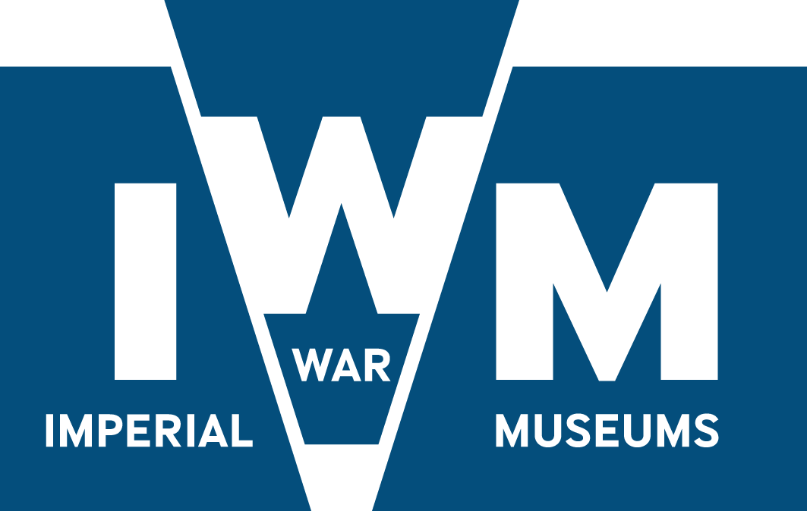
CONFIRMATION OF FEE OFFER

To: The Trustees of the Imperial War Museums
Lambeth Road
London
SE1 6HZ

Dear Sirs,

Tender – IWM Branded Carrier Bags, Tender ref: IWM/RET/1776

I/We having read the tender documentation issued in relation to the above tender, do hereby confirm that the fee for the delivery of the Services is (based on designs and numbers listed under Appendix One – IWM Carrier Bag Design Details’):

Under Appendix One ‘IWM Carrier Bag Design Details’ fee’s should be broken down in to each sized bag and the order quantity that IWM has provided. A overall total should be provided as well.

Fee (written):

Fee (numerical):

All Fees are exclusive of VAT.

I/We undertake in the event of your acceptance to execute with you a Contract upon the terms and conditions of contract as included within IWM’s tender documentation.

I/We understand that IWM does not bind itself to accept the lowest or any tender and that neither he, not his professional advisors, are responsible for paying the tendering costs incurred by the lowest of any tenderer.

I/We agree that this Tender remain open for consideration by IWM until 9th September 2017.

Sign: ............................................................................................

Name: ............................................................................................

Date: ............................................................................................

In the capacity of: ............................................................................................

Name of Company: ............................................................................................

