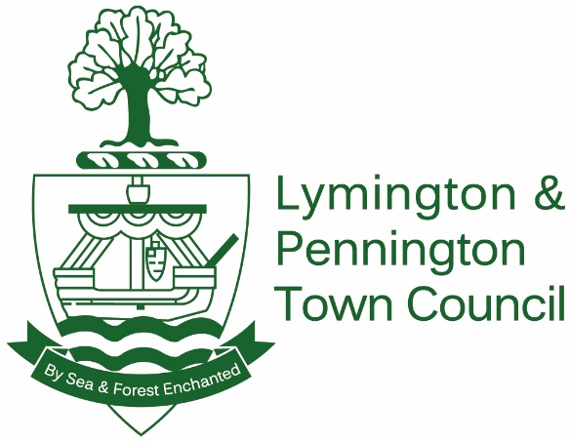

www.LymingtonandPennington-tc.gov.uk
t: 01590 630830 e: info@lymandpentc.org.uk

Provision of Insurance Services

Lymington & Pennington Town Council invites tenders from suitably qualified professionals for the provision of the whole of the Council’s insurance cover.
Details of the cover currently in place are listed in the supporting document.
The Council is responsible for many of the Town’s open spaces and playgrounds which are spread throughout the Town.
It also owns and leases out various sports grounds and pavilions, as well as an open air sea water swimming pool.
The Council operates a weekly market in the High Street.

Tenders should be submitted to the council offices in writing by 12.00pm on Friday 9 April 2021, to the Town Clerk, Lymington and Pennington Town Council, Avenue Road, Lymington, SO41 9 ZG.

